Basic information about Sibiu county

- About our county
The county of Sibiu lies in the center of Romania, in south-eastern Transylvania, at the foothills of the Carpathians. To the south, the county is bordered by two mountains separated by the Olt valley: Făgăraş on one side, whose peaks often exceed 2500 m and Lotru and Cindrel on the other side, with altitudes of a little over 2200 m. To the north of the county, the relief loses altitude and becomes dominated by gentle hills and wooded heights. The region of Sibiu has a temperate continental climate with warm, sunny summers and cold winters.

- Population
The county of Sibiu has approximately 423 000 inhabitants. The most populated city is Sibiu (county capital) followed by Mediaş, Agnita, Avrig, Cisnădie, Copşa Mică, Dumbrăveni, Miercurea Sibiului and Tălmaciu.
The population is mostly made up of Romanians (90%), Hungarians (3,7%), Roma (4,2%) and Saxons (1,6%). 89% of the population are orthodox while 2,5% are protestant, 2,3% Greek catholic and 1,5% catholic.

- Sibiu in numbers
5.432 km2 - surface of the county of Sibiu (2,3% of the total country surface)
-34,4 grade C - lowest temperature recorded in the county in 1888
+39,5 grade C - highest temperature recorded in 1946
12 grade C - average annual temperature
420 m - average altitude of the county of Sibiu
155.000 inhabitants in the city of Sibiu, of which approximately 25.000 are university students

- Administrative divisions
Sibiu County has: 2 municipalities, 9 towns and 53 communes.
Its geographic position and the historical circumstances have led to a genuine cultural diversity in the county of Sibiu. The high number of colonists having succeeded each other in this region had a great influence on local culture and civilization. Today, the ethnographical and folkloric regions of our county are very well individualized and they each have their own identity, like pieces of a puzzle which are put together to create a whole, homogenous image.
- Valea Hârtibaciului
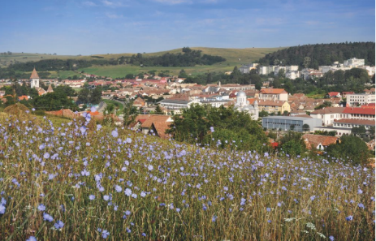
It is also called the "Green Valley" and offers the unique view of the wild nature and the spectacular Saxon fortified churches. Surrounded by defense walls, these buildings are provided with galleries and guard towers - true Transylvanian castles. The urban center of the Valea Hârtibaciului is the town of Agnita, the economic center is Selimbăr commune, and the sustainable development priorities are industry, organic farming and in-kind tourism.
More detaisl - http://www.sibiu-turism.ro/Destinations-Tourist-regions-The-Land-of-Saxon-Settlements.aspx

- Țara Oltului
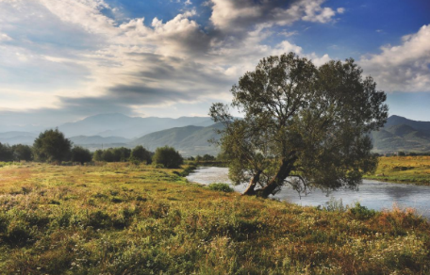
The Olt river has dug into the mountain a natural amphitheater that rises spectacularly up to 2.500 m altitude. The urban centers of the area are: Tălmaciu - representative of the wood and filament industry and Avrig, renowned for the glass industry, preoccupation with renewable energy and energy independence. From the village of Cârţişoara there is Transfagarasan, the alpine road with the most spectacular serpentines in Europe.
More details http://www.sibiu-turism.ro/Destinations-Tourist-regions-Tara-Oltului.aspx

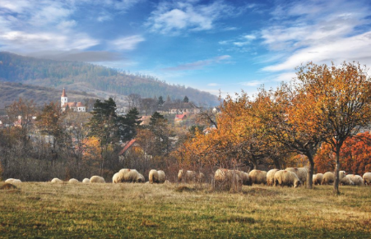
- Mărginimea Sibiului
Coming from the south on Transalpina - the famous "Road of the King" crossing the mountains - it reaches the villages of Mărginimea Sibiului, famous for the crafts and industries related to the sheep breeding, the authentic folklore, the popular harbor full of charm and color for the folk and occupations kept from generation to generation. Mărginimea Sibiului is one of the few destinations in Europe where agritourism matches perfect with mountain and leisure tourism.
More details http://www.sibiu-turism.ro/Destinations-Tourist-regions-Marginimea-Sibiului.aspx

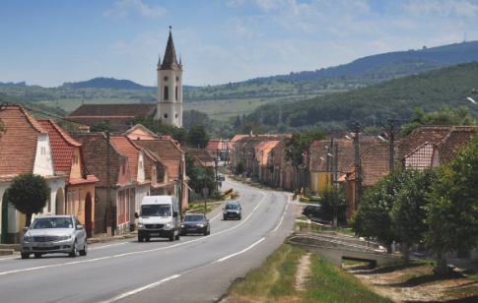
- Țara Secașelor
It is famous through the potential of the vineyard and by the traditions of the village. Miercurea Sibiului is the main economic pole, and Ocna Sibiului is the main touristic area. The lakes of Ocna Sibiului were once salt mines. The deposits were also exploited by the Romans, and the healing effect of saline waters has been known since the Middle Ages. The heliothermal resort, which has been celebrated since the 19th century, was upgraded, and the development of rural and countryside tourism coupled with legends and handicrafts on the archaic salt road is a sustainable priority for Țara Secașelor.
More details http://www.sibiu-turism.ro/Destinations-Tourist-regions-Tara-Secaselor.aspx

- Valea Târnavelor
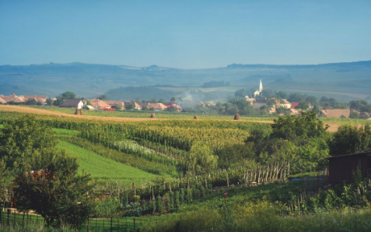
Due to its famous wines, Valea Târnavelor was also called "The Wine Country". Valea Târnavelor includes an agglomeration of the Saxon fortified churches in Romania. Two of them are declared UNESCO monuments: Valea Viilor and the Biertan Architectural Complex. The economy is based on tourism and on industries developed in the urban area of ​​Mediaş, as well as in Copşa Mică and Dumbrăveni.
More details http://www.sibiu-turism.ro/Destinations-Tourist-regions-The-Land-of-Saxon-Settlements.aspx

- Useful links
Sibiu County Council – http://www.cjsibiu.ro/
Sibiu County Tourism Association - http://www.sibiu-turism.ro/About-us.aspx

