KICK-OFF EVENT | Minutes

Date 5 & 6 September 2019 | Location Campus Arts et Métiers de Cluny, Burgundy-Franche-Comté, France
Meeting called by | HESAM Université (Lead Partner)
Type of meeting | Project partners meeting + Steering Committee
Facilitators | Jordana A. Harriss & Serge Gadbois (HESAM Université)

Attendees (Country, Organization, Name, Position)
Romania, Regional Development Agency, Centru: Mrs Gabriela Tarau, Policy Officer European Network
Spain, Provincial Council, Granada: Mrs Trinidad Manrique de Lara Vílchez, Project Officer European Projects
Czech Republic, Central Bohemian Innovation Centre: Mr Vedran Bostandžić, Project Manager
Netherlands, Van Hall Larenstein University: Mr Emiel Elferink, Researcher; Mr Mindert de Vries, Researcher
France, HESAM Université: Mr Serge Gadbois, Head of International and EU Affairs; Mrs Jordana A. Harriss, Project Coordinator;
France, Regional Council, Burgundy-Franche-Comté: Mr Pierre Grosset, Regional Councillor in charge of Circular Economy; Mr Sylvain Riffard, Head of Department on Territorial development, Mrs Florence Catanese, Policy Officer on Innovation & European Projects Policy Officer, Mrs Pauline Treissac, Policy Officer on European Projects
France, Communauté de communes du Clunisois: Mr Jean-Luc Delpeuch, Elected representative

Getting to know each other
This summarizes two 2-hour sessions (getting to know each other + work session). PPT are available online.
The project brings together 6 partners from 5 different European countries: from France, HESAM Université and the Regional Council of Burgundy-Franche-Comté; from Spain, the local council of Grenada’s Province; from Romania, the regional development Agency of the Centru Region, from Czech Republic, the Central Bohemian Innovation Centre; from North East Friseland region in the Netherlands, the Van Hall Larenstein University.
A 30 minutes ice-breaker activity allowed project partners (PP) an informal first contact. Most of PP are policy officers dedicated to European affairs, some are researchers. In attendance were also 2 elected representatives and a civil servant in charge of Territorial Development Department, all 3 from France.
Experience in Interreg Europe (IE)’s projects varies from one partner to another. Number of IE projects per partners: RO=7; ES=3; FR=2; CZ=1; NL= 0. See ppt presentation for more info, including experience on other European programmes.
Each partner presented key figures from its country and region (population, density, land cover and urban-rural typology), allowing interregional comparisons as well as a good understanding of PP’s regions specificities within their own country. See ppt presentations for more info (ppt “Getting to know each other”)
Key facts from the discussion on local authorities:
- The number of municipalities varies from one country to another: NL=390, RO=3 181, CZ=6 258, ES= 8 176, FR=34 968. NB: in the NL, one municipality counts many voluntary citizen groups.
- Every country except the NL have an intermediary level between the local (municipalities) and regional divisions.
Key facts from the discussion on circular economy:
- Almost every country in the partnership has a national strategy (or program or roadmap) dedicated to circular economy (CE).
- National strategies on CE are quite recent (2016 for the NL, 2019 for Spain, Romania and France, under elaboration in CZ).
- In several countries waste management is the 1st way in CE, especially at the regional level (RO, FR, CZ)
- Not all regions have a dedicated strategy on CE, that can be addressed through the Smart Specialization Strategy (RO), Biomass plan (RO), Waste management plan (FR, CZ).
- CE’s definition varies depending on the country. Key aspects from the discussion: the scale of the loop; its economical added value for a more competitive, innovative, attractive region; sustainability, with low-impact on resources and landscapes.
On challenges and expectations expressed by PP:
- For general audience to be more aware of CE, to think it is important, and start to introduce it in their daily life (ES)
- To produce guidelines for local authorities, based on study visits to understand and implement circular economy with one’s own resources and capacities (RO)
- To find out if NE Friesland regional method is replicable elsewhere + to learn something from PP to implement in our country (NL)
- To establish a regional expert group that can be of use for different purposes + to encourage cooperation between ministries (environment, agriculture) + to come out with a financial tool to support circular economy solutions from the national level (CZ)
- All above + to learn from unsuccessful cases that can help identify the blocking points (FR).

PROJECT METHODOLOGY, REGIONAL MAPPING AND NEEDS ANALYSIS
This summarizes two 2-hour sessions. PPT are available online.
Coming back to the partnership’s origins, the session begins with a reminder of what is at the core of the partnership, the shared issues we want to address with this project:
- Circular economy (CE) is a cross-disciplinary issue (economy, environment, social organization), requiring a more cross-sector approach;
- Most of circular economy related projects focus solely on industrial players (eg triple helix);
- This project will focus on the role of local authorities in CE as they oversee natural resources management, social and economic territorial organization;
- We will also look at the connections between local authorities and other local stakeholders (eg quadruple helix), and more specifically with researchers.
- Common ground betweens PP is the will to emphasize on rural areas
Therefore, COLOR CIRCLE’s main topics are:
- Circular economy’s governance,
- Cooperation between local authorities and researchers *,
- Local authorities’ empowerment,
- Rural areas, small and medium size cities,
That is why COLOR CIRCLE stands for “COnnecting and empowering LOcal authorities with Research capacities to unlock the full potential of CIRCular Economy”.
* The term “cooperation between researchers and local authorities” raises question, as it might be excluding other stakeholders e.g. industry farmers and contradicting the quadruple helix approach used in the Fjildlab in Friesland. It is reminded that local authorities are a key target for the project the aims of which is to influence policy. The discussion leads to the consideration that the project focuses on the lack of skills locally, and the contribution research capacity can make to empower local authorities. The project pays a attention to these two categories of actors, though it embraces the large processes that can involve a wider scope of stakeholders. Eventually the purpose is for the regional authorities (not just local) to engage in a dialogue with all these stakeholders to consider how to design or improve its policy on circular economy.
A second point of discussion revolves around the reasons and drivers for policy improvement. In Friesland, a topical issue is the degree of localism for circular economy: how local do we aim to close the loop, how do we create economic added value at the level of the region, and keep the region attractive for people to stay? In Romania, Centru region, regulation will be a strong driver as companies have to develop or adopt new technologies to abide by the new directives, e.g. on single use plastic items. In Spain, Granada, the project is expected to raise stakeholders’ awareness about the comprehensiveness of circular economy and to build bridges between different fields.

The key blocks of our four-year long partnership are then explained.
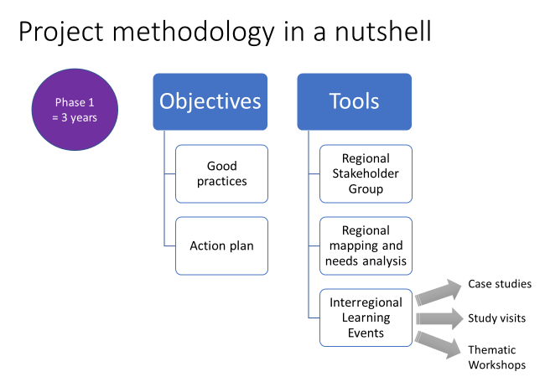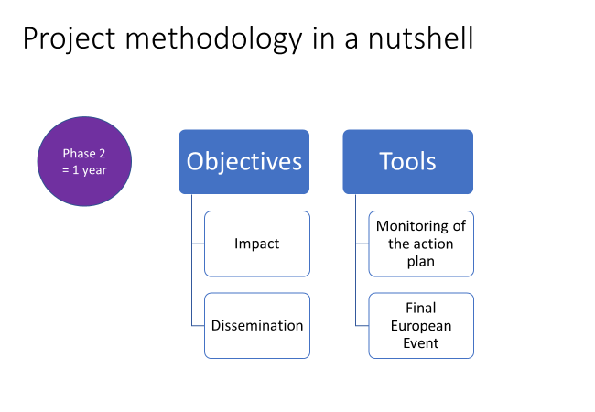
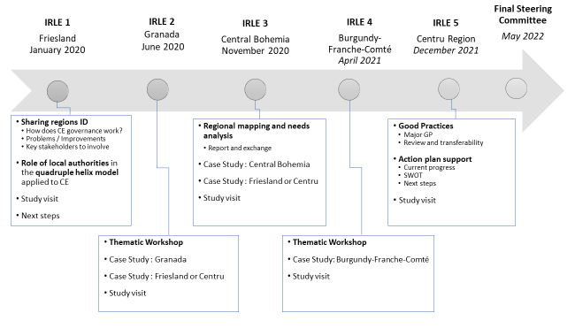
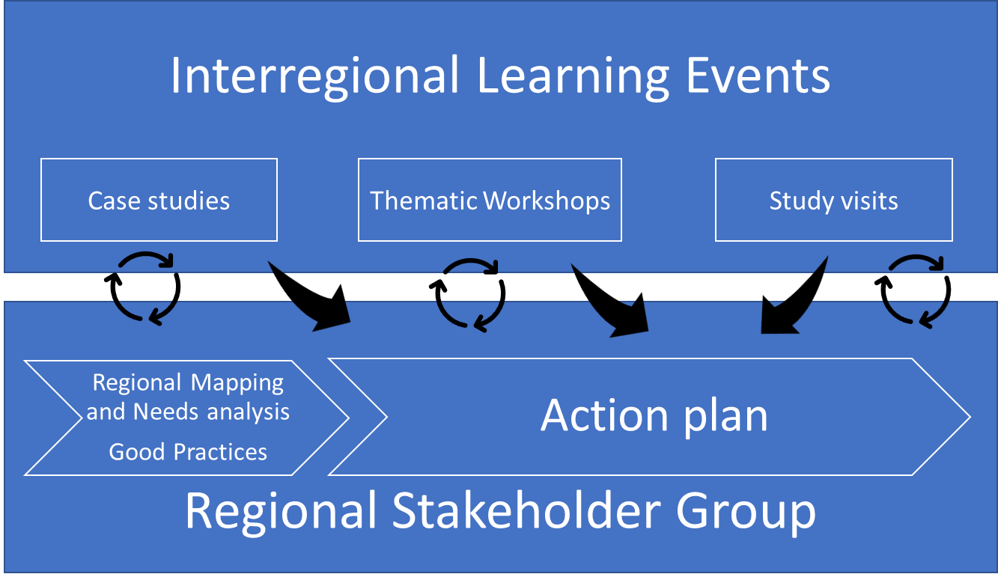
Interregional Learning Event (IRLE) will happen once per semester, hosted every time by a different partner, according to the application form’s calendar. They are the chance to exchange experiences and lessons learned in our different regions with our regional stakeholders group but also to explore more deeply one specific regional case every time we will meet. They are also the chance for the host partners to show local experiences and to involve local stakeholders in the event. It is reminded that local stakeholders from the non-host regions are also invited to join. In order to make that happen the host partner needs to share the event agenda in advance, with a short description of topics and speakers for every sessions so that non-host partner can invite relevant local stakeholders. As the 1st IRLE will take place in NE Friesland in January or February 2020, the Dutch parner agreed to send these descriptions in October. One last element of the IRLE is the “thematic workshop” planned in only 2 IRLE. Thet are made to provide expert input to key questions shared by partners and regions. The 1st one that is planned for IRLE 3, will be prepared during the steering committee of IRLE 2.

As for the regional mapping and needs analysis, to build together a common methodology that will be used to share good practices and lead to regional action plans, the lead partner showed the SWOT matrix as a first draft of methodology, as well as a set of maps that will be used in the French context. Discussion followed on methodology planned to be used in other countries:
- to facilitate a committee with the key agents from the municipality and deputacion, enriched with a participation from the University. A key point of attention will be to keep up the interest of the group during the three years (ES),
- to approach potential RSG’s members in pre-existing meetings and not on one dedicated to CE (FR),
- to build on an existing stakeholder group on building and refurbishing and enlarge it to universities (RO),
- to build on an existing stakeholder group from the Fjildlab. A first two-day meeting took place on May 2019 with
- parallel sessions on technical matters, identified by stakeholders, each chaired by a researcher. The discussion was introduced with inspiring practical examples
- plenary sessions with insights on technical aspects, as well as stakeholders’ views and regional governance analysis.
First results will be reviewed during the Steering Committee at the first IRLE, and finally shared at IRLE 3.
Action items | Deadline
Fill the Doodle on scheduling the exact date of our 1 IRLE in NE Friesland  https://doodle.com/poll/z6x7p26wxgbeet6z | 30 Sept 2019
Send draft agenda for IRLE 1 to all PP | 31 Oct 2019

ADMINISTRATION AND FINANCE

The Lead Partner informs Project Partners about Interreg Europe general contracting requirements and management rules. Insistence is made on the respect of public procurements requirements (see page 118-119 of the programme manual), and new rules regarding staff costs.

For more information on these aspects and country specific details, project partners are invited to consult the Programme manual and national pages (information on first level control; national guidance when existing; bodies responsible for structural funds) and to contact their national contact person:
- CZECH REPUBLIC https://www.interregeurope.eu/in-my-country/czech-republic/
- FRANCE https://www.interregeurope.eu/in-my-country/france/
- NETHERLANDS https://www.interregeurope.eu/in-my-country/netherlands/
- ROMANIA https://www.interregeurope.eu/in-my-country/romania/
- SPAIN https://www.interregeurope.eu/in-my-country/spain/

All activities should be properly documented (attendance sheets, agenda, minutes) - according to a principle of proportionality - to ensure the eligibility of costs. Actual activities should be all reported to planned activities in the application form against which they are justified.

Staff costs
In this last round of Interreg Europe projects, staff costs are declared on the following basis:
Option 1. Person employed by the partner organisation, and working full-time on the project
Option 2. Person employed by the partner organisation, working partly on the project at a fixed percentage
Option 3 (no longer exists, see option 4)
Option 4 (hourly rate mentioned in an employment contract) is available to NL organisations (and should be checked with NL Interreg Europe contact points; see document).

For all partners: check pages 109 and following of the programme manual

Short-term contractual steps: Partnership Agreement and FLC contract
All partners must sign the Partnership Agreement. The partnership agreement is based on the subsidy contract and contains additional sections on decision-making and on budget distribution. The early signature of the Partnership Agreement is requested to submit expenditure at the end of the first semester. For some partners, the contracting process with the FLC cannot start before the effective signature of the Partnership Agreement.
All partners are also requested to engage as early as possible in the arrangements related to First Level Control (subcontracting for Spain, Netherlands, France).

Reporting
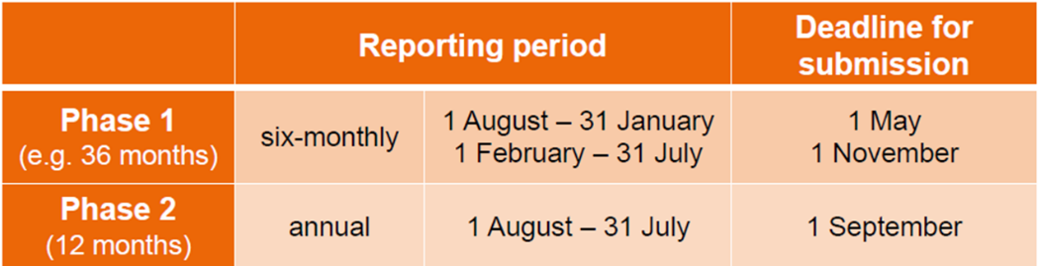
Partners report at the end of every semester on activity and finance.

Please note that the 1 reporting period exceptionally starts on March 27 ie the day the project was officially accepted.

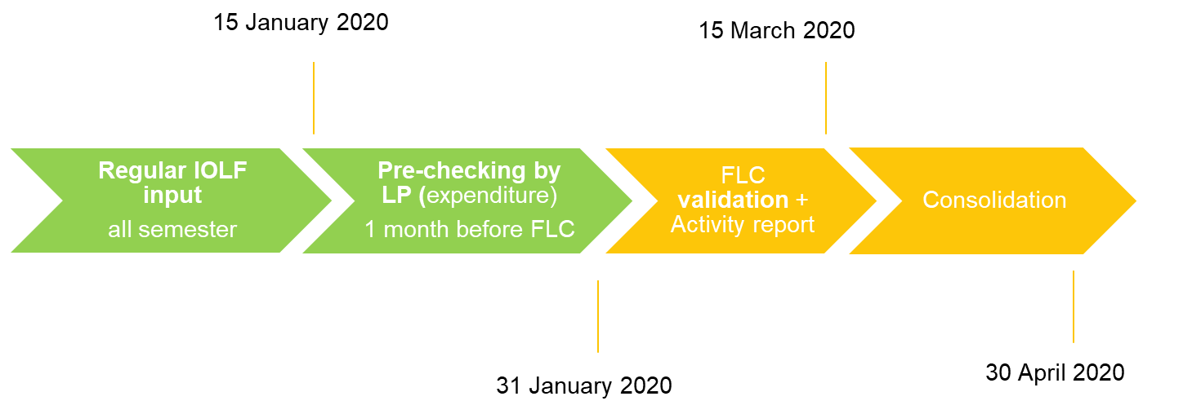Two key elements come into the process of financial reporting:
- The Lead Partner pre-checks partners’ list of expenditure before they are submitted to the FLC (see example below for the first reporting period). This pre-checking is aimed at preventing any mistake, and ensuring consistency between partners, and coherence with the application form. It is noted that changes cannot be made once the report is submitted to the FLC.
- The FLC validates the expenditure, after a process of clarification, if necessary. The length for FLC verification may vary from one country to another: partners are requested to make sure the process starts as early as possible to avoid any undue delay in reporting and related payments

In parallel, partners report on activity. The lead partner is responsible for the consolidation of partners’ report into a project report.

A Skype meeting will be organized in November for more explanations on requirements for reporting.

Steering Committee
The Steering Committee comprises all partners and will meet every semester at IRLE to discuss progress, and make decisions. Interim distant meetings on Skype are held once between two IRLEs to address specific issues. A last Steering Committee takes place before the start of phase 2.
Action items | Deadline
Read and give your ok to the Lead Partner | 20 September 2019
Sign the Partership Agreement and send it back to the Lead Partner | 31 October 2019
Contract with a First level controller | ASAP
Fill the Doodle for a Skype meeting on admin, finance, and com in November  https://doodle.com/poll/nekh7755m9hdpdqb | 30 Sept 2019

COMMUNICATION
The projects Interreg Europe supports must follow the programme’s corporate design guidelines when developing their project communication tools. To this end, the programme provides each approved project with a communication toolkit, including:
- Project logo set
- Project poster template (not available yet)
- Suggested PowerPoint template
- Project website (https://www.interregeurope.eu/colorcircle/)
Logo set and ppt template will be made available in the shared library.
Report to the following guidelines for proper logo use.
Source : Project Branding Guidelines (v January 2019)
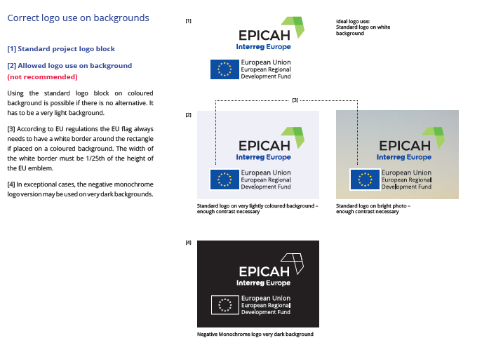
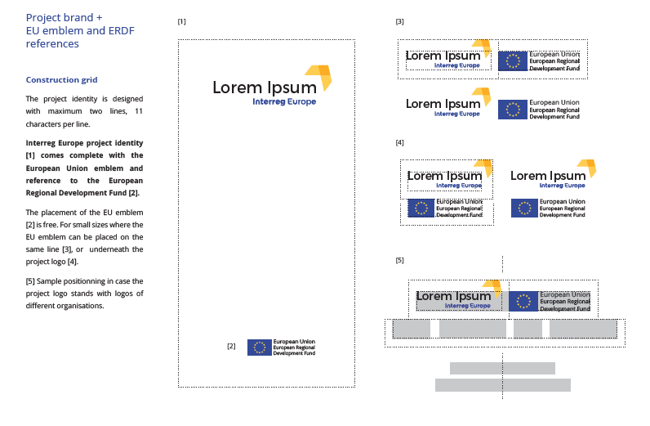
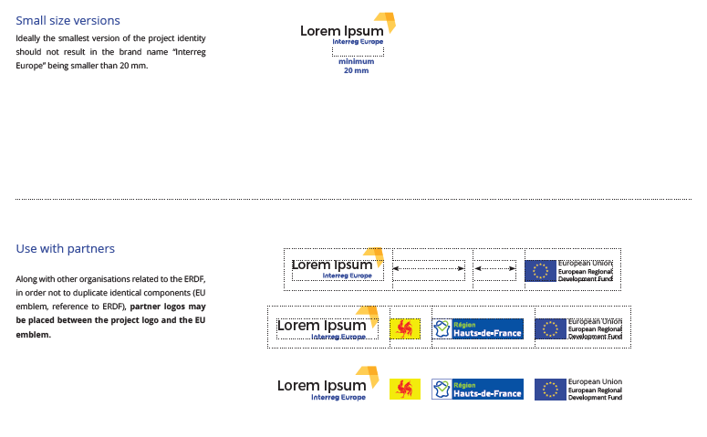

Once available, please print and place the A3 poster in a visible place. It must be seen.
HESAM Université oversees the project website as well as social networks. A Skype meeting will be planned every two-month to review what needs to be done in terms of website editing and social networks’ animation. PP will be asked to write articles in the “news” category of the website, write tweets, etc.
Action items | Deadline
Check your contact details on the website (they are on the map). Send us an email if not correct. | 30 Sept 2019
Send the HD logo from your organization to Jordana | 30 Sept 2019
On the section “What policy instruments does the project address?” please reword it (only the one regarding your region) in a more user-friendly way so that it can be understandable to a general audience. You can either send the text in an email or in a word document | 15 Oct 2019
Fill the Doodle for a Skype meeting on admin, finance, and com in November  https://doodle.com/poll/nekh7755m9hdpdqb | 30 Sept 2019
Keep tracks of event your organizing (RSG for ex) and please inform us | always
Vote for the web site banner picture and poster’s banner https://ehesam.sharepoint.com/:x:/s/COLORCIRCLEforPP/EXEWfFhKDmNOrklYZytFx-cBhidrV6uazIQEQ3Nt7Kjeyw?e=Ou04Up | 30 Sept 2019
Suscribe to our shared library https://outlook.office.com/owa/COLORCIRCLEforPP@hesam.eu/groupsubscription.ashx?action=join

TERRITORIAL OPEN-LAB VISIT
5 local initiatives on CE were presented to PP by local stakeholders at the end of the first day.
Wood material and machining lab: Mr Guillaume Pot (Associate Professor, Labomap, Arts et Métiers School) and Mr Jean-Luc Delpeuch (Local representative, Communauté de Communes du Clunisois) introduced PP to an initiative of local forests’ valorisation, a good example of cooperation between local authorities and researchers. Towns around Cluny own some local woods. They get some financial resources from cutting and selling trees. But the ones they own are twisted and consequently can only be sold to make fire wood, which does not make as much money as selling wood for silviculture use. Is there a way to make something else out of his wood, something that could generate more revenue for local municipalities? The question was asked to the Arts et Métiers School. It was found that logs can be rolled out, transformed into thin timber sheets that, assembled, can be used to make high quality carpentry, eg window frames. Consequently, the municipality-owned trees usually sold for 30 euros/m3 for fire wood use, can now be sold 300 euros/m3. Following that first research made by a Master student at the engineering school, a local window company hired a PhD student to keep on studying the possibilities of local wood valorisation.
1000 PhD students for local action (1000 doctorants pour les territoires) is a national programme funded by the French Ministry of Research and Innovation and run by HESAM University. By sending PhD candidates in local councils and non-profit organizations for 3 years i.e the entire time of their doctoral studies, HESAM University (whose President is also a local elected official) aims at empowering local authorities, while giving PhD candidates the opportunity to do a long-course research-action work for a local administration. Furthermore, only few of these local authorities know they can apply to a 42 000 euros state subsidy when they hire a PhD student. The programme was presented by Jordana A. Harriss with testimonies from Mr Boris Chevrot (ex PhD candidate at the Communauté de communes du Clunisois and now an employee of the same ‘intercommunalité’) and Mr Jean-Luc Delpeuch (see above).
The European College of Cluny is a training institution for students, local elected representatives and local actors from all over Europe. The year-long programme combines 6 months of academic courses (eg: history of local governments across Europe) and practical training (ex: designing public policies) with 6 months of territorial immersion in local administrations in a European country.
Le Pain sur la Table is an organic bakery, a restaurant and a cultural venue, presented to PP by one of its cooker, Mr Manu Gaillard. Le Pain sur la table is the realization of a project that defends social aspect, respect for nature and the environment, agriculture of proximity and quality. It is a cooperative society of 60 associates, all equal, no boss.
L’agence du patrimoine is a social and solidarity-oriented non-profit organization funded by the European Social Fund, in partnership with the local ‘intercommunalité’. Its Incluniso project aims at helping long-term unemployed people (ie unemployed for more than 2 years) by hiring them for sustainable activities of general interest (working on public buildings maintenance, collecting unsold food and ensuring their distribution for local NGOs…). The project was presented by Mr Julien Masse.

KEY NOTE SPEECH

Speaker Pierre Grosset | Time allotted 2 hours
Pierre Grosset sits at Burgundy-Franche-Comté Regional Council as Councillor in charge of Circular Economy. At first attached to the regional competence on waste management, circular economy opens up now to a fully comprehensive approach. This is a new domain of action for the Council, where much remains to be started. A first strategy was built following extensive consultations with stakeholders. The strategy comprises 36 actions along 4 lines of regional policy :
- circular economy is approached as an asset, not a constraint : we should create the necessary conditions for transition
- solutions are built with stakeholders not on their behalf : we should support local communities in initiatives built on cooperation
- protecting the environment and building a new economy based on biodegradable resources go hand in hand
- the regional council shall be a model in the implementation of circular economy principles
In 2019-2020 50 projects will be supported by the Regional Council, e. g. on ecodesign. Projects making use of bio-sources material will get a bonus. The Council also supports local authorities that start local circular economy plans. Training on circular economy in schools and universities is given a special attention. Finally the region set up an eco-design cluster within the regional Development Agency.
The general purpose is to do more with less and to shift from a growth model built on resource consumption to a reasonable and sustainable economic model, that takes due account of the fact that we do not live on endless resources.

It is reminded that circular economy is not included per se in the current ERDF program. Therefore, the policy referred to in the application form comes from different sectors according to partners. This is a topical issue for the next programming to have circular economy fully included as such, while considering its cross-cutting dimension.
Following the kick-off event, the Regional Council of Burgundy Franche Comté informed the Lead Partner of a difficulty to host an IRLE in Spring 2021 due to the regional election calendar. How to reorganize the IRLE calendar will be one of the topic of our November Skype meeting.

