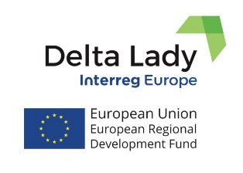
Press Release
January 2023

DELTA LADY FINAL CONFERENCE
Results and the Lessons Learned from the exchange of experience process

The Final Dissemination Conference of the Delta Lady project was held on 26-27 January 2023 in the city of Leeuwarden in Friesland, the Netherlands. The final conference was held in a hybrid mode, as part of the participants attended the event online via Teams. In total 22 people attended the final conference, from which 15 were in person and 7 online. The conference was attended by the representative of the Interreg Europe secretariat, the policy officer of the Delta Lady project, who presented the state of play of Interreg Europe programme, including information about the new programme. The conference focused on the results of the project.
On the first day, the partners presented their progress in relation to the implementation of the Action Plans and held the panel discussion around the issues and lessons learnt during the lifetime of the project. The Pilot Action of the Province of Friesland (a web-based application/tool using Policy-Enhanced Sustainable Cost-Benefit Analysis for assessing the impacts of the projects and policy initiatives) was presented on the first day as well. The Pilot Action was presented by 5 students from the University of Groningen who were involved in the development of the tool. The tool can be accessed at: https://sustainabilityevaluation.org/
The second day was dedicated to the presentation of the Province of Friesland about the effects of 25 years of Interreg projects on Cultural Heritage and Sustainability in the Province of Friesland, which was followed by guided tour in Leeuwarden to visit locations of some of the projects.
Delta Lady finalizes the project by 31st of May 2023. All partners are mobilized to submit their results regarding the implementation and monitoring of Action Plans and improvements of the addressed policy instruments.

If you want to know more, please, contact the Lead Partner, University of Twente (CSTM)
f.h.j.m.coenen@utwente.nl or m.lordkipanidze@utwente.nl;

or visit project website Delta Lady (Floating Cultures in River Deltas)
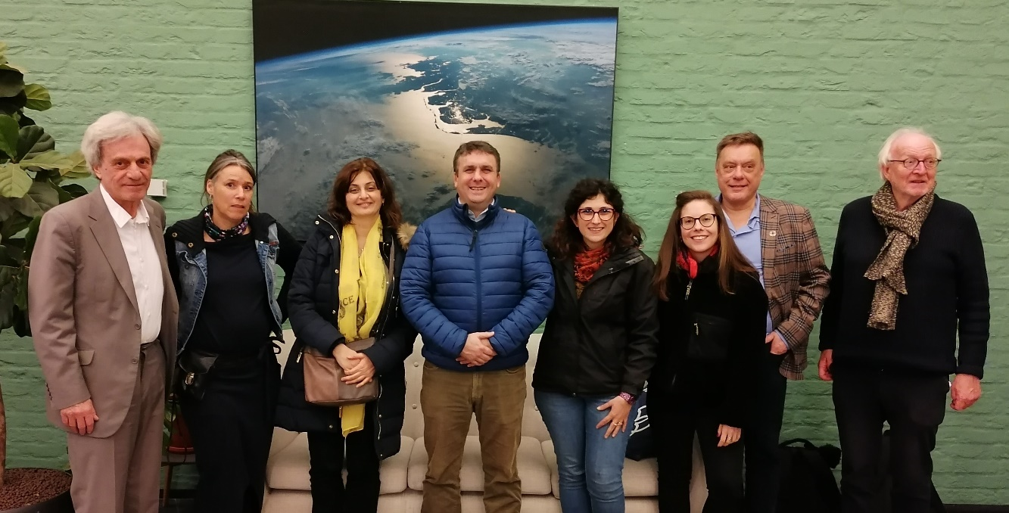
Project funded by Interreg Europe programme

