http://neaflorina.gr/2017/03/evropaikes-periferies-epikentrononte-stin-kenotomia-ston-tomea-ton-metaforon/
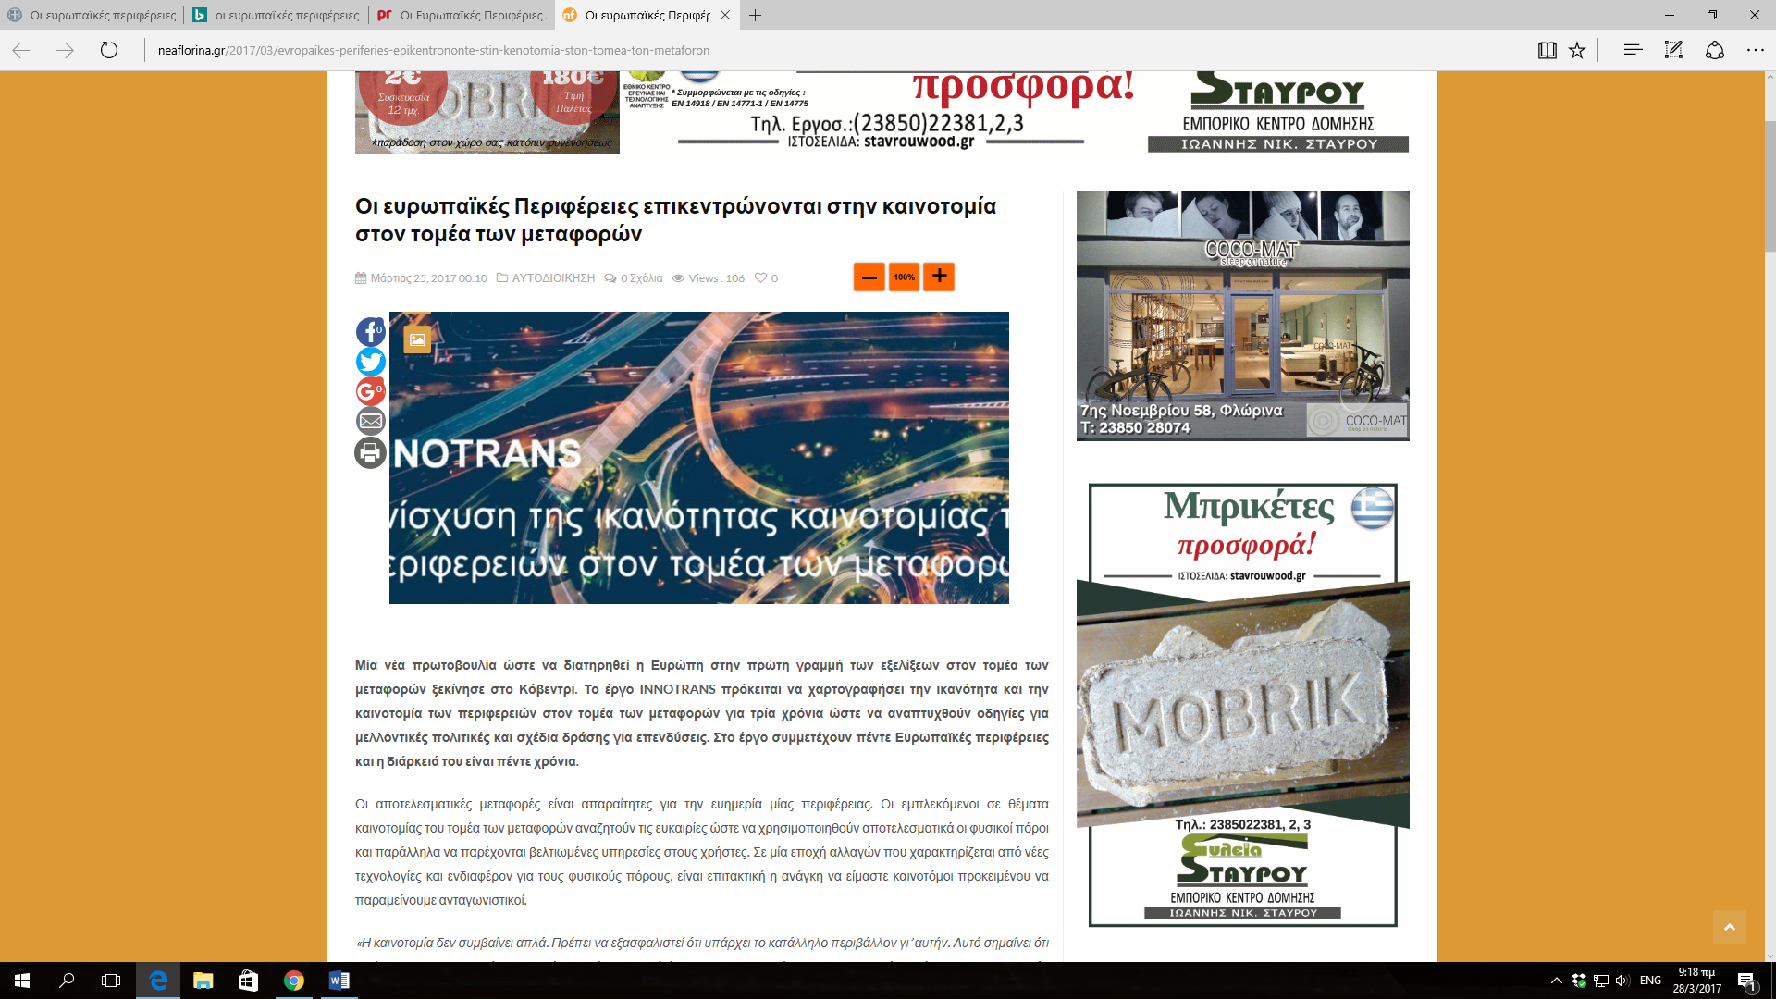
http://www.prlogos.gr/%ce%bf%ce%b9-%ce%b5%cf%85%cf%81%cf%89%cf%80%ce%b1%cf%8a%ce%ba%ce%ad%cf%82-%cf%80%ce%b5%cf%81%ce%b9%cf%86%ce%ad%cf%81%ce%b9%ce%b5%cf%82-%ce%b5%cf%80%ce%b9%ce%ba%ce%b5%ce%bd%cf%84%cf%81%cf%8c%ce%bd/

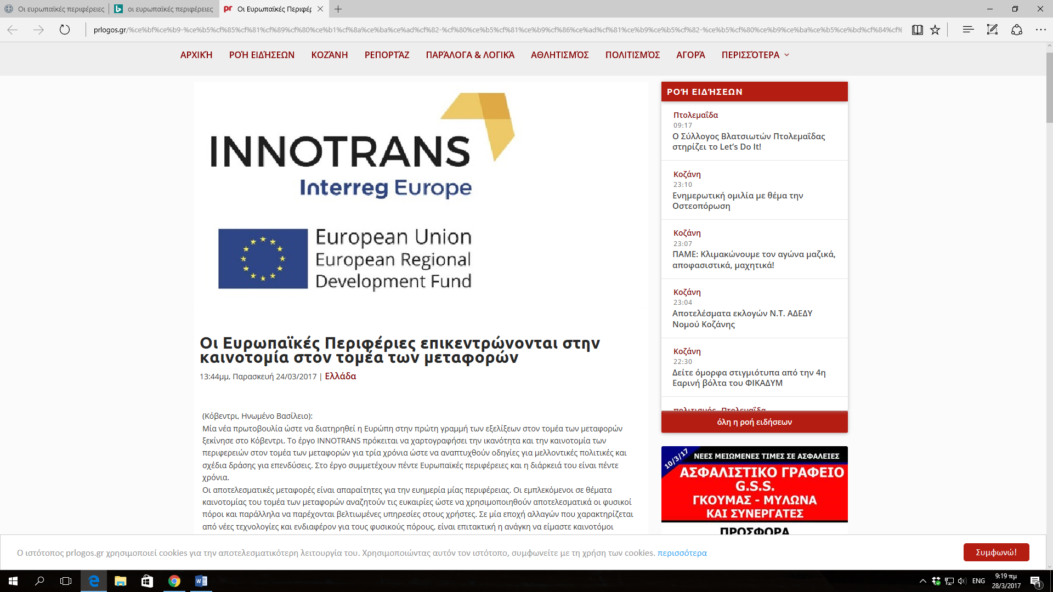

http://www.tharos.gr/oi-eyropaikes-perifereies-epikentronontai-stin-kainotomia-ton-metaforon
http://www.kozanilife.gr/2017/03/europaikes-perifereies-tomeas-metaforon/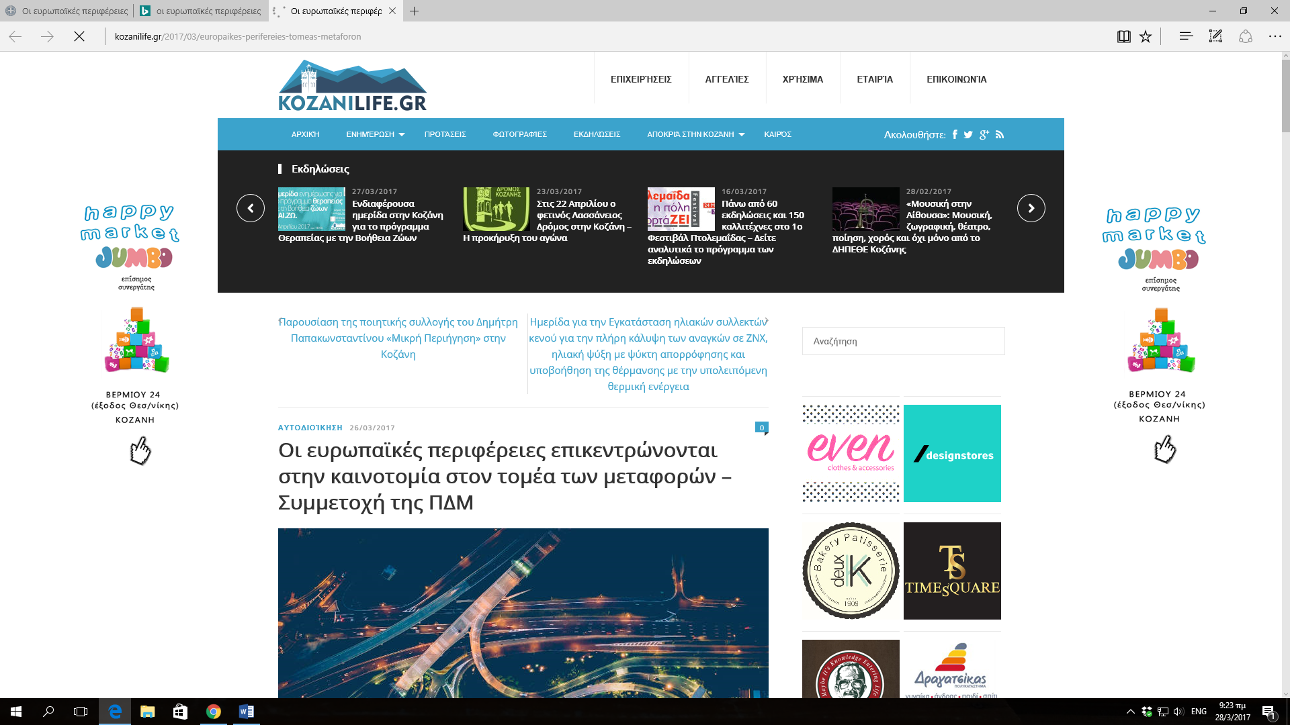
http://energeiakozani.blogspot.gr/2017/03/blog-post_59.html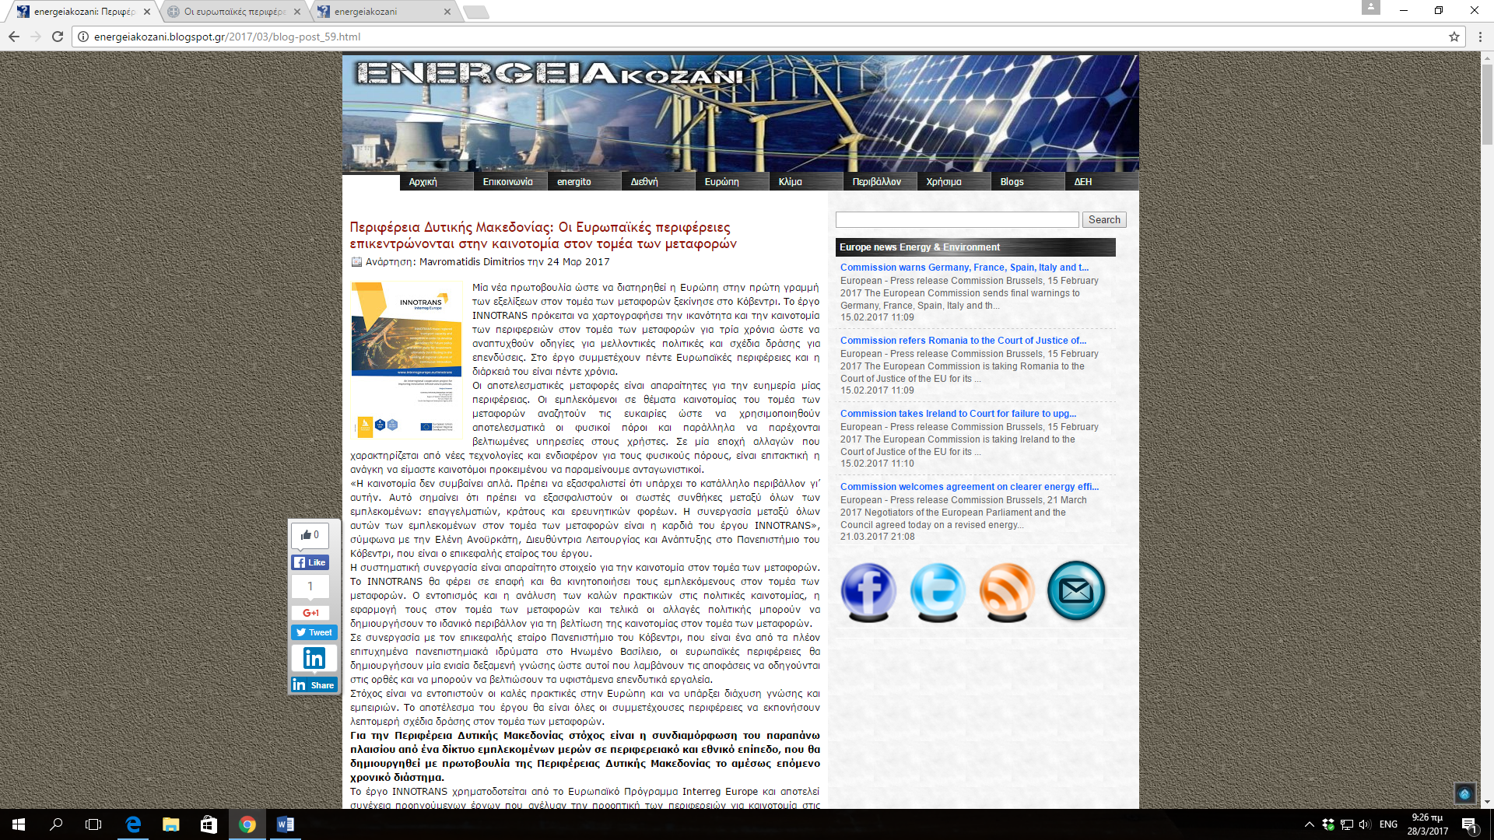
http://kozan.gr/archives/26963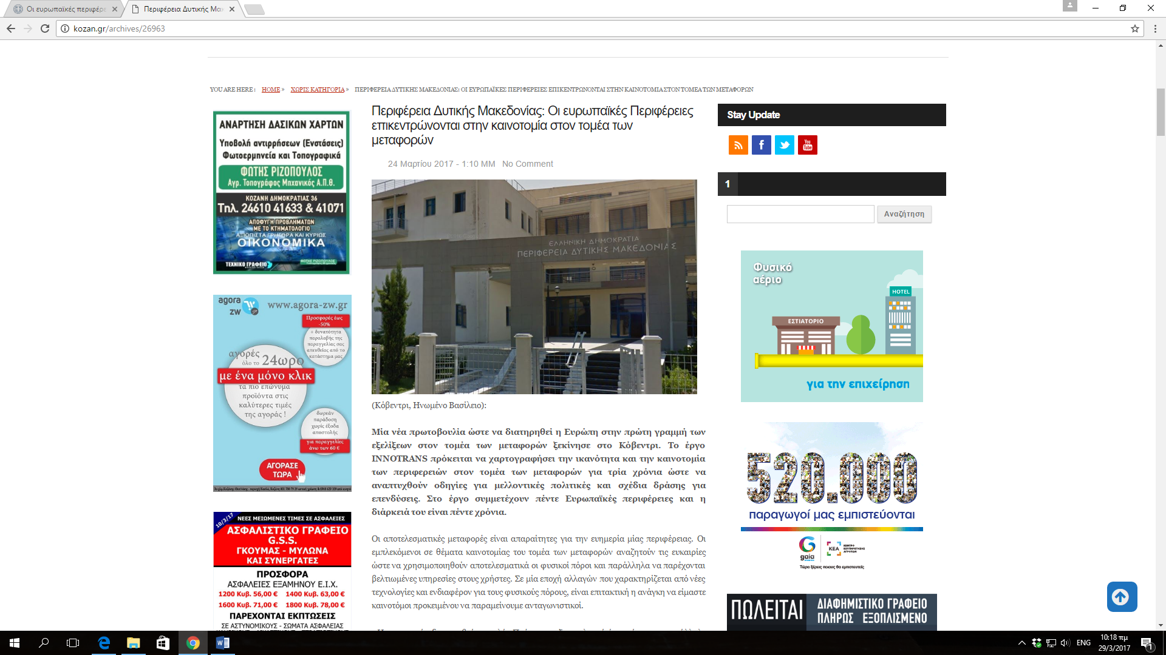
http://www.pdm.gov.gr/evropaikes-periferies-epikentrononte-stin-kenotomia-ston-tomea-ton-metaforon/