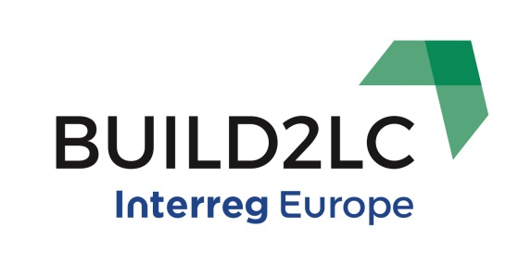

Gloucestershire, UK Consortium Agenda

Interregional Thematic Seminar - New energy culture, citizen involvement and energy poverty, Gloucester, UK
Tuesday 13th & Wednesday 14th June 2017
Venue: Gloucester Guildhall, 23 Eastgate Street, Gloucester, GL1 1NS

Day 1 – Tuesday 13th June 2017
Interregional Thematic Seminar

I – Registration and Welcome
08:45-09:15 Registration (refreshments available)
09:15-09:30 Welcome and introduction to the UK decision making structure in the region (Mike Brain, CEO, Severn Wye Energy Agency and Joaquín Villar, Lead Partner, Andalusian Energy Agency))

II – Health and Energy Poverty in an EU Context
09:30-10:00 The health and well-being impacts of energy poverty across 32 countries (Dr Harriet Thomson, Project Manager, European Energy Poverty Observatory)

III – The impact of energy poverty on health and citizen involvement in the UK
10:00-10:30 Causes of energy poverty and the impact of policy on citizen involvement (Barry Wyatt, Strategic Head (Development Services), Stroud District Council)
10:30-11:00 The impact of energy poverty on health and social care (Mary Morgan, Lead Commissioner for Older People, NHS Gloucestershire Clinical Commissioning Group and Gloucestershire County Council)

11:00-11:30 Break

11:30-12:00 Evidence: Providing the evidence that retrofit can have positive impacts on health (William Baker, Head of Fuel Poverty, Citizens Advice)

IV – How to successfully engage citizens
12:00-12:15 Engaging citizens and lessons learnt in Lithuania (Gvidas Dargužas, VIPA)
12:15-12:30 Engaging citizens in Energy Poverty in Croatia (Slavica Robic, DOOR)
12.30-12.45 Social Prescribing (UK) (Hannah Gorf, Gloucestershire Clinical Commissioning Group)
12:45-13:00 Cheltenham Borough Homes: energy efficiency and fuel poverty in our properties (Frances Crick, Cheltenham Borough Homes)

13:00-14:00 Lunch – delegates go straight to workshops after lunch

V – Strategies to manage fuel poverty and engage citizens – Workshops
The workshops provide an opportunity for smaller groups to find out more about project
and allow time for discussion between partners. Delegates should select two workshops
from the options below in advance.
Workshop 1: Warm & Well –a programme for providing advice, support and retrofit to domestic properties (Brian Canning and Sarah Dittman, Severn Wye Energy Agency)
Workshop 2: Link2Energy – Establishment, training and co-ordination of an energy and installers network (Neil Towler and Mike Brain, Severn Wye Energy Agency)
Workshop 3: Target 2050 – A project in Stroud District to reduce carbon emissions across domestic properties, businesses and community buildings. The project explores managing different types of buildings, support for those in fuel poverty and engaging installers (Maria Hickman and Barry Wyatt, Severn Wye Energy Agency)
14:00-14:30 Workshop rotation 1
14:30-15:00 Workshop rotation 2

15:00 Close for stakeholders and coffee break for partners

VI - Application to local areas
15:30-16:15 Making an impact on a local scale-case studies
Three 15 minute presentations summarising how those in fuel poverty have been targeted on a local scale. Potentially include a representative from:
- Combating energy poverty in Andalusia (Ms Inmaculada Guerrero, Andalusian Federation of Municipalities and Provinces)
- Energy wise housing cooperative, Sweden (Anneli Kamb, RJH)
- Combating energy poverty in Slovenia (Mrs Katarina Kafadar, Eco Fund)
16:15-16:45 Small group discussions – engaging citizens in policy and programmes. What works and what doesn’t?

16.45 Close
17.15 City Tour of Gloucester – meeting outside the front of Gloucester Guildhall
18:45 Bus departs for dinner at Red Hart Inn, Longhope from Southgate Street following the tour

Day 2 – Wednesday 14th June 2017
Partnership Meeting & Study Visits

I-Site Visit to Berkeley GREEN & UTC
09:15-10:00 Travelling by coach to Berkeley GREEN and UTC
10:00-11.15 Site visit – Berkeley GREEN and UTC
Berkeley GREEN and UTC is a new training and educational establishment situated on the site of a former nuclear facility. The project aims to provide an avenue for professionalising the construction industry for adults and young people. It also works in partnership with a range of private and public organisations.
The trip will include a tour and a talk about: The history of the site; reasons for creation, courses & enrichment opportunities offered and expected outcomes; partnerships; building design and sustainability

11.15-11.30 Coffee break

II– Innovative ways to manage housing and energy issues
11:30-12:00 Schneider: Innovative ways to manage housing and energy issues (Dave Evans, Schneider)
12:15-13:00 Travelling by coach back to Gloucester

13:00-14:00 Lunch at Gloucester Guildhall

III-Partnership Meeting
14:00-16:00 Partnership meeting for partners only
16:00 Close
19:00 Dinner at Bill’s, Gloucester Quays*
*Dinner will be arranged for those flying home on Thursday 15th June. As this is after the close of the meeting, partners will need to fund their meal from their travel budget.

