6th-9th of September, 2017 | SUCEAVA, ROMANIA

GREEN PILGRIMAGE REPORT on the International Conference, 2nd Partner Meeting, and Study Visit to Suceava County, Romania

Table of Contents

1. | Introduction
2. | Format of the Event
3. | Event Description
 | 3.1. International Conference
 | 3.2. Steering Committee
 | 3.3. Study Visits
4. | Conclusions
 | Appendices

1. Introduction

The National Institute of Research and Development in Tourism - INCDT organized, with the support of the Suceava County Council and of the Ministry of Tourism, the International Conference, the 2nd Partner Meeting, and a Study Visit under the project called "Green Pilgrimage - Supporting Natural and Cultural Heritage".

The event took place between the 6th-9th of September, in Suceava county, and involved 35 participants.
The Green Pilgrimage - Supporting Natural and Cultural Heritage project is co-financed from the ERDF (European Regional Development Fund) through the INTERREG EUROPE Interregional Cooperation Program under the Priority Axis 4: Environment and efficient use of resources, Specific Objective 4.1: Improvement of natural and cultural heritage policies.
The INTERREG EUROPE program aims to improve the implementation of regional development policies and programs, mainly those pursuing investments for growth and jobs and, where appropriate, those of European Territorial Cooperation, by promoting the exchange of experience and new learning policies between relevant actors at regional level.

Under "Interregional Cooperation Projects" - organizations from different regions of Europe are working together on a common policy issue for a three-five years duration, ensuring that lessons learned from co-operation are put into practice.

In order to strengthen the results-oriented approach and to provide the learning process with better chances to lead to tangible results, an interregional cooperation project is conceived in two phases:
• "Phase 1" ‒ dedicated to interregional learning and to the preparation of the implementation of lessons learned from cooperation, by developing an action plan.
• "Phase 2" ‒ dedicated to monitoring the implementation of each Action Plan. Where appropriate, pilot projects may also be carried out in this phase.

The theme of this event was “Relation between tourism, religions and pilgrimage to stimulate and facilitate the dialogue among different civilizations and different faith groups" and aimed to identify and exchange good practices between partners and stakeholders involved in the project, thus fitting the first phase of the project.

INCDT has chosen Suceava County as the venue for this event. This choice has been substantiated by the richness and value of the religious heritage in this area, the resources being in the process of touristic capitalization, but also by the existence of traditional pilgrimages here, involving various religious confessions and different ethnic groups.

2. Format of the event

- International Conference, with 3 sessions:

Session 1: Introduction to religious tourism and pilgrimages
Session 2: Good Practices in Romania
Session 3: External stakeholders’ presentations

- Steering Committee

- Study Visits

3. Event Description

3.1. INTERNATIONAL CONFERENCE

The purpose of the conference was to increase the information and awareness of the target group (ministries, regional and local public authorities, associations, and organizations with an active role in the development and promotion of religious tourism in Romania, universities, etc.) on the importance of pilgrimage tourism, and the regional economic impact of this form of tourism, as well as the importance of developing a pilgrimage route in the Bukovina region.

Target group of the event:
- partners in the Green Pilgrimage project and their stakeholders, to whom good practices in Romania will be presented;
- Romanian stakeholders in the project, namely the representatives of the Ministry of Tourism, of the Suceava County Council, the Suceava County Mayors, the local churches, professional associations in the field of tourism, the Mountain Rescue County Service, "Ştefan cel Mare" University in Suceava, tourist information centres county, etc.

The unfolding of the conference:
The conference was opened by Ms. Alina Cârlogea, INCDT, who welcomed all the partners and participants on behalf of the organizers.
During this plenary session, welcome remarks were also expressed by Ms. Laura Ursu from Suceava County Council.

Session 1: Introduction to religious tourism and pilgrimages

Speakers:
Mrs. Catherine Brady, Project manager Kent County Council, United Kingdom
Mr. Octavian Arsene, Ministry of Tourism
Mrs. Lăcrămioara Beilic, Association for Tourism Bucovina
Mr. Petre Ariciuc, Mountain Rescue Association

Moderator:
Mrs. Rodica Trifănescu, National Institute of Research and Development in Tourism

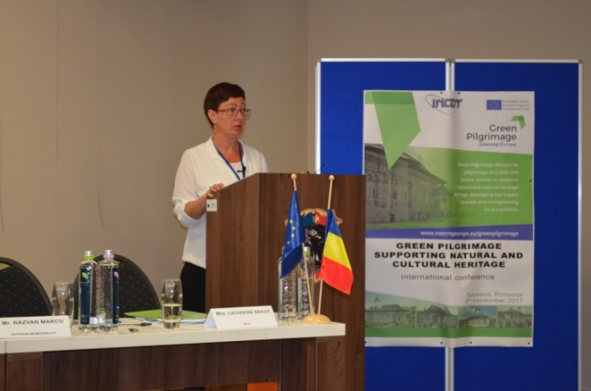
In the opening of the first section, Mrs. Catherine Brady, project manager from the leading partner - Kent County Council (UK) - made a short description of the Green Pilgrimage project. In this presentation, she emphasized the place of pilgrimage tourism in the context of the global tourism industry, stating that approximately 330 million people go on world pilgrimages annually (about one third of tourists, according to UNWTO).
To highlight the role that sustainable development of pilgrimages has in a particular region, she gave the example of the pilgrimage taking place at Santiago de Compostela. The number of pilgrims on this route increased during 1985-2009 from 3,000 people to nearly 300,000 persons each year. More factors have contributed to increasing the notoriety of this pilgrimage route, among which:
- Visits of Pope John Paul II in 1982 and 1989;
- Designation of Way of St. James as the First European Cultural Route of the Council of Europe in 1987;
- Investments of 120 million Euros on infrastructure, cultural and socio-economic activities, realized through the Xacobeo 1993 Plan;
- Creating a route brand with specific markings
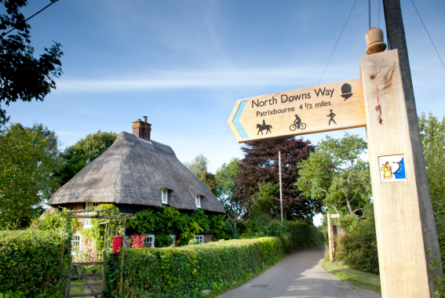
Over the next 25 years, the Authorities in Galicia are planning further investment of 65 Million Euros and they foresee a return to a regional income of 650 million Euros.
Drawing on this example of good practice, Mrs. Catherine Brady emphasized the potential of Bukovina for the development of pilgrimage tourism. In this respect, based on the experience of the other partners in the project, she outlined some investment ideas that could be made to facilitate the pilgrims' access to the area:
- creating a Pilgrimage Centre;
- activities focused on promoting the pilgrimage route;
- the development of accommodation and catering facilities for pilgrims;
- the creation of a Pilgrimage Festival;
- on spot signalling of routes;
- creation of both physical (printed) and digital maps;
- creating an on-line journey planner application (distance calculator, travel planner, accommodation planner, food & drink app, heritage information app).

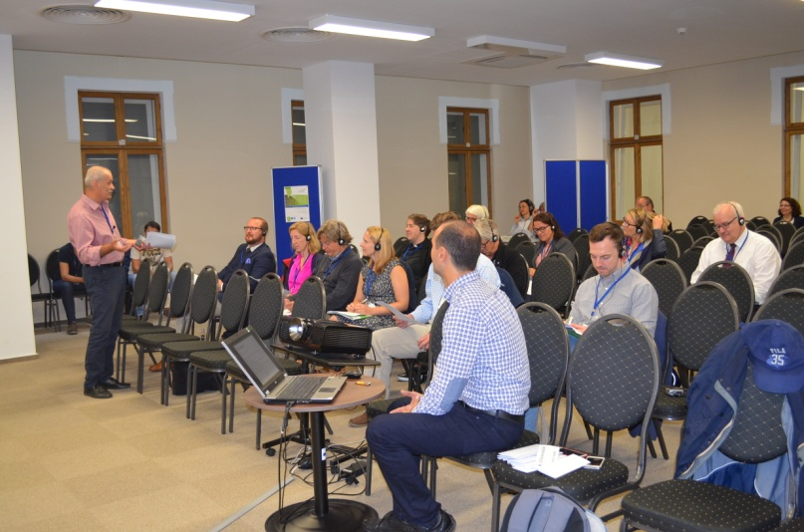
Within the same section, a second presentation was made by Mr. Octavian Arsene, the Ministry of Tourism (Romania). In the first part of the presentation, Mr. Arsene made a review of existing definitions for key terms such as "culture" - "religion" - "pilgrimage" - "pilgrim" - "tourism" - "cultural tourism" - "religious" tourism. A first conclusion was that from the point of view of the UNWTO concept, religion and pilgrimage are the main motivations of tourism, and religious cultural objectives can be very well capitalized on by integrating them into the European Cultural Routes. In the second part of his exhibition, Mr. Arsene presented the strengths of Romania in the view of the inclusion to European Cultural Routes, stressing out that Romania could participate in up 15 to 18 routes.

Mrs. Lăcrămioara Beilic, Bukovina Tourism Association, presented Bukovina as a unique tourist destination in Romania, well-known for monasteries and churches with exterior frescoes, included in the UNESCO World Heritage List.
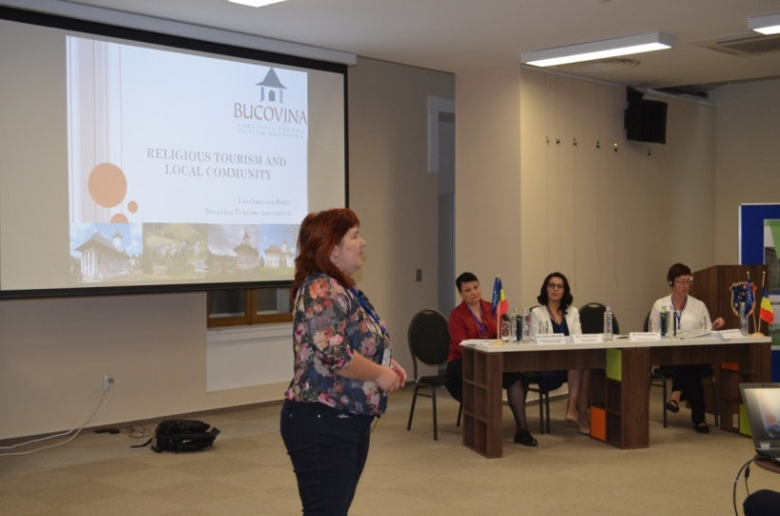
In her view, religious tourism was becoming more and more important, as a tourist branch, as many religious sites were visited as heritage sites, and visitors were expected to be treated as guests or tourists rather than believers.
Mrs. Beilic made a short description of the main pilgrimages in Bukovina:
Mrs. Lăcrămioara Beilic, Bukovina Tourism Association, presents Bukovina as a unique tourist destination in Romania, well-known for the monasteries and churches with exterior frescoes, included in the UNESCO World Heritage list.
Mrs. Lăcrămioara Beilic has made a brief description of the main pilgrimages that take place in Bukovina:
- Saint John the New, of Suceava (24th of June)
- Assumption of the Virgin Mary (the 15th of August) - is celebrated in many churches, but most important pilgrimages related to it are those that take place at:
  - Putna monastery (a Romanian Orthodox monastery, one of the most important cultural, religious and artistic centre from Middle Age and that houses the tomb of Stephen the Great and his family);
  - Basilica Minor from Cacica (a place of pilgrimage for Catholics across Europe, who used to come to bow before the Miracle-working Icon in Cacica, a copy of the miraculous Icon of the Virgin Mary, the “Black Madonna” from the Church of Jasna Gora in Czestochowa, Poland);
  - Hagigadar monastery (the most famous place of pilgrimage for Armenians from everywhere).

Mrs. Beilic has noted the fact that many times there could be a real gap between tourist / pilgrim expectations and services offered to them at places with a rich religious signification.
Tourists / pilgrims who come to the area expect:
- to discover impressive architecture and to explore the local traditions;
- to find a place which supports reflection and meditation;
- to experience a special atmosphere (candles, bells, music, smells, chilliness);
- to gain a spiritual added value during their travel.

Problems identified at the monasteries in Bukovina are generally related to the lack of adequate infrastructure (accommodation for pilgrims, toilets, hiking and cycling routes, recreational opportunities for children, WIFI hotspots, phone charging possibilities), lack of information on the schedule of various services, lack of information on nearby objectives, lack of information on the existence of online and offline promotional materials.
Among the identified improvement directions are: preserving authenticity (define how to sustain the dignity of a religious site); staff training (improve the skills in marketing and public relations); cooperate with other religious sites, travel agencies, cultural routes, religious and cultural networks; visibility improvement (interactive websites, blogs, activities in social media).

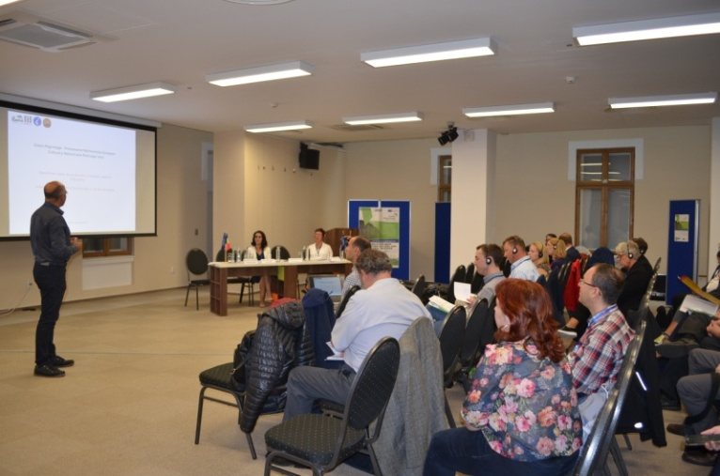
The final presentation in this first section was made by Mr. Petre Ariciuc, from the Mountain Rescue Association. After a brief presentation of the tourist activities in the Vatra Dornei area and a statistical analysis of the tourist activity in Vatra Dornei (area based on active tourism, winter sports and balneary treatment) compared to Gura Humorului (a region based on religious tourism and of the pilgrimage) it was concluded that for the extension of the tourists' stay, a connection should be created between the two areas. In this respect, the organization he represents is currently working on the marking of pedestrian and cyclo-tourism tourist routes through which a connection will be made between Vatra Dornei resort and the painted monasteries of Bukovina. It is estimated that this route network and its subsequent map will be ready by 2018.

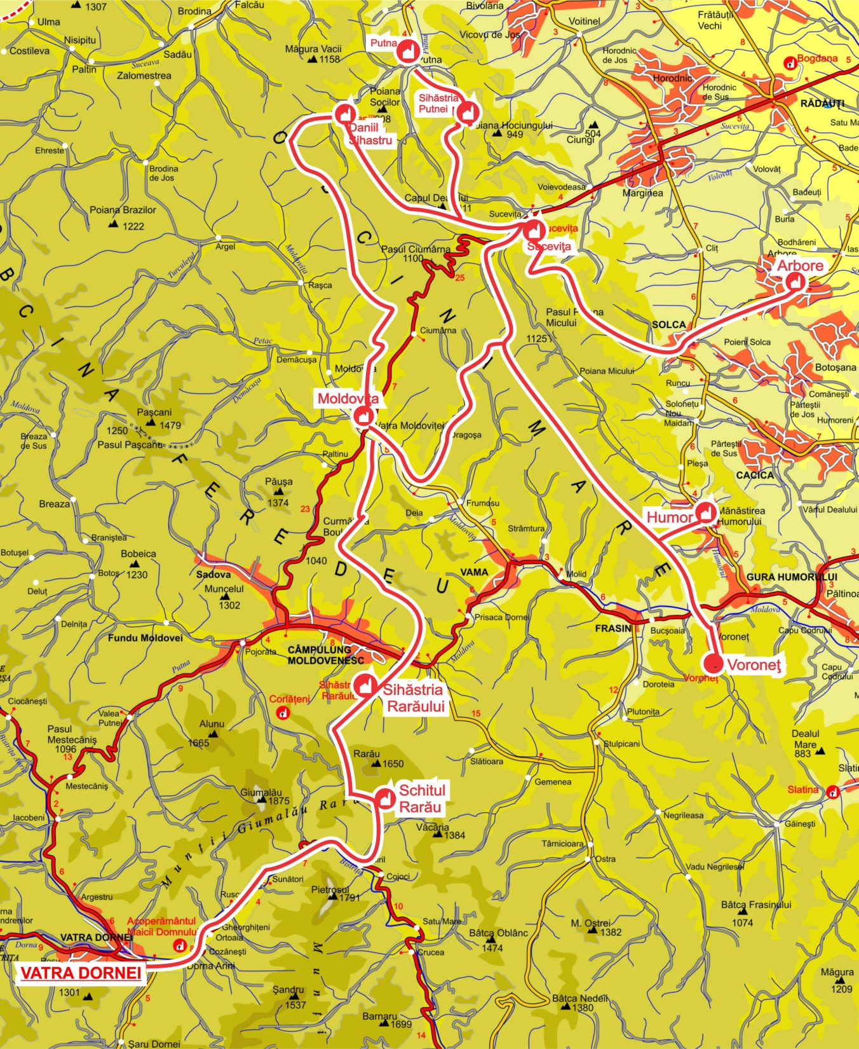

Session 2: Good Practices in Romania

The session included the presentation of experiences with good practices by participants.
Speakers:
Pr. Paul Valenciuc, Romanian Orthodox Church
Pr. Cristian Blăjuț, Basilica Minor from Cacica
Pr. Azad Mandalian, Hagigadar Armenian Orthodox Monastery
Mrs. Laura Ursu, Suceava County Council, Tourist Information Center
Mr. Molnár Sándor and Mrs. Koszta Csaba János, Via Mariae Association

Moderator:
Mr. Octavian Arsene, Ministry of Tourism

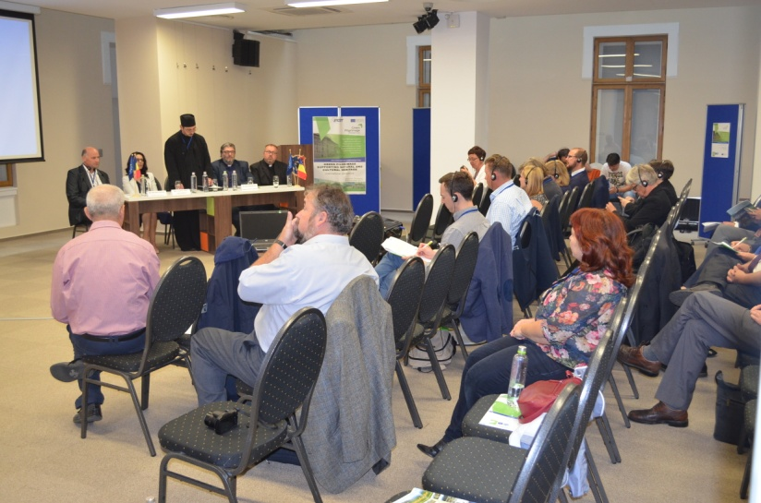
Father Paul Valenciuc, the representative of the Romanian Orthodox Church, made an account of the pilgrimage history at the relics of Saint John the New in Suceava, while emphasizing the difference between the terms "tourist" and "pilgrim" (the pilgrim is a person seeking God).
The first procession (with a pre-established program, with hymns and Christian songs) was organized in 1889 by priest Nichitovici, a parish priest from the village of "Davideşti de peste Prut", who went on pilgrimage with his parishioners. On the way, many believers from the villages they crossed along the way came along too so in the end, in Suceava, there were about 3,000 believers. In the following years, the procession grew even more, reaching the third pilgrimage (in 1891) that gathered about 20,000 people. Mr. Paul Valenciuc noted that the Armenian Orthodox community joined these processions, pointing out the lack of barriers that existed even by then between the two communities.

Father Cristian Băjuţ, the representative of the Minor Basilica of Cacica, wanted to emphasize from the beginning that he is against the approach of pilgrimages in terms of tourism, as, in his opinion, when speaking of pilgrimages, it should be discussed strictly from a religious point of view.
He drawn a short history of the Polish community in Cacica, a town founded by the Polish miners who came there starting with 1788 for the extraction of salt deposits discovered here. The first families who came here brought with them a copy of the miraculous Icon of the Virgin Mary i.e. the "Black Madonna" from the Church of Jasna Gora in Czestochowa, Poland.

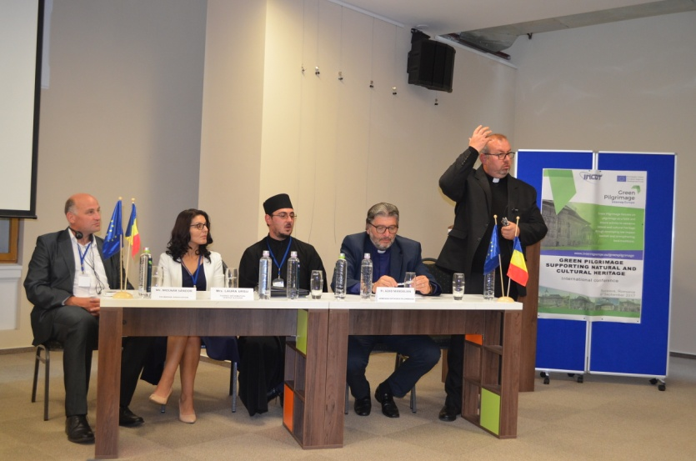
In the continuation of his presentation, Mr. Cristian Băjuţ made a description of the pilgrimages organized annually in Cacica during the 14th-15th of August (on the occasion of the Assumption of the Virgin Mary), during which many groups of Polish Catholics and Catholics from other countries come to pray to the miracle-working icon. With more than 100 years of experience, the pilgrimages at Cacica attract over 20,000 believers from Romania and abroad each year. For example, 28 groups from Poland were registered this year, adding to them many other ethnic groups (17 German groups, 9 Italian groups, etc.). Due to its symbolic importance to Polish believers, in 2000, the church was raised to the rank of Minor Basilica by Pope Paul II, becoming thus a part of the great European sanctuaries.
Mr. Băjuţ highlighted the peaceful coexistence of the various ethnic and confessional groups in the locality, giving the example that there is both a Roman Catholic Chapel and an Orthodox altar in the Saline. He also pointed out the lack of adequate pilgrim-oriented infrastructure (e.g. lack of toilets, lack of infrastructure for spiritual pilgrim rest, etc.).

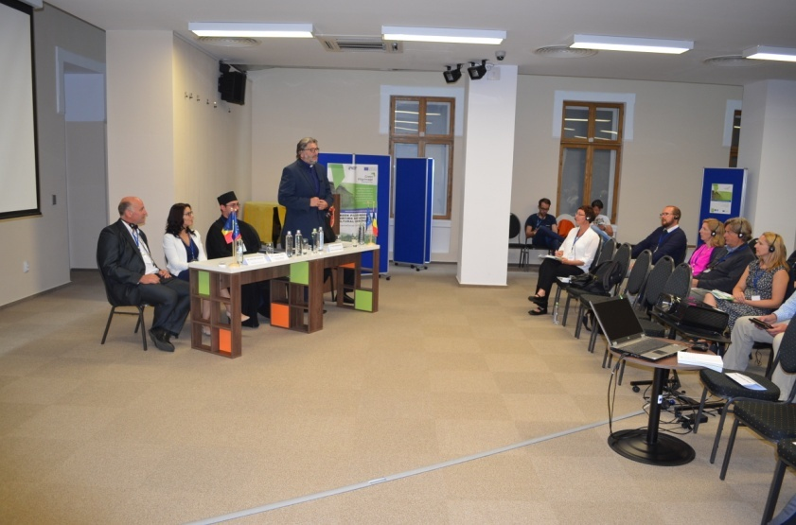
Priest Azad Mandalian, from the Hagigadar Armenian Orthodox Monastery, made a short history of the Armenian community in Romania (the first Armenians came to the area in 1401, during the reign of Prince Alexandru cel Bun).
He then briefly presented the Hagigadar monastery, whose church was built in 1512 by two Armenian merchants.
The Hagigadar Monastery (Armenian Monastery of Fulfilment of Desires) has become a significant pilgrimage place for the Armenians in Romania and abroad, but also emphasized that many Romanian Orthodox Christians also participate in the pilgrimages.

Mrs. Laura Ursu, from Suceava County Council, presented two initiatives by the institution she represents.
1. The "Pilgrimage in Bukovina" project is run annually from the15th of July to the 15th of August, starting with 2010.
The general objective of the project was to develop and strengthen domestic tourism by supporting the promotion of specific products and traditions in Bukovina.
Specific objectives:
• promoting pilgrimage tourism in Suceava County;
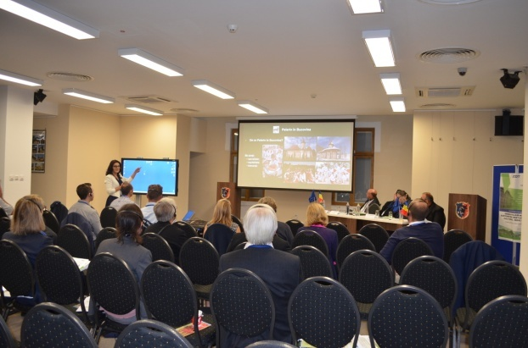
• promotion of Orthodox, Catholic and Armenian pilgrimages from Putna Monastery, Minor Basilica of Cacica and Hagigadar Monastery (next to Suceava), occasioned by the Feast of the Assumption, celebrated on the 15th of August;
• Stimulating the blending of the religious aspects of the journey with the strictly cultural and natural ones.
Some of the actions undertaken within the project include:
- Creation of a pilgrimage route from Vienna to Suceava, having as final destination the localities of Cacica and Putna in Suceava County;
- Creation of three pilgrimage routes in Suceava County towards Putna Monastery, Minor Basilica of Cacica and Hagigadar Monastery near Suceava;
- Creation of the Pilgrim Certificate to be handed to the persons arriving at Putna Monastery, Minor Cacica Basilica and Hagigadar Monastery - documentary evidence of the pilgrimage route, and of the participation in religious services and prayers at the places of worship;
- Organization of a bicycle pilgrimage, linking Vienna to Suceava County, on the Vienna - Bratislava - Budapest - Oradea - Cluj - Cacica - Putna route;
- Organization of a motorcycle ride on Suceava - Păltinoasa - Cacica - Solca - Marginea - Putna route, starting with the Suceava Fortress, with the participation of 150 motorcyclists;
- Organization of bicycle pilgrimage on the Suceava Citadel - Voroneţ Monastery - Humor Monastery - Minor Cacica Basilica - Cacica Salt Lake - Hagigadar Monastery route;
- Creating a special attraction for pilgrims by facilitating a trip by steam train during the 8th-15th of August 2011, on different routes in the county;
- Organization of various cultural and artistic events in Putna, Cacica, Suceava (religious music concerts, folkloric performances, theatre plays).
- As a result of the actions undertaken by this project, there was a doubling of the number of tourists and of the number of overnight stays in Suceava County in August 2010-2016.

2. The "Ştefanian 2017 Program", a program run during the period of the 24th of June (pilgrimage from Suceava, occasioned by the feast of St. John the New) – the 2nd of July (pilgrimage from Putna, for the celebration of St. Stephen the Great, the founder of the Putna monastery)

Objectives of the program:
• capitalizing on the historical cultural heritage built during the reign of the prince Stephen the Great;
• sustainable development of tourism, through the development of national and inter-state tourism routes (Romania, Ukraine, Republic of Moldova);
• increasing interest in the restoration and protection of historical monuments.

Actions taken: cultural-artistic and scientific events (exhibitions, memorial service of the Moldovan rulers, music and theatre performances, Te Deums, scientific symposia, historical film screenings) organized in the localities founded by Stephen the Great, creation of a certificate of pilgrimage for those who visit the foundations of Stephen the Great.
In this case, also, it is considered that the impact was positive. According to the data presented by Mrs Laura Ursu, the number of tourists increased by 13.5% and the number of overnight stays by 5.6% between June and July 2017, compared to the same period of the previous year.
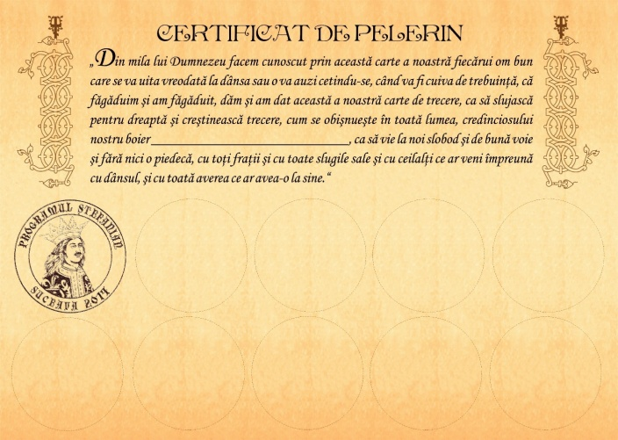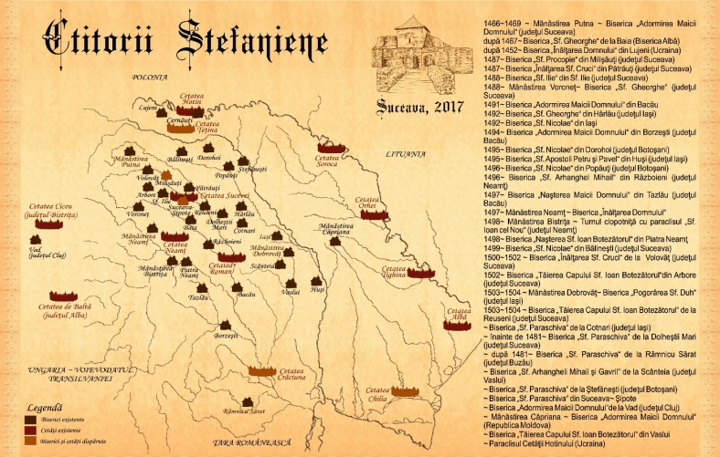

Mr. Molnár Sándor and Mr. Koszta Csaba János (Via Mariae Association) presented Via Mariae, a spiritual – touristic way, built for honouring Mary by Central European nations. This way, are connected the shrines of Holy Mary, without any historical, cultural, religious differences, and makes a traditional pilgrimage network, similar with El Camino. This road, open to all ethnicities and confessions, connects four major pilgrimage centres in Central and Eastern Europe:
- in the west-east direction, between Mariazell (Austria) and Şumuleu-Ciuc (Romania). The speakers made a short digression on the history of the pilgrimage to Şumuleu-Ciuc, its cathedral and its symbolism for Hungarian Catholics.
- in the north-south direction, between Czestochowa (Poland) and Medjugorje (Bosnia-Herzegovina), the two branches coming together in Budapest.
The road is addressed to those who want to run it for religious reasons, as well as to those who want to run it for tourist or sports reasons. The aim is to build up a unified pilgrim`s way between the different religious traditions of Central Europe (The Way of Reconciliation), and to create a network between these places.
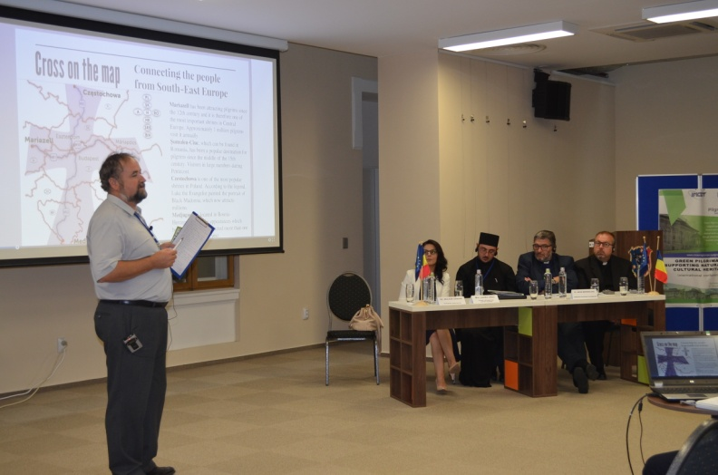
Further on, were presented the activities that took place in Romania, starting in 2010, for the physical signalling of the route (especially in Harghita county), as well as the activities related to creating awareness, networking and promotion, ensured by organizing numerous events (festivals, marathons, conferences etc.). A key success factor is finding local partners who will ensure the signalling of certain portions of the route and will create local ramifications. At a future time, one of the possible ramifications of the route that might be developed could be a road to the churches dedicated to the Mother of God in Suceava (e.g. the Catholic Church in Cacica, the Hagigadar Monastery in Suceava, and the Orthodox churches there).
At the same time, the problems encountered were also mentioned, on the one hand, in terms of issues related to maintaining the infrastructure (vandalism acts), and. on the other hand, the issues related to maintaining the safety of pilgrims (attacks of wild animals), but also other general threats (building thematic roads, accommodation for pilgrims), difficulties in obtaining financial support).

Session 3: External stakeholders’ presentations

Speakers:
Mr. Tim Hall, England Coast Path Senior Adviser, Natural England
Mrs. Julia Peters, Kent University Post Graduate
Rev. Berit Lånke, European Green Pilgrimage Network

Moderator:
Mrs. Catherine Brady, Project manager Kent County Council, United Kingdom

In the last section of the conference, the first presentation belonged to Mr. Tim Hall, Natural England. He presented his British experience in developing the UK's longest coastal path, highlighting the economic benefits of such an investment, sharing the lessons that could be learned about the development, maintenance and promotion of such routes.

Natural England is a non-departmental public body in the United Kingdom sponsored by the Department for Environment, Food and Rural Affairs. It is responsible for ensuring that England's natural environment, including its land, flora and fauna, freshwater and marine environments, geology and soils, are protected and improved.
It also has a responsibility to help people enjoy, understand and access the natural environment. Natural England focuses its activities and resources on four strategic outcomes:
- a healthy natural environment
- enjoyment of the natural environment
- sustainable use of the natural environment
- a secure environmental future.

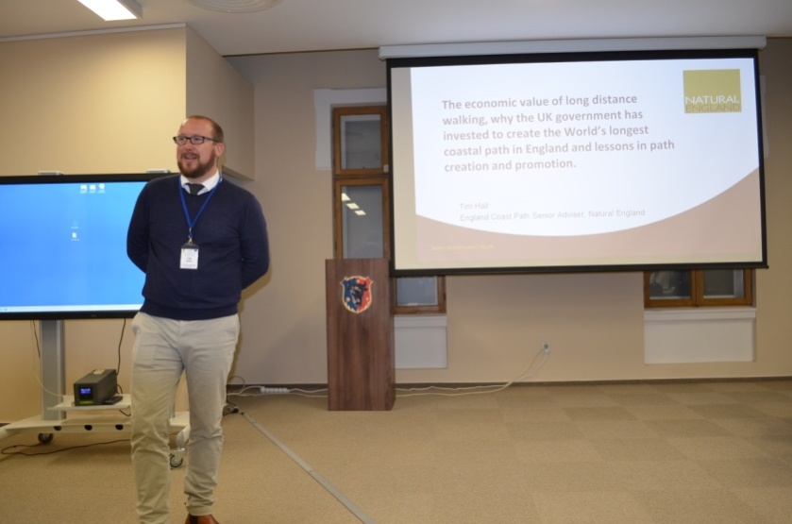
Developing such a route means:
• secure, continuous, well-marked, well managed
• National Trail brand and funding
• tourists with spending money
• reconnecting people with their local coast
• reduced liability on coastal access land
• better management of some sites
• a unique and straightforward way to deal with coastal change.
The first steps in achieving the England Coast Path were made in 2009, the year in which the Marine and Coastal Access Act entered into force. This act establishes the coastal access duty to create a 4500-km long-distance walking route around the English coast, which should be accessible to the public on foot. The actual work on this route began in 2010. A Detailed Development Plan, signed by the Department for Environment, Food & Rural Affairs and Cabinet Office, was carried out. The entire route was divided into 67 segments, and the target is to complete the entire track in 2020.
Every year, £ 5 million is invested in creating the England Coast Path, but the economic benefits are enormous. Only the South West Coast Path contributes about £ 436 million per year to the local economy and about 10,610 full-time equivalent jobs. Also, every £ 1 spent on the Pembrokeshire Coastal Path brings in £ 57 in tourist spending. National Trails offer access through some of the most remote areas bringing visitors to areas previously hard to access.
In the last part of his presentation, Mr. Tim Hall presented the stages of the realization of such a route, wishing to help the Romanian stakeholders who want the future development of such a route:
- Stage 1 Prepare – define the extent of the coastal stretch to be develop; consult the stakeholders about their ideas and concerns for the stretch; identification of key sensitive features; assess problems, opportunities, constraints; consider existing access patterns and early route options.
- Stage 2 Develop - contact owners of the land; checks on the ground; share initial thinking with owners and occupiers; plan protection of key sensitive features; talk further to key interests as necessary; reality check the developed proposals.
- Stage 3 Propose - finalise proposals and associated maps; publish them in a statutory report; invite anyone who wishes to comment; invite any objections to report from owners or occupiers of affected land.
- Stage 4 Determine - receive any representations or objections; forward or summarise all the objections; approve the final proposals, with or without modifications.
- Stage 5 Open - establishment works done after discussion with affected owners; any agreed restrictions or dedications implemented; approved map published; order brings new public rights into effect.
In terms of funding, Natural England is the institution responsible for route planning works, following that local public authorities would take responsibility for maintaining sections of the route. They receive government aid to maintain the road aligned to the high-standard pursued by the National Trails (the network of scenic, historical and recreational trails in the UK).
Information on all long-distance routes in the UK is provided by the National Trails Website (http://www.nationaltrail.co.uk/).

The following exhibition belonged to Mrs. Julia Peters, a Kent University Post Graduate, who, based on her personal experience gained in relation to two pilgrimage routes (Via Francigena on the Canterbury – Rome trail and Camino de Santiago route on San Jean Pied di Port – Finisterre trail), made a brief presentation of the profile of the pilgrim traveling through such long-distance routes, as well as of the benefits that the development of a pilgrimage route has for a certain area.
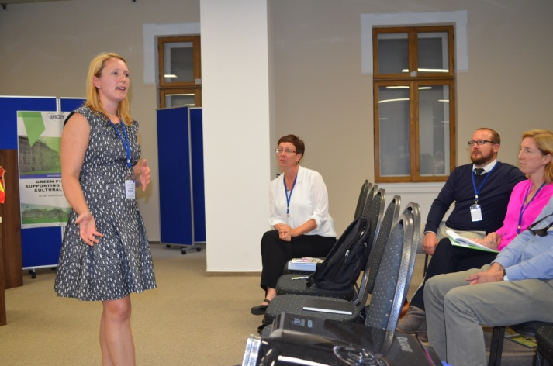
In her opinion, it is very difficult to achieve a segmentation of pilgrims as they cover all ages, a wide range of nationalities, different degrees of physical training, varied linguistic abilities, and have different levels of experience.
And, from this point of view of the purpose of the journey, there are many motivations. If many persons cross the path for spiritual reasons, there are also several people for whom that journey is a physical challenge, but also some of the people are motivated by obtaining social benefits.
Also, she made a brief inventory of the needs a pilgrim has during his or her journey, considering as indispensable the covering of the following issues:
• Safe routes;
• Good Signage;
• A range of Accommodation;
• Credentials;
• Pilgrim meals;
• Access to water and food along route;
• Good information.
At the end of the presentation, she emphasized the benefits that the development of pilgrimage routes has, namely:
• Contribution to sustainable tourism development;
• Brings visitors to rural communities - develops local economies;
• Potential for growth (Tuscany example).
At the end of the presentation, she highlighted the benefits that the development of pilgrimage routes has, and namely:
- Contribution to sustainable tourism development;
- Brings visitors to rural communities – develops local economies;
- Potential for growth (Tuscany example).
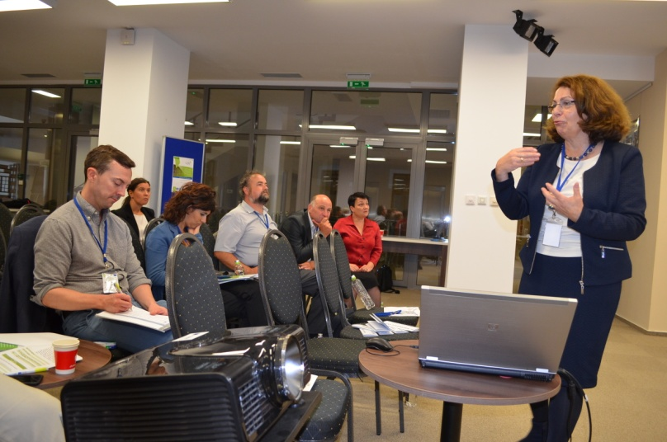
The last presentation of the conference was Rev. Berit Lånke, representative of the European Green Pilgrimage Network. Having been a member of the Conference of European Churches and carrying out the "European Pilgrimage 2000+" project (which includes places like the Nidaros Cathedral in Trondheim, St. Andrews in Scotland, Iași in Romania, and Prague in the Czech Republic), she had the chance to travel a few times to Romania in the past, and on this basis, she has made comparative observations on the Pilgrimages in these two countries based on theological, environmental and tourism aspects.
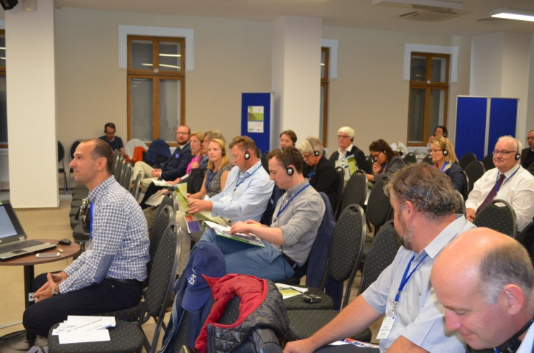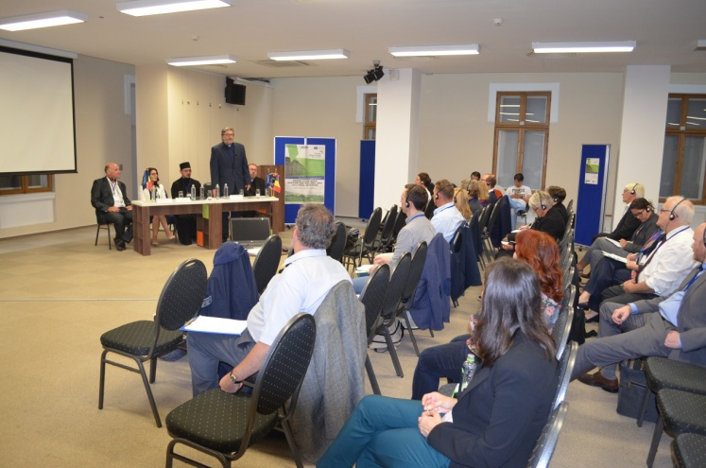
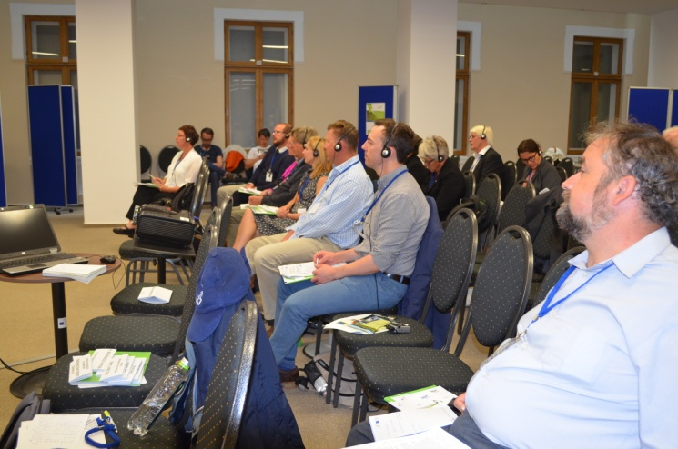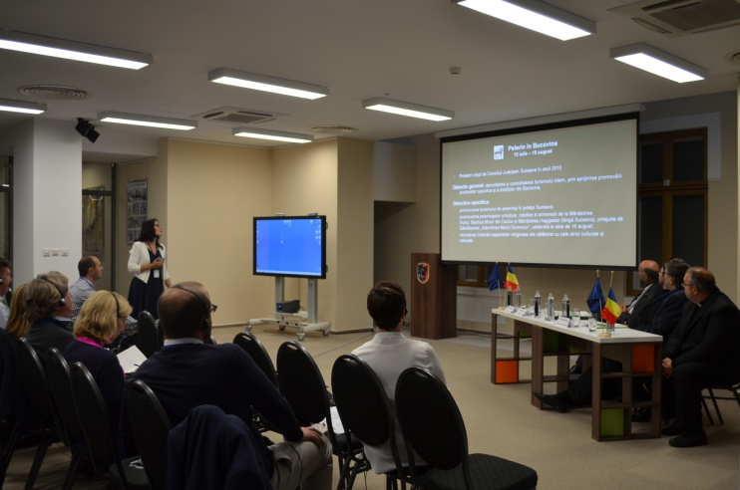
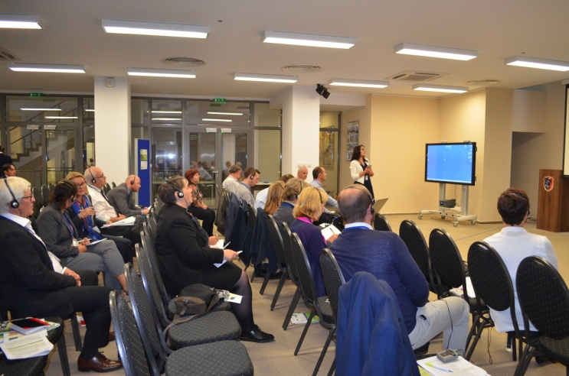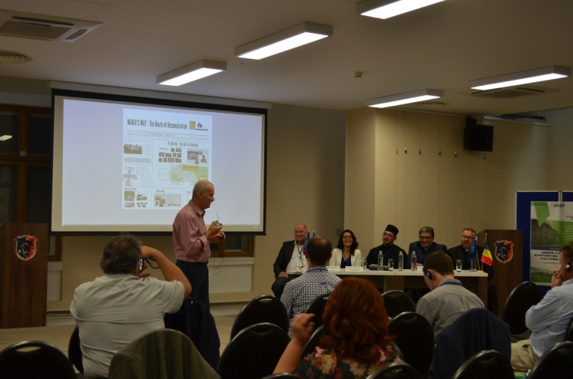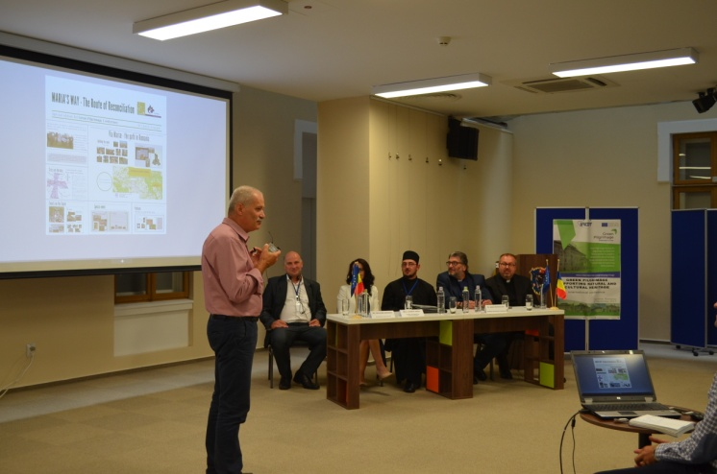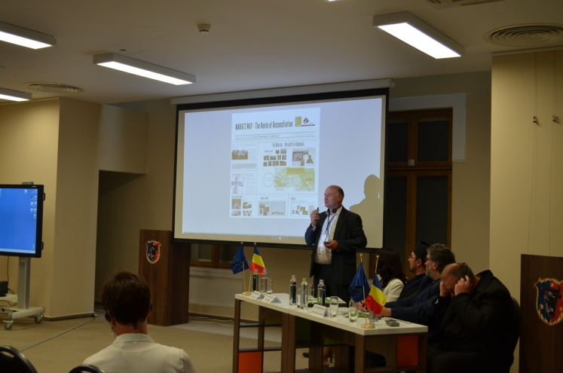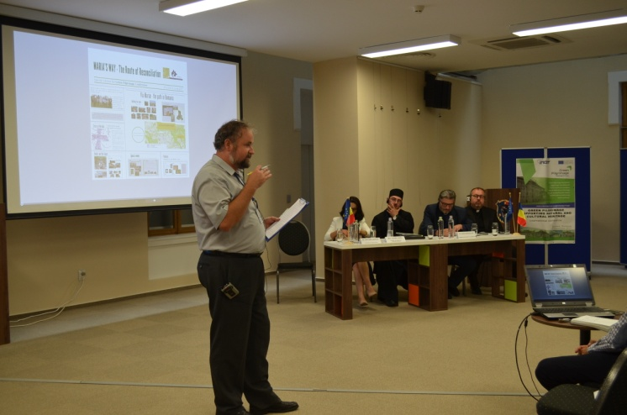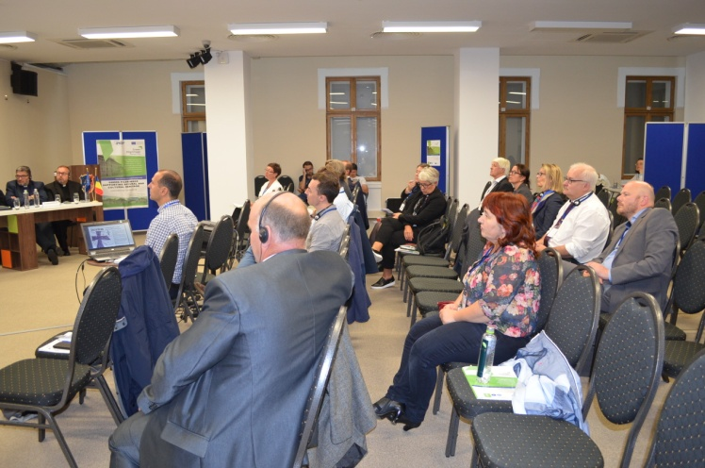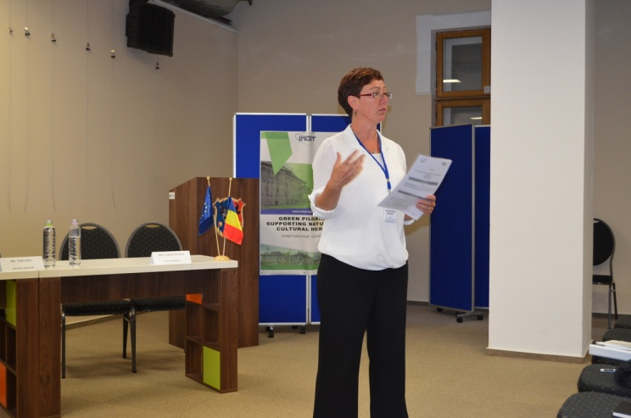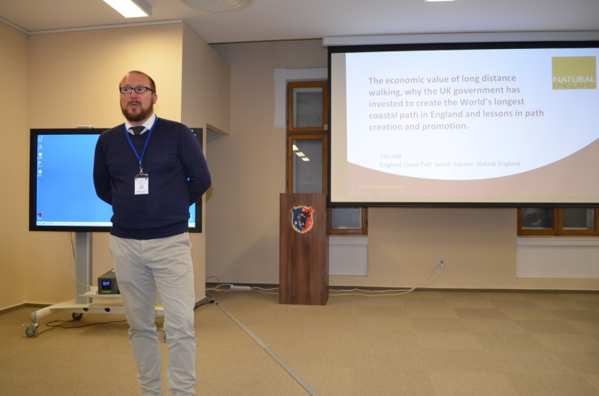

3.2. Interreg Europe Green Pilgrimage Project
2nd Steering Committee Meeting

The 7th of September 2017

Popas Bukovina. Sucevița, Bukovina, Romania.

Attendees:
- Catherine Brady (KCC Lead Partner & Chair)
- Peter Morris (North Downs Way National Trail, KCC & Secretary)
- Caroline Pinchbeck (Diocese of Canterbury)
- Alina/ Doru- (INCDT, Romania)
- Knut Wik (Trondheim, Norway)
- Are Skjelstad
- Charlotte Watts (NCC)
- John Jones (NCC)
- Berit Lanke & EGPN
- Cathrine Roncale
- Per- Sweden
- Anna- AEVF, Puglia, Italy
Connecting Via Skype: Silvia Lecce (AECVF, Puglia, Italy)
Apologies for not being present: Daniela Mazzucca, Puglia Region

Agenda
- Italian All Partner Policy Review (via Skype)
- Silvia to discuss Exec Summary & circulate full doc post conference
- Silvia talked us through a Ppt doc
- Logical Framework
- Best practice Galicia Master Plan- benchmark
- Methodology
- Policies vary greatly- geographical coverage, level of responsibility and wider tourism practices across stakeholder group
- Some common frameworks- national/ regional/ local policies interrelated
- EU & international policies reflected in above
- 6 policies reviewed
- Overall tourist offer
- Territorial pilgrimage background
- References to pilgrimage/ religious/ long distance walking in policy docs
- Recommendations & improvements for future development of pilgrimage routes/ long distance cultural trails
- Conclusions:
  - All policies refer to natural & cultural heritage
  - More integrated approach by local stakeholders to develop complex trail projects
  - Religious pilgrimage characterised by respect for environment with contribution from religious organisations to protect & conserve. These characteristics reflected by secular groups in “green tourism” offers.

8 Key Recommendations
- Participatory Governance Model
- Co-operation between many stakeholders at regional and local level
- Planning policy should refer to trails & cultural routes for landscape & heritage protection and economic growth
- Targeted qualification
- Social & Demographic values. Respectful & mindful of environment.
- Digitalisation to improve access
- Advertise & Promotion
- Monitoring sustainability and usage models to measure demand and economic impact. Indicators.

Report & Deadlines Discussed:
- CB- report looks good, but need more time to read, review and provide feedback.
- Anna has Norwegian documents from Knut Wik.
- KW- has sent a copy of Norway policy doc via email.
- CB- partners would like to comment on all partners review (incl. Norway). Prefer a complete report rather than rush this through to stick to a deadline.
- CB requests more discussion & consultation around policy review to identify any changes in policy
- The partnership requests an extension of the 16th September deadline in light of the study visit to Romania and travel/ timescales
- Anna Introna says that partners should comment on current draft by 23rd September. In the meantime, Silvia will work on incorporating Norwegian policy into the document.
- KW- suggests report circulated in current form with the notes from this meeting with an updated doc circulated once the Norway policy is reviewed.
- CB- JS has already extended deadline for policy review so some pressure to complete this task. However, a full report is more useful than an incomplete report working to a shorter deadline. CB confident JS will be flexible.
- JJ- opportunity to discuss with other project partners would be helpful
- CB- we haven’t seen full report so difficult to comment in context.
- John Jones- most important that we agree recommendations & conclusions are discussed with external partners & policy makers

Actions
- CB to circulate Italian report
- CB to propose additional deadline of 23rd September and confirm with Silvia
- Silvia Lecci to clarify what territory data and maps she requires from each partner
- All Partners to send Silvia requested territory data and maps of each partners region
- All partners to comment on draft by 23rd September
- CB to confirm delayed timetable with JS
- Anna- after the discussion and the draft is agreed by all partners we will design final design template to present final findings infographic for sharing (1 week)

- Claim 1 Progress & Overview
- CB reports- claim 1 gone well generally
- Received partner reports & financial claims, this is OK.
- Partner Narrative reports- 2,000 characters to update. Not enough in some cases.
- Lead partner report much bigger - CB will need separate commentary to assist in this.
- All partners need to update policy report progress even if this is “no progress” in future claims
- Please contact CB if unsure.
- Some indicators very specific
- Study visits need to identify 3 good practices
- Refer to partner requirements in Excel document previously circulated to partners
- Need to drive more information to the website. KCC only partner to update website.
- News events not necessarily specific to GP project. Upload in your own language. This is not an issue. Google analytics show where people access website from.
- Semester 1 review indicates we have completed most tasks
- Semester 2 objectives discussed
- Semester 2 concludes Dec 2017
- CB requests partners communicate any budget issues- mainly under spend which is expected at this stage.
Actions
- All Partners need to be mindful of indicators for future reports & project goals. CB requests all partners review their policy indicators in the application form
- CB requests links to press appearances shared on google drive- individual stakeholder’s responsible for updating – has emailed partners regarding this.
- All partners to send Catherine their Facebook and social media contact details so that all partners can follow each other
- CB to create a partner report template for Claim 2
- All Partners to put more material on Green Pilgrimage website

- Activity Update from Partners
Norfolk County Council - Charlotte
- Background on Norfolk region & trails. Churches & broads.
- Walsingham site 300k visitors/ yr. Small village, 2 shrines. Issues with overcrowding.
- No overnight stays. Little benefit to local community.
- No walking routes- visitors arrive by car/ coach. Need to create a pedestrian route.
- Met with churches & village landowners
- Installed people counter on link route between shrines
- Feasibility study walking/ cycling routes to major populations in Norfolk
- Networking with local stakeholders (LAF/ Diocese/ Academics/ Politicians)
Norway- Knut
- Explained EU programme context as non-EU member
- Partner in 11 Interreg Programmes
- Norway/ Sweden partnership in this programme
- Established admin systems & stakeholder groups
- Feedback to politicians to help influence future developments
- Attended 2 study visits
- Reporting 1st semester IOLF
- Translation of policy instrument. Focussing on Environment/ Commerce/ Church & Culture
- Use GP project to test the policy for updates/ weaknesses
- Preparing study visit to Dovre Mountains to Trondheim. Sept 2018.
- Route Creation, maintenance, signposting & low carbon transport
Romania- Alina
- Attended 1st Stakeholder meeting in Canterbury
- In June 2017 – first stakeholder meeting with representatives from Central Public Authorities (ministry of Tourism and Ministry of Regional Development and Public Administration) – inform about the project and study visit, discussion about ROP and possibility of improvement of the programme, ID good practice& lessons for Romanian policy
- In July 2017 in Suceava - meeting with regional public authorities (County Council Suceava) and local Public Authorities (Campulung Moldovenesc and Gura Humorului towns), with church representatives to inform them about the GP project and study visits
- 19th – 22th of September 2017 - will attended to international conference looking at European cultural routes, organized by the European Cultural Tourism Network to present the project
- Reporting 1st semester IOLF
- Organised this study visit!
Kent – Catherine
- Business engagement workshop & feedback
- Formed working group with local authorities promoting VF
- Public engagement via mini pilgrimages to provide experience/ gather feedback & understanding
- Continue to build this knowledge. The wide variety of participants is interesting and provides opportunities in the future.
- Identified some key themes:
  - Monetary value of pilgrimages is becoming evident
  - Multi faith experiences and interpretations
  - Barriers to participation still remain
  - “Pilgrimage” branding more powerful than hiking
- Planning some research into income generation from Pilgrim routes
- Planning Pilgrimage festival in 2018 – pilot initiatives for development
- Policy influence- SELEP presentation on GP project and trails, protection of natural & cultural heritage for future funding of projects
Italy- Anna
- Carried out Policy Review presented by Silvia above.
- Attended 2 Stakeholder meetings
- Developed a regional tourism group to support VF
- Monti Dauni area- national festival
- Pilot project “hospitality community” aims to improve services for tourists & pilgrims
- Focus on developing the 1st section of VF in Puglia (we will visit this during study visit)
- Working Group to coordinate projects related to tourism & cultural routes
  - Strategy inland areas – remote areas, improving essential services & infrastructure particularly highlighting historic & cultural features
  - Ministerial Funding- south cultural routes in Italy. Infrastructure of VF in Puglia. Promotion activity & events. Educate & influence. Lead walks with a tutor on themes. Arts festival on cultural routes.
  - Property management- re-use public buildings along cultural/ pilgrim routes
  - Develop new services for travellers & pilgrims. 43 buildings granted to use for free to provide services.
Sweden- Per
- June- divide SH groups into trail development & business services
- Digital conference- cultural heritage themes. Use these for study visit.
- Increase commitment to link to longer routes across
Diocese of Canterbury- Caroline
- Pilot eco- diocese. Looking at practical & environmental issues.
- Charging points for cars/ community areas & churches
- Way St Augustine- stakeholder meetings to develop the route & grow participation numbers
- For example, 40 Pilgrims arrived at an isolated country church, this is positive but need to understand better how to develop capacity & service provision.
- Looking at the tourism approach to build heritage; partnering with volunteer organisations running heritage sites in a sustainable way (finance/ environment)
- Co-ordination of interest groups to maximise benefits
- European Green Pilgrims Network: Alison has left the organisation, Berit taken over from Alison & remains involved in developing this network.

- Future Study Visit Timetable & Activity Schedule
Spain
- Next Study Visit Spring 2018- Spain
- Galicia to host April/ May 2018
- St James Way Masterplan – benchmark & best practice learning
- Discussed proposed timetable of activity presented by Galicia
  - CB requests feedback and to consider additional time for discussion
  - CP- measuring environmental impact & mitigation
  - PL- proactive management of routes to promote sustainable/ green practices
  - KW- aims and objectives of visit- how does this influence overall project?
    - Look at the route & management from a GP perspective
    - Evaluate our learnings from Galicia and how this influences the GP project
    - Daily conclusion with a final day debrief
  - Berit- how to deal with litter/ condition of trail/ safety of pilgrim/ how are they managing these issues?
  - PM how do you manage capacity/ deal with consequences
  - CW- lessons learned and what would you do differently?
  - PL- how do you ensure that incoming economy stays local and benefits communities
Actions
- CB to check dates with Spanish and then consult with partners
- CB to circulate proposed new agenda to Spain for feedback

Sweden 28th – 30th May
- Originally proposed 5th- 9th June- PL this no longer works due to National holidays
- PL proposes 28th- 30th May
- Digitalisation projects
- Pilot projects for years 3-5 to carry out works on the ground. Need to gather evidence to support pilots.
- Policy in practice workshops- CB to confirm schedule
Actions
- CB to consult Sweden and partners re dates in 2018, possibly a day before proposed dates to avoid National UK holiday
- CB to confirm schedule for Policy in Practice workshops

Norway 4th- 7th September 2018. Study Visit for Kent & Norfolk partners after main conference.
- Low carbon transport
- Route creation & management

Kent- Options:
- Some options were discussed:
- 2018
  - 30th September to take in Pilgrims Festival (NDW 40th)
  - October to coincide with NTO meeting
  - Agreed that this would be difficult given we have 2 study visits confirmed for 2018

- Proposed May 2019 when Kent comes to life
  - We can share how Kent used anniversary events to promote & develop the trail
  - Agreed by partners that May 2019 preferred. CB to confirm with JS.
Actions
- CB to check new Kent Study visit date with JS
- CB to confirm Kent visit content as per application
- CB to contact partners (Husna) for multi faith perspective
- All partners to arrange study visit agendas and dates at least 4 months in advance so that stakeholders have time to arrange attendance.

Italy April 16th – 19th 2019
- CP notes these dates clash with Easter.
- Look at the tourism brand based on south VF route
Actions
- Anna Introna suggests they look at dates earlier in April and will confirm to the group via email

Norfolk September 2019
- Economic benefits
- Methodology
- Influencing Policy
Actions
- Charlotte Watts to propose Norfolk dates

- AOB

- CB thanks Alina & her team for the study visit & conference
Actions
- CP requests we share pictures and will suggest mechanisms to do so
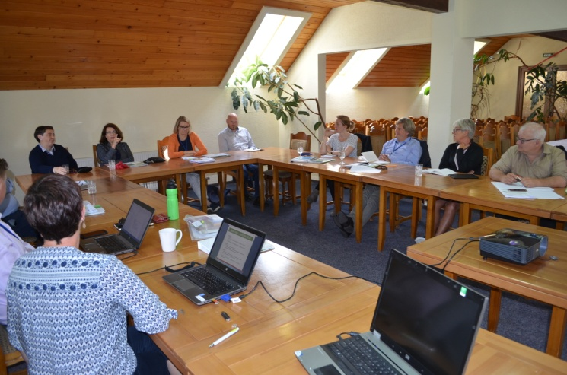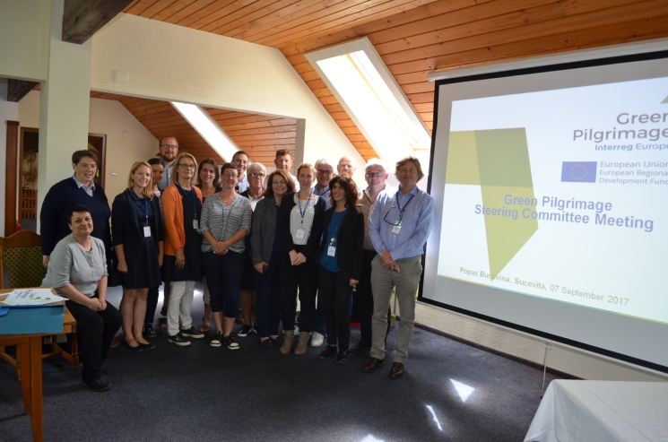

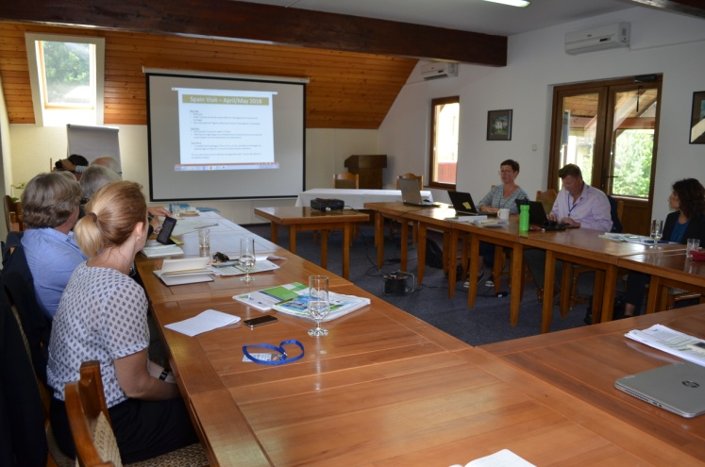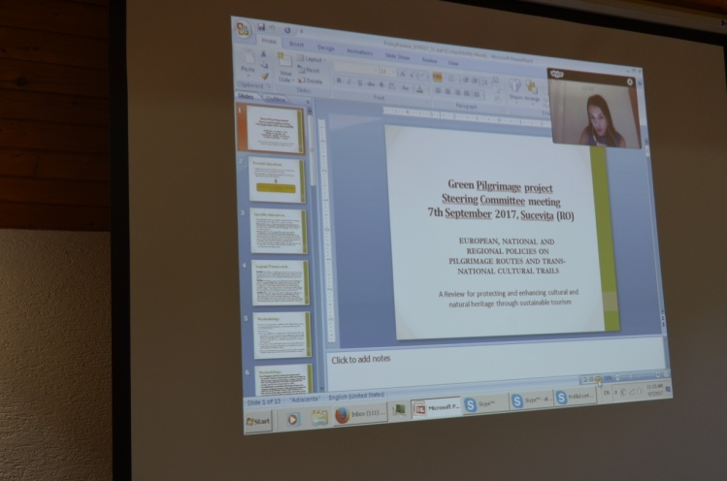

3.3. Study visits

During the scheduled study visits, six churches / monasteries - UNESCO monuments (Monasteries of St. John the New of Suceava, Sucevița, Moldovița, Voroneț, Humor, and Pătrăuţi Church) were visited.
The purpose of these visits was to observe the economic and social impact that the tourism development had as a consequence of the inclusion of these objectives in the UNESCO World Heritage List.

Also visited were 3 religious sanctuaries famous for their pilgrimages (St. John the New Monastery of Suceava - famous for Orthodox pilgrims, Hagigadar Monastery - for Armenian Orthodox pilgrims, and Minor Basilica of Cacica - for Romanian-Catholics).
When visiting all of these monuments, the partners had the chance to speak with representatives of the churches, who presented a brief history of the pilgrimages there.

An important moment during the visits was the Church of Nativity of Our Lady in Câmpulung Moldovenesc, where we attended the All-night vigil service occasioned by the Church's Day (7th of September, in the evening). In addition to the Romanian priests in Southern Bukovina, Romanian priests from Northern Bukovina (now a part of Ukraine), who have arrived in a real pilgrimage on this occasion, also served at this ministry.

A last aspect of the planned study visits was the testing of an existing hiking trail between the Dragomirna Monastery and Pătrăuți Church.

The 6th of September

Saint John the New of Suceava Monastery, Suceava town – UNESCO Monument  The monastery was built between 1514-1522. In 1534, during Petru Rareș reign, the church was painted both on the inside and on the outside.  The church was the metropolitan cathedral of Moldavia until the 17th century. In 1866, it becomes a monastery. Nowadays is the headquarters of the Archbishopy of Suceava and Rădăuți.  Here there are the relics of St John the New of Suceava, brought to Suceava by Alexander the Great in 1402.  Saint John the New of Suceava Pilgrimage  The great martyr Saint John the New of Suceava is celebrating on the 24th of June.  The pilgrimage usually starts a day before, early in the morning, when the priests move the relics of the saint outside the church, in the monastery’s courtyard.  In the evening, the priests pray together with the pilgrims until late at night. Lots of pilgrims choose to spend the night near the relics of the saint praying.  In the morning, they attend the liturgy and after the liturgy, the relics of the saint are carried throughout the town. | 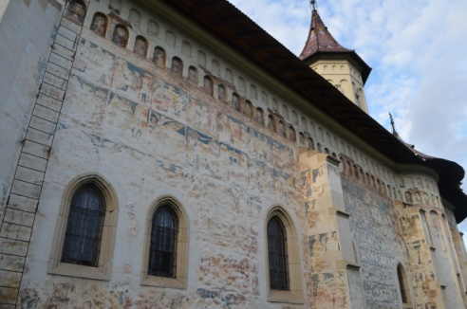  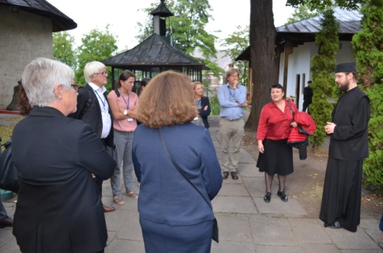  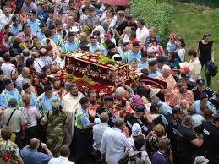

The 7th of September
Sucevița Monastery, Sucevița village – UNESCO Monument  The monastery was built at the end of 16th century (starting with 1583) by a Moldavian boyar family – Movilești.  The church of “God’s Resurrection” was built in the Moldavian architecture style, combining Byzantine and Gothic art elements.  The interior and exterior painting, made between 1595-1596, is well kept and impresses mostly through the Stairs of the Virtues, painted on the North side and the Tree of Joshua and the Hymn, on the South side.  Moldovița Monastery, Vatra Moldoviței village - UNESCO Monument | 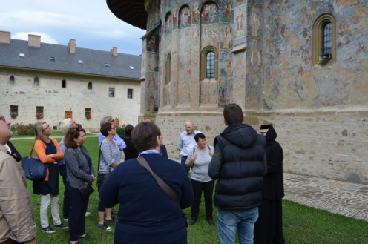  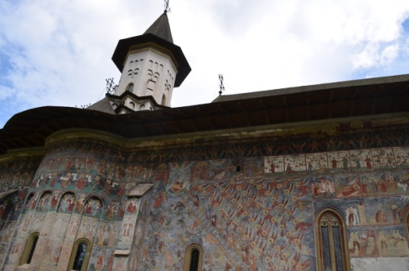
The monastery was funded by the ruler Petru Rareş in 1532.  The monastery is a fortress with strong walls of 1,20 m thickness and height of 6 m, having towers on both sides of the walls and strong gate tower.  The "Annunciation" church preserves both interior and exterior wall paintings finished in 1537 (religious and historical scenes), which stand out due to their rich chromatic, complex images, and expressiveness.  The museum of the monastery preserves the "Golden Apple" - a prize offered by the International Federation of the Journalists of the Northern Bukovina monasteries for their value in the context of universal art and culture.  The Birth of Virgin Mary Church, in Câmpulung Moldovenesc town  The church was built between 1855-1858 on the spot of another wooden church dating back to 1751.  Here, the team participated in the ceremony occasioned by the Church's Day, respectively, in the Watching Service which took place on the eve of the Birth of the Mother of God (September 7th, in the evening). It is remarkable that in addition to the Romanian priests in Southern Bukovina, Romanian priests from Northern Bukovina (now a part of Ukraine), who have arrived in a real pilgrimage on this occasion, also served at this ministry.  Bogdana Monastery, in Rădăuți town (study visit only for stakeholders)  The church of „Saint Nicholas” is the oldest church in Moldavia, built by the ruler Bogdan I in 1365. Along the time, this architectural monument has played an important historical, religious and cultural role.  Here the grave of Moldavia’s first ruler can be found. | 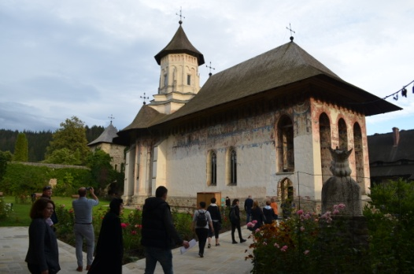  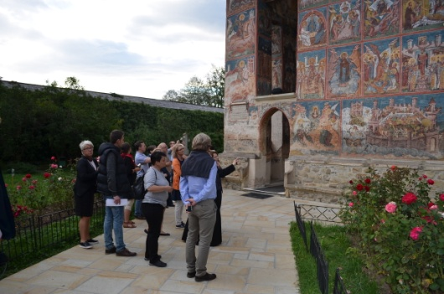  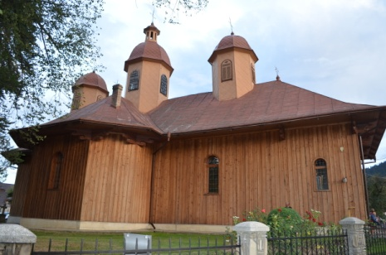  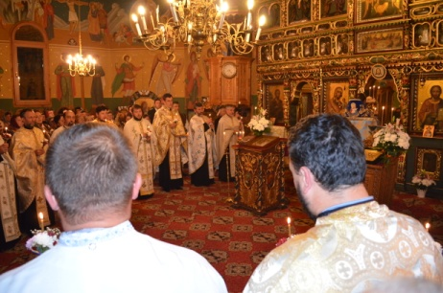  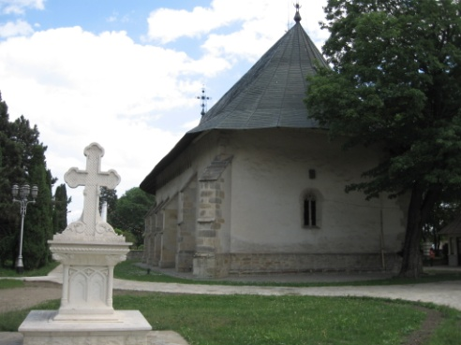
The 8th of September

Hagigadar Monastery, Moara village, near Suceava  The church of the monastery was built in Moldavian style by the Donavachian brothers in 1512.  Hagigadar Monastery Pilgrimage  “The Wish Fulfiller”, as it is known, the Hagigadar Monastery is the most famous place of pilgrimage for Armenians from everywhere.  The legend has it that the believer who walk on his knees the hill up to the monastery and then surrounds the church three times on his knee again he will have his wishes fulfilled.  The most important celebration is the patronage of the church (Assumption of the Virgin Mary), which is always celebrated on the Sunday before August 15th. The pilgrimage is led by the Armenian parish priest of Suceava, with the participation of Armenian leaders in Romania and sometimes also senior hierarchs.  After the church service, all the people present at Hagigadar Monastery, regardless of religion, are invited to a Christian lunch called "Hurban" where Armenian dishes are served. | 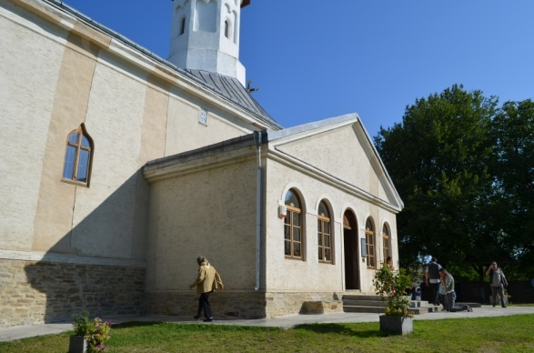  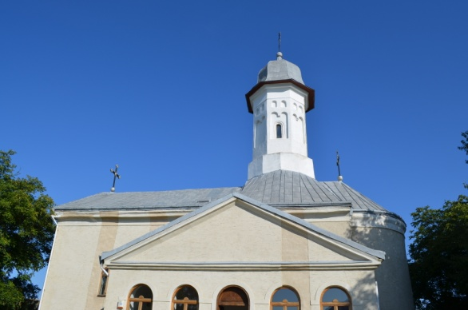
Basilica Minor from Cacica  The Roman Catholic cathedral celebrating the “Assumption of the Mother of God” was built in 1903-1904, on the place of a former wooden church from 1810.  Built in Neo-Gothic style, the raw-brick church impresses through the dimensions of the tower (50 meters high) and through its numerous stone ornaments.  The church has a symbolic value for the Polish community of Cacica and of Bukovina.  Basilica Minor Cacica – Catholic Pilgrimage  The pilgrimage from Cacica are over 100 years old (the first pilgrimage was in 1905).  Each year, on the 14th and 15th of August, thousands of pilgrims come to bow before the Miracle-working Icon in Cacica, a copy of the miraculous Icon of the Virgin Mary, the “Black Madonna” from the Church of Jasna Gora in Czestochowa, Poland.  Remarkable is the pilgrimage of youth. Together with other pilgrims, the young wait for the Bishop 5 km from Cacica and follow the road along to the sanctuary, singing and reciting the Holy Rosary.  In the interwar period, around 15 August, a train was circulated along the Vienna-Cacica route, facilitating the access of Catholic pilgrims across Europe. In 2000, recognizing the importance of Marian pilgrimages in this church, Pope John Paul II awarded this church the title of Minor Basilica. | 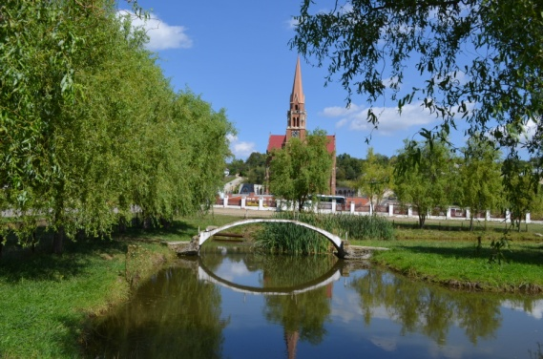  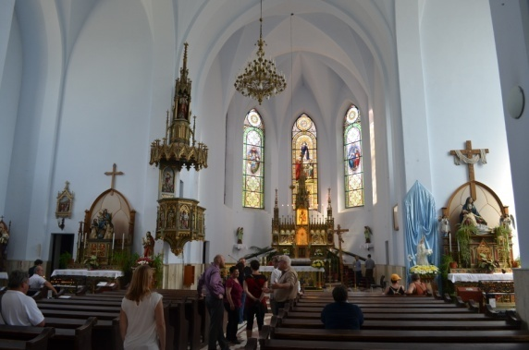  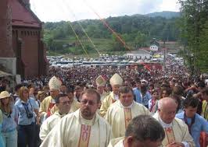
Voroneț Monastery, Gura Humorului Town – UNESCO Monument  Voroneţ Monastery with "St. George" Church is the most important building founded by the ruler Stephen the Great, erected on the site of an ancient wooden hermitage between May 26th and September 14th, 1488.  The church, carved in stone, has the interior and exterior paintings made between 1534-1535 and 1547 and attracts through the way they were made and coloured. The church is famous for the background of the exterior paintings ("blue of Voroneț", a colour unique in the world) and for the scene “Final Judgement”, painted on the West side (the reason for which it is called the Sistine Chapel of the Orient). | 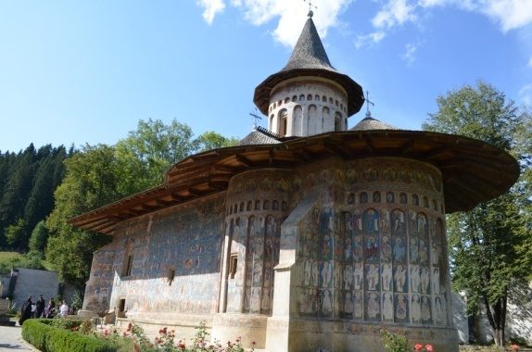  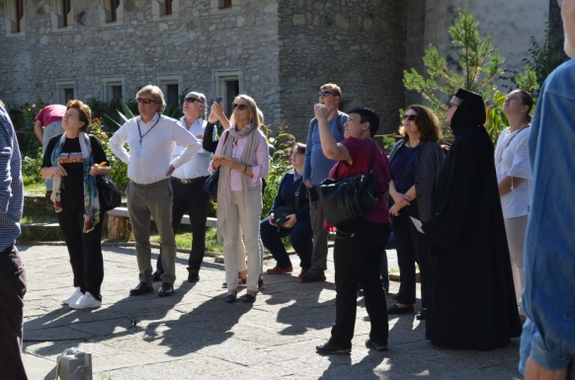
Humor Monastery, Mănăstirea Humorului village – UNESCO Monument  The Monastery was founded by the great chancellor Toader Bubuiog and his wife Anastasia and was finished on the 15th of August 1530.  The church celebrating the “Assumption of the Mother of God” and “Saint George” holds inner and outer wall paintings, executed in 1535 by Thomas the painter from Suceava. The exterior painting of the monastery is characterized by a chromatic tone unit, predominantly red and purple.  The particular element of the church is the open porch, with arcades, an innovation in the epoch when the church was built and determined both by the local constructive tradition (stoops, turret) and by the renaissance influences from the outside (the loggia ‒ later assumed by Brâncoveanu style). The edifice has a tiled plan, with no tower on the nave, like other buidlingh founded by boyars. The defence tower was built by the ruler Vasile Lupu in 1641. At that time, the surrounding walls were also reinforced. | 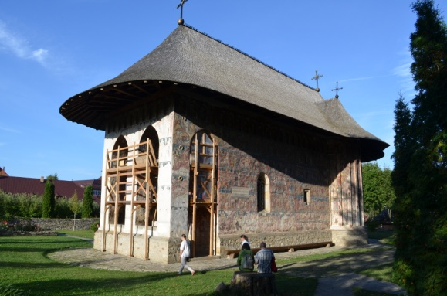  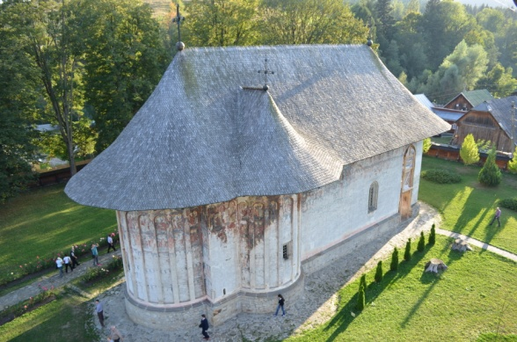

9th of September (optional tour)

Dragomirna Monastery, Mitocul Dragomirnei village  “The Descent of the Holy Soul” Churh was built between 1608 and 1609 by the metropolitan scholar Anastasie Crimca and the great chancellor Lupu Stroici. The church impresses with its monumental alluvium, with a narrow and elongated structure, finished with a polygonal apse on the west. The frames of the windows with Gothic elements are in harmony with the decorations of the tower, which are of Romanian influence.  In 1627 the church was surrounded by massive walls, flanked by defence towers and countertops that give it the appearance of a fortress. | 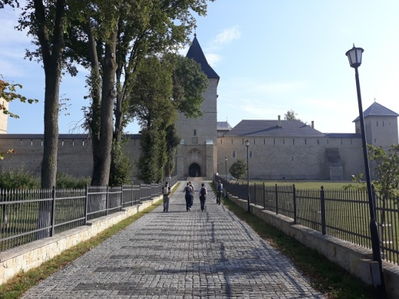
Pătrăuți Church, Pătrăuți village - UNESCO Monument  „The Exaltation of the Holy Cross” church was built by Stephan the Great in 1487 and it is the smallest of all his buildings.  The interior paintings date from the voivodship period, without renewals. The exterior walls are decorated with row of bricks and arcades and on the west side there is the “Final Judgement” painting. | 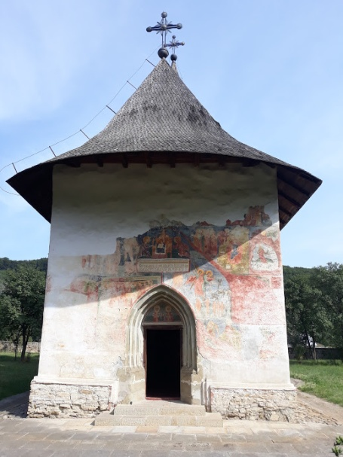

4. CONCLUSIONS
We believe that the four days in which the event took place were particularly fruitful, as a permanent exchange of ideas between the members of the partnership and their stakeholders took place.
The area chosen to make study visits to is particularly promising for the theme of the project, with an invaluable world-renowned religious heritage (eight churches with exterior frescos that are listed on the UNESCO World Heritage List).
However, decisive in the choice of this area was the fact that in a relatively limited area there are several churches associated with a tradition for pilgrimages belonging to different religious cults and different ethnic groups (Romanian Orthodox group ‒ at Sf. John the New Monastery, Armenian Orthodox group ‒ at Hagigadar Monastery, and Polish Roman Catholic group ‒ at the Minor Basilica of Cacica). Besides the symbolic value that the pilgrimages have for the respective ethnic and religious groups, the presentation of the three pilgrimages revealed the existence of a peaceful coexistence between them, and the participation of different congregational groups in the pilgrimages of others could only result in a welding of this communion, in time.
Field trips have highlighted the tourist potential of the region, largely generated by the presence of these places of worship, but also by the extent of tourism that has taken place in the area over the last 15 to 20 years, and the statistical data testimony in this regard:
- As regards the accommodation facilities, one can notice the development recorded by two localities that are situated on the main tourist flows, towards the monasteries of Bukovina: Gura Humorului (near Voroneţ and Humor Monasteries) and Sucevița (with Sucevița Monastery). In the two localities, several accommodation facilities have emerged in recent years, most of them consisting in small tourist structures owned by locals. Thus, in Sucevița there was an 8.5 time increase in the number of accommodation facilities, from 92 to 783 between 2001 and 2016. At the same time, in Gura Humorului the increase was of 6.3 times, from 201 to 1,260 accommodation facilities, reaching in the last analysed years the level of accommodation facilities of the city of Suceava, the county capital!

Accommodation capacity (number of bed places)

- In terms of the number of tourists accommodated in classified tourist structures, the figures are equally surprising. Between 2001 and 2016, the number of tourists increased in Sucevița by 6 times, from 2,735 to 16,317, and in Gura Humorului by 62,7 times, from 947 to 59,331 accommodated tourists. It is remarkable that in 16 years, Gura Humorului has turned from a marginal locality to the tourist map of the county, in an important tourist destination, exceeding the number of tourists of Vatra Dornei - tourist resort of national level, renowned both for its skiing slopes and for its spa facilities!

Number of tourists

At the same time, both during the conference and through direct observations on the field, some gaps could be identified, mainly related to the lack of the specific infrastructure (special accommodation facilities for pilgrims, appropriately marked routes, toilets, existence of information points, a Pilgrimage Centre).
However, as we have seen, there is a real interest in the area, both from local public authorities and tourism development associations as well as from the churches, for the development of these facilities.
By bringing the various Romanian and foreign stakeholders to the same table, each with his or her own ideas and experience, are generated new ideas for development and improvement, and thus the foundations for future partnerships were laid. The development of a branch north of Via Mariae, towards the churches dedicated to the Holy Virgin of Bukovina, is only one of the ideas that were born in these days. In order to create this route, Mr. Tim Hall (from Natural England) presented the usefulness of the economic importance of long-distance hiking routes and the methodology used in the UK for the development, maintenance and promotion of these routes.
Taking into account the challenges that this area should face in the future, the participants become aware of the fact that maintaining local authenticity is the way forward for the sustainable development of the area.
Increasing the visibility of the destination through the use of social media and other IT&C facilities, improving the cooperation between the stakeholders in the area, and improving the skills of the staff who come in direct contact with pilgrims / tourists are another important aspect that should be taken into account in the future.

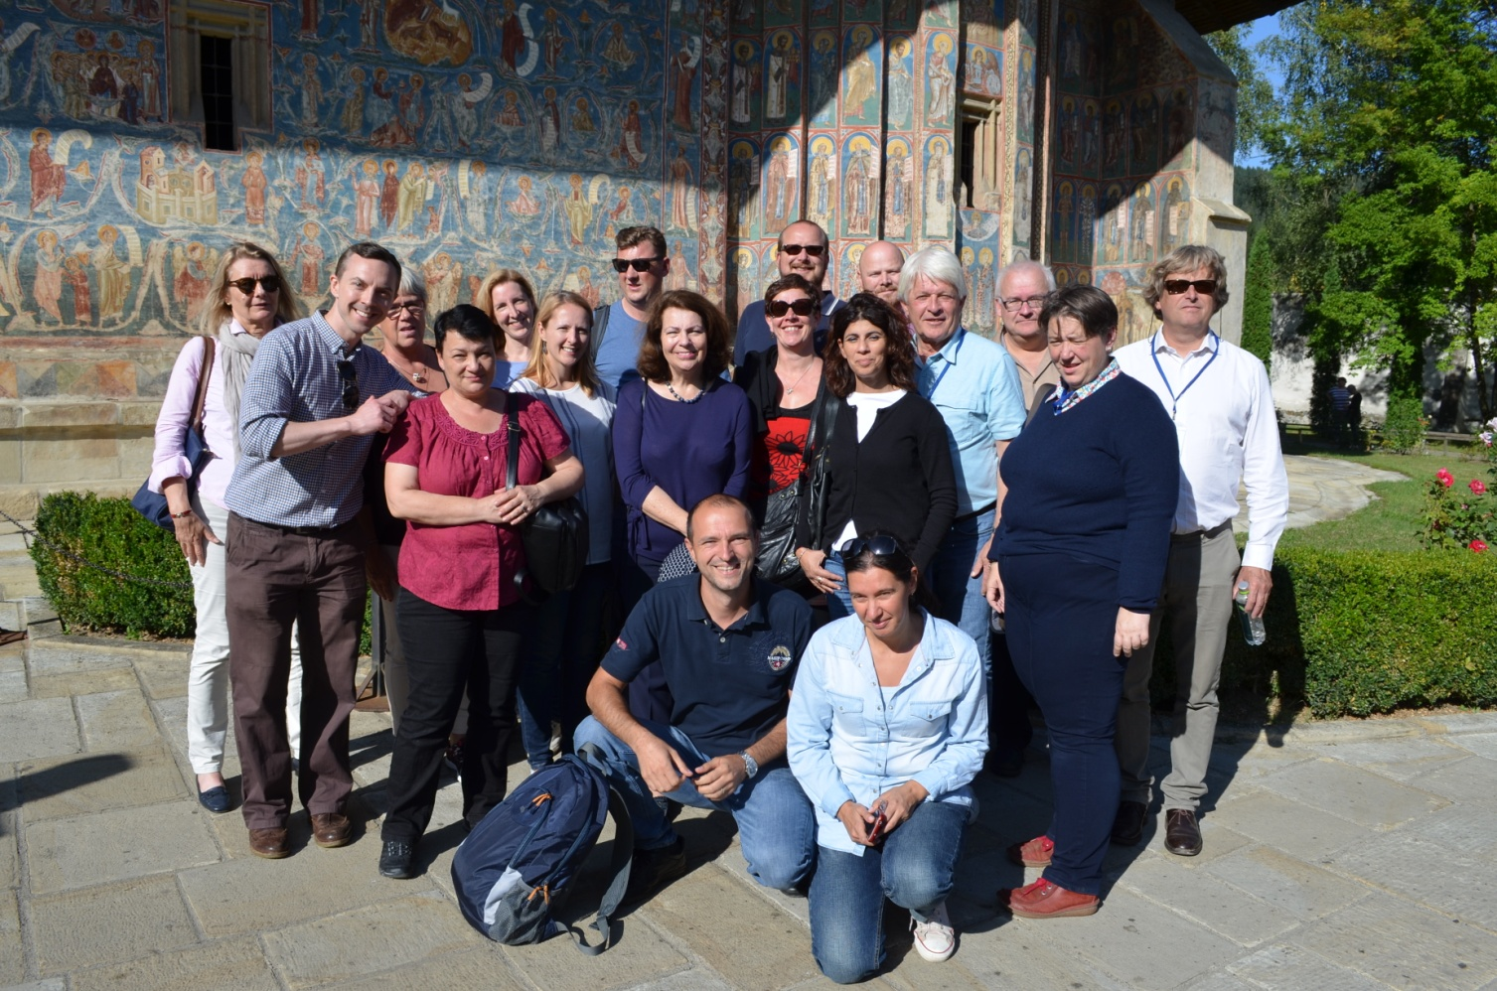
Appendix A: Agenda

Green Pilgrimage International Conference, 2nd Partner Meeting and Study Visit

5-9 September 2017
Suceava, Romania

Tuesday
5th September 2017

Arrivals

Arrivals, Transfer from Iași

Check in at Conacul Domnesc Hotel, Suceava

Wednesday
6th September 2017

Green Pilgrimage International Conference

Venue – Bukovina Museum, Suceava

8.30 | 9.00 | Transfer from the hotel
9.00 | 9.30 | Registration
9.30 | 9.45 | Welcome speeches:  Mrs. Alina Cârlogea, INCDT, Bucharest  Mrs. Laura Ursu, Suceava County Council
9.45 | 11.00 | Introduction in religious tourism and pilgrimage  - Mrs. Catherine Brady, Project manager Kent County Council, United Kingdom – Green Pilgrimage presentation of the project  - Mr. Octavian Arsene, Ministry of Tourism - Cultural and religious tourism in Romania: a perspective of cultural routes  - Mrs. Lăcrămioara Beilic, Association for Tourism Bukovina – Religious tourism and local community  - Mr. Petrică Ariciuc, Mountain Rescue Association - Developing cycling routes and pedestrian trails in Bukovina: a connection between Dornelor area and painted monasteries
11.00 | 11.30 | Coffee break
11.30 | 13.00 | Good Practices in Romania  - Presentation of the regional pilgrimage in Suceava County:  - His Eminence Damaschin Dorneanul, Diocese of Suceava and Radauti  - Pr. Mărăndescu Anton, Cacica Catholic Church  - Pr. Azad Mandalian, Hagigadar Armenian Orthodox Church  - Mrs. Laura Ursu, Suceava County Council, Tourist Information Centre - Presentation of the national project – Pilgrim in Bukovina  - Mr. Molnár Sándor, Via Mariae Association – "Via Mariae" pilgrimage route - the "El Camino" from the Eastern Central Europe
13.00 | 14.30 | Lunch
14.30 | 15.00 | Short visit to the Bukovina Museum
15.00 | 16.30 | External stakeholders’ presentations  - Mr. Tim Hall, England Coast Path Senior Adviser, Natural England – The economic value of long distance walking and why the UK government has invested to create the World’s longest coastal path in England. Lessons in path creation and promotion.  - Mrs. Julia Peters, Kent University Post Graduate, Founder of Kent on the Via Francigena pilgrimage website – A personal perspective of long distance pilgrimage walking. Why people walk long distance and what services they require. Lessons from the Camino to Santiago de Compostela, Spain, 800 km and the Vie Francigena Canterbury to Rome 1900 km  - Mrs. Berit Lånke, European Green Pilgrimage Network - Comparative observations of Pilgrimages in Romania and Norway based on theological, environmental and tourism aspects
16.30 | 17.00 | Coffee break
17.00 | 17.30 | Conclusions
17.30 | 20.00 | Visit to the Saint John Monastery (UNESCO monument)
20.00 |  | Transfer to Conacul Domnesc Hotel and dinner at participants own expense

Thursday
7th September 2017

Green Pilgrimage Steering Committee Meeting (Sucevița) and Study Visit

9.00 | 10.00 | Transfer Suceava – Sucevița, Popas Bukovina, Sucevița village
10.00 | 10.15 | Registration
10.15 | 10.30 | Coffee break
10.30 | 13.30 | Steering Committee (only for project partners)/ Study visit of the art crafts (black pottery) centres Marginea and Rădăuți and Bogdana Monastery (for invited stakeholders)
13.30 | 15.00 | Lunch at “Popas Bukovina” Restaurant at participants own expense
15.00 | 18.30 | Study visit to the Sucevița and Moldoviţa Monasteries (UNESCO monuments) - all participants
19.00 | 21.00 | Pilgrimage to the “Nașterea Maicii Domnului“ Church in Câmpulung Moldovenesc town - Dinner included
21.00 | 22.00 | Transfer from Câmpulung Moldovenesc to Conacul Domnesc, Suceava

Friday
8th September 2017

Study Visit

9.00 | 9.15 | Transfer from Conacul Domnesc Hotel
9.15 | 10.30 | Visit to the Armenian Church Hagigadar, Suceava town
10.30 | 11.30 | Transfer Suceava town – Cacica village
11.30 | 12.30 | Visit to the Cacica Catholic Church
12.30 | 13.30 | Transfer to Gura Humorului town
13.30 | 15.00 | Lunch at Best Western Hotel at participants own expense
15.00 | 15.30 | Transfer to Voroneţ Monastery
15.30 | 17.00 | Visit to the Voroneţ Monastery (UNESCO monument), Gura Humorului town
17.00 | 17.15 | Transfer to Humor Monastery
17.15 | 18.30 | Visit to the Gura Humorului Monastery (UNESCO monument), Gura Humorului town
19.00 | 21.00 | Festive Dinner at the “Acasa in Bukovina” Restaurant
21.00 | 22.00 | Transfer Gura Humorului - Suceava

Saturday
9th September 2017

Optional Study Visit & Departure of the participants

8.00 | 15.00 | Optional Demonstration of Potential Walking Pilgrimage Route between Dragomirna Monastery and Pătrăuți Church
Some Green Pilgrimage partners were able to join a long distance walk between two important religious sites in Suceava County. This walk was led by Cristina Achiței working for the Tourism Information Center, representing the tourism department of Suceava County Council
During the walk partners were able to discuss in more detail the tourism potential of walking in Suceava. The UK participants were all senior managers and trail managers and so were able to share detailed information about route development, signposting and promotion. It was also useful to demonstrate to Christina how the route demonstrated would appeal to international walking visitors and what modifications or facilities international walkers might expect or hope for in the long distance route demonstrated. Romania’s unique offer for long distance walking and pilgrimage was demonstrated on the ground by revealing the combination of ancient traditions and culture, beautiful countryside and incredible heritage churches.

Departure, Transfer to Iași airport

Appendix B: List of participants
Crt. # | NAME OF PARTICIPANT | PARTNER / ORGANISATION
1. | Chaterine BRADY | Kent County Council (UK)
2. | Peter MORRIS | North Down Way, KCC (UK)
3. | Britt Louise Nilsson | Region Östergötland (Sweden)
4. | Julia Peters | North Down Way (UK)
5. | John Jones | Norfolk County Council (UK)
6. | Charlotte Watts | Norfolk County Council (UK)
7. | Tim Hall | Natural England (UK)
8. | Berit Lånke | EGPN (Norway)
9. | Kari Mette Elden | South-Trøndelag County Authority (Norway)
10. | Cathrine Roncale | Nidaros Pilgrims Centre (Norway)
11. | Caroline Pinchbeck | Diocese of Canterbury, EGPN
12. | Per Rosenberg | Diocese of Linköping (Sweden)
13. | Knut Wik | South-Trøndelag County Authority (Norway)
14. | Are Skjelstad | National Pilgrim Centre (Norway)
15. | Matthew Nouch | Ashford Borough Council (UK)
16. | Anna Introna | Puglia Region (Italy)
17. | Lăcrămioara Beilic | Bukovina Tourism Association (Romania)
18. | Alexandru Nedelea | Stefan cel Mare University, Suceava (Romania)
19. | Octavian Arsene | Ministry of Tourism (Romania)
20. | Koszta Csaba Janos | Via Mariae Association (Romania)
21. | Molnar Sandor | Via Mariae Association (Romania)
22. | Petre Ariciuc | Vatra Dornei Municipality, Mountain Rescue Association (Romania)
23. | Vasile Mihăilă | Basilica Travel (Romania)
24. | Magda Grădinariu | Bukovina Tourism Association, Access Travel (Romania)
25. | Laura Ursu | Suceava County Council, CNIPT (Romania)
26. | Cristina Achiței | Suceava County Council, CNIPT (Romania)
27. | Cătălina Velniciuc | Suceava County Council, CNIPT (Romania)
28. | Traian Gabriel Ojog | Câmpulung Moldovenesc Municipality, CNIPT Rarăul (România)
29. | Pr. Cristian Blăjuț | The Roman Catholic Parish of Cacica (România)
30. | Pr. Paul Valenciuc | Archbishopric of Suceava (România)
31. | Pr. Azad Mandalian | Parish of the Armenian Church (România)
32. | Alina Cârlogea | INCDT (Romania)
33. | Doru Tudorache | INCDT (Romania)
34. | Rodica Trifănescu | INCDT (Romania)
35. | Eduard Chilom | INCDT (Romania)

The list of workshop participants is provided in Annex B.

