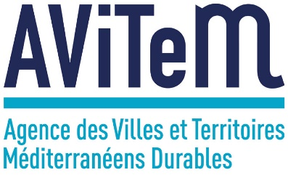

TOWARDS ZEROCO2 EMISSION BUILDINGS
MARKET NEED
REPORT

Introduction
The following review has been produced as an outcome of bilateral meetings with regional and local stakeholders in Provence Alpes Côte d’Azur (PACA) Region. These exchanges explored the current status and quality of energy efficiency projects in public buildings in the PACA region, and, in particular, the funding measures available to support them from the public sector. It also allowed for discussing the impact of financial instruments available in France for energy efficiency measures within public buildings. The grounds for this review are therefore based on the visible data available on the internet dealing with funding options for energy efficiency projects in public buildings, whose target is zero CO2 emissions. Based on these inputs, AVITEM formulated recommendations that could improve regional and local public policies in terms of funding opportunities. These recommendations were discussed and amended during a local stakeholders’ group meeting gathering all concerned actors in Marseille.
Therefore, this report ambitions to better understand market needs in France with respect to energy efficiency in public buildings, and how best these can be addressed with improvements to public policy and funding measures. This requires practical improvements in the infrastructure and systems for public buildings’ energy consumption, using technologies both existing and new. But these depend on a public policy framework supported by investment.
However, it seems necessary to underline that the different investments policies presented in this report only concern building operation and energy use. Indeed, the ZEROCO2 project focuses on the building operation phase. PACA Region Local stakeholders reminded the following limits of such approach during the previous group meetings:
- The renovation works, and all the more so the construction works, may have more weight than the sole operation. The concept should thus apply to the building life cycle, recognizing that optimized choices in terms of design can prove counterproductive at the operational level and vice versa. Only a global approach would allow obtaining systematically a satisfactory compromise.
- The « sobriety-efficiency-renewable energy » trio should lead both our energy and carbon policy.
Consequently, the best way to reach a non-carbon operation is to tend towards passive buildings, which brings out the importance of the construction or renovation phases.
- Regarding the climate issue, the stake lies in an optimal development of a building or territory energy potential, which is not contradictory with the ZEROCO2 concept but which gives it a greater ambition.
- The nuclear issue is not addressed by the ZEROCO2 concept, which remains a pending issue.

2. Main support mechanisms in PACA region
La loi de transition énergétique pour la croissance verte (TECV) du 17 août 2015 prévoit de nombreux dispositifs de soutien aux investissements.
Pour les particuliers, ces soutiens prennent différentes formes : crédits d’impôt, fonds de garantie pour les ménages modestes, soutien à la création de sociétés tiers pour le financement, subventions à l’achat.
Les collectivités et les bailleurs sociaux peuvent bénéficier de prêts bonifiés de la Caisse des Dépôts et Consignation.
Par ailleurs il existe des tarifs garantis sur 20 ans pour le rachat de l’électricité qui constituent une aide à l’investissement dans les énergies renouvelables.
S’agissant de la région PACA, il convient de noter les dispositifs suivants :
2.1 The Regional RHEA programme
Launched 10 years ago, and relying on a political consensus, this programme greatly contributed to the improvement of social housing in PACA.
The mobilisation of ERDF allows carrying on with the mechanism while increasing energy requirements (BBC renovation).
Main strengths:
Capitalization on achievements thanks to the partnership with the ARHLM and BDM (training, technical guidebooks, etc) in a works massification perspective.
Works assessment based on a consumption monitoring.
Inhabitants’ involvement is a programme added value insofar as projects results are linked to use criteria and to a sociological approach which is often insufficiently taken into account.
Main weaknesses:
Very few public buildings in spite of objectives set by ERDF.
Weak requirements in terms of renewable energy and lack of carbon dimension.
For this programme, and also in general terms, primary energy consumption is the main criteria. This is sometimes inconsistent with the costs of using.
2.2 The heat fund
The heat fund is carried out by ADEME, is complementary to the Regional Council grants as part of the CPER which concerns small facilities. It finances thermal renewable energies rollout: biomass, solar hot water, geothermal, geothermal heat pump, district heating.
All targets, such as social housing, public buildings, businesses and enterprises are eligible to this programme. Private individuals are excluded because they can benefit from tax credit.
Projects are selected in the regional call for proposals on size criterion (i.e. for wood: higher than 100 TEP, for solar power: higher than 25 square meters; Beyond €1,5 millions in aid the application goes through national selection committee), on cost-effectiveness criterion (investment payback between 5 and 15 years) and energy efficiency criterion.
A local and heritage approach is promoted by territorial or heritage contracts gathering various projects and enabling economies of scale.
Despite the trend initiated by the CPER, the PACA Region remains below its theoretical contribution to renewable energy production. The initiatives of local authorities stay remain low especially due to more attractive prices of carbon energy.
2.5 Platforms of renovation and shared energy advisors.
If the platforms target private individuals, their action on the structuration of the channel (referencing, organization, etc.) indirectly contribute to supporting local authorities. They are part of an awareness and support function which must be better developed with PACA local authorities.

3. Policy background
3.1 La prise en compte des dimensions énergie et carbone dans la réglementation nationale
3.1.1 New buildings
So far, the French Thermal Regulation RT 2012 does not take into account the carbon dimension, but sets a primary consumption lower to 50 kwhEP/m/year in average as a limit.
The regulatory performance is based on buildings technical characteristics but also on conventional data on building use and its climate environment Most of the time, post-construction results prove remote from the initial set standards of regulatory performance. The latter is often considered as a forecast whereas the regulatory framework is only designed to assess the set-up of buildings’ characteristics in standardized conditions of functioning.
However, labels with stronger requirements (Effinergie+, Bepos effinergie 2013, etc.) exist but most of them do not take into account the carbon dimension except the BBCA label (about 750 kg of CO2 by square meter built).
The low carbon national strategy established in 2015 in the wake of the French energy transition for green growth Law (TECV) includes for the building sector, which represents around 25% of carbon emissions, the following objectives:
- Reducing carbon emissions by 54% by 2030 and 87% by 2050.
- Reducing energy consumption by 28% in 2030.
The new thermal and environmental regulation scheduled for 2018-2020 will rely on the results of the experimentation launched in November 2016 among voluntary contracting authorities. The objective of this experimentation is to test the technical practicability and the economic sustainability of the levels of ambition enabling the reduction of non-renewable energy consumptions, the spreading of renewable energy at the building and district level and the use of materials, energy systems or low carbon footprint building methods. Coming out from this experimentation, the E+C- label takes into account the carbon dimension. It relies on the Energy-Carbon reference document, and takes into account GHG emissions on the whole lifecycle. The label thus promotes energy-efficient buildings. Therefore, it will enable voluntary contracting authorities which followed the reference guidelines as a whole (energy performance and environmental performance) and willing to engage in a labelling process, to promote energy-efficient buildings (participation to experimentation is not a pre-requisite for enrolling in the labelling process). The experimentation management relies on the observatory whose mission is to carry out an inventory of the technical and economic characteristics of operations which participate to the experimentation, capitalising on the lessons learnt and analysing the results to fine-tune levels and assessment method As an illustration, for a level 2 tertiary building, the total carbon will have to reach maximum 1000 kg CO2.
The analysis of the experiences feedback, via the observatory data, will allow tuning the energy and carbon levels of the future regulatory framework.
However, nor the French Thermal Regulation RT 2012 or other schemes and the regional climate and energy plan (PCET) rely on mandatory results.
It should also be noted that in spite of quality achievements, new buildings performances are often remote from the theoretical calculations, or even lower to those of the replaced equipment.
There are many different causes: non-adapted regulation, non-binding administrative tools, lack of political attention to energy and carbon challenges, fluctuating costs and lower costs of carbon energy, especially gas the last few years, lack of technical skills at the various steps of the production line: (design, building, operation, maintenance), lack of resources for technical project management, no willing from contracting authorities for assessment, etc.
Each new building is, due to scattered competences and decision-making processes, a prototype which does not benefit from the advantages of a certain standardization; if the architecture of the early 20th century primary schools could be identified easily in villages, that is no longer true for 21st century ones which size and technical expertise increased dramatically. As a result, the lessons-learned process is affected.
3.1.2 Public buildings and social housing renovation: a weak constraining regulation which does not explicitly take into account the carbon dimension.
Concerning public buildings, the TECV Law in its article 17 extends the obligation to renovate these buildings until 2050, with performance levels reassessed every 10 years. The decree project related to the obligations for improving energy performance in existing buildings for tertiary use, currently at the consultation stage, should contribute to improving energy performance of each building while optimizing the works cost / energy saving ratio. As an illustration, the tertiary buildings are concerned beyond 2000 square meters, and according to return on investment time.
Regarding social housing, the TECV Law provides for obligations of renovating the housing stock for the energy-high consuming buildings (F and G rated) and on-board works in case of important renovation. Tertiary buildings are also concerned by this obligation (Article 14 TECV law).
Yet, due to the importance of the existing housing stock (30 million of housing to compare with 300 000 new buildings yearly), the energy and carbon renovation remains a major challenge. All the more so when we compare the carbon balance between new and renovated buildings. Without a thorough regulation, which seems recommended, public authorities play a major role in terms of exemplarity and considering their potential impact on economic trend of some sectors.
3.2 Regional policy in PACA Region
Le parc bâti en région PACA compte 277 millions de m² qui représentaient 30% des consommations finales régionales en 2014 et 10% des émissions de GES liées à la consommation finale d’énergie. Ce parc est caractérisé par une prédominance des consommations liées au chauffage (60% pour le parc résidentiel) ainsi qu’une surreprésentation du chauffage électrique (44% des logements), par des pics de consommation électrique en hiver, un développement de la climatisation et un accroissement des pics de consommation en été. Plus de la moitié du parc a été construit avant 1975 et près de 31% du parc total de logements affiche des performances énergétiques E, F ou G.
Le programme régional pour l’efficacité énergétique retient trois grands axes d’intervention :
- La rénovation énergétique des bâtiments privés :
En accompagnant les copropriétés dans l’aide à la décision, le suivi technique et l’ingénierie financière. Ainsi la Région soutient la réalisation d’audit globaux partagés, des missions d’assistance à maitrise d’ouvrage, l’accompagnement à l’ingénierie financière via une plateforme régionale de la rénovation énergétique.
Par la massification de la rénovation énergétique grâce à des plateformes territoriales de la rénovation énergétique
Par l’accompagnement des particuliers via un soutien aux travaux de rénovation :
- La rénovation énergétique des bâtiments tertiaires
En incitant les collectivités à mettre en place des systèmes de management de l’énergie
Par des outils d’accompagnement des hébergements touristiques et des commerces de bas d’immeuble
- Par l’aide à la structuration du secteur du bâtiment face aux enjeux réglementaires et technologiques :
La Région apporte son concours à l’expérimentation E+C-
Elle favorise le recours aux écomateriaux et aux filières locales
Elle soutient les initiatives structurantes à destination de la filière (formation, retour d’expérience, financements innovants …)
4. Current local and regional investment projects
The annex presents three ongoing investments in the field of energy efficiency and renewable sources in public sector and their measures.
5. Policy/Funding compatibility and market need to support public investment in ZEROCO2 buildings
Les échanges issus des travaux du groupe de travail local ont permis de formuler des recommandations relatives à l’amélioration des politiques publiques, et qui permettraient de répondre aux besoins du marché :
Recommendation 1: In order to take into account PACA regional specificities, there is a challenge to arouse a sample of experimentations representing different types of buildings, including public ones, and regional microclimates. In order to ensure a good representation of the Mediterranean coast, it should make sure that there will be sufficient applications in the H3 (/RT2012) climate zone.
Summer comfort should especially be taken into account in the national specifications.
PACA Regional Council and local authorities could commit to establishing this list. A partnership support mechanism (ADEME, DREAL, Region, liaising with CEREMA and BDM) is currently being set up and should foster the emergence of Mediterranean experimentations
Recommendation 2: Leading a strong awareness-raising campaign of local authorities in order to trigger operations on public buildings under passive renovation.
Recommendation 3: Better integrating the renewable energy and carbon dimensions in the project selection criterion, but also the cost of using and functioning of the equipment. In doing so, financing of quality engineering upstream and downstream of the project is crucial.
Recommendation 4: Going beyond thermal energy financing only, especially extending cogeneration at local level.
Recommendation 5: Better taking into account cold as a renewable energy.
Recommendation 6: Identifying the regional sectors which deserve an increased development: hot solar water, solar heating, etc., and set support mechanisms for these sectors.
Recommendation 7: In case of renovation project, conditioning the heat fund subsidies to carbon criteria.
Recommendation 8: Elaborating a simplified carbon and energy lifecycle analytical framework.
Recommendation 9: Establishing reference sources for spreading out passive renovation adapted to the Mediterranean context, in particular in view of summer comfort.
Recommendation 10: Commit PACA local authorities to use BDM approach for their public buildings renovation projects (cf. recommendation 10).
Recommendation 11: In the context of the region-wide roll-out of the platforms, in addition to their articulation with the other social operators and ANAH, they should include an adequate number of shared energy advisors. Apart from the awareness and advisor functions vis-a-vis local authorities, they should be able to lean on a collection of coherent measures coming out from the SRADDET and take into account the objective of spreading out these public policies which cannot only rely on the call for proposals approach.
Recommendation 12: Promoting, under the impulse of the Region, the emergence at different territorial scales of energy operators as provided by TECV Law, able to support the public contracting authorities on the design, construction, and performance monitoring functions, even third-party financing together with the Caisse des Dépôts et Consignations.
Recommendation 13: Commissioning should be more systematically required by public contracting authorities.
Recommendation 14: In view of the complexity of energy and carbon approaches, air quality, etc. to be considered at design and construction level of public buildings, a substantial aid for engineering funding would be necessary.
Recommendation 18: The territorial dimension is not covered by the ZEROCO2 project. However, it is suitable to emphasize the relevance of an energy approach, as well as a carbon approach, at a scale which exceeds buildings, and thus the interest to support TEPOS, QDM, and other similar approaches.
Focus on: The Mediterranean Sustainable Buildings (BDM) approach
The BDM approach, which is carried out by an association gathering more than 350 professional stakeholders from the building sector, is a participative certification which allows a technical and human support on environmental, social and economic aspects of a building and taking into account the territory’s special features.
The BDM approach is selected by local authorities for the management of their construction and renovation projects. It aims at favouring bioclimatology, minimizing the impact of materials, reducing water and energy consumption in order to protect inhabitants’ comfort and health while taking into account social and economic issues.
This global, thorough, professional and participative approach is highly relevant to respond to market need due to the complexity of the energy and carbon approaches even though this last dimension is only considered indirectly.

6. Conclusion: strategies and the art of implementation
L’approche near zéro CO2 s’agissant des bâtiments publics ou des logements sociaux, doit différencier les constructions neuves des opérations de rénovation.
Pour les bâtiments neufs l’expérimentation E+C- permettra de réviser la réglementation thermique en intégrant le facteur Carbone sur le cycle de vie du bâtiment. On peut considérer que ce futur dispositif, qu’il convient donc de suivre de près en PACA en intégrant les spécificités de confort en climat méditerranéen, apportera une réponse satisfaisante à l’enjeu Carbone.
Pour les bâtiments anciens, qui constituent l’enjeu majeur au regard du stock existant, la réglementation demeure peu exigeante. A défaut d’une modification de la réglementation, la solution ne réside pas tant dans un ajustement des dispositifs d’aide que dans une mise en mouvement de l’ensemble des acteurs de la filière.
The TECV Law strengthens the role of local authorities to mobilise their territories and the role of the region in the energy efficiency area completing Energy, Air and Climate Regional Scheme (SRCAE) with energy efficiency plans. It states that the regional climate and energy plans (PCAET) which now integrate the air quality issue, are only redefined at the inter-municipal level with an inter-municipal objective.
The ambition given to these strategic tools will be thus critical. The PACA region is on a path that does not allow achieving the energy transition objectives.
Yet, in order to tackle the complexity of energy and carbon approaches, it is crucial to make available a full technical and financial support mechanisms for the contracting authorities, from the design until the equipment management phases, whose experience shows it is often ineffective. Some mechanisms exist, even incomplete, yet a contracting authority support would be necessary.
In terms of carbon, due to the multiplicity of the issues at stake, which are sometimes contradictory, and due to the complexity of constructive and urban systems, depending on their facilities energy or not, contracting processes (of the building, of a city block, or even of the city in general) require new skills and the emergence of a strong expertise, thus coupled with strong public authorities’ incentive, across the different actors in order to take into account the interactions between their practices.
Validating experiences’ feedback (on buildings, facilities, use, practices, functioning) and capitalising on this diffuse but rich and decisive knowledge, making them available to everyone: this should form a great part of the action plan, enabling to obtain better performances in terms of carbon and energy.
Commissioning is a quality insurance process, which aims at ensuring that a building, and particularly its systems, are designed, installed and tested according to the required performances by the contracting authority so that they can be well managed. Thus, this process allows guaranteeing energy and using performances to the contracting authority and building users. The commissioning contributes to the overall quality and energy global cost management.

Annex
Current Local and Regional Investment Projects

- Thalassothermie Euromediterranée

L’opération urbaine Euroméditerranée à Marseille a souhaité la mise en place d’un système de production d’énergie performant et renouvelable, associé à un réseau de chaleur, pour alimenter le quartier en réhabilitation.
L’objectif était d’avoir un système de production d’énergie pour des usages mixtes entre habitat et activités tertiaires avec donc une production de chaleur et de froid, et à faibles coûts en raison de la présence de logements sociaux.
Après analyse de plusieurs scénarios, seule la solution de thalassothermie permettait d’atteindre les performances environnementales souhaitées et pour des coûts production raisonnables.
Avantages de cette solution : production renouvelable, technologies simples et matures, permettant une production industrielle, permettant la production de chaleur et de froid, d’améliorer la qualité de l’air et de réduire l’effet îlot de chaleur, permet réduire le dimensionnement du réseau électrique sur le quartier desservi, permet de récupérer de la chaleur dans un bâtiment (en cas de surchauffe) pour en chauffer un autre.
Limites de cette solution : nécessite une densité urbaine importante pour assurer une bonne rentabilité du réseau de chaleur, nécessite une mixité fonctionnelle, difficulté de synchroniser le développement de l’installation/réseau de chaleur avec le développement du projet urbain, difficulté à convaincre les différents promoteurs présents sur le quartier de se connecter au réseau de chaleur.

Deux opérations différentes ont finalement été développées dont la dernière vient juste d’être inaugurée. Il s’agit de 2 installations de production et de réseaux de chaleur de taille similaires (500 à 600 000 m² chacune, 30 à 35 millions d’euro chacune) mais avec des fonctionnements différents.
- L’opération Thassalia est développée et exploitée par Engie, assure le chauffage et rafraîchissement de la partie sud du quartier et fonctionne à 80 % par thalassothermie et à 20 % avec un appoint gaz lors des pointes de consommation. L’installation de production est centralisée (échangeur de chaleur sur boucle d’eau de mer, pompes à chaleur et chaudière appoint gaz) puis distribuée par le réseau de chaleur.
- L’opération Massileo est développée et exploitée par EDF, assure le chauffage et rafraîchissement de la partie nord du quartier, fonctionne à 100 % sur la boucle d’eau de mer, pour distribuer un réseau d’eau tempérée sur lequel viennent se brancher des pompes à chaleur réversibles à l’échelle des îlots ou des bâtiments.

1.1 Ilot Allar C- Thalassothermie Euromed
Dans le cadre du programme Euroméditerrannée et au sein de l’Ilot Allar, labéllisé « Eco-Cité », l’Ilot C présente une surface totale de 10 232 m2 avec 154 logements et commerces au rez-de-chaussée. Les objectifs de performance énergétique fixé par le cahier des charges de la ZAC vont au-delà de la réglementation (RT2012 -10% ; Bbio -20% hors compensation réseau énergie). Le bâtiment est raccordé au réseau de chaleur de thalassothermie.
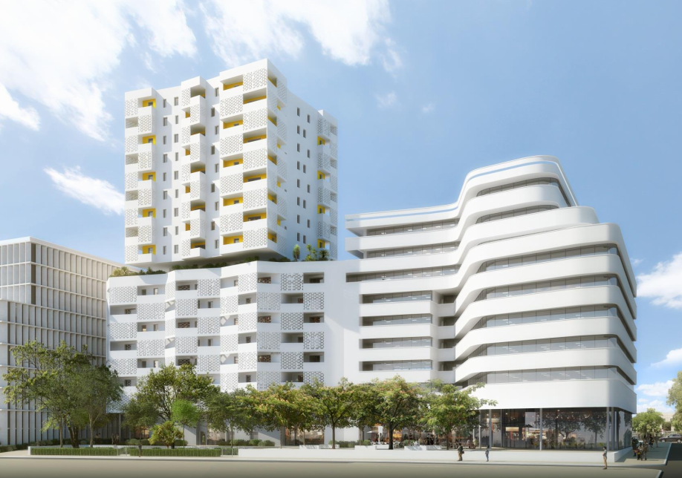
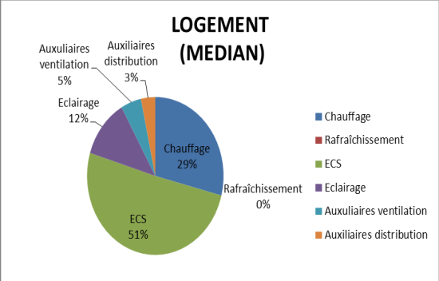

1.2 Ilot Allar E - Thalassothermie Euromed
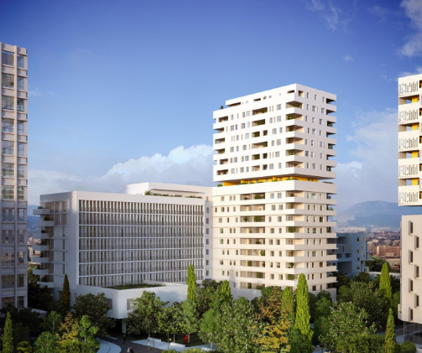
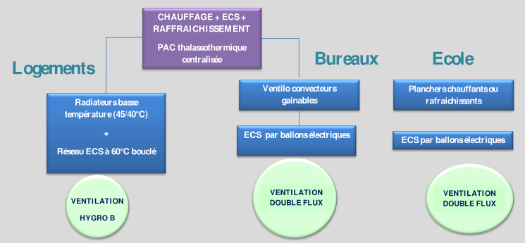
L’illot E présente une surface 9196 m2 pour 136 logements ainsi que 8 plateaux de bureaux et une école. Le bâtiment est raccordé à la boucle d’eau tempérée thalassothermique et équipé de pompe à chaleur.

2. La ferme de Beaurecueil – Grand site Sainte-Victoire
Le site de de la Ferme Grand Site Sainte-Victoire, ferme du XIXe siècle, a été totalement réhabilité avec des matériaux écologiques et de très basses consommations d’énergie. Les besoins en énergie sont assurés par un puit climatique associé à une ventilation double flux, complété par une chaudière à granulés de bois (de 35 kW pour 1254 m2) et un chauffe-eau solaire pour l’eau chaude sanitaire.
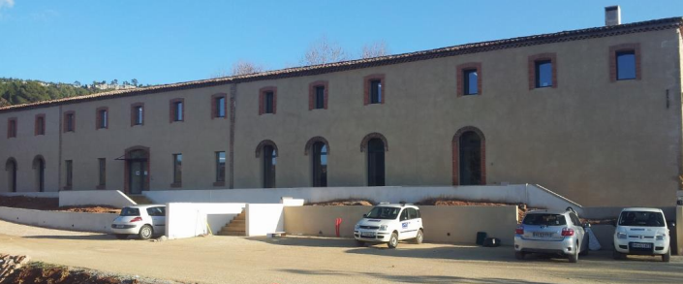
Le niveau d’émissions de CO2 est très bas puisqu’il se limite aux émissions de la chaudière bois (33 gCO2/kWh) et des besoins en électricité.
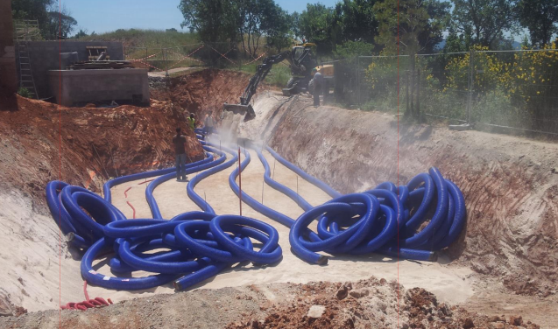
3. Lycée Audiberti (06)
Construit en 1963, le lycée Audiberti à Antibes accueille 1500 élèves. Afin d’améliorer sa fonctionnalité et de suivre une démarche de qualité environnementale, il a fait l’objet d’une réhabilitation globale intégrant une amélioration de son efficacité énergétique :
- protection solaires extérieures
- ventilation passive + VMC
- isolation des paroies
- renouvellement du système de chauffage
- ECS solaire
- végétalisation
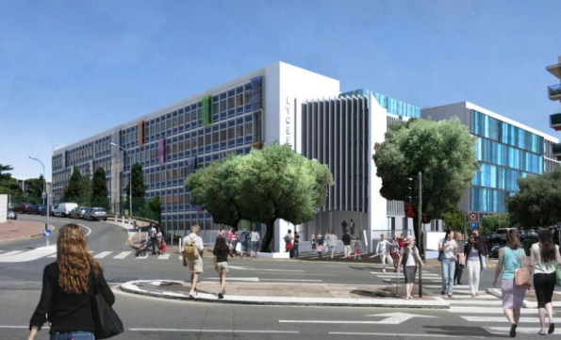
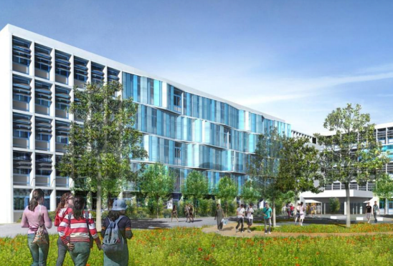

Housing Rehabilitation Energy Improvement Program
Regional Association of Social Housing
Mediterranean Sustainable Buildings
Agency for Environment and Energy Management
Planning agreement between the national and regional governments
National Agency for Housing
Bâtiment Durable Méditerranéen

