Description of the 1stPublicConsultation meeting

The event of the 1st Public Consultation took place the 4th semester of the implementation of the SYMBI project, covering the period October-March 2017-2018. The1st Public Consultation meeting theme was:
“Industrial Symbiosis and Circular Economy-Discussion over the existing policies, investing possibilities, good practices and green public procurement.” in line with the methodology developed by the Andalusian Regional Ministry of Environment and Spatial Planning.
The Public Consultation event, organized by Municipality of Kozani, was held on Wednesday, March 28, 2018 in Koventario, in the city of Kozani
The total participants in the event were:20.
In detail, the following stakeholders were participated:
Institution | Number of participants
Municipality of Kozani | 6
Municipal Enterprise for Water Supply and Sewerage of Kozani | 1
Waste Management of Western Macedonia S.A. | 2
Athena R.C. | 2
Technological Educational Institute of Western Macedonia | 1
University of Western Macedonia | 1
Union of Municipalities of W. Macedonia | 1
National Technical University of Athens | 1
Public Power Corporation SA | 1
Technical Chamber of Greece | 2
Certh/Cperi(Εκετα) | 1
Bioenergy and Environment Cluster of Western Macedonia | 1
Total institutions:12 | Total participants:20
In order to inform the public a press release was released with informative material about the main themes. The press release, with the online questionnaire, was displayed on the site of the Municipality of Kozani from the beginning of March.
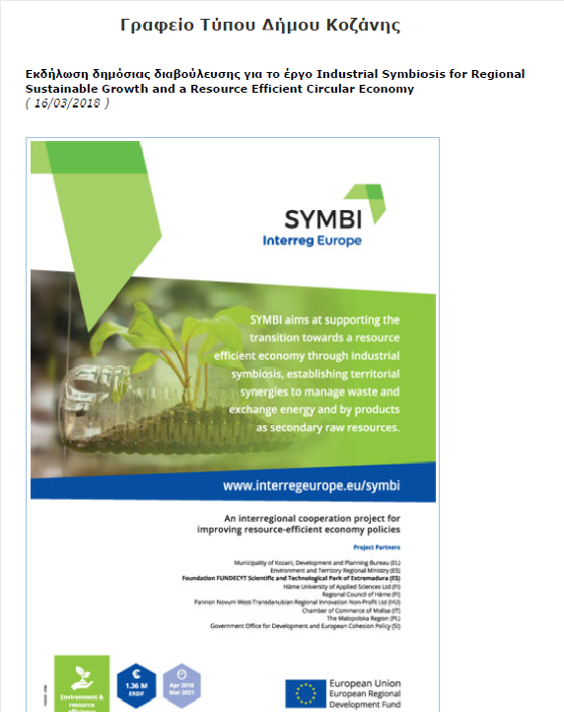
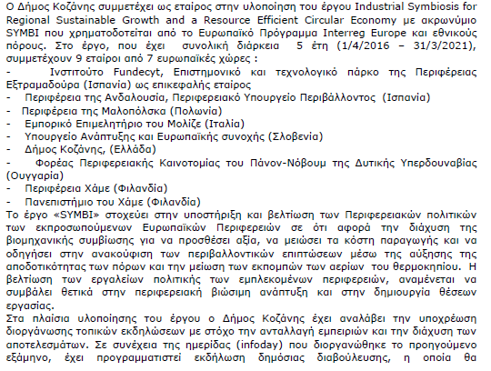
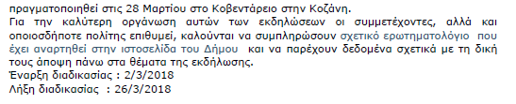

The main themes of the consultation were:
- Existing policies on industrial symbiosis and circular economy
- Investment potential in industrial symbiosis
- Good practices on ecosystems of by-product and energy exchanges
- Green public procurement as an enabler for industrial symbiosis

Results, conclusions and basic policy recommendations
Below are summarized the main conclusions, suggestions and recommendations

Summary report of the 1st SYMBI public consultation meeting held in Kozani
Partner organising the meeting: | Municipality of Kozani
Partner members organising the meeting: | Dimitris Kakoulidis , Development and Planning Bureau, Municipality of Kozani
Details of the meeting | Number of completed pre-consultation questionnaires: | 21
 | Number of registered participants: | 20
 | Number of completed evaluation questionnaires: | 16
 | Number of participants from each category of the target groups: | Public organization: 3  Businesses & SMEs : 3  Technical Chambers : 1  Universities & research centres:5
 | Round of the meeting: | 1 | 2
 |  | X
KPIs | Completed pre-consultation questionnaires received: 21 questionnaires  Attendance: 20 participants  Completed evaluation questionnaires received: 16 questionnaires
Participants’ interventions concerning theme 1 : | Regarding the completed questionnaires :  62% answered YES that they have noticed the industrial symbiosis and circular economy in their region through projects such as: SDIT for waste management, reuse of airborne Ash and conduction of raising awareness events. The same people answered that the existing policies are ineffective due to the lack of experience, awareness and incentives, businessmen unwillingness, priority to individual projects and inappropriate institutional framework.  90% answered YES that the Special Developmental Programme of Western Macedonia should found actions for raising awareness.  Regarding the participants’ suggestions for policies improvement:  Enhance the creation of public-private networks  Clear legislative provisions  Cooperation of different levels of administration  Exploitation of the Special Development Programme of Western Macedonia
Participants’ interventions concerning theme 2 : | Regarding the completed questionnaires:  52% answered YES that they are aware of the investment chances of their region such as: Industrial Area of Kozani, exploitationof wood waste, exploitation of bio-waste for biogas, SDIT and exploitation of Airborne Ash. The same people answered that the problems, in seeking and exploiting these investment chances, are: implementation complexity, lack of awareness, founding and cooperative culture.  Regarding the participants’ suggestions for investment potential:  Financial instruments should include criteria based on circular economy and industrial symbiosis  Administration should inform companies about funding programmes
Participants’ interventions concerning theme 3: | Regarding the completed questionnaires:  52% answered that they are aware of some successful examples of industrial symbiosis in their region such as: SDIT,ELPIS LLC (production of combustible biomass in the form of pellet),Waste Management Unit (MEA), district heating by DEI, Airborne Ash and industrial by-products exploitation. The same people answered that the obstacles in this kind of symbiosis are the following: lack of awareness, incentives, culture and specific framework and bureaucracy.  Regarding the participants’ suggestions for good practices :  Symbi programme should be used as a tool for dissemination of good practices in circular economy  Platform development for the dissemination of information about circular economy projects.
Participants’ interventions concerning theme 4: | Regarding the completed questionnaires:  9,5% answered YES that they know about the founding of Industrial Symbiosis and Circular Economy projects by green public procurements, which amplify the symbiosis. The same people answered that the problems during the implementation of those, are the lack of awareness and the enhancing of upper quality solutions.  Regarding the participants’ suggestions for green public procurement :  Legislative provisions
Participants’ other interventions: | -
Evaluation of the meeting: | Score How would you rate the quality of the organization of the meeting? Do you think that the time allocated to each topic was sufficient? How would you rate the quality of the proposed policies? How would you rate the quality of the discussion during public hearings? How would you rate the quality of the discussion during the workshop? Do you agree that the meetings will lead to improvements in the proposed policies? The meeting as a whole has been appropriate and productive?  5 94% 44% 56% 62% 31% 63% 75%  4 6% 56% 31% 38% 69% 19% 25%  3 0% 0% 13% 0% 0% 6% 0%  2 0% 0% 0% 0% 0% 13% 0%  1 0% 0% 0% 0% 0% 0% 0%
Conclusions and policy advice: | Overall the attendees were quite satisfied by the organization of the consultation meeting.  The basic results and conclusions which derive from the evaluation of questionnaire are:  The residents of this region are aware of industrial symbiosis and circular economy, the most prevalent examples are SDIT for waste management and reuse of Airborne ash. Additional examples of industrial symbiosis are the exploitation of dry lignite and steam, which is emitted by the cooling towers of DEI, in order to heat the nearby greenhouses. About circular economy, was referred the recycling and use of byproducts, which are produced with materials such as tire and other.  As basic policy recommendations, the attendees recommend better exploitation of Special Developmental Program and raise awareness.  It would be beneficial if private sector enhances the trial and a support mechanism was established.  All the above require the structural change of the institutional framework and the development of certification standards for the use suitability of byproducts.  Further utilization of DIADYMA and DEI with the view to enhance industrial symbiosis and circular economy.

