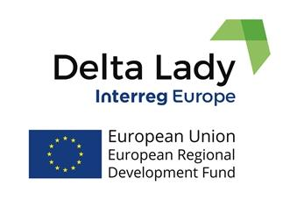

Agenda
Exchange of experiences:
1st Interregional Learning Event and kick-off meeting

Towards learning the best practices and innovation policies in deltas

Venue: Parc Naturel Régional de Camargue;
Mas du Pont de Rousty – RD 570, 13200 Arles; Tel: +33 490 97 10 40

Day 1: October 1st 2018
9:00 - 9:15 | Registration
9:15 - 9:30 | Welcome by the host partner
9:30 - 9:45 | Introduction by the Lead partner
9:45 - 10:45 | Presentations of partners (4x), 15 minutes per partner with Questions & Answers:  - Background of the partner  - Aims for the participation  - Envisaged activities  - Relation to policy instrument
10:45 - 11:00 | Coffee break
11:00 - 12:00 | Presentations of partners (4x), 15 minutes per partner with Questions & Answers
12:00 - 12:15 | Elaboration of the detailed work plan by the lead partner
12:15 - 13:45 | Lunch
13:45 - 14:15 | Administrative issues: Project management, communication, finances
14:15 - 18:30 | Tour to the Delta (coffee and food on the way)  Issues related to traditional human activities in the Camargue and the actions for Interreg
20:00 - | Dinner / Evening event

Day 2: October 2nd 2018

9:00 - 9:30 | Partners’ reflections on day 1 and presentation of the Steering Group
10:00 - 10.30 | Partners mention their Stakeholders groups (3 - 5 minutes per partner)
10:30 - 11:00 | Camargue stakeholders’ group presents its view with Questions & Answers:  - Objectives  - Work in progress  - Instruments for implementation
11:00 - 11:15 | Coffee break
11:15 - 12:00 | Finances and reporting: template for the finance, template for the reporting
12:15 - 13:30 | Lunch
13.30 - 14.00 | What did I learn and how can I use it (3 - 5 minutes per partner)
14.00 | Closure and next meeting
14.00 - 14:30 | Coordination team: practicalities
15.00 - | 2nd tour to the delta for those who stay  Brainstorming about possible improvements and innovations using experiences across deltas

