rural retail diagnosis

index

I. | Objective of the Mapping Analyses in SARURE | x
II. | Concept of Rurality in force in WARMIŃSKO-MAZURSKIE VOIVODESHIP | x
III. | Socioeconomic state-of-the-art in WARMIŃSKO-MAZURSKIE VOIVODESHIP | x
 | - Sociodemographic aspects  - Sociodemographic characterization of the territory  - Depopulation  - Demographic imbalances in the structure of the rural population | x
 | - Economy and Employment  - Business activity and proximity services in the territory  - Employment  - Analysis of the retail offer: Survey to rural retailers and stakeholders groups  - Analysis of the retail demand: Survey to the inhabitants | x
IV. | Rural Development Policies (Plans & Programmes) in force in the territory | x
V. | SWOT Analysis of the Rural Environment studied | x
VI. | Conclusions | x

Objective of the Mapping Analyses in SARURE

The path to a good monitoring and evaluation system is started with a sound mapping analysis.

Baseline information is necessary to understand the cause and/or effect of any project, study or policy implementation; however, mapping reports often don’t get the attention and effort they should, spoiling the possibility to see how far a project reached after implementation. To put it in simple words, mapping analyses measures key conditions before a project begins and provide a clear starting point to benchmark progress. Without something to measure new results against, it is difficult to assess results as positive, negative or otherwise.

Quantitative and qualitative data collected through the mapping analyses need to correlate with the end goal of the project. Thus, the scope of the analysis must be thoroughly defined, in order to request only strategic information serving the purpose of the analysis. Moreover, data to be collected should be those which can be tracked in the future in the same way, as baseline data are most useful when they can be compared to new data at a later date.

In summary, a sound mapping analysis is that one providing a present photo of where we are today with regard to a topic, a snapshot of indicators and circumstances at a time; but also one serving for later benchmarking from which to measure progress.

SARURE Advisory Lead Partner, the Chamber of Commerce of Teruel, has produced an ad hoc template for the partner regions in SARURE to produce Mapping Analyses of the state of the art of rural retail in their territories. Thus, the present template is accompanied by surveys to be launched to retailers and related stakeholders as well as to inhabitants/ consumers.

Some partners allocated budget for external support to draft the Mapping Analyses: these funds can serve to subcontract the launching and exploitation of the surveys and/or the support to write the report itself. The partners with only internal resources to draft the Mapping Analyses can launch the surveys to a sample of retailers and consumers they are in direct contact with (through their internal data bases or through the stakeholders’ groups, for example), even if the number of addressees to make the sample valid and reliable is not observed. However, the surveys will provide some feedback worthwhile having.

As the Advisory Lead Partner will summarise and conclude the main hints behind all the analyses, it is kindly requested the structure and limitations of space in the following pages to be observed. Please include quantitative and qualitative information and the sources when necessary.

Concept of Rurality in force in WARMIŃSKO-MAZURSKIE VOIVODESHIP

Rural areas in Poland are villages and cities with up to 20,000 inhabitants. In the region of Warmia and Mazury there are 116 municipalities, including 16 cities.
The Warmian-Masurian Voivodeship is characterized by a high share of rural areas. It is 97.53% and significantly exceeds the national average of 93.20%). The share of the rural population in the region is 59.51%, while on average in the country it is 38.7%.

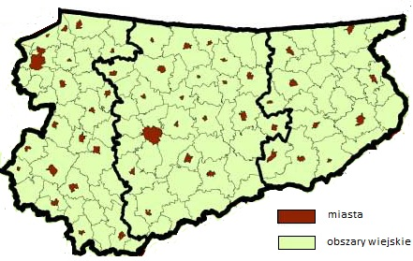

Rural areas by classification | Share of rural areas in the total area (in %) | Share of population living in rural areas in the total population (in %)
TERYT | 93,2 | 38,7
OECD | 91,0 | 34,4
Eurostat | 85,7 | 29,3

Rural area:
- According to the definition of the Central Statistical Office, it is an area located outside the administrative borders of cities
- In the European Union, the rural area is the area where the population density is lower than 100 persons / km².
- According to the OECD, the rural area is the area where the population density is lower than 150 persons / km².

Socioeconomic state-of-the-art in WARMIŃSKO-MAZURSKIE VOIVODESHIP

- Sociodemographic aspects
- Sociodemographic characterization of the territory

In Warmia and Mazury voivodship there are over 1.4 million inhabitants, which is 3.7% of the country's population. The region is the least populated province in the country. Natural growth, which in the 1990s set the region in the forefront, decreases and at the same time the negative migration balance persists, which results in a decrease in the number of population.
Especially rural areas are sparsely populated compared to the country. Demographic forecasts indicate that by 2030, the number of inhabitants of Warmia and Mazury will decrease by approx. 80,000. people. In the population structure, the share of people in pre-working and production age will decrease, while the number of people in the post-working age will almost double. The map below illustrates the assessment of living conditions in rural areas.

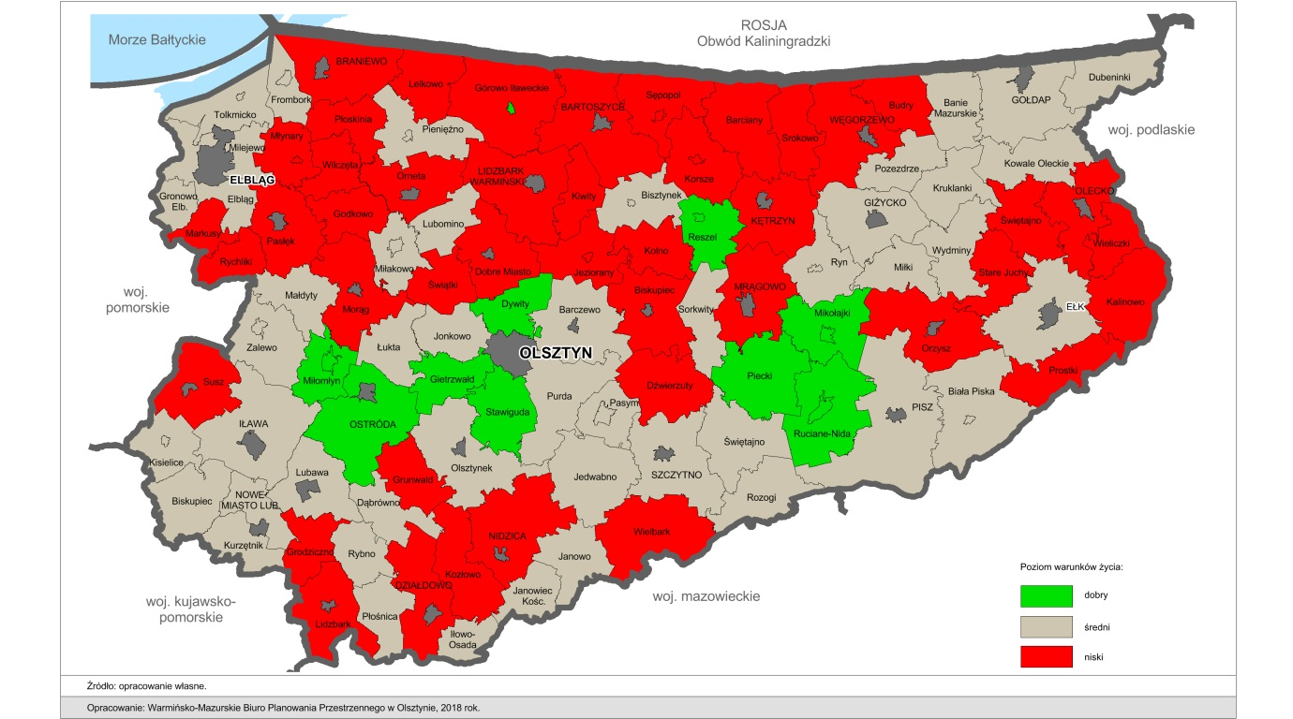

- Depopulation
Both in the entire Warmińsko-Mazurskie Voivodeship and in most poviats, a negative migration coefficient of people in pre-working age was recorded. This means that the voivodship was characterized by a larger outflow of population of a given age group than by an inflow (-3.3 people per 10,000 population). The greatest negative disproportion between the inflow of population to a given poviat and its outflow at 10,000. people were registered in the poviat of Braniewo (-81.82 people), which is also struggling with the problem of low birth rate and the aging of the population living in it.An unfavorable situation also occurs in the Elbląg poviat (-29.63 people), Pisz (39.14 people) and Olsztyn (-22,87 people), in which the indicator deteriorated compared to 2014, and also in Gołdap (-67 , 2 people) and Lidzbarski (-44,3 people), in which this tendency is permanent. The ratio of the migration balance among persons of working age in the Warmian-Masurian voivodship amounted to -48.8 persons in 2017 (for 10,000 people). The prevalence of the number of emigrants over the number of immigrants in this group was recorded in 19 of the 21 voivodship poviats. Additionally, only in three poviats characterized by a negative value of the migration coefficient of people of working age a relatively stable improvement in the situation in 2014-2017 was registered, i.e. in the poviat of Braniewo, Kętrzyn, Iławskie and Elbląg.
The positive migration balance among people in the productive age of the Warmian-Masurian Voivodeship and the positive direction of changes in the phenomenon were registered only in the Ełk poviat (12.86 people) and Olsztyn (63.54 people).
Negative migration balance in the Warmian-Masurian Voivodeship was also recorded in the group of post-working age people. The value of the coefficient for the voivodship in 2017 amounted to -2.6 people for 10,000 people. In relation to 2014, an increase in the value of the coefficient by 0.4 persons was noted. The lowest migration balance factor of 10,000 people in 2017 were registered in the poviat of Braniewo (-33.97 people), Kętrzyn (-35.44 people), Nidzica (-26.43 people) and Węgorzewo (-32.84 people)
Particularly high positive value of the migration balance factor of 10,000 persons among post-working age people were registered in the Ełk poviat (35.92 people). A positive consequence of the positive balance of population inflow in post-productive age is the fact that it slows down the depopulation of the region, but with the declining group of people in pre-productive and productive age leads to unfavorable changes in the region's population structure. The observed changes confirm the unfavorable demographic situation of the voivodship, which in connection with the negative balance of migration of people in pre-working and production age, leads to the phenomenon of population aging in the region. The key factors influencing the decision on emigration in recent years were economic reasons and insufficient number of desired jobs, which largely determined the level of migration.

- Demographic imbalances in the structure of the rural population
As a result of negative demographic changes taking place in the Warmian-Masurian Voivodeship, the population in the perspective of 2030 and 2050 relative to 2015 will decrease by -4,8% and -16.1% respectively. The greatest rate of decline in the dynamics of the region's population in 2030 will affect a group of people in pre-working age (-18.22%). In the category of people of working age there was a decrease in the number of people by 13.5%, and their share in 2030 will amount to 60.8% of the total population (reduction by 6.11 pp.). It is forecasted that the only group whose number will increase in 2030 will be the category of people in the post-working age (increase by 39.65%). The share of the group of post-working age people in 2030 will in turn amount to 26.02%, which will be an increase of 8.28 pp. in relation to 2015 According to the population forecast, the negative trend of demographic changes in the region will last at least until 2050. The share of residents in the pre-production and production age will permanently decrease and in 2050 will be 12.01% and 51.32% respectively. In relation to 2015, a further decrease in the number of people in the pre-working age (by 34.36%) and production (by -35,64%) is forecasted. The demographic aging process will deepen and the increase in post-working age population in relation to 2015 will reach 73.45%. The share of this group of people in 2050 will amount to 36.66%, which will be an increase in relation to 2015 by 18.92 pp. In 2050, only in the county of Olsztyn there will be an increase in the number of residents - men by 11.84% and women by 13.33%. This result will be a derivative of a relatively low decline in the dynamics of people in pre-working age (-6.99%), production (-8.56%) and the highest increase in the number of people in this category in the post-productive age by 196.74%. In the perspective of 2050, the Warmian-Masurian Voivodeship will witness a significant loss of population combined with a negative trend of changes in its structure - an aging population. In each of the poviats of the region, an increase in the share of the group of people in post-working age by 2050 is predicted, oscillating around 20 pp. relative to 2015, with a simultaneous decline in the share of people in pre-working and production age.

- Economy and Employment:
- Business activity and proximity services in the territory:
The Warmian-Masurian Voivodeship is characterized by very low entrepreneurship, measured by the number of people conducting economic activity per 1000 inhabitants (14th place in the country). Also, data on entities newly registered and deregistered in 2011 indicate that the level of entrepreneurship is lower than it could result from the population potential.
After discussions with entrepreneurs during the meetings organized by the LAG Southern Warmia, you can indicate some important problems:
- rozwoju firm, unsatisfactory availability of financing sources for companies' development
- ack of innovation support system
- low purchasing power of the population, as well
- inappropriate attitude of the authorities to entrepreneurs
The labor market of Warmia and Mazury voivodship was perceived for many years through the prism of unemployment resulting from the liquidation of state agricultural farms. In fact, the region has the highest registered unemployment rate in the country (10.5%). The situation is particularly difficult in this respect in the northern part of the voivodship.
However, the characteristics of the voivodeship labor market should take into account the following facts:
- the region is characterized by a relatively low (close to the national average) unemployment rate calculated in the study of economic activity of the population (BAEL), which shows that the inhabitants show a high level of commitment to finding a job
- the economic activity rate in the voivodship, amounting to 51.7% in 2011, is one of the lowest in the country. In Warmian-Masurian voivodship per one job offer there are 266 registered unemployed, with the national average of 90
- the share of employees in micro and small enterprises in general employed is relatively high (higher than the national average and much higher than the other voivodships in Eastern Poland)
- in general the number of employees and the dynamics of changes place the region at the final places in the voivodship ranking
- the employment structure is noticed by high employment in the public sector, and definitely low in information and communication (less than 1.3%), professional, scientific and technical activities (less than 2.2%) and financial and insurance activities (2.4%)

- Employment (Zatrudnienie)
Since the beginning of the 1990s, the labor market in the Warmian-Masurian Voivodeship is one of the most difficult areas of socio-economic activity in the country. This is largely due to low employment (lower than average in Poland), low wages and the highest unemployment in the country. The peripheral location makes the Warmian-Masurian Voivodeship one of the poorest regions in Poland, at the same time struggling with the most difficult problems in the labor market in the country, including the lowest employment rate and the highest unemployment rate
The employment rate of people aged 15-64 in the Warmian-Masurian Voivodeship was 60.8% in 2017 and increased by 3.9 percentage points compared to the base year (2015). In Poland, the rate was 66.1% in 2017 and was 3.2 pp. higher than in the base year. The growth rate of the employment rate in the Warmian-Masurian Voivodeship in the analyzed period is higher than the national average by 0.7 percentage points.
The unemployment rate in the Warmian-Masurian Voivodeship in 2017 was at the level of 11.7%, and in the country - 6.6%. In comparison to the base year, the value of the index fell in the region by 4.5 percentage points, and in the country by 3.1 percentage points. Despite a significant decrease in the registered unemployment rate in recent years, the Warmian-Masurian Voivodship continues to occupy the last position in the country. The lowest unemployment in the country was recorded in the Wielkopolskie Voivodship - 3.7%. The low unemployment rate is due, inter alia, to declining professional activity, declining working-age population, emigration and government policies, such as lowering the retirement age or the "Rodzina 500 plus" program.
Poviats with the lowest registered unemployment rate in the Warmian-Masurian voivodship are: Olsztyn (4.5%), Iława poviat (4.9%), Nowomiejski (8.5%), Nidzica (8.9%) and Elbląg (9) %). However, the highest unemployment is registered in the districts of Braniewo (22.2%), Bartoszyce (20.6%) and Węgorzewo (19.5%).
The number of professionally inactive people in 2017 decreased in the Warmian-Masurian voivodship by 49 thousand. persons compared to the base year, from 563 thousand persons to 514 thousand people. The analysis of the structure of professionally inactive people by gender shows that despite the overall decline in the number of inactive people, the share of women rose from 59.7% in 2015 to 61.3% in 2017. The main reason for professional inactivity in the region is retirement (48%) and then learning and improving qualifications as well as illness and disability (respectively 15.2% and 15%). In the case of women, a reduction in economic activity may be a consequence of the government program - "Family 500 plus", which, due to the no income criterion, also does not help to development of entrepreneurship.
The number of registered unemployed aged 50 and more is successively falling from year to year. In the Warmian-Masurian Voivodeship, the number of registered unemployed aged 50 and more decreased by nearly 25% in 2017 in relation to the base year 2015. A similar situation is also observed in relation to the country. On the national scale, the number of registered unemployed aged 50 and more decreased by nearly 40%, from the level of 226,000. people in 2015 to the level of 142 thousand people in 2017.

- Analysis of the retail offer (exploitation of survey to rural retailers and stakeholders’ groups)

25 representatives of retail trade in rural areas took part in the survey, of which 60.00% are women. The youngest respondent was 35 years old, the oldest 63 years old, 2 people did not want to give their age.

The scope of activity they represented was presented in the chart below:
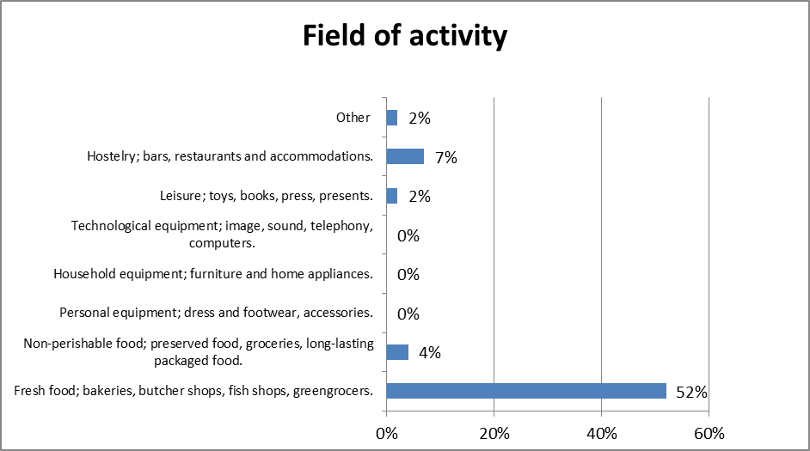

The most common selling method was Direct sale to the public - 84%.
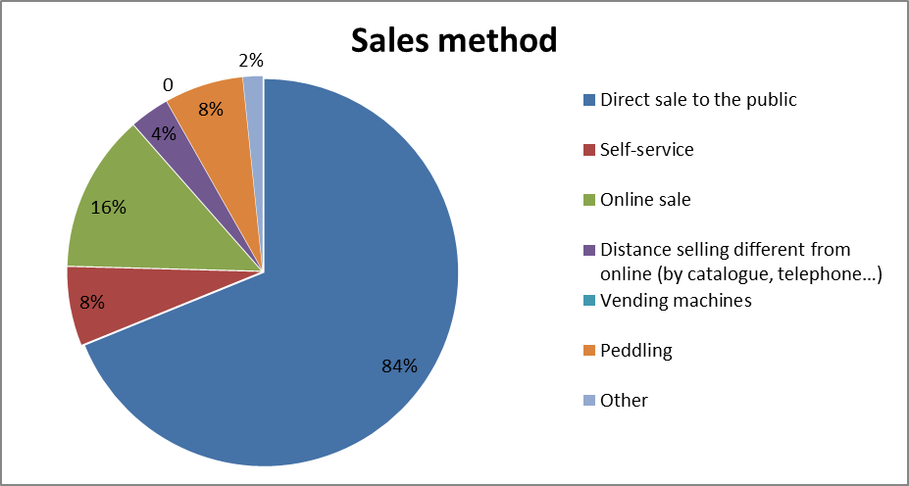

Companies run up to 2 years constitute 12% of respondents and only 3% more than 30 years.
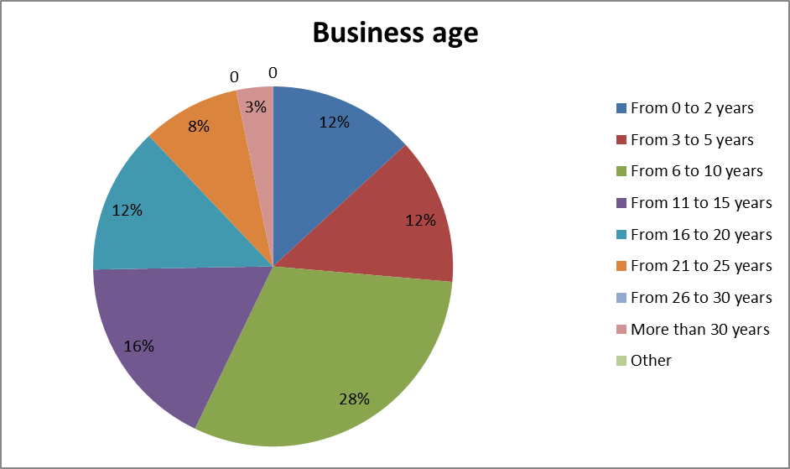

The current condition of companies is rated as Regular (64%).
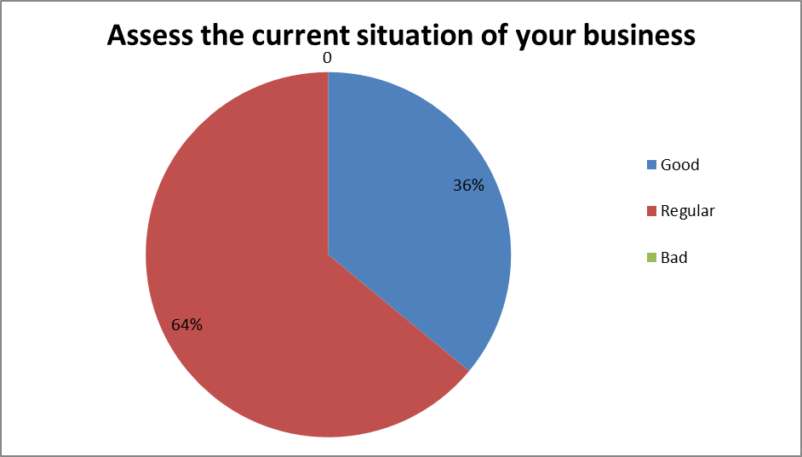

The changes they would like to make are presented in the chart below.
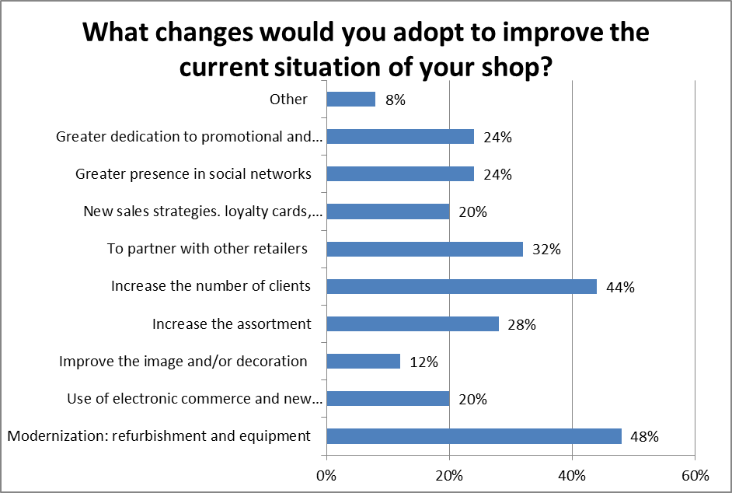

56% of respondents see their future in business as optimistic.
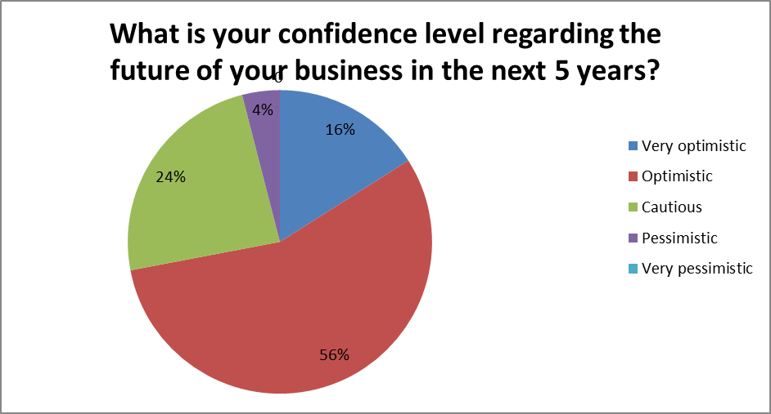

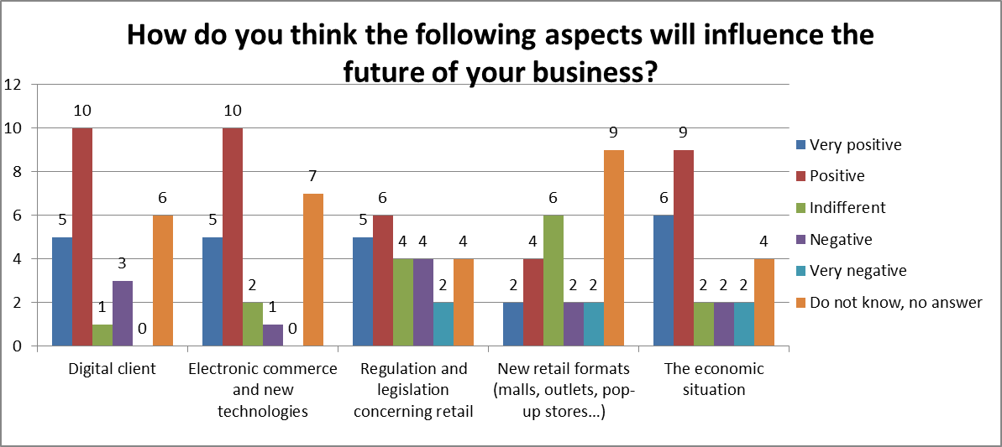
Various aspects have an impact on the future of doing business, our respondents responded as follows:

29.2% consider specialized chain stores (national and international brands, franchises) as their greatest competition.
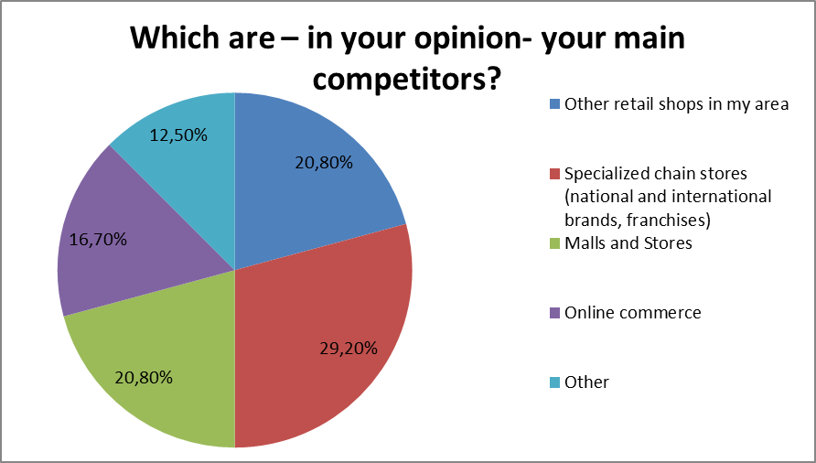

Main advantages, why customers buy in my store are as follow: 32% indicates locations and only 4% points Product / service differential, unique, without competition and Product / service adapted to the client.
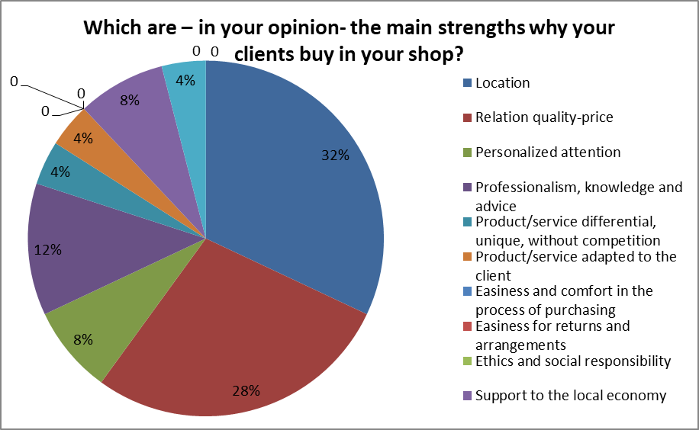

The most valued form of contact with suppliers is the telephone form (76%) And the least (4%) Internet, Network of contacts (business networking).
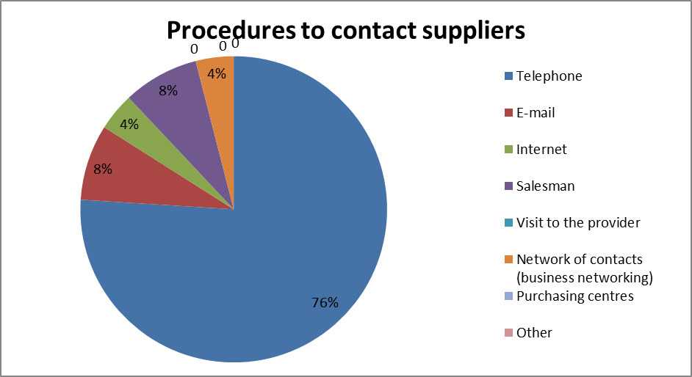

Social networks and Internet (79.2%) are the most valued form of promotion, while Media (paper press, digital press, radio, TV) is indicated least often

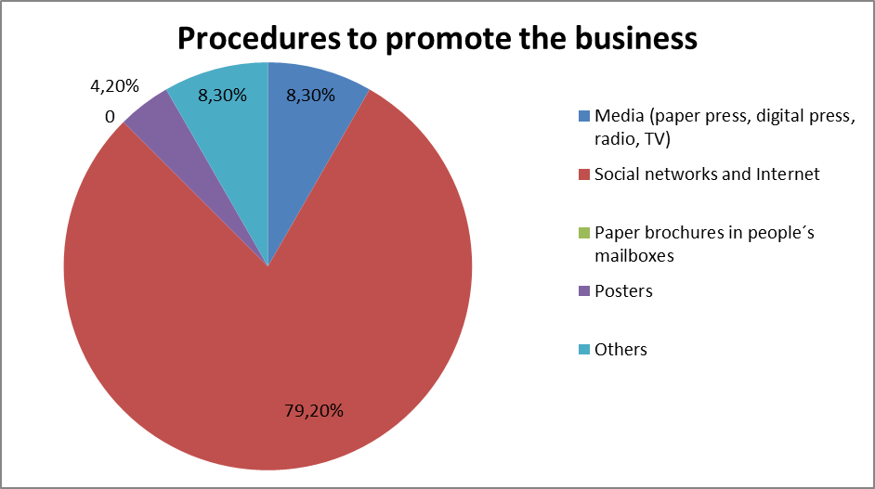

Datalists most often promote customer loyalty through Discounts and direct promotions addressed to the client 60.9%, the smallest number of retailers use loyalty cards (8.7%).
To analyze the results of promotions and loyalty campaigns, retailers most often use Sales and promotions statistics (62.5%), least often Satisfaction surveys addressed to the clients (16.7%).

54.2% of respondents mark their presence on the network through the Informative website and social networks.
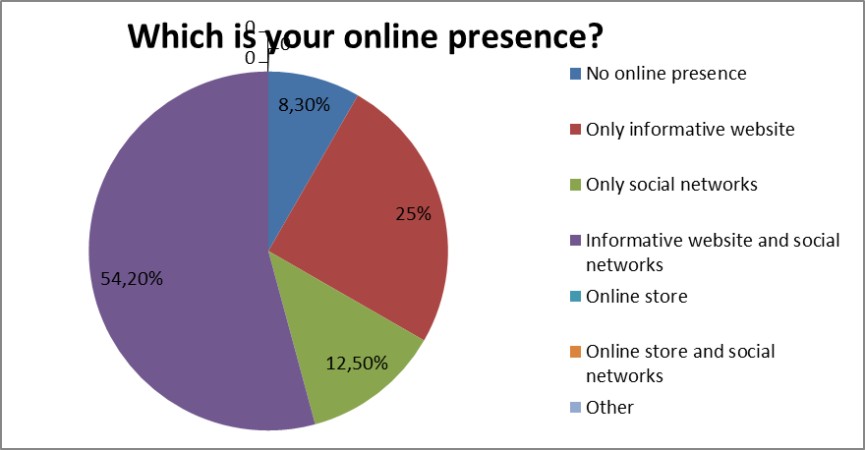

52% of respondents intend to increase their online presence over the next 12 months.
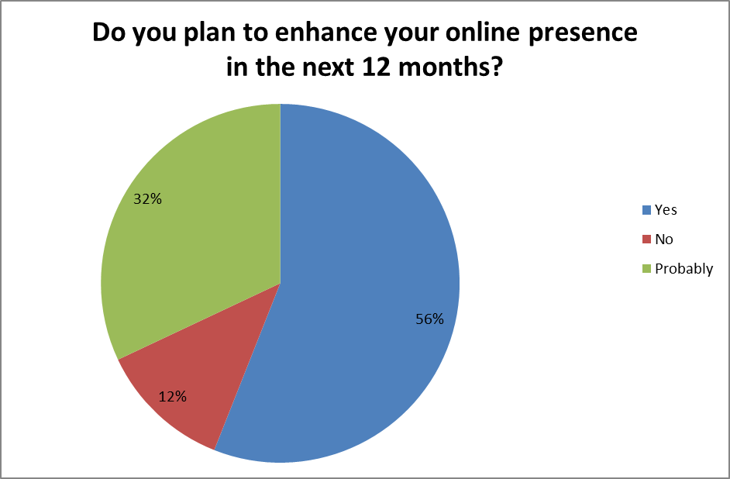

Retailers show Necessary time as the biggest obstacle to online presence (52%).
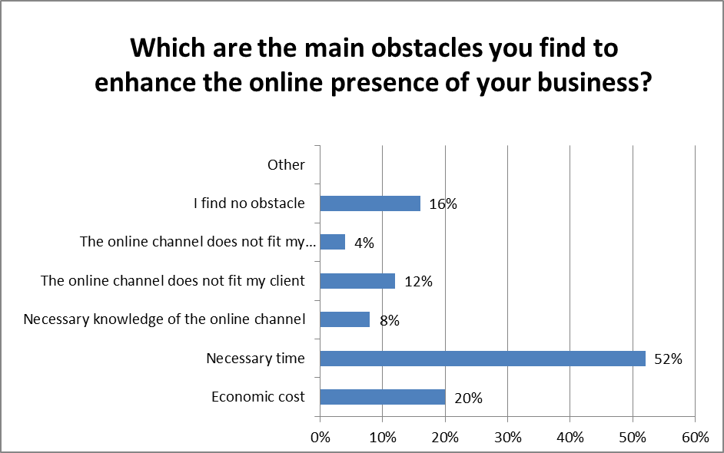

To improve the results of the promotion and loyalty campaigns, respondents indicate: Direct grants -20%, Actions to improve the prestige of local retail and the awareness raising of the inhabitants - 16%.

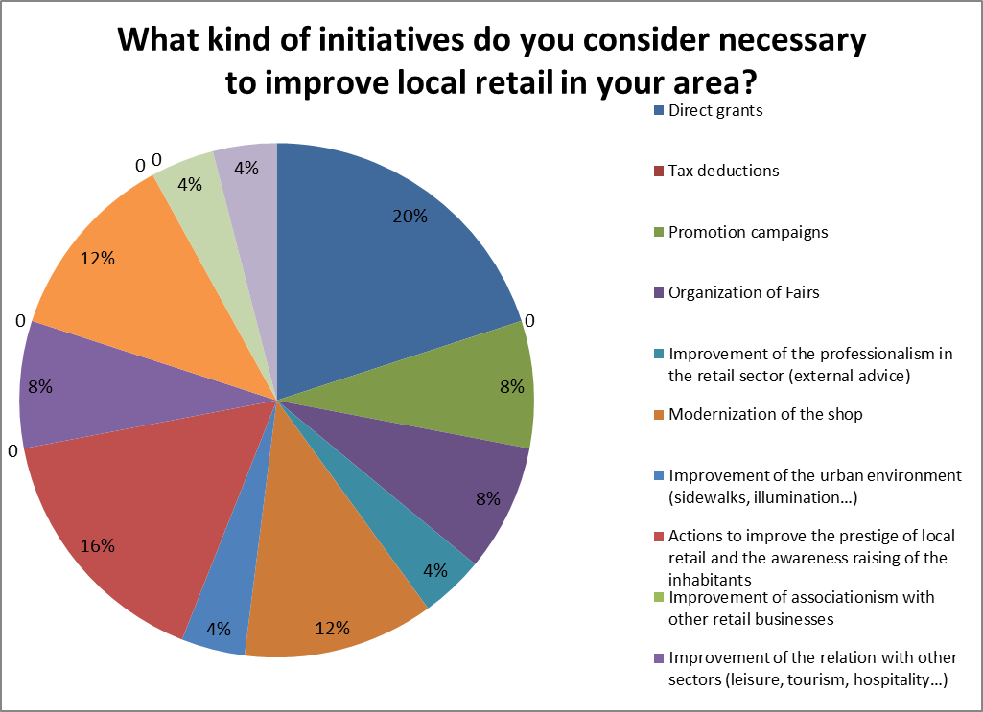

- Analysis of the retail demand (exploitation of survey to inhabitants-consumers)

65 consumers took part in the survey, of which 63.1% are women. the youngest respondent was 25 years old, the oldest 70 years old, 2 people did not want to give their age.
The 50% annual income is between € 15,001 and € 30,000 (PLN 65,001-130,000). Only 1.6% of consumers earn over € 120,000 (more than PLN 250,000).

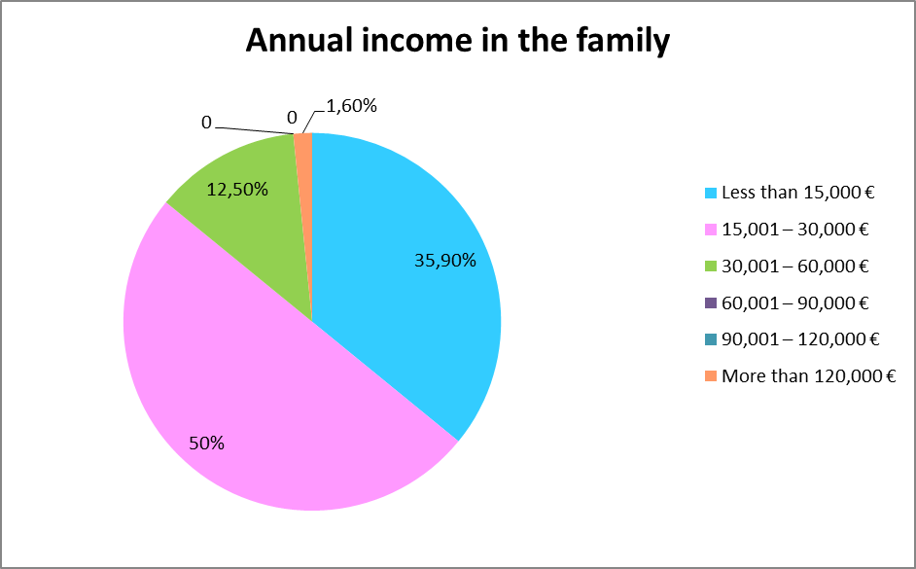
source: own study

When asked what types of stores do you choose for each of the following purchases? Most answers were given to food (90.91%).
Most people buy online (50%) and in a provincial city (27.27%).

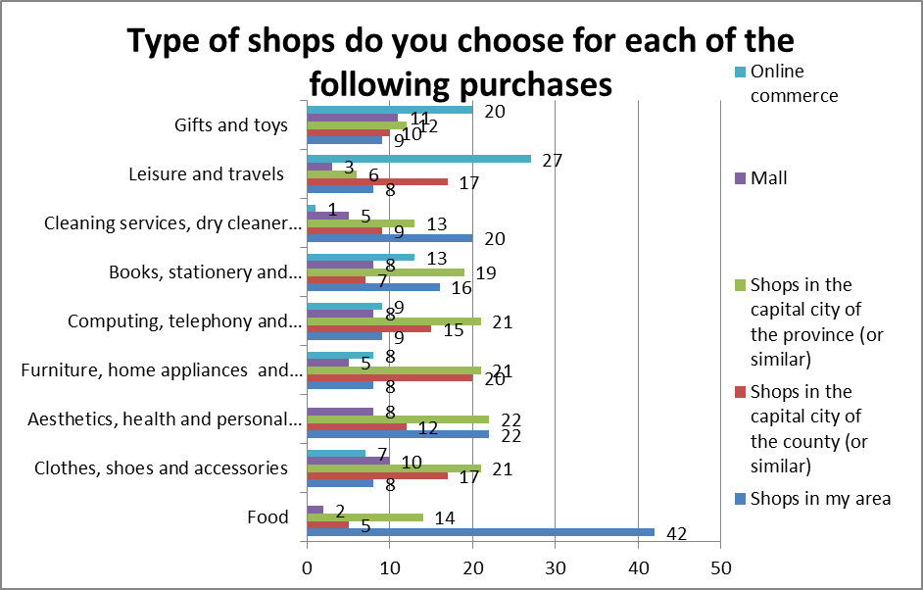
source: own study

When buying outside your home, which aspects do you value most? - 33.8% Closeness, availability and low time commitment

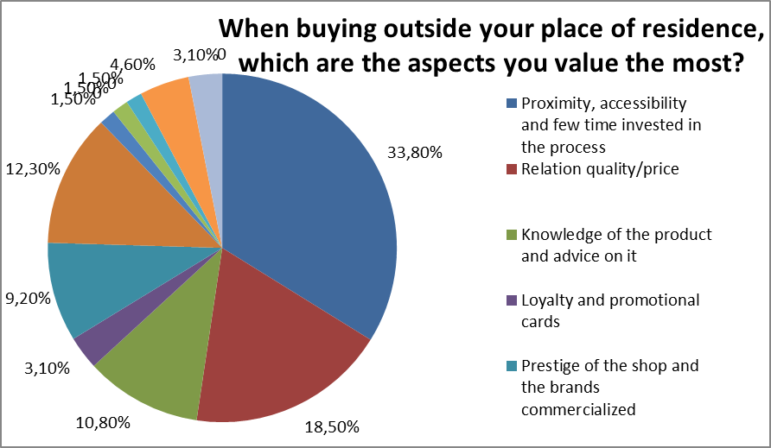

Which of the following aspects will encourage you to shop more often in local stores? - 50% Price improvement and easier payments.
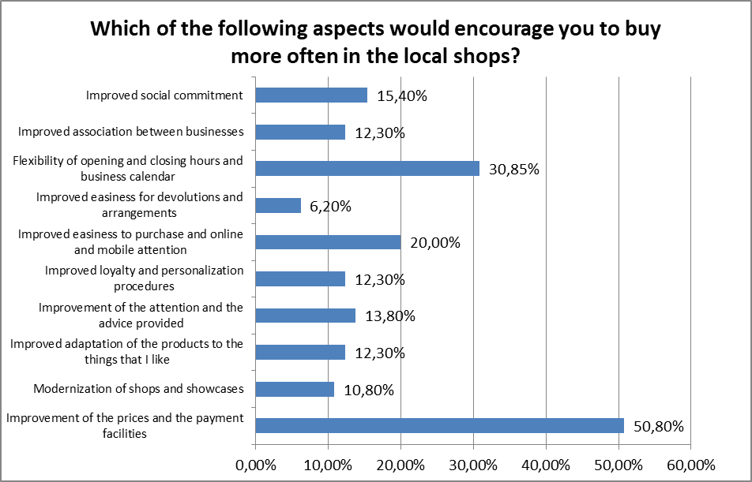

What local stores would you promote in your area? - 78.1% of consumers would promote local grocery stores, and only 1.6% Computing, telephony and electronics, Bookstore, stationery and reprography, Leisure and travel, Gifts and toys.

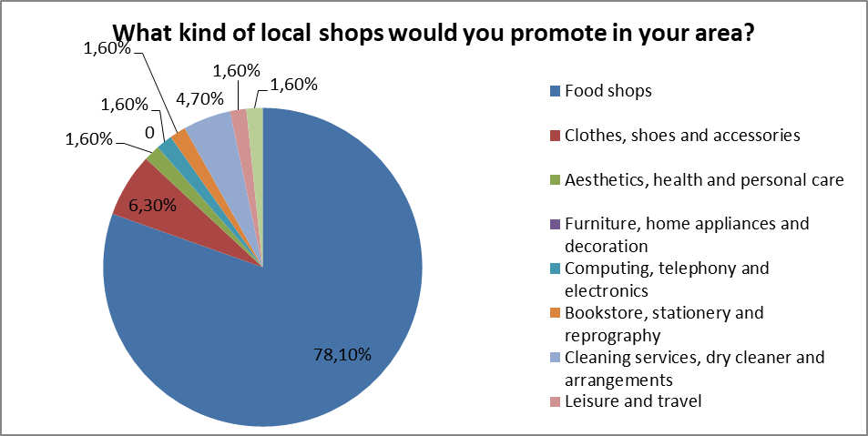

How often do you travel outside your municipality to buy goods outside the concept of daily consumption? - 36.9% of consumers travel every week and only after 1.5% never and once a year.

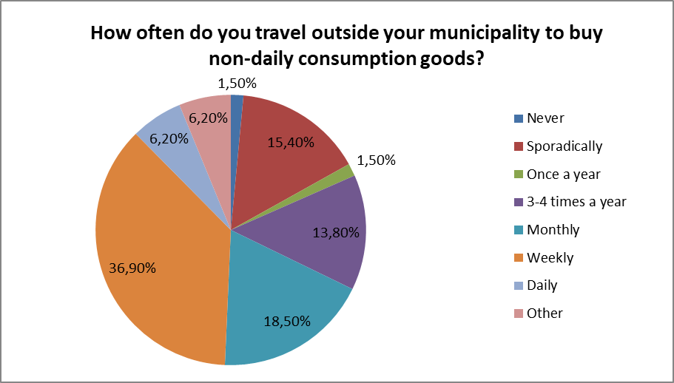

38.5% I usually inform myself and buy in physical shops, only people because only 6.2% usually inform myself in physical shops but I buy online.

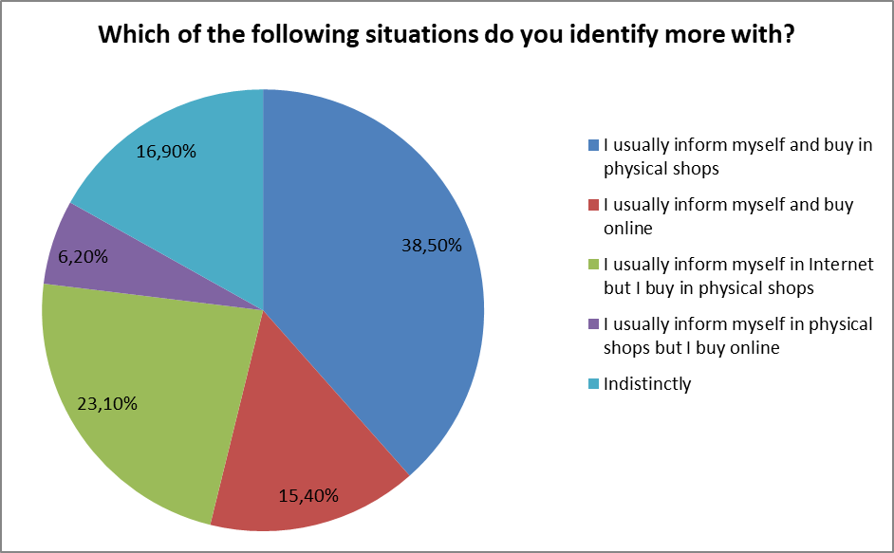
The decisive factor for online shopping are price and promotions (51.6%) and easiness in the process of purchasing (45.3%). The least important factors are: Exclusiveness / personalization of products (2%) and Spontaneity and impulsiveness (7.8%).
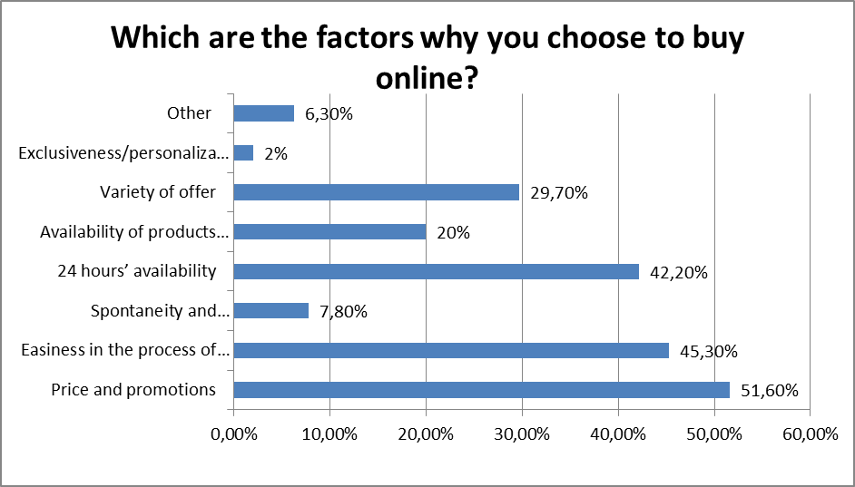

The most visited shopping platforms are the General Market (Amazon, Ebay, Allegro, Olx) - 47.6%, or at least the Specialized marketplace (Privalia, Pixmanía ...) (6.3%).

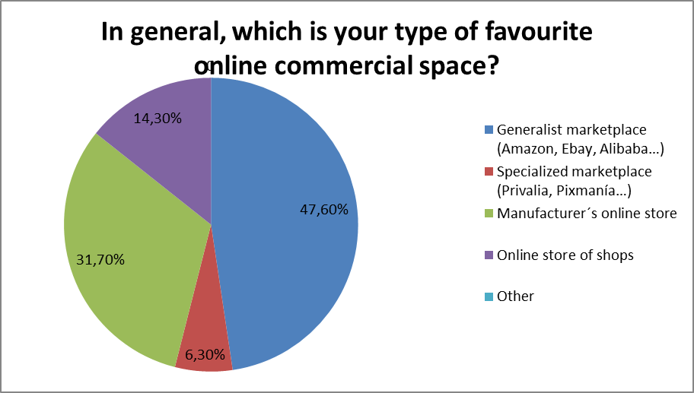

Rural Development Policies (Plans & Programmes) in force in the territory

Documents that have or may have an impact on the competitiveness of retail trade or may support development at the local level include:
- Regional Strategy of Socio-Economic Development of the Warmian-Masurian Voivodeship
- Areas with low accessibility to public services
- Plan for Social Economy Development
- CitaSlow's strategy
- Strategy of the Great Masurian Lakes
- Broadband Internet Access Strategy
- Strategy for the Development of Intelligent Specialties (high-quality food, water economy, wood / furniture.
- Culinary Heritage
- The development of local marketplaces

SWOT Analysis of the Rural Environment studied

STRENGTHS | WEAKNESSES
- Big potential and business needs in rural areas  - Local Action Groups as an experienced territorial partnership in rural areas  - Integration (combining areas of the economy, cooperation of various interest groups).  - Directing interventions where it is most needed. Allowing to solve problems of specific areas, taking into account their specificity. | - Complicated and unclear support rules, especially for small businesses  - Inconsistent approach in terms of conditions and mode of granting aid under various funds / actions  - Ambiguity and multiplicity of interpretation of regulations  - Small interest of entrepreneurs in cooperation and joint actions.
CHANCES | THREATS
- Synergy and integration, targeting interventions where it is most needed. Identifying needs at the lowest possible level.  - Precise selection of interventions to solve problems most effectively.  - Possibility to support a larger number of entities and enterprises. Easier access to RPO funds for smaller and less experienced applicants  - Raising knowledge and skills in acquiring external funds by the inhabitants of rural areas  - Building capacity of non-governmental organizations in rural areas. | - The end of the financial perspective 2014-2020 - no funds for the announcement of further competitions on the changed principles  - Lack of program flexibility  - Due to the lack of guidelines regarding the new financial perspective - the risk of delay in the implementation of planned projects

Conclusions

To summarize our analysis, the following conclusions can be drawn:
- There is a need to provide more than just a standard trading service - delivering emotions,
- We need more holistic approach to business (barefoot walking, production consistent with nature and tradition),
- There is observed trend - people from cities, looking for more sophisticated products, become a potential market for rural areas,
- Future generations will be focused on seeking a return to universal values, contact with nature, peace, serving higher purposes,
- Necessary business support in the field of cooperation and providing comprehensive services in rural areas.

