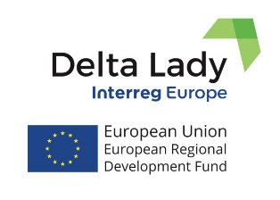
Press Release
September 2019

THE DELTA LADY PARTNERS MEETING IN COMACCHIO.
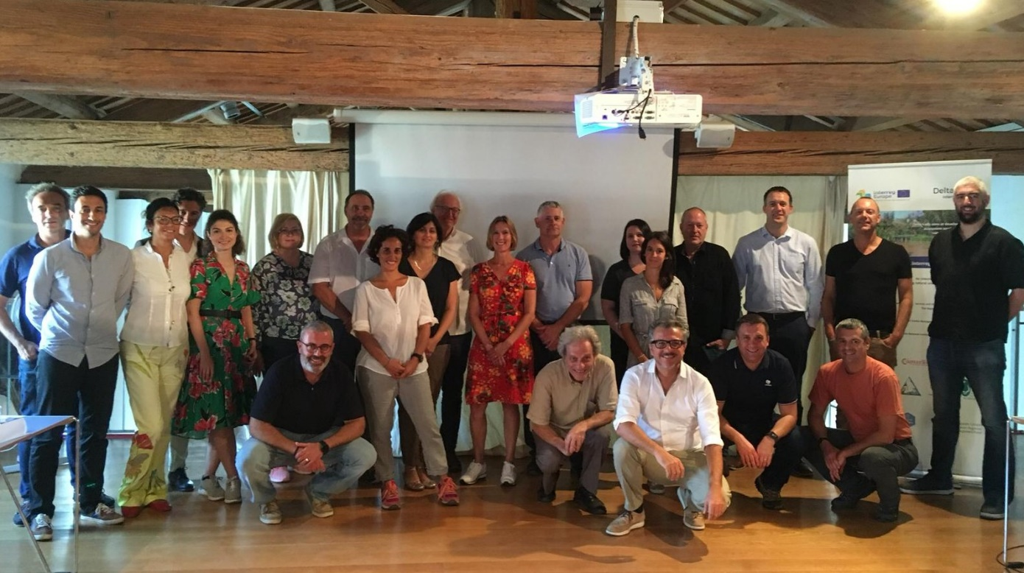
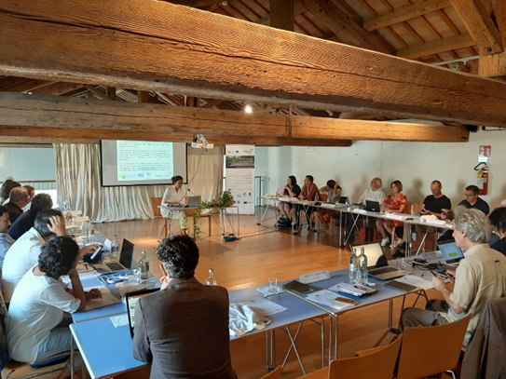
The 3rd Interregional Learning Event and partner meeting of the Delta Lady project was held in Comacchio, Italy on 17-18 September 2019. The aim was to exchange experiences on the use of Payments for Ecosystem Services (PES) schemes in the participating delta regions. Po Delta Park hosted the Interregional Learning event in cooperation with ART-ER. The event was held in Manifattura dei Marinati in Comacchio, which is the Ancient Factory where the manufacturing of the fishing products of the Comacchio Valleys (as centuries ago) takes place. Attendees included 26 participants from which 18 project partners and 8 stakeholders/external experts. Partners discussed examples of the PES schemes in delta environments. Stakeholders were from the Province of Friesland (NL), from the University of Ferrara (IT), from the Assut Foundation of the Valencian Community for the Sustainability of the coastal areas of the Mediterranean (ES), from the Local Authority Waters Programme (LAWPRO) which is a shared service working with Local Authorities and state agencies to develop and implement River Basin Management Plans in Ireland, from the Regional Development Agency - South East Region, Romania, and external experts from Italy: from S. Anna School of Advanced Studies, Pisa, and from ART-ER.
The first day meeting was dedicated to the partners' presentations on the envisioned policy instruments and examples of the PES schemes in delta environments. The meeting was followed by the study tour to the Po Delta: by boat from Stazione Foce to Lagoons of Comacchio Valley, Birdwatching from Stazione Foce and train ride and guided tour to Torre Rossa and Salina (saltworks) of Comacchio.
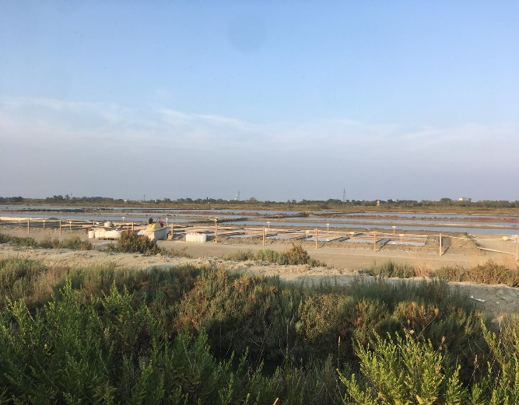
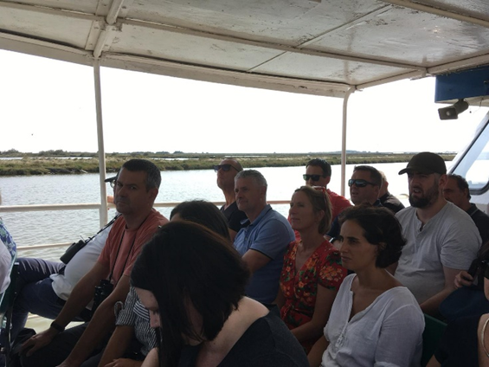
The second day continued with stakeholders’ presentations: about evaluation of environmental costs in Romagna Acque case study: implications for PES design (School of Advanced Studies, Pisa); about Soil4Wine Life project: PES in agricultural sector (ART-ER); about the 3rd Report on Natural Capital in Italy: new vision for planning and opportunities for PES (University of Urbino); about Ecosystem services and Culture and Fish Migration project on the sea dike (Frisian stakeholders); about ecosystem services and tourism (University of Twente); and ecosystem services in river Po Delta: monetary evaluation and good practices towards the implementation of PES schemes (University of Ferrara); about Slow Tourism in Comacchio Saltwork (CADF La Fabbrica dell'Acqua); and presentation on Clam farming in Goro (University of Ferrara).
The two day meeting in Comacchio was successfully concluded with reflections of partners on the event and with identifying further steps and activities for continuation of the project and preparation for the next meeting in Cork.
For more information, please, contact University of Twente (CSTM)
f.h.j.m.coenen@utwente.nl +31 53 489 3216; m.lordkipanidze@utwente.nl +31 58 284 9002.

Delta Lady (Floating Cultures in River Deltas)
Project funded by Interreg Europe programme
https://www.interregeurope.eu/deltalady/
https://www.facebook.com/InterregDeltaLady/

