Action Plan for Creative Centres and Collaborative Makerspaces for Vilnius, Lithuania
(English summary)

Vilnius, 2019

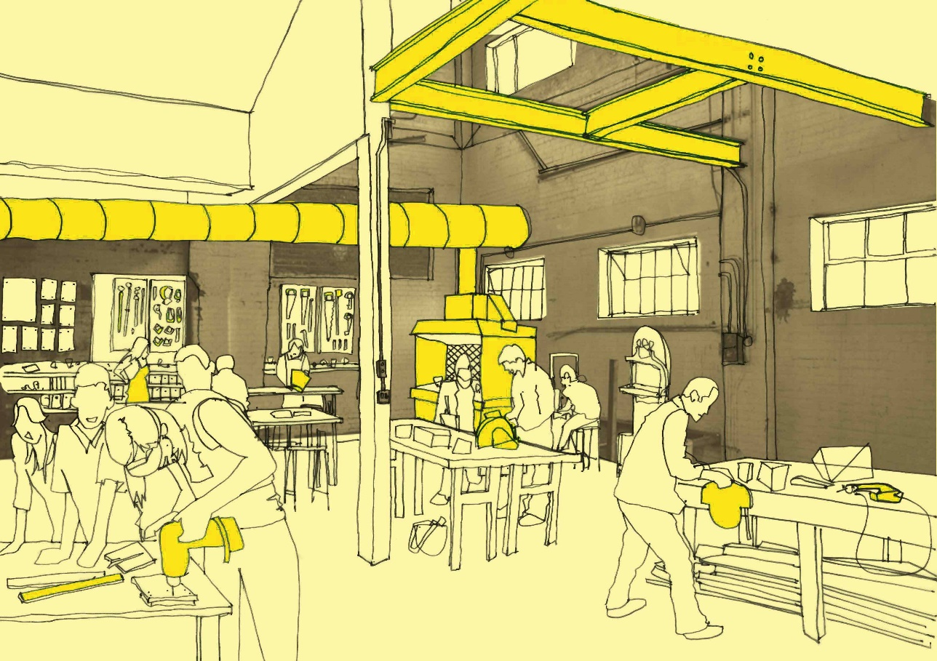

Authors:
Dr. Erika Furman, External Expert
Indrė Norkeliūnė, External Expert
Veronika Jaruševičiūtė, Vilnius City Administration
Rūta Matonienė, Vilnius City Administration
Lina Melianienė, Vilnius City Administration

Urban Manufacturing in Vilnius
Outcomes
Solution
Problem
CCI companies do not exploit the potential to create innovations, engage in R&D activities and commercialize innovative products.

To develop measures to foster environment favorable for the development of creative centres and collaborative makerspaces and innovation commercialization.

1) Set the CCI-related priorities in the strategic documentation of the Administration of Vilnius City Municipality.
2) Establish a long-term program with sustainable funding mechanisms for cultural and creative industry development and innovation promotion.
3) Establish the development and funding for collaborative makerspaces based on successfully operating business models.
How

Effective tools for a long-term development of creative eco-system (e-platform, education and collaboration programs, calls for creating innovative products and services). Establishment of start-up collaborative makerspaces.

SUMMARY

The main goal of the Action Plan of the City of Vilnius is to integrate cultural policy developed by the Administration of Vilnius City Municipality into the general EU innovation and culture policy. We strive to improve the City's policy approaches, methods and to create mechanism supporting Creative Centers and Collaborative Makerspaces in Vilnius.
The Action Plan is based on the analysis of national and Vilnius City’s strategic documentation, EU Structural Funding programs, good practice exchange during the project, expert recommendations during the “Policy Clinics” and study visits organized as part of the Urban Manufacturing project framework.
The Action Plan is designed for various types of creative centers and collaborative makerspaces, such as, Fab Labs, Open Innovation Centers, Living Labs and Cross-Sectoral Incubators existing in Vilnius.
The Action Plan is focused on three project sub-themes: 1) establishment of creative laboratories and centers (incubation period); 2) investment in research and development (R&D); 3) commercialization of innovations. It will serve as the ground for steps and recommendations that aim to create favorable conditions for the development of maker-spaces, innovation infrastructure, new products and services.
The Action Plan consists of three sections: policy, funding and infrastructure. The targets set for the development of the Action Plan are, as follows:
1. Policy. Submit proposals for policy change in the Vilnius City’s strategic documentation upon evaluation of the Vilnius City’s and State policy documents affecting the development and funding of creative centers and collaborative makerspaces.
2. Funding. Recommend policy changes contributing to the development of collaborative makerspaces in the City of Vilnius upon evaluation of the funding programs of the Vilnius City’s and EU Structural Funds. A considerable part of the analysis should include measures adopted by the EU Structural Funds. It is important to identify and make recommendations on the ways how the EUSF can become more effective, more favorable to the creation and development of creative centers and collaborative makerspaces.
3. Infrastructure. Evaluate the situation of creative spaces in the City of Vilnius – successfully operating creative centers and collaborative makerspaces, developing innovations; submit proposals for policy change of political

instruments to ensure positive environment for the development of CCI considering the urban and community demands.
Creative centers and collaborative makerspaces are part of creative industry ecosystem, therefore the assessment of Vilnius City’s creative industries in the national and international – the European Union’s, context, as well as interlinkage with other fields, innovations in particular, is crucial for their development.

POLICY CHANGE
To initiate the involvement of the Administration of Vilnius City Municipality into the general EU innovation and culture policy which correlates with the Lithuanian national policy guidelines.

Aim

Objective
An effective ecosystem for creation of R&D, innovations in CCI.

Action 1. Set a priority to enhance the development of creative centers and collaborative makerspaces, innovation and entrepreneurship.
Action 2. Prepare and establish program for the funding of creative centers and collaborative makerspaces, entrepreneurship and innovations.
Action 3. Prepare and establish financial funding plans for successfully operating creative business models. involvement in creating innovations.

Actions

Increased ESIF investment as a percentage of GDP - 2%
Result indicator

Action 1. POLICY

Set a priority in the strategic documentation of the Administration of Vilnius City Municipality: to enhance the development of cultural and creative industries and sector entrepreneurship, to promote the involvement in creative incubation and innovation commercialization.
Relevance to the project | During the project visits, discussing with the project partners and experts on ecosystems of creative centers and collaborative maker spaces of Vilnius and other project partners, as well as on the actions of the Action Plan being developed, it was identified that in order to provide for the measures in the Action Plan of the project, first of all, a change at urban policy level must be ensured and intended. Inspiration for this action came from ‘’Policy Clinic” discussions with the project partners and experts, in particular considering already established well-functioning economic and innovation environment, various city municipal projects and initiatives that create a sustainable ecosystem for the promotion of creative centres and collaborative maker spaces and innovations development in Lisbon and Birmingham (Invest Lisboa/ www.investlisboa.pt, Startup Lisboa/ www.startuplisboa.com, Study in Lisbon/ www.studyinlisbon.pt/en/).
Learning Process | The key terms behind this Action refer to “Entrepreneurship” and “Innovation”. The Action aims to foster the development of self-sustaining creative eco-systems that accommodate efficient commercialization strategies and paying off financial models. There is a great of potential in Vilnius creative sector for commercialization of innovative products and services not only in local market, but also abroad. However, the level of well-functioning creative eco-systems that constantly invest in innovative ideas by turning them into successfully marketable products is still relatively low in Vilnius.  As part of Urban M knowledge-sharing sessions, site visits and best practice examples of Partner cities, the below cases were identified as a source of inspiration for this Action:  - Cooperation and innovation center „STEAMhouse“ (http://www.bcu.ac.uk/business/steam/steamhouse)  Based in the heart of Digbeth, Birmingham, STEAMhouse supports businesses, start-ups and sole-traders to develop new ideas, skills, products and services. STEAMhouse is a centre for innovation, creative thinking, prototyping and business development. Center has been created in partnership with Eastside Projects and is funded by the European Regional Development Fund and Arts Council England.  This good-practice example is particularly interesting for Vilnius, because it focuses on cross-sectoral collaboration, commercialization through business-scient cooperation, development of innovation and entrepreneurship. Established in 2018 this organization proved to be extremely successful with ambitious plans of expanding premises and working spaces more than twice. “STEAMhouse” experience reveals a potential of establishing analogous open spaces in Vilnius that would be extremely useful for creative SMEs.  Several good practices exercised by ”STEAMhouse“ have a potential to be applied in Vilnius as well:  - Besides standard business development and incubation consulting, interactive trainings (in the form of a game) that satisfy the needs and nature of modern young businesses should be oferred to creative organizations.  - The effectiveness of cooperation and innovation can be increased by incorporating all innovation development stages (rather than focusing on one). This would help small and medium sized enterprises to concentrate on new product instead of business processes (that usually consume a lot of resources).  - Open innovation and idea-sharing proved to be more efficient way to commercialize and drive products to the market than protecting know-how as a commercial secret. Therefore, inter-institutional cooperation and knowledge-sharing should be promoted in similar organizations.  - Innovation Birmingham campus (https://www.innovationbham.com)  Innovation Birmingham Campus is the leading location for Birmingham’s digital and tech community; providing office suites, meeting and conference facilities and co-working opportunities for innovators, entrepreneurs and investors looking to develop or fund innovative digital start-ups with high growth potential. It offers a range of specialist incubation and acceleration programmes to support business growth including access to finance and talent and open innovation. This is a fascinating example of united efforts of different universities to make Birmingham “A City of Innovations”. Numbers evidence the success of Innovation Birmingham Campus: more than 280 start-up companies have already been incubated and over 18 million pounds have been raised to fund startup activities.  Vilnius is eager to adopt good practices of “Innovation Birmingham Campus”. This example shows that large business has an interest in investing in innovations created by SMEs, because increasing decentralization forces large companies to get rid of innovation departments in their premises and outsource innovation incubation elsewhere instead.
Nature of action | Set a priority in the strategic documentation, culture guidelines of the Administration of Vilnius City Municipality: to enhance the development of cultural and creative industries and sector entrepreneurship, and to promote the involvement in creating innovations.  Upon expiry of the Strategic Development Plan of Vilnius City Municipality Administration of 2010–2020, the planning documents of the new period from 2021 – the city’s strategic plan and culture policy guidelines – suggest defining the long-term priorities of cultural and creative industry development and innovation promotion policy, which should correlate with national strategic documents (“Lithuania 2030”, National Progress Program for 2014–2020, Lithuanian Innovation Development Program for 2014–2020, Culture Policy Trends “Culture 2030”, Development Trends of Cultural and Creative Industry Policy for 2015–2020, etc.).  Recommendation is to link the priority of CCI development, entrepreneurship promotion and involvement in creating innovations through strategic goals and programs with both cultural policy and other areas such as science, education, youth employment, promotion of communities, business.  - Include the priority of cultural and creative industry development, entrepreneurship increase and promotion for involvement in creating innovations in the Strategic Documentation of Vilnius City for 2021‒2035.  - Prepare and implement the strategy of cultural creative industry development, promotion of entrepreneurship and innovations.
Stakeholders involved | Administration of Vilnius City Municipality and Vilnius City Council shall prepare and approve the strategic documents for the development of the city.  Potential partners to be engaged in the policy change:  Ministry of Culture of the Republic of Lithuania ‒ national CCI strategy in correlation with the CCI development strategy of Vilnius City.  Ministry of Economy and Innovation of the Republic of Lithuania ‒ Vilnius City involvement in the national innovation ecosystem.  Ministry of Education, Science and Sports of the Republic of Lithuania ‒ science potential assurance and CCI development based on advance scientific knowledge.  The National Association of Creative and Cultural Industries - proposals and recommendations for the establishment of CCI field’s needs.
Timeframe | Initial discussions: September 2019  Preparation: 2020  Implementation: 2021
Indicative costs | No additional budgetary needs are expected.
Change indicators | CCI and innovations development priority in the Strategic Plan of Vilnius City from 2021 (Yes / No).  CCI and innovations development priority in the Culture Guidelines from 2021 of the Administration of Vilnius City Municipality (Yes /No ).

Action 2. FUNDING

Prepare and establish in the strategic documentation of the Administration of Vilnius City Municipality a program for funding and priority of promotion of Vilnius CCI, entrepreneurship and innovations correlating with national, EU structural funds and private financing.
Relevance to the project | The recommendations and guidelines on what measures can be developed and funded to stimulate, combine and empower innovations in creative centres were clarified after reviewing Vilnius creative centres and summarizing various practices of study visits during the project. The key benefit came from the recommendations purified during the discussions of the project partner’s and experts from Birmingham, Bratislava and Kranj at “Policy Clinic Vilnius”. Valuable knowledge and experience about innovation promotion, commercialization, communication and collaboration, educational practices were received from visits to collaborative maker spaces in Lisbon, Zagreb and Birmingham.
Learning Process | The key terms behind this Action refer to “Funding Schemes”, “Financial Programmes” and “Private-Public Investments”. The Action is designed to encourage the development of new maker-spaces and innovative creative organizations in Vilnius by introducing efficient and well-targeted financial mechanisms with easily measurable indicators. Since there are no specific funding programs for creative maker-spaces as part of EU Structural Funds in Lithuania, this Action aims to review existing funding measures that are working successfully in other Partner cities and apply good practice examples in Vilnius.  Below cases were identified as a source of inspiration for this Action  - Zagreb Technological Park (http://www.technopark.hr/eng/)  Zagreb Technological Park is funded and owned by Zagreb Municipality. This is 9000 sq, m. object, dedicated to the incubaion of creative businesses. Park provides all necessary infrastructure and consulting that is necessary for moving innovative idea through all stages towards actual product creation and commercialization. This centre is based on co-working principle: start-ups can not use common premises, conference and modern technical equipment.  This good-practice example is truly inspiring, as it shows the importance of well-functioning eco-system that increases the inter-dependency between education, politics, creators and manufacturers. In order to ecourage cooperation between innovative companies and expoit the potential of new business models, it is crucial to create a financially strong eco-system.  Learning points from this success story:  - Cooperation between public and private sectors is crucial and various forms of investments should be encouraged in Vilnius.  - In case of changing policies and funding priorities, a lot of atention should be given to a synergy and chain reaction of small creative organizations that may lead to a sustianable eco-system.  - Vilnius should focus more on education and STEAM activities while designing certain financial programs for creative maker-spaces.
Nature of action | In the strategic documents and financial plans of the City of Vilnius for 2021 there are suggestions to establish a long-term program for cultural and creative industry development and innovation promotion with sustainable funding mechanisms, which should supplement the existing programs and correlate with national and EU structural fund programs, funding mechanisms:  Programs funded by the Culture Support Fund of the Lithuanian Council for Culture;  Programs “HR Competition Increase”, “Small and Medium-Size Business Promotion” funded by the EU structural funds of the Ministry of Economy and Innovations of the Republic of Lithuania;  Programs “Promotion of Scientific Research Experimental Development and Innovations”, non-formal education programs funded by the EU structural funds and the Ministry of Education, Science and Sports of the Republic of Lithuania, as well as the Ministry of Economy and Innovations of the Republic of Lithuania;  Subprogram “Culture” of “Creative Europe 2014–2020”.  It is recommended for CCI development, entrepreneurship and innovation promotion program with sustainable funding mechanisms to encompass:  CCI ecosystem  - Create an e-platform for mapping, information, communication and advertisement of collaborative makerspaces.  - Provide continued support for:  - networking and cooperation promotion;  - entrepreneurship of innovative products and services development / creation  - innovations, R&D education and promotion;  - commercialization of innovative products and services;  - involvement of school students, youth and communities.  It is recommended that the support should promote not only technological, process, product, business model innovations but also creative, social, small scale (local) innovations.
Stakeholders involved | Administration of Vilnius City Municipality and Vilnius City Council shall prepare and approve the strategic urban development documents, programs and funding.  Potential program funding partners:  Ministry of Culture of the Republic of Lithuania, Lithuanian Council for Culture – correlation with CCI program funding.  Ministry of Economy and Innovations of the Republic of Lithuania, Agency for Science, Innovation and Technology, Lithuanian Innovation Center ‒ correlation with funding of innovation, R&D, entrepreneurship and HR promotion programs.  Ministry of Education, Science and Sports of the Republic of Lithuania ‒ correlation with funding of R&D and non-formal education programs.  The National Association of Creative and Cultural Industries – proposals and recommendations for the establishment of program and funding needs and models.
Timeframe | Initial discussions: May 2020  Preparation: 2020-2021  Implementation: 2022-2025
Indicative costs | The budget will be determined in the Preparation phase in 2020-2021.
Potential funding sources | The initiative of the Administration of Vilnius City Municipality shall be discussed with the institutions concerned, the opportunities of funding via innovative procurement for public sector shall be explored.
Change indicators | E-platform for mapping, information, communication and advertisement of collaborative makerspaces (Yes / No, 1 unit).  Initiatives of Continued support (4-5 units) for:  - networking and cooperation promotion;  - entrepreneurship of innovative products and services development / creation  - innovations, R&D education and promotion;  - commercialization of innovative products and services;  - involvement of school students, youth and communities.

Action 3. INFRASTRUCTURE
Prepare and establish in the strategic documentation and financial plans of the Administration of Vilnius City Municipality the development and funding of successfully operating creative centers models.
Relevance to the project | During the study visits organized as part of the project, creative centres, collaborative makerspaces and their support programmes were reviewed, the examples of which ‒”STEAMhouse“, “Innovation Birmingham“, “Fizz Pop“, “STAX“, “Custard Factory“ (Birmingham), ‘’Fabrica Moderna”, “Fabrica Moderna”, ‘’FabLab Lisboa” (Lisbon), “Zagreb Technological Park”, “Radiona Makerspace”, “Croation maker” (Zagreb) ‒ should serve as a basis for elaboration of activity model for Vilnius City’s creative centres and collaborative makerspaces.
Learning Process | The key terms behind this Action is “Successfully operating collaborative models”. The Action aims to create an infrastructure that encourages the development of new creative maker-spaces in the city. Before any support mechanisms are established, it is crucial to evaluate and understand what operating models can function in Vilnius and bring greatest returns on investment. There is a great potential in the city for the new establishments, as there are plenty of opportunities to re-use abandoned buildings, create new hubs in districts that undergo revitalization.  As part of Urban M knowledge-sharing sessions, site visits and best practice examples of Partner cities, the below cases were identified as a source of inspiration for this Action:  - FabLab (http://fablablisboa.pt/)  This maker-space was created based on international network operating model. It operates not as a private unit, but as a separte division of a City Council of Lisbon. FabLab focuses on prototyping and manufacturing while engaging in experimentation and new idea development. The space is equipped with various modern technological equipment and creative spaces for collaboration. FabLab stands out for its openness to the communities as well as cooperation with other participants of eco-system (for instance, if new experimental ideas appear to have real marketable value, then ideas are further developed in incubators).  FabLab serves as a good-practice example that successfully incorporates municipal efforts and investment in fostering innovation in the city.  - Creative laboratory “FAB Lab Spazio Attivo”  “FAB Lab Spazio Attivo” one out of 8 creative spaces that are funded by Lazio region. This creative maker-space is designed for incubation, acceleration, consulting and support of digital design innovations. Residents of “FAB Lab Spazio Attivo” have already created innovative solutions in the area of apparel, accessories, medical devices. Although creative-maker space has catalyzed several innovations, the return on investment is not the key aim. The main goal is to foster overall culture of innovation in the region.  There are several learning points that could be adapted in Vilnius:  - Vilnius was inspired to hear how actively this maker-space collaborates with high schools: students often resides in the maker-space and develop their innovative ideas. Vilnius should pay more attention to cooperation betwen business and education.  - Successfully operating business models incorporate and manage all stages of innovation development. This speeds up the acceleration and introduction of innovative ideas to the market.  - Maker-spaces should be encouraged to register new innovation. Laboratories that do not prioritize such goals, will not have a stimulus to develop something new (even if they have necessary resources to do so).
Nature of action | Establish the development and funding of collaborative makerspaces based on the models of successfully operating centers in the strategic documentation and financial plans of Administration of Vilnius City Municipality as of 2021.  Determine the models of successfully operating collaborative makerspaces.  Ensure establishment of the new collaborative makerspaces in Vilnius.
Stakeholders involved | Administration of Vilnius City Municipality and Vilnius City Council shall prepare and approve the strategic urban development documents and budgeting.  The National Association of Creative and Cultural Industries, existing collaborative makerspaces shall submit proposals and recommendations.
Timeframe | 2020-2022
Indicative costs | The budget will be determined in the Preparation phase in 2020.
Potential funding sources | Administration of Vilnius City Municipality’s funds, investments into EU Structural Funds.
Change indicators | New collaborative makerspaces in Vilnius (2 units).

