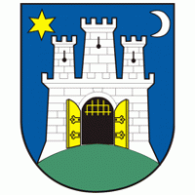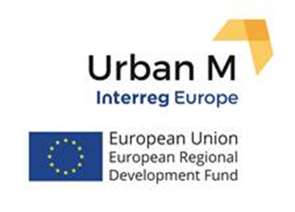

Project „Urban Manufacturing Stimulating Innovation Through Collaborative Maker Spaces“(Urban M)

Action plan
for developing maker spaces in the City of Zagreb

Maker spaces - places where people from different disciplines work together to produce new products and services, while sharing ideas, equipment and knowledge.

Second draft
Zagreb, November 2019

Content

Part I – General information about the project 1
Short description of the Project 1
Maker spaces 1
Part II– Programme context 4
The status of crafts, small and medium businesses 4
Strategic Policies 6
Supporting institutions 9
Part III – Stakeholders 10
Zagreb Innovation Centre - ZICER 10
Institute for Youth Development and Innovativity - IRIM /Croatian Makers 12
Radiona / Zagreb Makerspace – Association for Development of ‘do-it-yourself’ Culture 13
Croatian Association of Technical Culture (CATC) 13
Association Bioteka 14
Technical Museum Nikola Tesla 15
Association FabLab 16
Zagreb Chamber of Trades and Crafts and Zagreb Association of Craftsmen 16
Town of Velika Gorica 17
Other stakeholders 18
Part IV - Urban M as a learning process 19
Part V - Action plan 22
Identified challenges 22
Purpose of the Action Plan 23
Objectives and activities 23
Objective 1 - To gather and connect stakeholders and beneficiaries 23
Pilot action - Makers Community Hub 24
Objective 2 – To analyse the situation and propose policy improvements 25
Objective 3 - To better use ESIF for development of maker spaces 26
Table 1. Action plan: Objectives, activities, expected impact and indicators 29
Monitoring activities 32

Part I – General information about the project
Title of the project: Urban Manufacturing Stimulating Innovation Through Collaborative Maker Spaces – Urban M (further referred to as Project)
Lead applicant: Birmingham City University
Project partners: Birmingham City Council, Lisbon City Council, Fomento San Sebastian (Economic Development Agency), Lazio Region, Municipality of the City Bratislava, Vilnius City Administration, BSC-Business support centre Ltd., Kranj
Contact in Zagreb: Zrinko Rebrina, project manager
E-mail: zrinko.rebrina@zagreb.hr
Project duration: 2017 - 2021
Project budget: 1.831.204,00 €

Short description of the Project
The main objective of the project is to develop an innovative urban infrastructures - "maker spaces", the space where people of different occupations work together to create a new product or service. Some of the international names for these spaces are "Fab Labs", "Living Labs", "Open Innovation Centres" and "Cross Sector Incubators". Their work often has a number of challenges and some of them are: space management, application of appropriate business-financial models in the common space and maximising their impact or performance.
The goal of the Project is to ensure development of such spaces. The tools that are planned through the project are: the improvement of relevant public policies and identification and exchange of good practices among European cities.
Expected outputs and outcomes of the project are:
- Better use of funds from the European Structural and Investment Funds (ESIF) to finance joint innovation (primarily EFRR - European Regional Development Fund),
- Increasing the number of organisations associated with the "maker spaces",
- Better linkage of the existing infrastructure used for innovation development,
- Development of measurable indicators that show the impact on relevant public policies, ensuring sustainability.
One of the goals of the project for the City of Zagreb is linking the relevant stakeholders and establishing collaboration among them. Regarding the public policies, one of the most relevant is Programme for fostering the development of craftsmanship and small and medium-sized Entrepreneurship in the City of Zagreb for the period 2019-2023 (hereinafter referred to as the Programme) and therefore was chosen as a policy that will be influenced through the project. One of the indicators is also an investment in the design of a maker spaces at the ZICER Technology Park in Zagreb Fair.

Maker spaces
Maker spaces are collaborative workspaces in a public or private facilities, schools or libraries, founded for learning, researching, making and sharing ideas. The space is open to entrepreneurs, young people, adults, as well as children if such a concept is envisaged. It is often equipped with various equipment such as 3D printers, laser cutters, CNC machines, soldering machines, sewing machines and other technology/IT equipment. Such spaces do not necessarily have to include all the above mentioned equipment, it can be borrowed from others.
Maker spaces encourage entrepreneurship and can be used as business incubator/start-up businesses. It covers a range of activities that are done in cooperation (co-working), while hackerspace and fab labs have a common link - making. These are activities that have a similar meaning but are in practice different: fab lab (a fabrication laboratory) refers to a workshop for the production of physical objects for personal or limited use and is usually equipped with computer equipment, laser tools and 3D printers. Hackerspace is workshop focused primarily on computers and technology, which attracts computer programmers and web designers. Co-working space means a new way of doing business in a common work environment that provides the opportunity for collaboration and connectivity while also focusing on the work of the participants. Hackerspace is more intended for people who deal with certain hobbies, while co-working space for collaboration is intended for mostly independent professionals.
Maker spaces can be established in public or private facilities. Common private spaces are different from those in public ownership, since in private spaces beneficiaries have to pay the membership fee to access tools and equipment and to use the space. As far as public spaces are concerned, many museums, libraries and schools have introduced a maker space into their programmes, and some cities and regions encourage and establish such spaces for the development of entrepreneurial ideas. Supporting interdisciplinary approach in maker spaces opens up opportunities for new knowledge and directs beneficiaries to develop specific skills. Maker spaces carry a value of openness for collaboration and partnership in creation and making. Maker spaces in schools encourage young people to explore their interests, learn how to use new tools (both physical and virtual) and develop creative projects. Maker space in schools is a space related to formal education, while in open-type libraries, i.e. this is linked to lifelong learning.
Maker spaces for developing products and services have four key features:
1. Practical learning and exploration
In maker spaces, one can learn how to use a particular tool or technology, but in general, they are not the places where the planned learning programmes are implemented. The goal of such spaces is to assist and direct people with ideas to explore and freely create their products or services. A maker starts from the idea, and then follows the process of creating conceived products or services with their own hands, with the help of mentors and others working or using services there.
2. Co-working
Co-working redefines the existing way of working, offers a solution to the problem of isolation that many freelancers encounter and allows them access to space, equipment, meeting and presentation premises, as well as social and business networking. Co-working includes a common workplace where mostly independent professionals, who share values and interest in achieving synergy with people, are working in the same place.
Working in a maker space means working in an environment in which a person not only learns from others but also gets inspired by co-worker's ideas and creations. Creativity is amplified by joint efforts and contribution.

3. Focus on STEM education
STEM - Science, Technology, Engineering and Mathematics is an acronym used in schools and higher education institutions to enhance workforce skills and enable people to work with technologies and develop new ones. STEM is an applied, integrated approach to these subjects. It is about using math and science to solve challenges and problems in the real world. This applied teaching and learning method enables students to nurture curiosity and assist in developing creativity, solving problems, and acquiring critical thinking skills. Maker space focuses on many of these skills and can be a practical tool for transforming theory into practice.
Nowadays, the STEAM acronym - science, technology, engineering, art and math is increasingly used, adding design principles and encouraging creative solutions.
4. Maker culture and open sharing
Maker space includes a culture of sharing knowledge, ideas and design between participants/beneficiaries. This means that a particular person can use previous ideas and models of other participants in their production, thus saving time in creating their own product or service.

Sources:
https://www.makerspaces.com/what-is-a-makerspace/
https://books.google.hr/books?hl=hr&lr=&id=Yg0WBAAAQBAJ&oi=fnd&pg=PR7&dq=makerspaces&ots=S3eyqdQ-23&sig=fBjIqXDjVNnThZ7hu2ZIT_mnvQ0&redir_esc=y#v=onepage&q&f=false

Part II– Programme context
As part of the UrbanM project, the partners are preparing an Action plan for their area, which aims to influence growth and employment investment programmes and those related to employment and education. The programme instrument addressed in Zagreb Action Plan is primarily the Programme for fostering the development of craftsmanship and small and medium-sized Entrepreneurship in the City of Zagreb 2019-2023 (hereinafter referred to as the Programme), to provide a policy background for designing and financing development and linking of maker spaces in the city area.
A starting point for drafting an Action Plan was to have a look at the existing situation in the City of Zagreb relevant to the development of maker spaces. Consequentially the results of the existing analysis were used, primarily those relating to craftsmanship and small and medium-sized entrepreneurs, since this policy is targeted and affects directly this target group.
In addition, meetings and workshop with relevant stakeholders have been organized to hear first-hand practitioners' and support institutions' problems and challenges they face in their work.

The status of crafts, small and medium businesses
Number of business entities and number of employees by activities in the City of Zagreb

Based on the data of the City of Zagreb's Office for Economy, Energetics and Environmental Protection, it is evident that there is an increase in number of business entities in Zagreb in the last ten years. The recorded surge in entities was mainly in professional, scientific and technical activities, food provision and food preparation, administrative and auxiliary activities, education, health care activities and other service activities.
On the other hand, there has been a decrease in the number of employees, especially in the sectors of the real economy, which is considered a particularly negative trend.
Number of craftsmen and their employees in the City of Zagreb

The number of craftsmen and the number of persons employed by craftsmen in the period from 2009 to 2017 has declined, with counting only small exception in 2016. This was assessed as a negative trend in the economy. Data on the average number of employees in crafts has shown that, disappointingly, this was not an area of employment.
There is also a noticeable deflection in the structure and type of activity within craftsmanship, which are moving away from traditional activities in the real sector. According to current data from the Craft Register, the increase of new activities are in the area of: information and communication; professional, scientific and technical activities and administrative and auxiliary service activities.

Entrepreneurs in the City of Zagreb
The number of entrepreneurs in the City Zagreb in the period 2013 - 2017 has increased by 20.4%. It has been noted that dominant entrepreneurs, with a share of 90% are micro entrepreneurs followed by small entrepreneurs with a share of 9.0%. The smallest share is comprised of large entrepreneurs.
The statistics also show that, the number of entrepreneurs in the City of Zagreb that counted for net profit during the analytical period 2013 - 2017 has increased. By contrast, the number of investors in the city of Zagreb is significantly reduced by almost 40% in that period. Investments in fixed assets, which have been significantly reduced, are also unfavourable.
The number of employees in the analytical period in Zagreb has been kept at approximately the same level. Thereby the number of employees in micro-enterprises marked a significant increase which points to the conclusion that part of former employees from large entrepreneurs have initiated business activity on their own.
Business Competitiveness and Innovation of Small and Medium-sized Entrepreneurs
Small and medium-sized entrepreneurs, as previously stated, account for 99% of the total number of business entities and for almost 70% of total employment, which is above the European Union average. However, for those business entities there is a permanent lack of funding, which means that a large share of SMEs cannot obtain funding from banks, capital markets or other sources of funding. SMEs in different stages have different needs and this need definitely includes professional support from entrepreneurial support institutions (ESIs). Also, it has been shown that ESIs often do not have sufficient capacity to provide high quality services and lack modern approaches and methodology to be able to effectively address the needs and problems. An additional problem is the status of entrepreneurship in the Croatian society and the general lack of people’s entrepreneurial skills. Percentage of employees aged 18 to 24 involved in education and training is only 5.9% (2011), while the EU average is over 35%. Only 2.3% of the total number of employees participates in ongoing training and learning processes, while the average at EU level is almost 9%. The need to improve entrepreneurial skills and the status of entrepreneurship needs to be solved through support to small and medium-sized enterprises by creating advanced business infrastructure and related services offered to companies (i.e. through incubators, industrial and technology parks).
In Croatia, the Information and Communication Technology (ICT) sector has a share of some 4.0% of total GDP and employs slightly more than 2.0% of the active population.
Education, skills and lifelong learning
Structural reforms in education and training should focus on modernizing curricula basing them on learning outcomes and on developing key and transversal competences that are a prerequisite for lifelong learning. This is also a strategic goal of the Education and Training Programme for 2020. One of the national strategic documents that recognise this need is a National curriculum framework (NOK), which among other things, defines entrepreneurship as an important area. The level of ICT use and the level of ICT equipment in Croatian schools vary considerably, on average there is not enough ICT equipment and if it is present it is outdated. Furthermore, and perhaps more significant is that the frequency of its use and qualifications of ICT-related professors is below the EU average (Tesla in school, 2008; 2011; School Survey: ICT in Education - Study for the European Commission, 2013). For this reason, it is crucial to carefully coordinate investment in ICT equipment with investments in the professional development of professors and e-Content of the Operational Programme Efficient Human Resources, thus ensuring the optimum effects in higher degree of digital maturity of Croatian schools and education system on the whole.
Based on the indicators of the EU report Innovation Union Scoreboard, the Republic of Croatia is ranked as a moderate innovator compared to other EU member states, definitely lagging behind compared to countries such as Slovenia, Slovakia and Estonia. Data show that the share of innovative enterprises in Croatia is relatively low compared to other countries in the region. Some of the reasons for this are the following:
- Investments in research and development are low, mostly financed from public funds,
- Considering the structure of the economy made up of over 90% of micro-companies with a small number of employees there is a limited innovation potential,
- Lack of adequate linkage between research institutions and the business sector,
- Relatively weak patent activity compared to other EU Member States, taking into account the number of international patent applications,
- Low level of business sector investment in research and development due to a decreasing number of research and development business entities, lack of early-stage financing,
- Financing and innovation costs, lack of skilled labour and limited access to technology and market information.

"Innovation is not just about creating a company or a high-tech product, nor is it just about research that leads to the creation of new products. Innovation is, in the broader sense, a new approach to work and the way it is done, just as it relates to business and production processes or end products. In addition, new knowledge and ideas do not lead by itself to create successful innovation. Successful interaction between companies, academic sector and public administration becomes critical to transforming new knowledge and ideas into commercially viable products, economic growth and social well-being. The interactive collaboration among above mentioned stakeholders is included and explained by terms 'triple-helix' and 'innovation system' (Leydesdorff, 1998). Ultimately, innovation is not limited only to those subjects. Literature on innovation systems directly emphasizes the interactive and social character of innovation, and it also covers other areas such as culture and the non-governmental sector. "
Croatian Quotient of Innovation 2013
Source: inovativnost.hr
Small and medium-sized enterprises in Croatia have better results in terms of innovation which is not related to research and development. With regard to the introduction of new products or production processes, Croatian SMEs are not far from the EU average. Despite the economic benefits that business sector can have from research, development and innovation, Croatian companies are still not sufficiently involved in this field.
The investments in research and development in Croatia is mostly limited to several development-research intensive multinational companies, while the rest of the sector shows low intensity accomplishments.

Strategic Policies
Relevant policies and regulations in Croatia
Relevant thematic objectives and investment priorities of the Operational Programme Competitiveness and Cohesion 2014 - 2020 are as follows:
- Strengthening Research, Technology Development and Innovation
1a - Improving Infrastructure and Capacity for Research and Innovation
1b - Promoting business investment in innovations and research and the development of links and synergies between enterprises, research and development centres and higher education, in particular in regards to product and service development, technological connectivity, social innovations, eco-innovations, enhancing public services, incentive requirements, networking, clusters and open innovation through smart specialization, technology strengthening and applied research, pilot lines, pre-production validation, advanced manufacturing capabilities and initial production, especially in key technologies that encourage development and innovation and spread of technologies for general use
- Improving the competitiveness of small and medium-sized enterprises
3a - Fostering entrepreneurship, in particular by facilitating the economic exploitation of new ideas and encouraging the creation of new businesses, including through business incubators
10. Investments in education, training and vocational training and lifelong learning
10a - Investing in education, skills and lifelong learning through development of education and training infrastructure.
The Strategy for Education, Science and Technology for the period 2014-2020 specifically emphasizes the need for curriculum modernization based on learning outcomes and development of key and transversal competences that are a precondition for participation in lifelong learning, in line with European Commission's recommendations on introducing key competences in development and implementation of curriculum.
Smart Specialization Strategy of Croatia from 2016 to 2020 includes objectives and priority activities related to research, development and commercialization of innovations. The document is a key prerequisite for the use of funds from the European Structural and Investment Funds under the thematic Objective 1: Strengthening Research, Technology Development and Innovation of the Operational Programme Competitiveness and Cohesion 2014-2020.
Some of the strategic goals are: Strengthening capacities for research, development and innovation in order to achieve excellent research and meet the needs of the economy; Overcoming the gap between the research and business sector; Increasing private research and development; Establishing a partnership relationship with regard to social challenges; creating smart skills.
The Strategy for innovation encouragement of Croatia 2014-2020 focuses on long term development and systematic encouragement of innovation as a fundamental value in the successful economy and the society on the whole. It strives to advance the innovation system and the legislative and fiscal framework, establishing the method of communication and models of cooperation between the public, scientific, research sectors and the business sector in order to develop new products, services, business processes and technologies. The improvements include method of applying scientific and research work in the economy and whole society.
Strategy for Entrepreneurship Development in the Republic of Croatia 2013-2020 aims to strengthen entrepreneurial potential and promote the culture of entrepreneurship in order to be competitive and evenly developed, based inter alia on a high level of innovation and innovative manufacturing process. It also promotes favourable business environment and facilitated access to financial and other instruments.
Strategy for Promoting Social Entrepreneurship Development in the Republic of Croatia 2015-2020 aims to promote and develop social entrepreneurship through the establishment and improvement of the legislative and institutional framework for the development of social entrepreneurship; the establishment of a financial framework for the effective performance of social entrepreneurs and the promotion of the importance and role of social entrepreneurship through all forms of education. Promotion of the social economy and social entrepreneurship are the activities that are foreseen for funding through the ESF and EFRR, which have become an integral part of the Operational Programme Efficient Human Resources 2014-2020.
Women's Entrepreneurship Development Strategy 2014-2020 aims at achieving policy coherence and networking, improving systematic support for women entrepreneurship through the overall institutional infrastructure and promoting women's entrepreneurship. An Action Plan was developed in order for Strategy to be implemented.
The objective of the Cluster Development Strategy in the Republic of Croatia 2011-2020 is to strengthen clusters and cluster associations, but also to encourage innovation and transfer of new technologies.
Small Business Development Promotion Act (Official Gazette 29/02, 67/07, 53/12, 56/13, 121/16) lays down the bases for the implementation of incentive measures of economic policy aimed at the development, restructuring and market adjustment of SMEs and the establishment of Croatian Agency for SMEs, Innovation and Investments (HAMAG-BICRO).
Promotion of Entrepreneurial Infrastructure Act (Official Gazette 93/13, 114/13, 41/14, 57/18) regulates, inter alia, issues related to the establishment of entrepreneurial infrastructure and entrepreneurial support institutions (ESIs) and support systems, i.e. the prerequisites and criteria for granting assistance to improve the business activities of entrepreneurial support institutions.
Strategic documents of City of Zagreb
One of the goals of the City of Zagreb Development Strategy - ZagrebPlan till 2020 is a Competitive Economy, to be achieved through the implementation of the following measures: Development of a stimulating entrepreneurial environment, knowledge-based economy development, innovations and the quality supply of goods and services.
The Programme for fostering the development of craftsmanship and small and medium-sized Entrepreneurship in the City of Zagreb from 2013 to 2017 (extended in 2018) has set strategic objectives and main directions of activity for crafts, small and medium entrepreneurship and a framework for more comprehensive incentive mechanisms, as well as a creating better entrepreneurial climate that is conducive to overall economic and social development. In the process of developing the programme, all relevant stakeholders that have an important role to play in the implementation of the programme itself, were consulted, primarily city administrative bodies, institutions and associations of craftsmen and entrepreneurs and the Zagreb Innovation Centre Ltd. (ZICER). This Programme was chosen as a policy that would be influenced by Urban M project. The project team established a good cooperation with City Office for Economy, Energetics and Environment Protection, so the intervention in a new Programme for fostering development of crafts and SMEs for the period 2019-2023 was agreed and co-working and maker spaces were mentioned in one of the measures. The City Assembly adopted the Programme during the session held on 21 March 2019.
During the implementation of the Programme, the focus was put on valorisation of new products and production activities using new technologies. There was also an increase in amounts of individual grants for such activities. City of Zagreb recognized the importance of a growing start-up community and wanted to help start-up entrepreneurs to turn their business ideas into successful businesses. Therefore, significant part of the support was aimed at start-up companies.
Activities were undertaken to improve entrepreneurial support infrastructure and increase the capacity of the entrepreneurial centre, the techno-park and incubator for use of high technology, and possibility to implement a pre-accelerating programme for start-ups.
Two priority areas of the Human Resources Development Strategy of the City of Zagreb by 2020 that are relatable to "maker spaces" are: Education and Labour Market, with the aim of harmonizing educational programmes and activities for lifelong learning in line with labour market needs, in cooperation with business sector and civil society organizations; Entrepreneurship and self-employment, with the aim of providing conditions for creating new and preserving existing jobs by developing human resources for the development, growth and sustainability of business entities.
The proposal of the ITI contribution to the implementation of the Development strategy of urban agglomeration Zagreb envisaged development (construction and equipping) of entrepreneurial infrastructure and services. Measure 2.1.1. The development (construction and equipping) of entrepreneurial infrastructure and services will partly affect the fulfilment of the goal 2. Develop a competitive and sustainable economy and priority 2.1. Competitive Entrepreneurship and Craftsmanship.
The main objective of this measure is to modernize and increase the number of entrepreneurial support institutions - ESI (science and technology park, entrepreneurial incubators, incubators for new technologies, entrepreneurial accelerators, development agencies, etc.).
It is necessary to effectively absorb and use sources allocated within EU funds and invest them in modernization of facilities and increase number of business and technology centres for acceleration and incubation of small and medium-sized enterprises. ITI mechanism is seen as a potential solution.

Supporting institutions
The Croatian Agency for Small Business, Innovation and Investment was established by the Government of the Republic of Croatia with the aim to assist in the development and fostering of small and medium-sized enterprises (encouraging the establishment and development of small business entities, promoting and attracting investment in entrepreneurship, encouraging investment in small business, developing small business entities by lending under more favourable conditions, granting guarantees for loans given to small business entities by banks and other legal entities - creditors, etc.).
Croatian Bank for Reconstruction and Development (HBOR) gives financial assistance for growth and development of small and medium-sized enterprises, offering better credit terms than any commercial banks, including more favourable repayment terms and interest rates. Some services are negatively assessed by entrepreneurs (e.g. credit processing fees, unfavourable loan secured instruments). This input gives the indication that there is a need to develop a number of HBOR's direct funding programmes, thus circumventing possible obstacles by commercial banks.
Zagreb Innovation Centre Ltd. (ZICER) is an entrepreneurial support institution of the City of Zagreb which supports development and improvement of the entrepreneurial environment and the society as a whole. Through its activities, the Zagreb Innovation Centre contributes to creating a stimulating entrepreneurial environment, strengthening entrepreneurial competences, promoting entrepreneurship and supporting entrepreneurs in transferring business ideas to the product/service by facilitating access to funding sources.

Part III – Stakeholders
Current state in development of maker spaces
Six years ago in Croatia there were no co-working space, but in the last two years, the number of premises has doubled, going from 11 to 22. It is estimated that 9,000m² of space is in use, providing around 900 desks. The reality is that co-working premises are mostly located in cities, founders are local self-government units, entrepreneurs or firms and civil society organizations. In Zagreb, the most prominent and widely recognised co-working sites are HUB 385, Bizkoshnica and Impact hub.
As maker spaces that exist and are functional in Zagreb are: Zagreb Innovation Centre Ltd. (ZICER) with Technology Park, Start-up Academy, Entrepreneurial Centre "Blue Office"; Radiona/Zagreb Makers; Croatian makers- Institute for Youth Development and Innovativity (IRIM). All of them are actively involved in this project and in the process of drafting the Action Plan.
During the implementation of Urban M, the effort to recognise the stakeholders relevant and interested for maker space concept were identified and stakeholder meetings were held in order to prepare the Action plan and prepare the environment for its implementation. The project has tried to encompass different organisations that are supporting or plan to support in the near future activities related to maker spaces: those who provide assistance to entrepreneurs, craftsmen, freelancers, schools, students and professors, artists, libraries, but also general public in Zagreb, but also in near-by towns. Following organisations were identified, besides City of Zagreb and its different offices:

Zagreb Innovation Centre - ZICER
ZICER is focused on the development of an innovative entrepreneurial infrastructure that is a prerequisite for the development of high-tech companies, considered as the foundation of future economic development. Since it was opened in 2015, the Entrepreneurial Centre - Blue Office has become a starting point for all future entrepreneurs as a place for meeting and connecting of all supporting institutions and organizations that direct their activities to the development of entrepreneurship.
There is a continuous growth of infrastructure; Technology Park which is part of ZICER was expanded in 2017 at the Zagreb Fair. That further strengthened Zagreb's infrastructure for the development of a knowledge-based society and for the development, transfer and commercialization of technology. Further expansion is expected, within which maker space will be furnished and equipped.
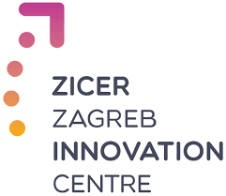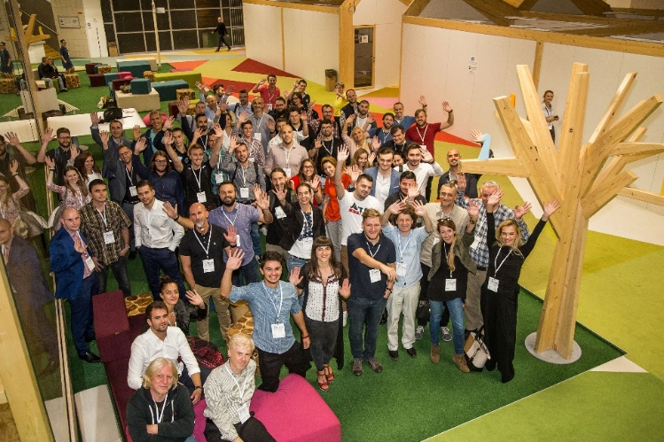

Activities
Zagreb Innovation Centre provides entrepreneurs with support for a faster and easier path from an idea to the market:
- Co-working - hiring a workplace in a shared office
- Laboratories - developing prototypes using 3D printers and scanners, equipment for the development of electronic assemblies, CNC machines and other modern equipment
- Office space - a modular and open space office for incubation of entrepreneurs
- Conference halls - rent of equipped conference hall for organizing events and conferences.
As an entrepreneurial incubator it helps small entrepreneurs realize their entrepreneurial initiatives in the initial stage of growth and development. In the realization of its programme, it provides the necessary professional assistance, using free production and office capacities and available sources of financing.
According to the needs of entrepreneurs within ZICER, six Technological Centres with specialized equipment designed for testing and developing of new products are equipped: Centre for development and testing of electronic products equipped with hardware systems and other devices necessary for the development of electronic solutions; 3D modelling and printing centre, equipped with 3D scanner, 3D printer; Computer Programming and Development Centre for mobile technologies, equipped with development computers, specialized software and state-of the art mobile and other devices designed for development and testing; Centre for Development and Testing of Specialized Environmental Technologies (Biological Processing of Solid, Liquid and sludge organic waste) and The Internet of Things Sensors Centre.
Business indicators of companies that were incubated and alumni companies, stemmed from the Technology Park/ZICER, show positive trend and that it is certainly important to continue expanding maker spaces and giving opportunity for the development of innovative entrepreneurship in the City of Zagreb.
Indicators for business incubated at The Technology Park Zagreb/ZICER
Year | 2012 | 2013 | 2014 | 2015 | 2016 | 2017 | 2018
Companies (number) | 21 | 19 | 18 | 21 | 25 | 70 | 106
Employed (total) | 71 | 71 | 83 | 87 | 116 | 163 | 278
Revenues ( mil. KN) | 13,5 | 17,7 | 20,8 | 31 | 32 | 38,3 | 59,1
Indicators for alumni business at The Technology Park Zagreb/ZICER
Year | 2010 | 2011 | 2012 | 2013 | 2014 | 2015 | 2016 | 2017 | 2018.
No. of businesses | 35 | 38 | 44 | 48 | 49 | 53 | 56 | 58 | 73
Employed (total) | 149 | 180 | 186 | 206 | 220 | 228 | 251 | 317 | n/a
Revenues ( mil. KN) | 93,9 | 91,7 | 106,4 | 113,9 | 126,8 | 135,8 | 139,4 | 172,1 | n/a
Export ( mil. KN) | 17,6 | 22,5 | 37,7 | 31,0 | 39,7 | 46,6 | 46,7 | n/a | n/a
Note: Data from annual financial statements filed with the Financial Agency (FINA) for statistical purposes.

https://www.zicer.hr/eng
Beneficiaries
Entrepreneurs with new innovative ideas, start-ups, business community.

Institute for Youth Development and Innovativity - IRIM /Croatian Makers
The educational system in Croatia currently cannot deliver well neither in STEM fields nor in developing key competences such as collaboration, communication and learning skills, creativity, curiosity, persistence and leaderships. IRIM has developed and implements the largest extracurricular STEM program in EU – the Croatian Makers movement, which now includes over 150,000 children in Croatia. IRIM donates a large amount of equipment through organized activities, teacher education (more than 3,000 teachers educated in Croatia only), content development, etc. IRIM strong capacity for partnership and a wide national/public support adds significantly to its success.

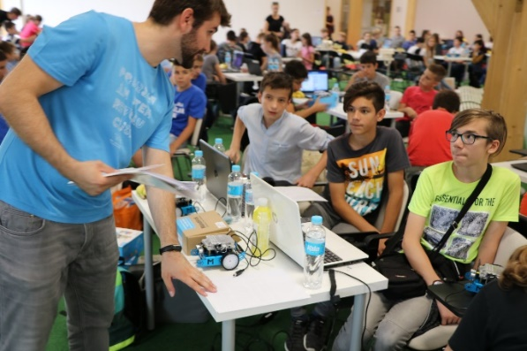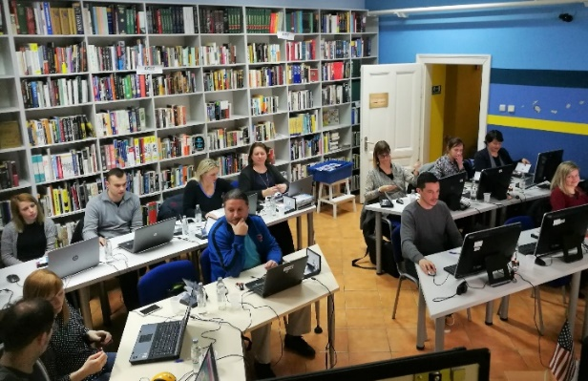

Activities
IRIM has developed a family of platforms, ranging from most democratic to more complex projects like robotics league, advanced coding competition and other advanced projects. Some of the projects:
- STEM revolution and ProMIkro - introduced coding to Croatian educational system and communities using a physical-computing controller micro:bit; some 70,000 coding devices were brought to more than 1,000 institutions in Croatia, elementary and secondary school, universities, libraries, orphanages, together with developing curriculum and teaching the teachers. Teaching the teachers was the key element of the projects.
- Croatian Makers Robotics League is the largest competition of such kind in EU with more than 12,000 children included per school year in more than 600 schools and non-profits, whereas IRIM has donated more 3,000 robots.
- STEM Revolution continues - Libraries and Digital Libraries for Local Development aim to empower public libraries to become centres for developing digital competencies in local communities
- Advanced IoT in Croatian schools - using advanced Arduino technology, 100 educational institutions – schools, NGOs, orphanages – simultaneously measured and publicly displayed seven ecological variables, including micro-particles
- Junior Engineering Academy is a vocational education project with a goal to transform 15 secondary schools into STEM centres of excellence, and integrate them into local business environment.
https://croatianmakers.hr/en/home/

Beneficiaries
Teachers and employees of primary and secondary schools, universities, mentors in associations, librarians, elementary and secondary school students, library users.

Radiona / Zagreb Makerspace – Association for Development of ‘do-it-yourself’ Culture
The founders of Radiona encountered problems like lack of: shared spaces and communities for lifelong learning, research and development; access to tools and communities willing to share knowledge; synergies between different professions; social inclusion in practice in the area of education and technology, new skills for digital market and better employability; mainstreaming of maker culture and innovative practices.
Therefore, Radiona / Zagreb Makerspace has been founded in order to enhance the visibility of makers’ open source culture and self-sustainable production, as well as with an aim of connecting all possible fields of art, science and technology, more precisely STEAM fields (Science/Technology/Engineering/ Art/Mathematics). The objective is to create new realities of networked and collaborative intermedia and new media practices in line with DIY (do-it-yourself) and DIWO (do-it-with-others) cultures.

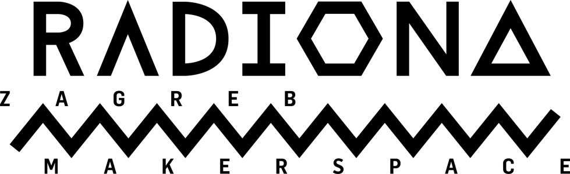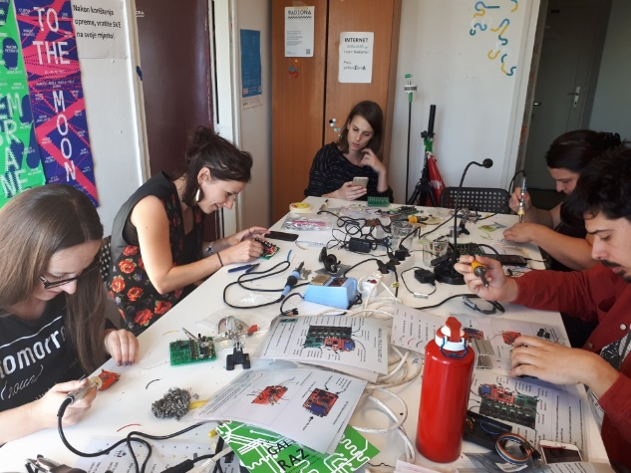

Activities
Radiona focuses its activities on education, research processes, artistic projects, curatorial practices, residencies, creative industries, social innovation, international and domestic inter-sector collaborations, renewable systems and social awareness related issues. The lab uses non-formal education through workshops, presentations, conferences and lectures, with the educational component as the main activity of Radiona’s programme.
Radiona is also very active on international open source hardware scene producing its own kits of entry level and advanced tech hardware.
www.radiona.org
Beneficiaries
Artists, hackers, makers, DIY people, technicians, enthusiasts, engineers and scientists in shared playgrounds, local community, students, pupils, participants of the programmes.

Croatian Association of Technical Culture (CATC)
The Croatian Association of Technical Culture, as the highest national institution in the field of technical culture in Croatia, together with Zagreb Association of Technical Culture, has continuously worked for many years with children and youth to enhance their technical skills and technical culture in general. The regular school system and specific educational programmes cannot, in a short amount of time, offer to a large number of participants' knowledge and skills necessary for the use of technical, economic and other potentials, and enable a large number of young people to recognise their inclinations and abilities, and the choice of educational programmes for technical and research-oriented vocations.
Activities
Activities are related to non-formal, non-institutional education in technical culture: workshops and lectures in robotics, modelling, computer science, creative-technical workshops and other creative activities, but also promotional activities related to technical culture (exhibitions, demonstration workshops and the like). Part of the activity is carried out in cooperation with the educational institutions of the City of Zagreb.
Scientists, engineers and technicians are contributing children to gain knowledge and skills and increase the level of technical culture. They also stimulate techniques in manufacturing and innovation among children, students and general public and the implementation of their ideas and creativity.
www.hztk.hr; https://zztk.hr/
Beneficiaries
Children and young people; general public.
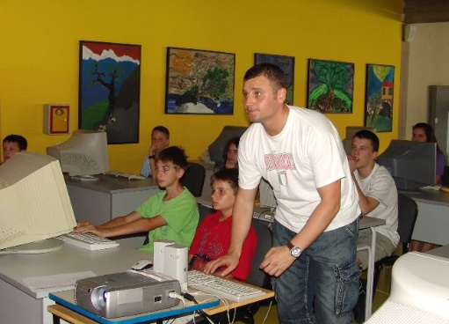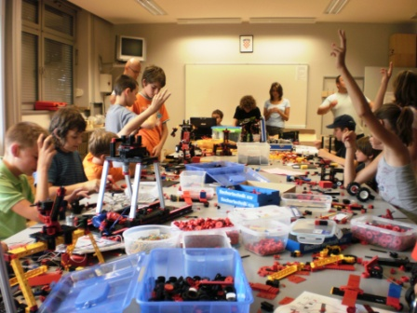

Association Bioteka
Bioteka has developed various programmes, including Bioteka Education Programme, with the aim to:
- Develop up-to-date, research, critically and analytically oriented and widely applicable educational programmes for children and young people that raise level of scientific literacy
- Popularize STEM approach and methodology in the non-formal education of children and young people
- Provide complement to formal curricula that are often unable to keep up with the latest scientific advances or lack sufficient time, expertise and other resources to deliver STEM education
- Develop a sustainable and modern education programmes for educators in the field of STEM and environmental and nature protection.
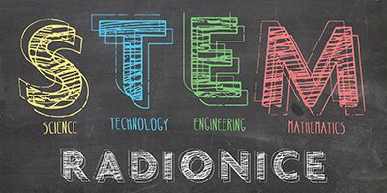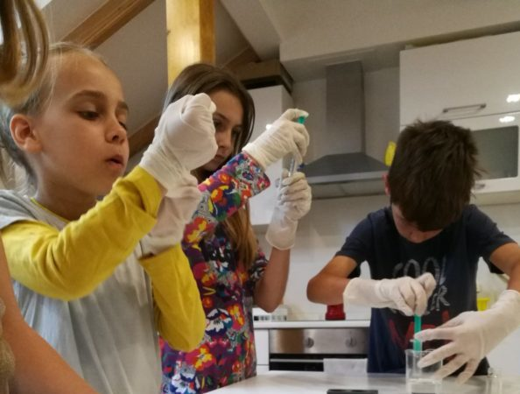

Activities
The Education programme is a year-round activity conducted through STEM workshops, camps, scientific birthdays and Bioteka on the Move. STEM education involves problem solving using knowledge in the fields of natural sciences, informatics, engineering and mathematics, encouraging learning that can be used in everyday life. The programme of workshops for popularization of science and STEM was created by experts, approved by the Ministry of Science and Education.
http://udruga.bioteka.hr/
Beneficiaries
STEM workshops are intended for all elementary school students, regularly held since 2012, and run throughout the school year.

Technical Museum Nikola Tesla
The Nikola Tesla Technical Museum in Zagreb was founded in the mid-20th century as a general museum of science and technology unlike specialized technical museums that deal with only a single field of technology. The main activity of the Nikola Tesla Technical Museum is to collect, protect, preserve and present tangible and intangible technical heritage to the public. Some of the departments of the Museum are: Energy Transformation, Transportation, Nikola Tesla Demonstration Cabinet, Department and Info Centre for Renewable Energy and Energy Efficiency.

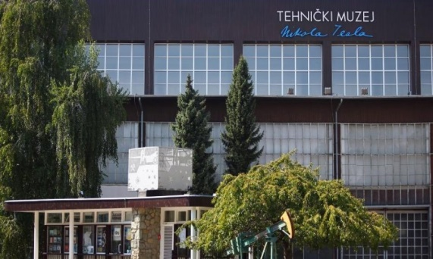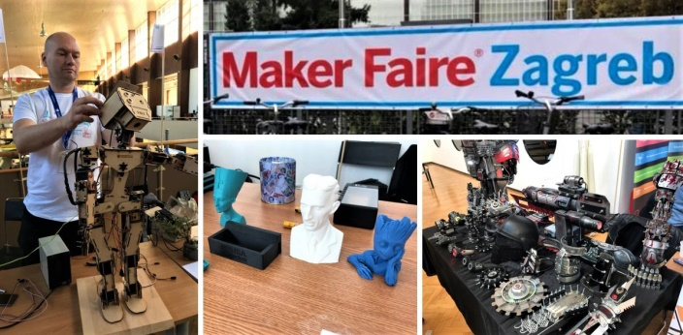

Activities
The Museum is a major contributor in the field of educational work, and is widely recognized by the public. By adapting its programs and contents to curricula, it achieves high quality cooperation with educational institutions. Additionally, through the series of lectures, workshops, interactive content, the Museum is committed to popularizing science and technology. It also cooperates with many associations, and in the Fall of 2019 Maker Faire was organized there. They also organized a science festival for the 17th time this year.
http://tmnt.hr/hr-hr/
Beneficiaries
The Museum is open to the general public, schools and students, cooperates with various associations and academia, and the City of Zagreb and its institutions.

Association FabLab
The FabLab Association for the Promotion of Digital Fabrication was founded in 2013 as the first such association in this part of Europe and is part of the international association of FabLab organizations. The first area of activity is focused on the education of all those in need and interested, from the youngest to those who, in their mature years, want to expand their knowledge. Second area of interest is related to the problems of the local community, that is, all those whom technology can assist in life. From the needs of people with special needs, to the tailored business solutions. The third area is developing an entrepreneurial mindset, that is, testing ideas and bringing them to a prototype or product.
The organised the first Maker Faire in Zagreb in October 2019
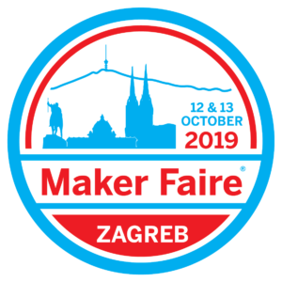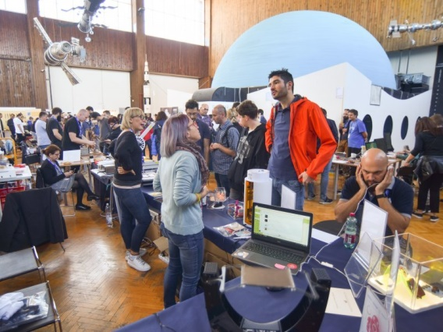
Activities
Promotion, events and education in the field of digital fabrication; informing the public about the development and application of digital fabrication in the economy, etc.
https://fablab.hr/en/about/
Beneficiaries
The association involves in the work people of different age and social groups, from the young, the unemployed to the persons with reduced mobility, all with the aim of their additional education for the purposes of self-employment or employment. They are also working to strengthen co-operation with related organizations in Croatia and abroad.

Zagreb Chamber of Trades and Crafts and Zagreb Association of Craftsmen
Those two organisations have noted in their work with craftsmen a lack of support for self-employed craftsmen in sensitive phases of achieving sustainability, a lack of business networking of craftsmen in general, and a lack of knowledge of alternative forms of financing.
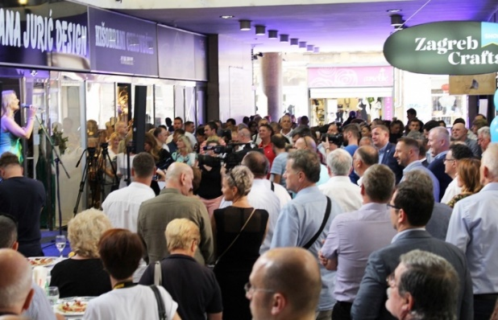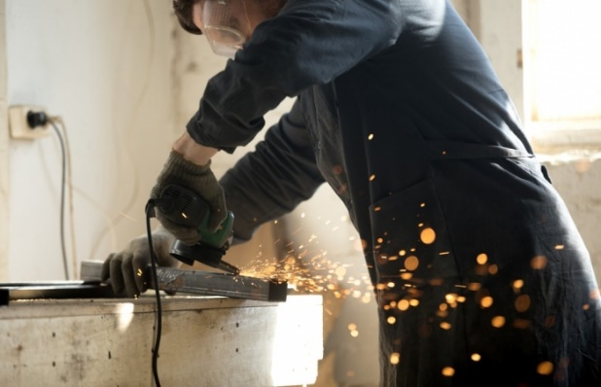

Activities
Therefore, they plan to organize a space for gathering, networking and providing support to self-employed craftsmen at the premises of the Zagreb Association of Craftsmen by forming several teams for organising crowdfunding campaigns for craftsmen and small businesses (marketing, advertising, social networks, design, etc.); organizing, running and promoting a web shop and for creating an application to connect entrepreneurs who have no successors with potential business transferees or employees / future successors.
They also have plans to promote and open co-working and maker space for craftsmen.
Beneficiaries
Craftsmen in Zagreb.

Town of Velika Gorica
Velika Gorica is a town in Zagrebacka County, close to City of Zagreb, where the Zagreb airport is located. The town itself has more than 30,000 inhabitants, but whole town area has more than 60,000.
About 2,500 entrepreneurs operate in the area of Velika Gorica, of which almost 1,000 are craftsmen. Until 2017, the Town of Velika Gorica has continuously given grants to entrepreneurs, mainly for the preservation and development of traditional, deficient and manufacturing crafts. In 2017, new grant scheme was created for beginner entrepreneurs. In order to promote the new support, the first Start-up competition was organized in Velika Gorica, which continues to be organized annually.
In order to enable further development of entrepreneurship in the town, in addition to town grants, the project documentation for the Incubator in Velika Gorica was prepared. Incubator is planned mainly for office spaces.
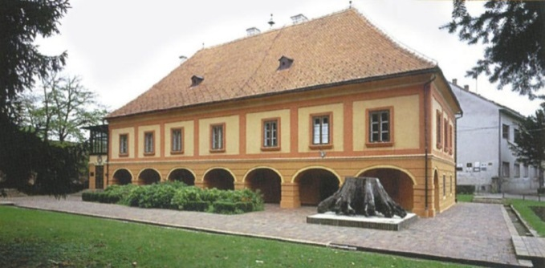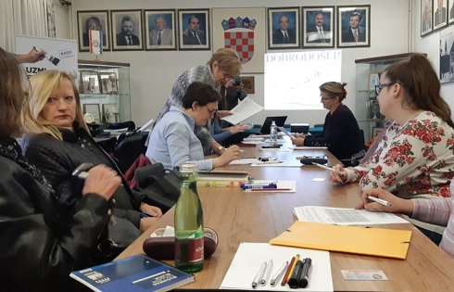
Activities
Start-up competitions in Velika Gorica have been held twice so far (2017 and 2018), with 130 participants. Registered participants, gathered in teams, presented their ideas to the jury, who awarded three prizes. Support is provided for enhancing business cooperation with the co-organizer and sponsorship with businesses.
Some activities required to build and equip Incubator have been completed (preparation of project documentation, obtaining of a building permit). Public procurement procedure for contractors and equipment, construction and equipment of the Incubator, production of promotional materials are the activities that should be done in the near future. The incubator investor is Town of Velika Gorica and VEGORA local development agency will manage the work of Incubator.
http://www.gorica.hr/

Beneficiaries
Start-up competitions are attended by people who intend to start their own business or have already started a business but want to improve their presentation skills. Incubator users will be people who plan to start their own businesses and need office space to get started.

Other stakeholders
Other relevant stakeholders that are active in promoting and implementing co-working and maker spaces will be involved in implementation of the UrbanM activities (HUB 385, Bizkoshnica, Impact hub, Algebra LAB, etc.). Furthermore, the list of relevant stakeholders includes organizations dealing with research and support of the development of entrepreneurship and human resources (e.g. Institute for the Development of the Labour Market, Craft College, etc.) and relevant faculties of the University of Zagreb.

Part IV - Urban M as a learning process
The UrbanM project is delivered through a series of learning activities designed to encourage partners to identify their own good practice, observe and get ideas from good practice in other EU regions, and through reflection and understanding, to improve the delivery of collaborative making in their region.
Although Zagreb already have some existing maker spaces, more awareness of these facilities is needed in the community and sectors. It has become clear through the policy learning events run throughout the Urban M project, that in all cities more connectivity amongst existing makerspaces and the innovation eco-system in the city is required, but also that new ideas and practices might be encouraged. Therefore, for Zagreb is very important to be part of the project, to learn and to be more ambitious in enhancing maker culture.
Following good practices are especially inspirational for Zagreb:

STEAMhouse, Birmingham
STEAMhouse, opened in May 2018, is a unique new space for innovation through interdisciplinary collaboration, which is powered by Birmingham City University (BCU), providing free workshops and events allowing people to share and develop their ideas with experts from many different backgrounds. They also offer co-working and co-making spaces, tech and grants. It combines STEM with Arts to create new products and services.
There are specially designed spaces to prototype new products and develop new ideas. Plus a fabrication facility where members can experiment with digital, wood, metal and print production.
STEAMhouse is a maker facility which provides open memberships and access for creative SMEs, policy makers, stakeholders, businesses, academics, entrepreneurs, designers, makers and others. This example is very interested for Zagreb from different perspectives:
- it provides open memberships and access for different creative stakeholders
- combines STEM with Arts
- it is powered by university.

Innovation Birmingham
Visiting Innovation Birmingham Campus, a leading location for Birmingham’s digital and tech community (providing office suites, meeting and conference facilities and co-working opportunities for innovators, entrepreneurs and investors looking to develop or fund innovative digital start-ups with high growth potential) was a good experience for Zagreb. With over 170 start-ups incubated, over 200 events held annually, with community of over 1000 digital techies and innovators and over £56 million start-up funding raised so far, is particularly interesting for Zagreb Innovation Centre (ZICER). From their experience ZICER can learn about their ways of organising co-working, mentoring start-ups in developing new ideas, collaborating with faculties and scientific-research institutions in developing new products, helping with internationalization of business.

Spazio Attivio
The Business Innovation Centre of Lazio’s mission is to promote and encourage the creation of innovative enterprises resulting from new business ideas (start-ups) or research projects (spin-offs), with the aim of generating and improving the entrepreneurial mind-set and providing work opportunities. It is owned by BIC Lazio SpA and founded in 1990 by Regione Lazio. For Zagreb is also interesting that FabLabs were funded through a European project submitted by BIC Lazio and Regional Ministry for culture and are managed jointly through a single contract for technical assistance.
The specific focus of the space is creative and cultural heritage; digital handcraft is the main form of making which takes place, but the lab is mainly used for prototyping. The space has links with the local community and holds a course every week which is open to everyone and ion different technologies for “making”. This example is interesting for Zagreb in the light of implementing the Programme of fostering development of crafts and SMEs, but also for nearby towns, e.g. Velika Gorica, which is already active stakeholder in UrbanM.

Fablab Lisboa
This kind of facility is of interest for Zagreb, as its specific focus is to be accessible to the ordinary citizens, as a space of knowledge and sharing experience, enabling democratic access to innovation, entrepreneurship, discovery and creativity. The impetus of developing this maker space was to provide a new rapid prototyping lab serving businesses and giving to the city an important tool for entrepreneurship and innovation. Connecting Fab Labs with municipalities is very intriguing model, as an initiative is imagined and implemented by the municipality, as part of its broader strategy in favour of innovation and entrepreneurship.
Technology is here only a way to gather people together, the true purpose of Fab Labs is to make people work together and collaborate. They are places that connect three main features—resources, ideas and people—in an innovating atmosphere.

Mercado de Ofícios do Bairro Alto, Lisbon
The aim of this new market, opened in April 2018, is promotion, dissemination and the protection of Portuguese Arts and Crafts. Through this comprehensive project and in partnership with various institutions in the city, it is intended to provide total coverage of a range of techniques and equipment associated with traditional know-how, since many of these crafts and techniques are in danger of extinction and they are of great value to the city and irreplaceable.
The Market provides equipment for different crafts and the space is owned by Lisbon City Council and has had public funding from Lisbon City Council.
Although, there is no plan in Zagreb at this moment to reconstruct or open any city market for such purpose, the aim of the City is to enhance development of crafts, so similar idea can be implemented in the future in some of the city spaces, make these spaces attractive, stimulate local employability, experimentation and prototyping in arts and crafts.

San Sebastian - Donostia Innovation League
The Donostia Innovation League is a true “maker” training programme which asks school and university students to work creatively in teams to explore solutions to a real city challenge. This approach might be interesting for existing makers in Zagreb or organisations who would like to boost such culture and practice through future projects.
The idea is interesting as it involve local youth in city challenges, and bring their view into the decision-making processes to address these challenges; build human capital through offering a training framework for local young people to help develop innovation skills, as well as linking them to employment opportunities; raise social awareness on innovation and city challenges by involving schools and universities in an open innovation undertaking.

Craft Centre (DUO) Škofja Loka, Slovenia
The need for such space is recognised in Zagreb, were craftsmen can meet and develop their ideas and to get support for traditional crafts and their connection with modern technologies.
The centre is owned by the local community, with expert support of DUO (providing leadership for the centre). The local community supports the initiative by ensuring that the rent for the premises is favourable.
For Zagreb would be of interest to learn how this Centre will overcome the challenge of how to establish sustainable support mechanisms that would allow the development of craftsmen's networks and at the same time contribute to the development of new working places (e.g. start-ups).

Part V - Action plan

Identified challenges
Generators of growth and development of the economy, crafts and SMEs are facing many problems in their work. The identified challenges refer to both business environment for craftsmen and small and medium-sized businesses, their need to strengthen knowledge and skills, and also to challenges related to new forms of work and business, including "maker spaces". Those challenges are recognized, both in relevant analyses made for the purpose of developing strategies and programmes, as well as through interaction and workshops with relevant stakeholders.
- Strengthening support for crafts and SMEs; access to finance
- Lack of vision/idea of different sector development by policy makers (national and local)
- Institutional framework for small and medium enterprises is still not efficient enough - there are still administrative barriers and regulatory instability, the efficiency of public administration has not increased
- Insufficient support through tax policy incentives
- Ineffectiveness of the judiciary, long-term ownership registration procedures
- There is a need for stronger support / capacity building of entrepreneurial support institutions (ESIs); insufficient information to the public about possible support/opportunities that are available for SMEs (start-ups)
- Access to funding sources due to high administrative costs, insufficient capital and other sources of insurance
- Insufficiently developed alternative financing methods whose features are flexibility, participation of the society and variety of forms (e.g. crowdfunding) as a good tool for young entrepreneurs with innovative ideas and projects that are able to enter the market in this way. The Republic of Croatia does not have the appropriate legal framework for this way of financing.
- The importance of bottom-up approach and micro-communities (city districts, local clubs, local associations) is not recognised, as well as need for inclusive approach
- Strengthening skills and reducing unemployment
- Lack of adequate work force / causes: migration, educational system that does not comply with labour market needs
- Lack of entrepreneurial skills and lack of educational content for building entrepreneurial competencies, especially for the needs of the maker space communities and start-ups
- Incompatibility of the curriculum for the development of appropriate skills according to the individual's preferences / creativity and innovation are not nurtured, insufficient work with new technologies, development of the motor that is needed for the successful work of maker spaces
- Inadequate recognition of the importance of lifelong learning and non-formal education
- Inefficiency of retraining system
- Strengthening innovation
- Insufficient transfer of research results to SME sector
- High costs of developing new products and services
- Lack of financial support for innovation development
- Infrastructure for development and work of maker spaces
- Lack of adequate and equipped spaces that can support development of innovative ideas, mentoring and product placement
- Available information cannot find the right path to potential beneficiaries / entrepreneurs
- Insufficient networking of relevant stakeholders and lack of community development initiatives (teamwork, socialization, integration, cohesion, self-esteem, empathy, acceptance of diversity, intergenerational knowledge transfer)
- Need to develop (online) platforms for presenting and selling products derived from work in maker spaces
- Personal competencies
- Insufficient entrepreneurial competences / lack of self-criticism and criteria
- The question of mentality (everyone wants to be a solo player, blocking other projects, short-term thinking, abolishing successful departments)
- Lack of good management
- The need to develop self-reliance and critical thinking.

Purpose of the Action Plan
- To gather and connect relevant stakeholders and impact relevant policies, programmes and plans thus creating the simulative and positive environment for the development of maker spaces in city of Zagreb.

Objectives and activities

Objective 1 - To gather and connect stakeholders and beneficiaries
Background information
It is essential that every high-quality programme that encourages entrepreneurship, including the promotion of innovation and the development of new products in maker spaces takes into account the views of all potential beneficiaries and organizations involved in the process. The cases of collecting such inputs from different stakeholders in the successfully run spaces were noted during the study visits organised within the Project. These spaces have one thing in common - opinions and suggestions for improvement are a permanent value and method of working and communicating. Therefore, when planning the development of a maker space and/or the modification of the measures in the policy/programme, it is extremely important to collect inputs from different stakeholders to get valid information that will serve for better (re)defining of policy measures.
In order to prepare the Action plan as realistic and feasible as possible, meetings and workshops have been organised with relevant stakeholders to get acquainted with their existing activities / projects in Zagreb and involved them in the process.
The idea is to gather stakeholders and create an opportunity for the preparation of partnership projects, which could be submitted to public calls from domestic and EU funds. Synergies with other compatible initiatives are planned, namely with the ZGAktiv project, within which a forums for defining partner projects will be organised. Also, during the European Week of Sustainable Development 2019, in co-operation with URBACT and the Urban M project a panel discussion was organise related to maker spaces. Relevant stakeholders were present. Wider community was invited to the event, as well as media.

Pilot action - Makers Community Hub
During the implementation of the UrbanM project, the City of Zagreb team and ODRAZ as an external expert have been continuously working on recognising additional relevant stakeholders, make them interested and involve them in the project’s activities. Among others, a good cooperation was established with the Technical Museum Nikola Tesla and it was agreed that they become a Makers Community Hub, with the plan to provide them within UrbanM phase II with needed equipment (e.g. 3D printers). There are several reasons for this plan. The Museum:
- is recognised as an educational place among public and schools in relation to technical issues;
- often organises different events to popularise new technologies, including workshops where visitors can work in practice; f.e. they hosted the first Maker Faire organised in Zagreb,
- is willing to serve as a Makers Community Hub.
The idea emerged based on the learning process of Urban M – namely from Fablab Lisboa, whose specific focus is to be accessible to the ordinary citizens, as a space of knowledge and sharing experience, enabling democratic access to innovation, entrepreneurship, discovery and creativity. For Zagreb project team it is very intriguing model, as an initiative is imagined and implemented by the municipality, as part of its broader strategy in favour of innovation and entrepreneurship. It is in accordance with the new measures introduced in the policy that was changed through the influence of Urban M (Programme for fostering development of crafts and SMEs). While preparing the application, the idea was to open a maker space in ZICER, mostly dedicated to entrepreneurs. Through the implementation of the project – interacting with local makers and by learning from partners’ experiences, the need for more democratic maker space was emerged. The Museum was a logical choice for such place, and the pilot action will be submitted to the assessment of Joint Secretariat, to fund the equipment and initial activities of Makers Community Hub. The idea is to equip the Museum with needed equipment (e.g. 3D printers and other devices) and organise workshops and events with existing makers, (by providing the space and the equipment) for general public or specific groups like children, youth, women, unemployed, NEET and similar.
Zagreb likes the idea that technology will be here only a way to gather people together, the true purpose will be to make people work together and collaborate in an innovating atmosphere.
This pilot action will be testing a new approach for the maker spaces community in the City of Zagreb.

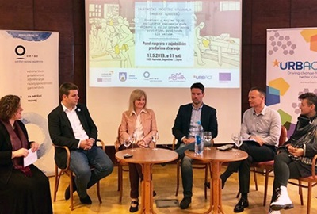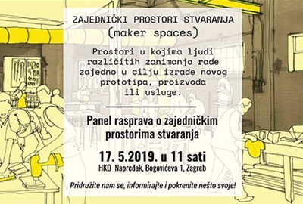

Activities
  - Organise stakeholder meetings to discuss challenges/possible actions and include stakeholders in the process of monitoring of the implementation of Action Plan
  - Organise and equip “Makers Community Hub” in the Technical Museum Nikola Tesla
  - Connect with other compatible projects and initiatives / Organise workshops for relevant stakeholders to present their project ideas, form partnerships, submit and implement together projects for enhancing maker culture and developing maker spaces
Stakeholders
Relevant stakeholders that are active in promotion and work of co-working and maker spaces will be involved in implementation of the activities (e.g. ZICER, Technical Museum Nikola Tesla, Radiona, IRIM/Croatian makers, Fablab.hr, HUB 385, Bizkoshnica, Impact hub, Bioteka, Algebra LAB, Croatian Association of Technical Culture, etc.). Furthermore, the list of relevant stakeholders includes organizations dealing with research and support of the development of entrepreneurship and human resources (e.g. Institute for the Development of the Labour Market, Craft College, Croatian Employment Service-Regional office Zagreb, etc.); supporting institutions for the development of crafts and entrepreneurship, and relevant faculties of the University of Zagreb. ODRAZ-Sustainable Community Development, will be actively involved in assisting City of Zagreb in all of those activities.
Wider stakeholder group will involve co-working, maker spaces and business spaces community and potential users of such spaces. Interested citizens and media will also be involved through public events.
Timeframe
During the project duration.
Sources of financing
Urban M project

Objective 2 – To analyse the situation and propose policy improvements
Background information
The exchange of experiences, opinions gained and study visits within the Project, gave an insight into work of maker spaces and their importance as platforms for common inventive creativity and knowledge exchange. Maker spaces have a great potential in contributing to the promotion of innovation and entrepreneurship that in turn ultimately contributes to sustainable growth and employment. Equally, these spaces play an important role in recognizing creative talents of individuals and their focus on entrepreneurship. They provide an opportunity for linking creative individuals with traditional craftsmanship and entrepreneurship in order to transfer technology and knowledge, encourage creative approaches to change in society, developing ideas of joint creation and building entrepreneurial spirit among youth.
Based on the analyses carried out, it has been noted that there is a need to continue activities on development of support systems for craftsmen and entrepreneurs as well as for creative individuals, which in turn will enable them to strengthen their competitiveness and networking systems, exchanging experience and knowledge. In this regard, it is necessary to intensify activities on the establishment and improving work of co-working and makers spaces which will serve as a network for potential and existing entrepreneurs who can jointly collaborate and interconnect in designing new innovative projects. In order to transfer of technology and knowledge, special focus should be put on cooperation with universities and scientific-research institutions.
With the goal of creating more enabling environment for entrepreneurial activities in the coming period, it is necessary to focus activities on higher use and application of ICT (Information and Communication Technology) among entrepreneurs and on raising their level of digital entrepreneurial competences.
Currently, there is no enough maker spaces in Zagreb. Therefore, the purpose of this Project and of this Action Plan is to influence the new Programme for fostering development of craftsmanship and small and medium-sized Entrepreneurship in the City of Zagreb and to incorporate measures and activities to address this problem.
Description of activities
  - Continuously monitor and analyse a situation for work of craftsmen and SMEs, their needsincluding maker spaces
  - Based on recognised needs of makers, new measures for the improvement of maker spaces, if needed, will be proposed to be added in the Programme for fostering development of craftsmanship and small and medium-sized entrepreneurship in the City of Zagreb. This will be the foundation for the City of Zagreb, ZICER and other stakeholders for writing partnership projects.
In the process of developing the Programme 2019-2023, the similar set of activities were carried out:
- Organizing meetings of the working group for the preparation of the Programme,
- Organizing workshops with all stakeholders,
- Drafting a Programme and preparing text for public consultations
- Analysis of comments collected through public consultations,
- Drawing up final proposal of the Programme,
- Putting the Programme into the adopting procedure by the City Assembly (The Programme was adopted in March 2019).
Stakeholders
The following stakeholders were involved in the development and will be involved in implementation of the activities:
City of Zagreb with relevant offices, Zagreb Innovation Centre (ZICER), Technical Museum Nikola Tesla, Croatian Chamber of Commerce/ Zagreb Chamber, Croatian Chamber of Trades and Crafts, Crafts Chamber of Zagreb, other relevant stakeholders are entrepreneurs with new innovative ideas, start-ups, maker spaces, businesses, relevant civil society organisations and academia.
Timeframe
Development and adoption of the Programme for fostering the development of craftsmanship and small and medium-sized Entrepreneurship in the City of Zagreb 2019-2023 was adopted in March 2019 and till the end of the project eventual new measures will be proposed, based on the makers’ needs.
Sources of financing
Budget of the City of Zagreb, Urban M project

Objective 3 - To better use ESIF for development of maker spaces
Background information
The mapping has revealed various funding opportunities (e.g. from EU funds) for financing partnership project for creating/supporting collaborative maker spaces and therefore the Action Plan has measures and activities towards achieving this.
The most feasible fund is Integrated Territorial Investments (ITI), a new mechanism of the European Union which was introduced with the aim of strengthening the role of cities as a driving force for economic development in the period 2014-2020. The ITI Mechanism is designed to facilitate the implementation of activities that have territorial dimension whilst sources for financing can come from three different funds: European Regional Development Fund, the Cohesion Fund and the European Social Fund.
In March 2016, in accordance with the Law on Regional Development of the Republic of Croatia, Urban agglomeration Zagreb was established with headquarters in Zagreb. Implementation of ITI mechanisms for urban areas is based on integrated strategic documents that include economic, environmental, climatic and social aspects, taking into an account the linking of the city's centres with the surrounding area.
Eligible activities within the ITI mechanism are divided into three thematic areas: smart cities - cities as drivers of sustainable and technological economic growth, sustainable cities - cities that are fighting climate change by promoting energy efficiency and environmental protection and inclusive cities - cities that fight poverty and advocate for social inclusion. The aim of the investment is, among other things, to provide a favourable environment for entrepreneurship development, rebuild brownfield locations (former military and/or industrial areas) and increase employment through the promotion of cultural heritage.
City of Zagreb, which is the owner of Zagreb Innovation centre-ZICER, has decided to invest in expanding its space. UrbanM saw the possibility to discuss with ZICER and relevant City Offices to establish maker space, mostly for entrepreneurs, in this newly planned premises and work closely to realise that idea using ITI fund.
Description of activities
3.1. Urban M will cooperate with the ITI Intermediary body to impact Integral territorial investments of Zagreb agglomeration,
The investment in the design of the ZICER space at the Zagreb Fair, which will, among other things, serve as a collaborative maker space is expected. ZICER will thus become a centre/hub for makers' community in Zagreb and Zagreb county, mostly for entrepreneurs with new ideas
3.2. Urban M will also cooperate with Zagreb partnership for employment (LPZ Zagreb) to explore the possibilities for cooperation in promoting and strengthen makers in Zagreb

Stakeholders
ITI Intermediary body of Urban agglomeration Zagreb within the Office for EU Programmes and Projects of the City of Zagreb, Sector for System Development and Implementation of the Integrated Territorial Investment Mechanism, ITI Implementation Unit (hereinafter ITI IU).
Other stakeholders include offices in the City of Zagreb, supporting entrepreneurial institutions, co-working spaces and maker spaces, chambers, civil society organisations, academia, Croatian Employment Service-Regional office Zagreb and others.
Entrepreneurs with new innovative ideas, start-ups, makers, business community.

Timeframe
During the Project implementation
Sources of financing
ITI and other ESIF, City of Zagreb, Urban M project

Table 1. Action plan: Objectives, activities, expected impact and indicators

Objectives | Activities | Expected impact | Indicators
- To gather and connect stakeholders and beneficiaries | - Organise stakeholder meetings to discuss challenges/possible actions and include of stakeholders in the process of monitoring of the implementation of Action Plan | - Makers community in Zagreb and Zagreb County connected  - Needs recognised, solutions for improved situation for maker spaces proposed | - At least ten (10) stakeholders gathered and involved in the project
 | - Organise and equip “Makers Community Hub” in the technical Museum Nikola Tesla | - Pilot action successfully tested a new approach for Maker Spaces community in the City of Zagreb | - Makers Community Hub open and functional through the second phase of UrbanM project in Technical Museum Nikola Tesla (1)
 | - Connecting with other compatible projects and initiatives / Organise workshops for relevant stakeholders to present their project ideas, form partnerships, submit and implement together projects for enhancing maker culture and developing maker spaces, | - Collaboration and synergies of relevant stakeholders achieved  - Makers partnerships established and new ideas proposed  - New projects for improving makers situation developed and submitted to donors | - Sinergy established with ZgAktiv project, financed through ESF, which aims to increase the employability of the most vulnerable groups in the labour market in the city of Zagreb and prepare a new City of Zagreb Human Resources Development Strategy  - At least one (1) partnership project related to maker spaces prepared during the UrbanM project duration
2. To analyse the situation and propose policy improvements | 2.1.Continuously monitor and analyse a situation for work of craftsmen and SMEs, their needs, including maker spaces situation | - Based on monitoring and analyses findings, propose new/improved measures and actions to the City of Zagreb | - Data on situation and needs of craftsmen and SMEs including maker space community will be gathered from the stakeholders involved in the project and through City of Zagreb reports and statistics (1 set of data)
 | 2.2. Based on recognised needs of makers, new measures for the improvement of maker spaces, if needed, proposed to be added in the Programme for | - Measures enabling and fostering maker spaces included in the new City policy based on recognised needs of makers  - City of Zagreb grants and financial support | - The additional measures for fostering co-working and maker spaces, if need is recognised, proposed to be added in the Programme for fostering development of

Objectives | Activities | Expected impact | Indicators
 | fostering development of craftsmanship and small and medium-sized Entrepreneurship in the City of Zagreb | available to makers/makers and co-working spaces | craftsmanship and small and medium-sized Entrepreneurship in the City of Zagreb 2019-2023  - At least one (1) public call for grants launched by the City of Zagreb for innovators developing entrepreneurial innovations, as a part of the implementation of the Programme for fostering development of crafts, small and medium-sized entrepreneurship in the City of Zagreb 2019-2023
3. To better use of ESIF for development of maker spaces | 3.1. Establish cooperation with the ITI Intermediary body to impact Integral territorial investments of Zagreb agglomeration | - Possibilities of ITI mechanism to complement existing systems of support for crafts and SMEs, including improving access to collaborative spaces maker spaces, discussed  - Investment in ZICER and other collaborative spaces to provide support to makers (more opportunities for spatial, organizational and technical-technological support to makers and innovators for realisation of their ideas, counselling/mentoring, pre-incubation and incubation by providing a support in product and service development and commercialization) | - At least two (2) meetings organised between UrbanM team and ITI Intermediary body to explore the possibilities for investment to ZICER as a maker space and improvement of maker space situation in Zagreb and Zagreb County  - New investment in expansion, refurbishment and equipping of collaborative maker space within ZICER at Zagreb Fair, mainly for entrepreneurs (1)  - ZICER become the second centre/hub for makers' community in Zagreb, mostly for entrepreneurs with new ideas
 | 3.2. Urban M will also cooperate with Zagreb partnership for employment (LPZ Zagreb) to explore the possibilities for cooperation in promoting and strengthening makers in Zagreb | - Measures for promotion of maker spaces and strengthen makers included in Zagreb Human Resources Development Strategy  - Partnership projects developed | - Urban M team and stakeholders participated at ZgAktiv project activities:  - at least at two (2) PIIP workshops to discuss possible partnership projects  - at least at two (2) evaluation workshops of the Zagreb Human Resources Development Strategy  - at least at two (2) workshops drafting new Zagreb Human Resources Development Strategy  to influence the new Strategy in favour of maker spaces development and to form partnerships for projects

Monitoring activities
The monitoring of the implementation of the proposed actions will be on regular basis, performed by UrbanM team: City Office for EU Programmes and Projects (UrbanM partner), together with City office for Economy, Energetics and Environment protection, ZICER and external expert.
The team will regularly organise stakeholders' meetings to discuss the implementation of Action plan and discuss eventual problems and how to solve them. The team will also regularly organise meetings with heads/representatives of relevant Zagreb offices to discuss what next steps might be and how to achieve improvements in regards to policies, funding and enhancing collaborative approach and foster development of crafts and SMEs through innovative practice, building eco-system for makers and similar.

The analysis is based on data on the number of business entities and the number of persons in employment by activities according to National Occupational Classification (NKD) for selected analytical period 2009 - 2017.

