Learning Report

Study Visit Spain

05-07 Nov 2019

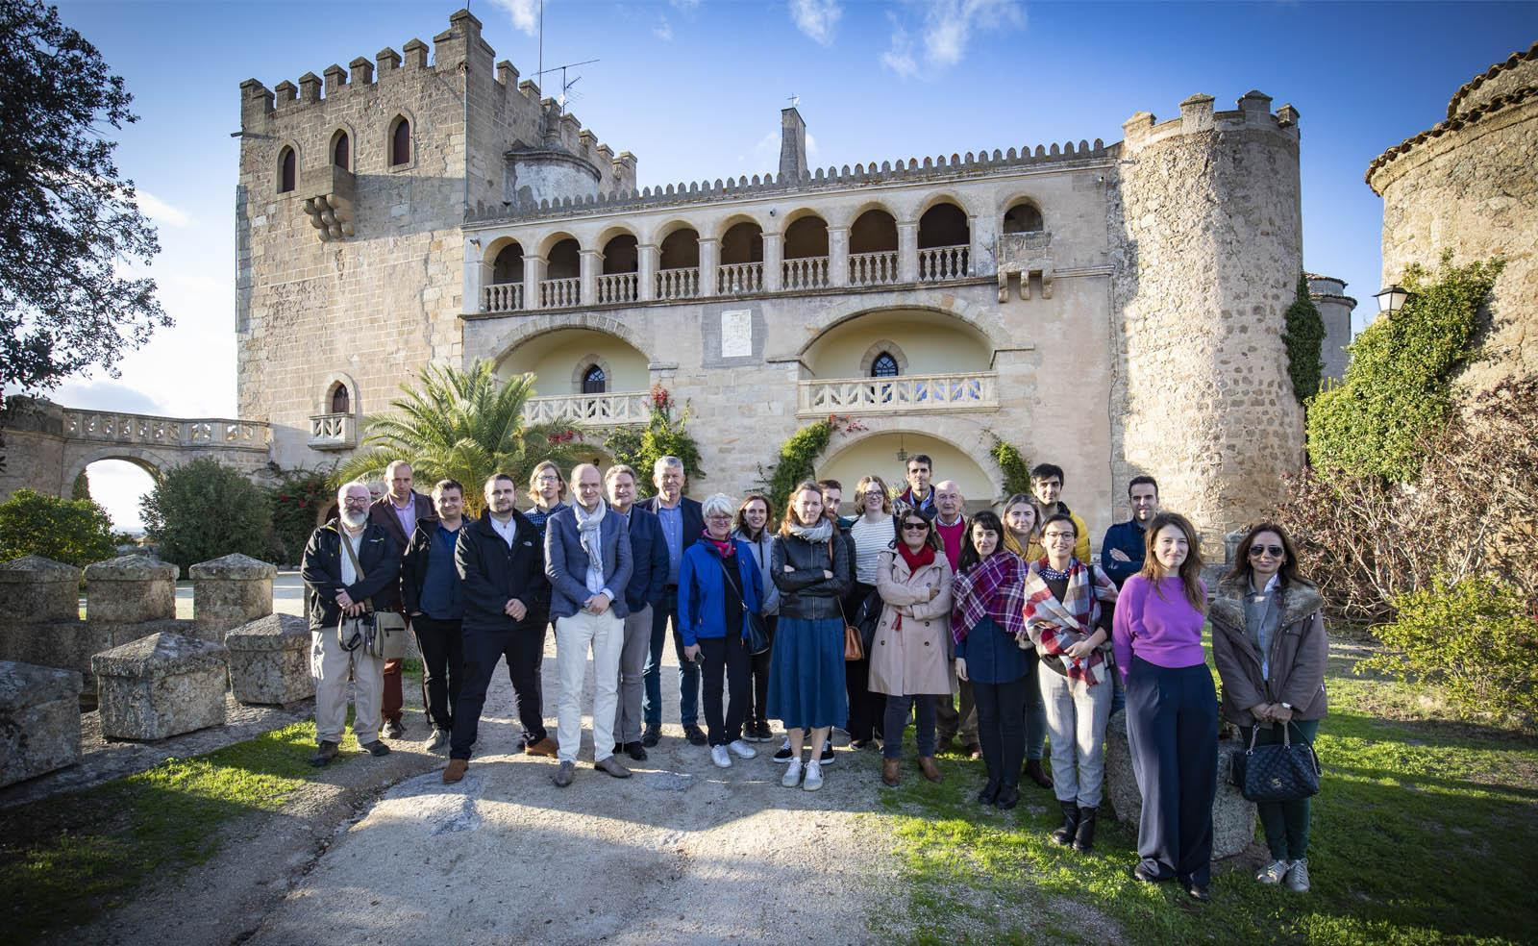

Glossary

Action plans | All partners will develop Action Plans to improve an identified policy instruments with input collected from the baseline survey, the study visits, the peer reviews and three stakeholder meetings.
HCME | Historic Castles, Manors and Estates
INTO | International National Trusts Organisation
NIH | National Institute of Heritage in Romania
NT | National Trust
PG | Province of Gelderland
Peer Review | At the end of each study visit, delegates participate in a peer review of the policy instrument, focused on identifying good practices and providing valuable input for the development of the action plans for all regions.
PTE | Preservation, transformation and exploitation
Study Visit | The organisational learning is focused on a series of Study Visits to each partner country, which consist of visiting inspirational sites in each country, a thematic seminar based on local needs, a peer review, a participant satisfaction survey and a learning report.
Thematic Seminar | An opportunity to dive in deeper to particular subjects, with other invited experts
UCG/HOG | University College Ghent

Overview of the Study Visit

The fourth study visit of the Innocastle project took place in the towns of Badajoz, Alburquerque, Zafra, Villanueva de la Serena and Medellín, all of them located in the Province of Badajoz, Spain, between the 5th and 7th of November 2019. The study visit was organized by the Diputación of the Province of Badajoz, partner of the Interreg INNOCASTLE project, and it included a project meeting and conference, four site visits, a thematic seminar and a peer review. The complete programme can be found in appendix 1.
1. In the morning of day 1, a project meeting was held in the headquarters of the Province, in the city of Badajoz. Project partners were welcomed by the President of the Province and by staff of the department responsible for the project implementation in the region. An update of project activities was carried out by the lead partner and different presentations regarding the baseline study, action plans and administrative and financial issues were implemented by different partners. This same day, after a working lunch, project partners visited two interesting sites in the municipality of Alburquerque: the castle of Luna (owned by the Regional administration) and the Castle of Piedrabuena (Private castle with an interesting business model). The day finished with a project dinner in Badajoz. | 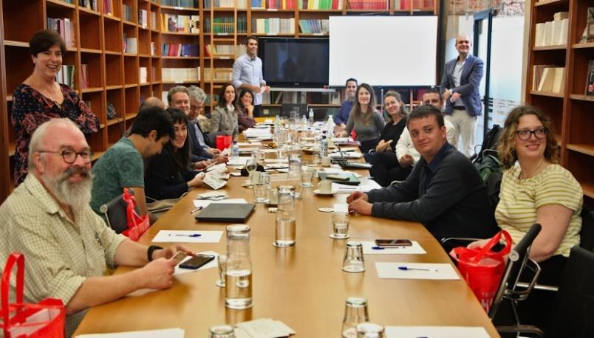
2. In the morning of day 2, project partners were driven by bus to the town of Zafra, where the thematic seminar “Governmental financial & fiscal support schemes to support HCMEs” was organised. The event took place in the Parador of Zafra, a publicly owned castle which is currently being run as a hotel, as part of the Paradores chain During the seminar different good practices and sharing of information on public-private relations in heritage management, governmental support schemes, regulation and policies, taxes and financial schemes, marketing and visibility tools, castles management and limitations were presented among other topics. After a project lunch with speakers and stakeholders, project partners visited the castle of Zafra and a guide explained the daily management of the castle as a hotel and the general model of the Spanish Paradores, a national network of historic buildings working as high standard hotels. At the end of the day, just before dinner, project partners and stakeholders participating in the study visit implemented a peer review.
3. In the morning of day 3, project partners were driven by bus to the Castle of La Encomienda in the town of Villanueva de la Serena. Despite some technical problems due to a mechanical breakdown of the bus which pressed on the planned agenda of the day, partners visited briefly this castle and headed to Medellín, a historical site were two presentations on heritage management and the involvement of the local community in the conservation and exploitation of the heritage were implemented before visiting the Castle of Medellín (Owned by the Regional Administration).

Thematic seminar
The thematic seminar approached mainly the themes of Governmental financial & fiscal schemes to support HCMEs, but other topics of interest for local stakeholders were also included. Each partner with competencies or experience in the topics and local key actors carried out a presentation.

SPEAKER | TITLE OF THE PRESENTATION | MAIN CONTENT/GOOD PRACTICE
Ms. Georgina Holmes-Skelton. The National Trust. The UK. | Public-Private relations in heritage management. | The importance of having strong and stable mechanisms of communication and coordination between responsible authorities and key actors at the highest level. The National Trust has a whole team and a strategy to involve and influence Parliament, government, and other main actors who can have a huge impact in the way HCME are seen from a political sphere.
Mr. Paul Thissen. Province of Gelderland. The Netherlands | Governmental support schemes. The Province of Gelderland. | The Province of Gederland has been applying very interesting and well thought out public financing schemes for more than 15 years. They have a structured participatory system to facilitate the involvement of different local actors, including local heritage trusts and private owners associations and provide private owners with means to maintain, restore and manage HCME. Within the project framework Gederland province is proposing an important improvement of funds dedicated to HCME and gardens management.
Ms. Sara Vermeulen/ Ms. Siska Van de Steene….. | Governmental support schemes. Examples from Belgium | The Flemish experience with government support schemes is long and fruitful. The Flemish region counts with a vast and active network of private heritage owners associations, trusts and foundations working in the heritage preservation.
Mr. José María Torres Muñoz. General Secretary of the Spanish Association of friends of the Castles | Regulation and policies: Problems and potential solutions for the sustainable exploitation of HCMEs in Spain | The Spanish Association of Friends explained some of the barriers and problems in Spain in present days concerning the preservation of castles which are in private hands. The heritage protection rules are strict and don’t favour public-private management models or even private restoration and conservation activities. Also tax systems are hampering in some cases a sustainable use of castles.
Mr. Manuel Cordero, Director of the  Provincial tax Agency | Regulation and financial schemes in Extremadura | An extensive overview on the National, Regional and Local different tax figures applied to HMCE in Spain, given by the main responsible for the Provincial tax Agency, pointing out both incoherences and potential improvements to be dealt with within the project lifespan.
Mr. José Manuel López; Xavier de Salas Foundation | Marketing and Visibility as tools for the promotion of the heritage and its exploitation. Good practices from Extremadura | A very interesting and replicable experience is explained where a group of amateur bloggers who hold a common interest and skills in wildlife, photography and cultural heritage come together on a yearly basis to produce a publication covering a chosen theme and presented in a seminar and on their different blogs. The experience consists in a joint effort with a large impact, as these persons are all professionals coming from different areas of knowledge and each provide an important amount of very trusting followers and national and international level. Impact, therefore, is not only broad, but effective.
Ms. Irina Leca, Romanian National Institute for Heritage | Marketing and Visibility as tools for the promotion of the heritage and its exploitation. Good Practices from Romania | The Romanian National Institute for Heritage presented interesting experiences with the involvement of young people through social media and different innovative actions, like the digital chroniclers, which could be very easily replicated in Spain, summer schools for professional volunteers, etc.
Mr. Alexander Lamont-Bishop. International National Trusts Organization; the UK | The International National Trusts Organisation | The INTO is a network dedicated to share experiences around the world on heritage conservation and sustainable management. Their technical publications and assessment on heritage management are very interesting for all partners.
Mr. Ian Grafton. Manager at Croft Castle. the UK | Managing a Castle | Croft Castle is an example of how a HMCE can be a profitable, open and community building resource for a small village and Ian Grafton provided a detailed insight on their visitors’ centred management success stories.
Mr. Daniel de Lamo. Director of the PARADOR of Merida | Heritage and exploitation: PARADORES, a successful story | The state owned network of hotels sited in listed buildings has been running since 1928 and constitutes one of the most successful heritage protection and sustainable management models in Europe. Partners found the figure and experience very interesting.
Mr. Francisco J. Serrano and Mr. Jose Javier Cano; DG for Heritage. Regional Government of Extremadura. | Cultural routes as elements for the exploitation of the heritage in rural areas: The Via de la Plata in Extremadura. | The Via de la Plata is a successful example of how a cultural route can bring visitors, economic and sustainable activity to rural areas and protection of HMCE together.

Key Takeaways from the Site Visits

The sites visited represent different situations of HCMEs in Extremadura with regard to ownership (public/private), access (open/close to the public) and exploitation model

- Castle of Piedrabuena.
- Castle of Luna.
- Parador of Zafra (Castle/Palace of the dukes of Feria)
- Castle of La Encomienda
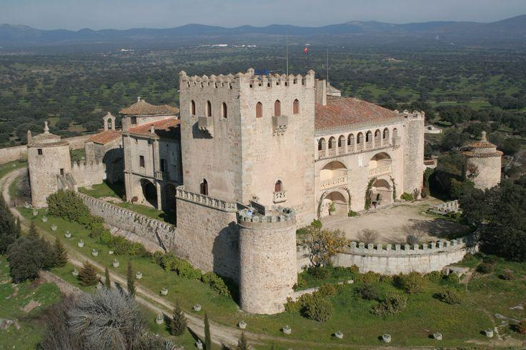
- Castle of Medellín.

1 Castle of Piedrabuena (S. XIII): Private castle in good condition and open to the public for private celebrations. The owner of the Castle has reached an agreement with a local company that organizes events. The company takes care of everything, from the publicity to the cleaning of the Castle. The owner receives an amount of money for each celebration depending on the size and characteristics of the event. The experience is satisfactory and profitable for both the owner and the company. The castle is located in the middle of an oakwood, the typical landscape of the Region of Extremadura. Heritage and nature are well connected in this rural region where a big portion of the territory is under environmental protection policies.

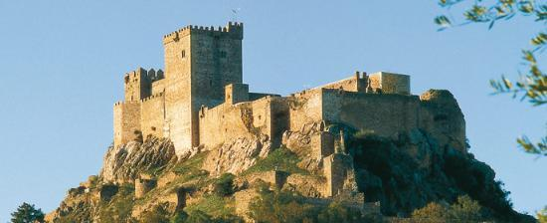
2. Castle of Luna (Alburquerque) (S.XIII) (Reconstruction S. XV): Public owned castle in good condition, open to visits under request. It is a good example for restoration using public funds, but the castle lacks an adequate exploitation plan, and the lack of communications among different administrations limit a correct exploitation strategy. Although during some years the castle was used as hostel, after an important investment (public funds) to build a Hospedería (public regional brand for rural hotels), within the outer walls, the exploitation phase for the hospedería never started (due to economic cuts for the 2009 crisis) and now it is closed. The importance of an adequate exploitation strategy is evident in this unique site. The castle is used once per year for the recreation of a local medieval festival very well known in the territory and supported by citizens and local associations.
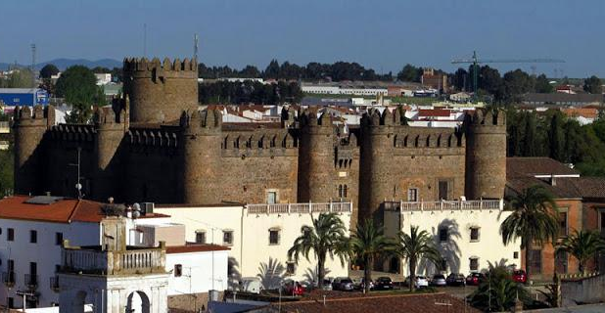

3. Parador of Zafra (Palace of the Dukes of Feria. S.XV): Restored castle exploited as Parador (Spanish public network of heritage sites hotels). This is an example of the Paradores model in Spain, which might be of interest for other territories.

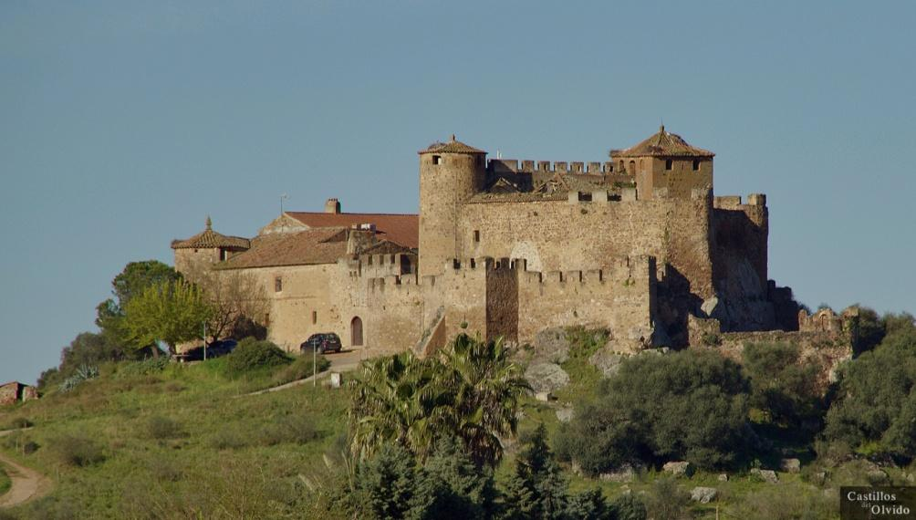

4. Castle of La Encomienda (S.XIII): Private owned castle closed to the public. Visits are not allowed. The condition of the Castle is relatively good regarding some elements, but others need urgent restoration works. The Castle is owned by different members of the same family and they do not reach an agreement for its exploitation. The lack of programs for restoration and for the promotion of the historical heritage limits the options of the castle of being restored and used.

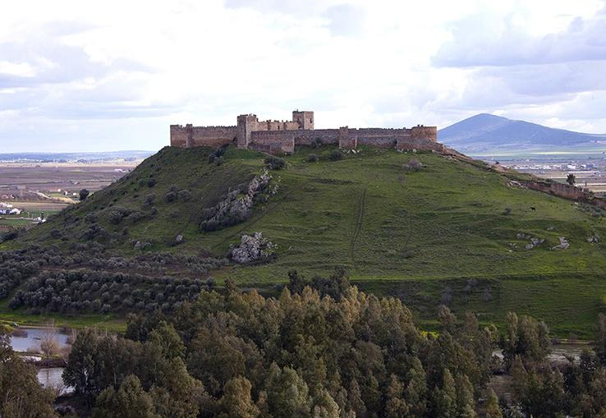
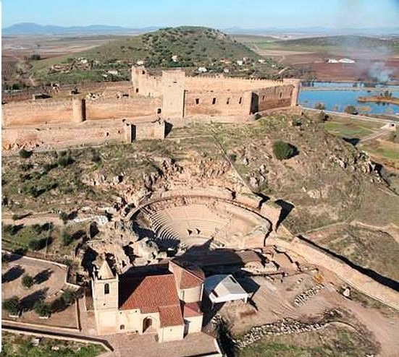
5. Castle of Medellín (S.XIII): Public owned castle open for visits 6 days per week. The castle is part of a site together with other heritage elements (roman theatre, church and a visitor center). The restoration works were implemented within a program in which local people were trained and contracted. The site was included in the framework of an existing festival (Classical theatre festival of Merida) taking place every summer in Merida (45km distance). The involvement of the local community in the restoration and use of the site was made through a participatory process in which both the regional and the local authorities collaborated actively. The castle is also used for educative visits for school groups.
After different study visits during the Innocastle project, partners have gained experience on the problems and potential improvements connected with the exploitation of HCMEs. A common view shared by partners after the site visits in Extremadura is the potential of the connection of cultural heritage with the natural landscape that this rural region can offer to the visitor. Trying to connect these two elements could offer very interesting possibilities for the exploitation of HCMEs in this region, but also in other rural European territories.

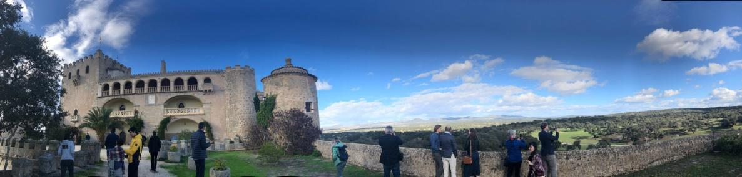

“What struck me in this area was the combination of really big and interesting castles and this incredible landscape”. Paul Thissen, Province of Gelderland.

“The connection between the castles and the nature and the whole landscape is remarkable”. Georgina Holmes-Skelton, The National Trust.

“I was deeply affected by the landscape, that huge column of vultures, and that castle behind it. I should probably remember that to my dying day, it was an astonishing thing….. These castles are in an astonishing landscape with astonishing wildlife,…. and I just wonder if you promote to a more mature audience, with maybe a social conscience, and see extraordinary things that your friends won’t see. And you go home and Facebook and Twitter, because they won’t have been at Alburquerque. That’s what I would give back...that’s really quite a unique package.” Ian Grafton. Manager at Croft Castle. UK.

The exploitation models of the site visits were also important elements to be considered. The Castle of Piedrabuena where the private owner collaborates with an event organizing local company, or the castle of Zafra, managed by the public Spanish touristic brand “PARADORES”, were two examples commented by most partners as models to be considered in other regions.

“I was thinking all the time, being a civil servant in a regional authority, what should be the relation with the private sector? For example, this is a Parador, state owned and exploited in a certain way. It’s completely unfamiliar for us. But these things make you think about what should be the right balance between state influence and entrepreneurship”. Paul Thissen, Province of Gelderland.

“Working together with private owners is often a good practice to protect the cultural heritage and to top up the tourism in the region. The example of the castle owner who works together with a caterer for organizing events in his castle showed that it can work”. Siska Van de Steene. Flemish Land Agency.

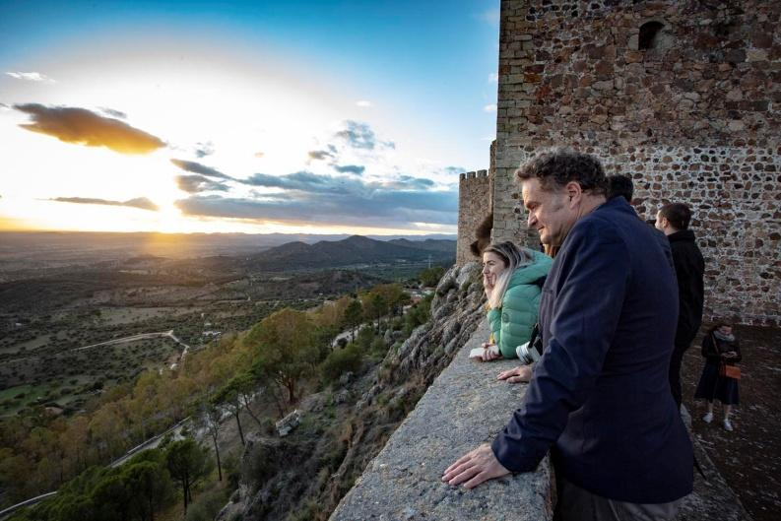

“What was new for me today was the fact that the Paradores are state owned, I didn’t know that, it was like a shock or something. Something really new. I agree with Paul that it questions also the fact if it’s a good thing or not, if we should do that or not, but I think it’s quite something we might think about in Flanders for example in order to get heritage rescued and do something with it”. Sylvie van Damme,University College
Ghent.

The topic of financial and fiscal support schemes to support HCMEs has been present during the whole study visit and partners could learn from each other during the thematic seminar, but also by talking directly with castle owners and locals on the situation in Extremadura when trying to set a business idea around the use and exploitation of a Castle.

“It’s important to have logic in taxes, in tax reductions. Why do you reduce taxes?, for whom? …I will take that home”. Sara Vermeulen, UCG stakeholder.
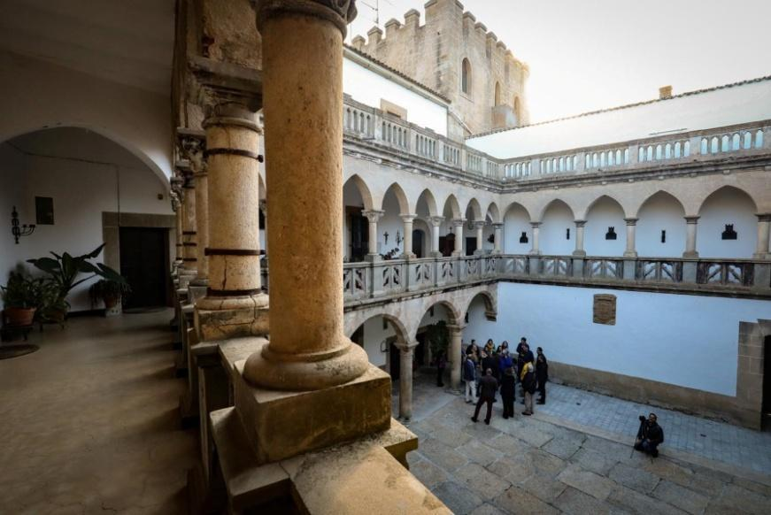

The lack of an efficient specific communication and marketing campaign for HCMEs is something that acts as a barrier for the promotion of such assets as observed by partners during their visits. However some initiatives might cause an important impact in the near future and have a good potential for being transferred to other territories. The Romanian experience and the best practice from the Xavier de Salas foundation in Extremadura with bloggers and with influencers are two very good examples.

“The example of the work with influencers in the territory is a modern thing to do…. it’s quite innovative. I haven’t heard anyone from the UK heritage sector doing that, it’s quite innovative.” Alexander Lamont-Bishop, National Trust

The inputs from project partners during the site visits and seminar and the involvement from key local actors during these days had an important impact in local key stakeholders that committed to start collaboration to improve the local situation.
“I think today we already made a change; we were talking about it with stakeholders. We had the right people; it wasn’t easy to do it. We had to have, all of us, a lot of patience. But it has been, maybe, hopefully a turning point. Patricia Mora. Extremadura.

Analysis of the policy instrument
General information

Extremadura ERDF Operational Program (2014-2020)-Objective OE 6.3.1” To boost the protection, promotion and development of the Cultural heritage”. Priority for investments number 6: “The preservation, promotion and development and natural heritage”.

The main objective of this policy is the valorisation of cultural and natural heritage resources of the Region. One of the main actions to be funded under this priority is the creation of natural and cultural itineraries in order to promote sustainable tourism and the economic development of rural and urban areas. The creation of virtual resources is also included.

The project will help in the identification and design of tools and actions for the correct implementation of programs under the addressed policy. The policy will be improved during the Interreg project due to the identification and adaptation of Best practices from other EU regions. Other partners can also study the actions implemented in Extremadura for cultural heritage and sustainable tourism.

The operational program objective 6.3.1 for the promotion of heritage is not limited to protected heritage sites or even listed sites. However, protected sites (BICs) have a recognized interest and this can play a role in the distribution of the funds.

The policy instrument defines an amount of funds that are supposed to be invested in heritage for the present period, but the definition of programs and strategies for the use of these funds is very general.
In fact, the DG for heritage promotion has a very limited budget for heritage projects funding and there is not a clear strategy for the design and implementation of programs in this direction.

Obstacles to the application of the policy instrument as defined by different stakeholders

The lack of a clear strategy from the DG for heritage promotion regarding the promotion and sustainable exploitation of HCMEs, due in part for the limited resources available during the last years for heritage at Regional and National level, together with a limited communication and cooperation with the DG for tourism, are two issues that have affected the implementation of the target policy instrument.

The policy is not being correctly implemented, and during Innocastle the aim is to define protocols to improve the design and management of actions towards heritage exploitation and maintenance. These actions will be focused on improving communication among different administrations, protocols to define more specific strategies for the use of ERDF funds for heritage and the promotion of specific taxes exemptions for castle owners to implement sustainable exploitation projects.

The following elements hinder the correct application of the policy instrument towards heritage related actions:

- Lack of more completed inventories for HCMEs
- Not specific programs for Taxation and subsidies focused on HCMEs
- Lack of programs for heritage exploitation projects
- Lack of an exploitation strategy for a good part of the restored HCMEs
- Scarce public-private partnership experience
- Difficulties from most of castle proprietors to afford restoration and maintenance
- A lack of general awareness of the problem
- A lack of communication structures or tools to allow collaboration between different administrative bodies and with the private agents

SWOT for the policy instrument (preliminary proposal)

STRENGTH | WEAKNESS | OPPORTUNITIES | THREATS
- Quality and quantity of the HCME regional heritage  - Previous efforts to restore most of the public owned HCME heritage has already been carried out  - Access to SF for the next programming period  - An important part of the HCME heritage is under public property.  - A will to collaborate among different administrations  - Most HCME located in attractive natural and rural touristic areas. | - Scarce or no future foreseeable public funding for restoration  - A number of restored closed HCME  - Scarce public-private partnership experience  - Difficulties from most of castle proprietors to afford restoration and maintenance  - A lack of general awareness of the problem  - A lack of communication structures or tools to allow collaboration between different administrative bodies and with the private agents  - Poor marketing and valorisation of heritage resources | - Innocastle project  - The awareness-raising from the general public  - Existing associations favouring Castle protection  - Increase in general interest for visiting cultural and heritage sites  - Increase in the interest in inland tourism  - Strong efforts to avoid rural depopulation | - Significant number of castles highly degraded and in risk of collapse  - The foreseen budget for heritage projects is very limited due to a foreseen cut of SF in the region  - Depopulation in rural areas

Recommended adjustments for the setup of the policy instrument

- Definition of public-private business models to apply to HMCE management validated by the regional, provincial and local administration.
- Elaboration of more completed inventories for heritage elements in collaboration with other administrations
- Definition of protocols to involve all key actors in the design and implementation of ERDF funds for heritage promotion
- Definition of protocols for a better promotion, marketing and product development together with other DGs (i.e DG tourism).

Stakeholder messages (from Participant Questionnaire)

Stakeholder | Main lessons learned in Extremadura about heritage and local economic development issues that can be applied to the Action Plan for your region?
Belgian stakeholders | - The link between the HCME and the landscape can be an important asset for tourism.  - The way public initiatives such as the Merida Festival and the Paradores network stimulate heritage tourism. Paradores is a simple idea, it works well and helps a lot of heritage.  - How HCME can be a lever for a less populated region.  - How Medellín benefits from a larger festival is tremendous and should be used in more regions
The UK stakeholders | - The example of the Parador model, a strong product, marketed as a group and emphasising the quality of the product. It is noticeable that the Government is able to bring these historic assets back into commercial use.  - cultural routes and the way that this brings benefit to rural parts of Spain
Romanian stakeholders | - The public administration can also have initiative and create models for including heritage in the economic circuits, like in the case of the Parador chain of hotels.  - The idea of an event/festival in several locations could be translated for HCME. The festival of Merida presents an interesting case of cultural programming taking into consideration a whole territory and not just one place. Sometimes it is necessary to think macro /at upper scale in order to produce a cultural attractor which is strong enough.  - I was interested in the transformation of castles into accommodation places. Considering Mures Region, I think this sort of transformation represents a possibility, but only together with the development of an adapted business model.  - The case of castle of Piedrabuena was an interesting example in this sense, with the collaboration between the owner and a private company of events.  - The inter-disciplinarity of cultural programing in Medellin – heritage and performing arts.  - The approach towards using landscape as a tool for marketing and promotion of HCMEs.  - It would be useful to involve all the regions from the country and make a national association of stakeholders (owners of HCMEs) such as the AEAC in Spain
General | - Need for a vision on the role of heritage castles and manors in regional context  - Need for a social-economic impact study on regional level  - Need for proper business plans per site  - Cooperation of local/ regional authorities to support the owners and initiators  - Potential of temporary use for (re) activating idle castles  - State owned castles as high-end hotels  - Pilgrimage routes connected to HCME and the Paradores model.  - How private owners collaborate in a very fair partnership with events organizing companies, which adds value for both parties.  - Most tourism offers worked with local resources (food, people etc)  - Various tax incentives from partners which are/could be helpful for development.  - The bloggers good practice in Extremadura.  - The Romanian good practice involving young people and getting the message across to as many people as possible.  - There are very interesting cultural routes such as the Silver Way and the Mozarabic road that can be combined with the visit to the castles.  - Programs of collaboration between existing Festivals and Castles  - Although there are some tax benefits, these are insufficient to encourage people to use and exploit private castles.

What ideas do you have for improving the PTE of HCME in Extremadura which they can use in their Action Plan?
- Spanish tax laws and the impact it has on owners taxation once they begin to gain any income from their assets do not incentive owners to be entrepreneurial and help to bring back these historic assets back into good order or indeed back into the public domain. Actions towards this issue should be considered.
- Need for better understanding of the socio-economic impact of investments in HCME’s. Actions towards the assessment of socio-economic impacts should be considered
- There is a huge lack of data. More data on material and immaterial values would help to convince policy makers to invest time and make better support structures for owners. Actions towards the elaboration of more completed inventories and on the situation of the different HCMEs should be considered.
- Temporary use could be an outcome for some of the castles. The Luna castle could be turned into a lab-castle to test this approach.
- Actions towards collaboration and community involvement/development should be considered
- A more efficient management of the castles should be achieved. Some, like Alburquerque are in perfect condition and yet not used. It is not profitable. Actions for the promotion of efficient management programs should be considered.
- In addition many of the benefits or incentives to HCMEs are not known to the owners, who consider that bureaucratic hurdles are more than investment incentives. Communication is essential.
- To include communication measures among administrations and with the private sector

Summary Table - good practices identified so far
Organisation in charge/ owner of the good practice | Practice | Geo scope | Short summary of the good practice (including URLs with further information) | Potential for learning or transfer | Evidence of success: What features make it an example of good practice
FOUNDATION XAVIER DE SALAS | Influencers and Bloggers to promote a territory through natural and cultural heritage promotion | Regional | The Xavier de Salas Foundation (XSF) develops among its various activities an Environment Program to implement and promote technical and informative initiatives to highlight the enormous cultural and natural heritage of Extremadura and encourage citizen participation in this matter.  To this aim, XSF organizes the Extremadura Bloggers Meetings, annual encounters bringing together enthusiasts to exchange experiences and know-how about cultural and natural heritage blogging. The event includes a program of conferences with recognized experts and the presentation of a book previously prepared by all those attending the Meeting.  It is about giving voice to people who, independent of their affiliation to companies, organizations and institutions, contribute to the common purpose by publishing their personal blogs and spectacular photographs. The bloggers share common interests but express them through their own creative formats, styles and content.  The XSF, together with the Directorate General of Tourism of Extremadura, each year defines a different theme as the basis for bloggers to prepare their posts, which are collected into a book (printed and also available in electronic format) as well as a calendar highlighting some of the best images, which are distributed to people and organizations working in the field of cultural and natural Heritage of Extremadura.  https://www.interregeurope.eu/policylearning/good-practices/item/2138/extremadura-bloggers-meetings-and-books/ | In all regions people use the Internet as a watchtower from which to show the world their individual and subjective views of the heritage assets (cultural, natural, immaterial, landscape, etc.) of the areas in which they live or work, through personal or professional blogs, articles in digital magazines or simply through Facebook or another social network.  The initiative to bring together all these people in a common project is undoubtedly a practice that arouses much interest not only for the participants but also for many institutions that, for example, work in the field of the dissemination and protection of heritage, tourism promotion of a territory, and even artists.  The feeling of belonging to a community of people with similar interests, the exchange of knowledge and experiences through a day of sharing and, especially, the publication of joint books, are great attractions making the Extremadura Bloggers Meetings an idea with a high potential to transfer in other parts of Europe | 8 meetings held.  7 books or printed publications (with a total of 7,000 copies).  250 articles related to the cultural and natural heritage of Extremadura.  800 participants to the meetings.  5,000 published calendars.  Increase in the number of visits to blogs and web pages related to the Meeting
REGIONAL GOVERNMENT OF EXTREMADURA | Valorization of the Castle and Roman  Theatre of Medellin | Local | In 2007 the Roman theater and castle of Medellín was an example of forgotten and abandoned heritage site. A Plan for its valorisation has turned it into a key monument.  The Plan tried to bring to life an underutilized cultural heritage site and make it socially profitable. The context that motivated this project was to try to reconvert and train workers from the construction sector who, due to the start of the economic crisis, had lost their jobs in 2007.  The idea was to recover an important archaeological site involving the local community in the whole process. Local unemployed people from the construction sector (mainly) were trained and contracted for the field works, and local associations were informed and involved in the decision chain. Questionnaires were distributed among the population to get information and feedback from the citizens. The project was carried out through agreements between different administrations (Regional and Local). The Regional Government provided the financing and was in charge of the supervision, and the local administration was in charge of the hiring of unemployed people.  The results are the transformation of abandoned ruins into a reference monument for the Region, and the new feeling of local proud that the Theatre projects over the local community that feel the theatre and the castle as something very special and that has to be preserved and respected for future generations. The new brand image of the town of Medellin is a broken letter M (bronze) that was found during the field works (see picture) | This practice can be transferred to any region with underutilized cultural assets and high rates of unemployed people.  It must be considered that although the investments are made from the public sector, they are materialized in the cultural heritage that is also public and most of the money invested is transferred to the population for the payment of their work. The revalorization of this cultural heritage site has significantly boosted the attraction of new tourists and therefore the local economy (bars, hotels, restaurants, etc.).  This type of project also contributes to fix the population to this rural territory and reduce the exodus of population that is currently leaving rural areas.. | This project was awarded with the Europa Nostra Prize for heritage conservation in 2013.  • Over 200 unemployed people were hired during the project.  • The project has been an engine of sustainable economic development for this municipality, as shown by the fact that from 2007 to 2017 this archaeological site has been visited by more than 123,000 people.
REGIONAL GOVERNMENT OF EXTREMADURA | Involvement of roman sites within the classical theatre festival of Mérida | Regional | The classical theatre Festival of Mérida that takes place in the impressive roman theatre of the city of Merida during July and August for the last 66 years, started to include other roman sites in the region as a scenario of the festival 5 years ago. (https://www.festivaldemerida.es/)  The Festival reached collaboration agreements with the towns were these new sites were located in the Region and as result every summer these sites (located in rural areas) receive thousands of spectators and visitors to see the plays. This has produced a strong promotion of the sites itself that has increased the number of visitors in other periods of the year (out of the festival) due to the strong publicity and marketing campaign of the Festival.  The Festival includes an “off agenda” in parallel to the official plays that involve the local population in parades, amateur plays and seminars.  In 2018 the festival included a site in Tarragona, the first scenario out of the Region of Extremadura that participates in the festival. | To extent the positive influence of a recognized successful heritage festival to other sites might bring benefits to these less known sites in any location. | Almost all tickets sold in the last edition of the Festival in all sites.  Three new sites in the Region involved in the festival:  - The roman theatre of Medellín.  - Regina.  - Cáparra.  The festival increases every year the number of spectators and the sites receive more visitors every year since they are part of the festival.  One new scenario in other Spanish region in 2018 on the occasion of the Mediterranean games in Tarragona, Catalonia.  For the site of Medellín, the Roman theater was re-opened in 2014, and in these 5 years more than 16,000 people have enjoyed plays and concerts there.  Over 180.000 spectators in the festival in 2019 (over 2 million euro in tickets).
PRIVATE OWNER | Piedrabuena. Exploitation model of a private castle | local | The owner of the Castle has reached an agreement with a local company that organizes celebrations. The company takes care of everything, from the publicity to the cleaning of the Castle. The owner receives an amount of money for each celebration depending on the size and characteristics of the event. The experience is satisfactory and profitable for both the owner and the company. | Model transferrable to other Castles | The number of celebrations is increasing every year, even out of the main season (spring). The income helps to the maintenance of the castle that is in very good condition after the last restorations.
PARADORES | Paradores/Zafra | National | Restoration of Heritage sites as part of a National network of high standard hotels managed as a private entity with public capital. This model has proven to be successful and produce a good amount of jobs all over Spain while preserving and maintaining heritage sites of interest | Model can be adapted to any location with available public heritage sites without use and a touristic public strategy for the use of such assets. | - Number of PARADORES: 97  - Regions with a Parador 16  - Number of stays: over 4 Million  - Number of clients: over1,5Million  - Number of meals offered: over 2 million  - Over 4.000 employees  - Friends of Paradores (fidelity card): over 1 Million  - Social networks:  - Facebook, over 160.000 followers  - Twitter over 48.000  - Instagram, over 40.000

Comments on the organization of the study visit:
Balance of site visits and discussion, choice and number of sites, logistical issues, ideas for next study visits (from Post-Study Visit Survey)

We have seen beautiful sites, all of a different kind that was very nice. There were too much lectures (which took too long). Although they were interesting, it was difficult to stay focused.

The sites were very interesting and contributed to my knowledge on HCMEs. Too much was packed in to too short a length of time,

Too many presentations at the thematic seminar. It was very interesting, but too much.

The program was wonderful and I really enjoyed visiting the sites. The Zafra thematic seminar was too long.

The schedule was very tight. There were too many presentations for one day and the amount of information was too big to grasp. However, overall, the study visit was very interesting and useful, especially in what concerns the way in which landscape is used to promote HCMEs.

We had some logistic problems but it was resolved well and quick, so well done to the team - as in all visists so far, it was a busy programme but we have really seen and learned a lot, and I think this visit added a lot of value to the project.

Appendix 1 Agenda of the study visit
PGI05215 - INNOCASTLE
4th Study visit and thematic seminar
AGENDA
05-07 Nov. 2019
Tuesday, 05 November 2019

STEERING GROUP MEETING
(Location: Diputación de Badajoz: Paraninfo del Palacio provincial. C/ Felipe Checa, 23 06001 Badajoz)
09:15 Welcome with coffee
09:30 Welcome by representative of the Province of Badajoz; and Press Conference
10:10 Pre-study visit questionnaire
10:20 Update of Project Activities
10:45 First draft of the Baseline study and presentation of good practices
11:45 Coffee break
12:00 Action Plans
12:25 Project administrative and financial issues
13:00 Lunch (Same location: Diputación de Badajoz: C/ Felipe Checa, 23 06001 Badajoz)

STUDY VISIT (PROJECT PARTNERS AND INVITED EXPERTS)
14:30 Bus from Badajoz to the Castle of Piedrabuena
15:45 Study visit to the Castle of Piedrabuena. (Private owned Castle).
16:25 Bus to the Castle of Luna (Alburquerque).
17:05 Study visit to the Castle of Luna. (Public owned Castle).
17:35 Bus to Badajoz
18:15 Back to the hotel and end of day 1
20:00 Dinner (Caesura Tapería. Calle Francisco Pizarro, 14, 06001 Badajoz)

Wednesday, 06 November 2019

THEMATIC SEMINAR AND INTERCHANGE OF EXPERIENCES: Governmental financial & fiscal support schemes to support HCMEs. (Location: PARADOR DE ZAFRA; Zafra, Badajoz) (Spanish-English Translation service available)
08:00 Bus from Badajoz to Zafra
09:15 Welcome by Authorities
09:35 Brief presentation of the Innocastle Project and Presentation of the thematic seminar
09:45 Public-Private relations in heritage management. (Ms. Georgina Holmes-Skelton. Head of Government Affairs at the National Trust. The UK)
10:05 Governmental support schemes
- The Province of Gelderland; The Netherlands (Mr. Paul Stein/ Mr. Paul Thissen)
- Examples from Belgium (Ms. Sara Vermeulen/ Ms. Siska Van de Steene)
10:45 Regulation and policies: Problems and potential solutions for the sustainable exploitation of HCMEs in Spain. (Mr. José María Torres Muñoz.. Spanish Association of friends of the Castles)
11:05 Regulation and financial schemes in Extremadura. (Mr. Manuel Cordero, Director of the OAR)
11:25 Questions
11:40 Coffee break
12:05 Marketing and Visibility as tools for the promotion of the heritage and its exploitation
- Good practices from Extremadura (Mr. José Manuel López; Xavier de Salas Foundation)
- Good Practices from Romania. (Ms. Irina Leca, Romanian National Institute for Heritage)
12:45 The International National Trusts Organisation. (Mr. Alexander Lamont-Bishop. Deputy Secretary General at International National Trusts Organisation; the UK)
13:05 Managing a Castle (Mr. Ian Grafton. Manager at Croft Castle. the UK)
13:25 Heritage and exploitation: PARADORES, a successful story (Mr. Daniel de Lamo. Director of the PARADOR of Merida)
13:45 Cultural programming and cultural routes as elements for the exploitation of the heritage in rural areas: The Via de la Plata in Extremadura. (Mr. Francisco J. Serrano; Expert from the DG of Heritage. Regional Government of Extremadura)
Open questions (end of the open session)

14:05 Lunch (Virutas tapas bar. Calle López Asme, 36A, 06300 Zafra, Badajoz)
14:55 Policy instrument to be addressed by the Spanish partner in the project (short presentation and review)
15:20 Visit to the Parador of Zafra and end of the day.
19:45 Project dinner (Virutas tapas bar. Calle López Asme, 36A, 06300 Zafra, Badajoz)

Thursday, 07 November 2019

STUDY VISIT AND PRESENTATIONS
07:45 Bus from Zafra to the Castle of La Encomienda
09:00 Visit to the Castle of La Encomienda
09:40 Bus to Medellín
10:05 Visit to the roman site, theatre and Castle of Medellín.
10:45 Coffee break
11:15: Presentations in Centro Cultural Quinto Cecilio Metello
11:15 Presentation: Engaging the community in the valorisation and exploitation of the local heritage. Santiago Guerra. Technical Responsible of the Site of Medellín. Regional Government of Extremadura.
11:35 Presentation: The impact of the cultural heritage in Medellín. (Mayor of Medellín)
11:55 Presentation: Culture and Heritage. Impact of a Cultural heritage event in a city. Best Practice: The Roman classical theatre festival of Mérida. (Mr. Pedro Blanco, Manager Director of Consortium of the International Theatre Festival)
12:15 Presentation: Management model of the Hospederías of Extremadura,
12:25 Open questions and Post Visit Questionnaire
13:00 Lunch (Picnic Bag)
13:30 Bus to Badajoz
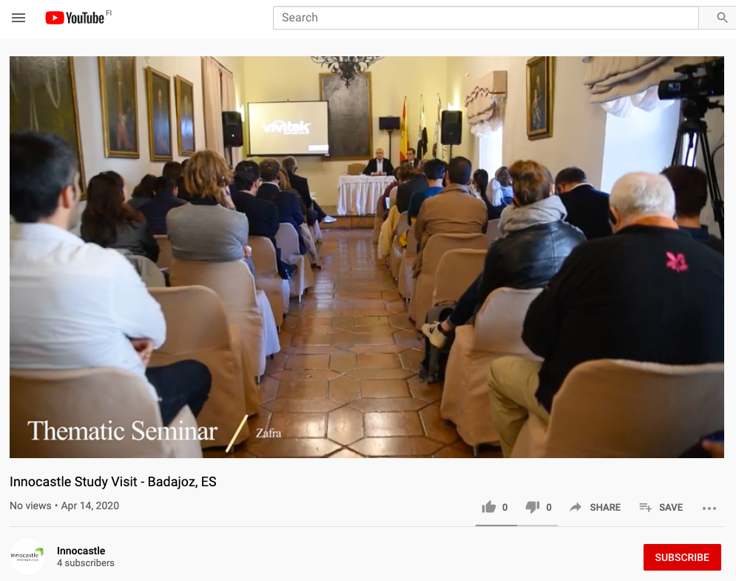

Link to the video of the study visit: https://www.youtube.com/watch?v=3oOR85v75So&feature=youtu.be

Appendix 2 Analysis of Participant Questionnaires

PGI05215 - INNOCASTLE
4th Study visit and thematic seminar (5-7 November 2019)
Badajoz, Alburquerque, Zafra, Medellín, Spain
Analysis of Participant Questionnaires

Delegates were invited to complete re- and post-study visit questionnaires as part of the organisational learning during the Innocastle study visit to Spain.

The following responses were received from participating partners, stakeholders and the project management team:

 | Romania | Belgium | Spain | UK | Netherlands | Eurodite | Total
Pre-study visit | 2 | 4 | 1 | 3 | 1 |  | 11
Post-study visit | 4 | 4 | 1 | 2 |  | 2 | 13

The key findings are summarised below. It should be kept in mind that quantitative scores are subjective and provided by the respondents. Qualitative comments are therefore important indicators for the performance of the project.

72% of the respondents did not have any professional contact with heritage experts or sites in Spain before the study visit. Participation in the programme therefore gave them the opportunity to connect and share experiences with Spanish colleagues and broaden their professional experience.

Pre-Visit Expectations

Before the study visit, delegates were looking forward to finding out how HCMEs are used for tourism purposes in Spain, particularly in the regional context. They were interested in learning more about Spanish policies regarding the sustainable management of HCMEs and how public authorities supported and facilitated their development. And how these could all feed into their own Action Plans.
Stakeholders were keen to find out about different approaches to heritage protection, and the different models of public and private bodies in the partner countries. They also wanted to understand the challenges faced by the other organisations involved in the project and the solutions they devise. Also
Our Spanish partners were looking forward to hearing from the group about best practices in state aid and tax issues relating to privately-owned HCMEs.

Key Takeaways from Spanish Study Visit

Key takeaways from the site visits centred on the following themes:

1. Paradors
We have separated out the Parador system of hotels and restaurants from the main section on rural tourism as delegates were all really interested in this. They were impressed by this network of luxury accommodation in converted historic buildings which they felt was:
- “An old strategy for touristic growth that still functions today” – Alexandru Mexi (National Heritage Institute, Romania)
- “The Parador network develops business strategies for touristic growth” – Lucia Leca (National Heritage Institute, Romania)
- “The Parador is a simple idea, it works well and helps a lot of heritage” –Bert de Roo (University College Ghent, Belgium)
- “It was interesting to hear about the pilgrimage routes connected to HCME and the Parador model” – Alina Tomescu (Eurodite)
- “A strong product, marketed as a group and emphasising the quality of the product” – Ian Grafton (National Trust, UK)
Several partners also felt that exploring this model could be useful in their own countries, particularly in Flanders and Romania.

“I was impressed by Parador in Zafra. I liked how the old building has been transformed into a luxury hotel, keeping the style and the value of the building. I have done a similar thing with a manor in my region, but after this experience, I would make different choices and I would focus more on the details like in Parador.” – Adina Dragu (National Institute for Heritage, Romania)

2. Rural tourism and cultural programming that simulates the local economy

The way public initiatives like the Merida Festival and the Parador network stimulate heritage tourism was very interesting to our delegates. It was also recognised that Spain is one of the world leaders in cultural routes and that these bring benefit to rural parts of the country. Particularly the Silver Way and the Mozarabic Route which can be combined with visits to castles.

Other examples of collaboration were also mentioned, such as the programme developed at Medellin between the International Festival of Classical Theatre and the castle. (Allying with another organisation with a strong presence in the media (the festival) is also a good way to ensure success.)
It was felt that the Medellin experience could be replicated in other regions, with estates joining forces – and not operating in competition. It was also agreed that combined cultural programming – both working with other HCMEs but also with other types of historical monuments, such as archaeological sites or theatres – was vital:

“At Medellin, with the Roman site, theatre and castle, is an interesting example of how the proximity of different monuments and their valorisation can create a point of attraction. Again, the festival of Merida presents an interesting case of cultural programming, taking into consideration a whole territory and not just one place. Sometimes it is necessary to think macro/at upper scale in order to be produce a cultural attraction which is strong enough.” – Adina Dragu (National Institute for Heritage, Romania)
It was also interesting for delegates to hear how most tourism offers work with local resources (food, people, etc) and work in seemingly equal partnerships that allow each side to benefit.

Accessibility was cited as a challenge to successful rural tourism initiatives. But when a castle becomes a destination, local economic benefit will follow:
“Croft has increased its visitor numbers 3-fold in the last 10 years, and this has driven local employment…local business for suppliers, hotels, petrol stations etc….a thriving tourist attraction will always help to drive the local economy … In Badajoz I visited the Museum of Archaeology within the castle walls but there was nowhere for me to donate…or buy a souvenir or any way to ‘put back’ towards the clearly expensive restoration works. One cannot be shy in asking people to contribute!” – Ian Grafton (National Trust, UK)

3. Connections between HCMEs and the surrounding environment

This is a theme that the Innocastle partners explored in detail during the Dutch study visit and it was good to explore it further in the Spanish context. There was some divergence of opinion on how this was being treated however. Some delegates expressed surprise at how sites were not well connected to their surroundings.

“There is a clear need to link the castles to the surroundings. The nature in Extremadura is amazing. The ‘Dehesa’ landscapes (type of multifunctional agroforestry and cultural landscape in central Spain) are loaded with beautiful castles. There should be more connections, routes, etc (and marketing).” – Joep de Roo (Eurodite)

Whilst others were impressed at how the surrounding landscape (be it agricultural, natural/wild, urban etc) was being used more and more as a tool for the promotion of heritage sites.
“The way in which, in some cases, the surrounding landscape – probably the most valuable asset of some HCMEs – is valued by the stakeholders and is used for promoting the HCMEs.” – Alexandru Mexi (National Heritage Institute, Romania)

“I thought that it was quite incredible to see the places where the traditional links between HCMEs and their surrounding landscapes remain intact. In many places where there are National Trusts, you hear about re-imagining the way that the landscape once looked or re-establishing the connections that once existed to the countryside. It was a real privilege and opportunity to see this living cultural landscape.” – Alexander Lamont-Bishop (National Trust, UK)

In any case, it confirmed to everyone the importance of “embedding the development of HCME in the broader landscape, intertwining both cultural and natural values” – Sylvie van Damme (University College Ghent, Belgium)

Delegates also talked about the surrounding communities. There was some concern expressed about how engaged and interested in their castles the local population were. There was a suggestion that it might be a good idea to interpret the repair works being undertaken in Badajoz. This could be a good opportunity to engage the community. It was also noted that local communities were not particularly empowered, and that heritage was something that was ‘done to them’, rather than something they might get really involved in decisions about.

4. Cooperation of local/regional authorities to support the owners and initiators

The cases visited during the study visit seemed to be very balanced, showing both good and bad examples of the ways local authorities were succeeding or failing to use HCME to successfully stimulate the local economy. Why for example, asked one of our respondents, is the castle in Alburquerque is virtually abandoned and the whole area is suffering, whilst in Medellín, the local authorities seem interested and active?
“I was struck by the fact that the attempts of transforming a castle into a youth hostel and then into a hotel failed that severely. I was not aware that the government effectively plays an important role in the success of these transformations.” – Sylvie van Damme (University College Ghent, Belgium)

“It seemed that owners were very much working in a silo way with little or no support from regional or local government.” – Ian Grafton (National Trust, UK)

However, the Parador system seems to be a great public initiative that has created an excellent model for the exploitation of HCMEs.

5.Partnership working

Another important theme in the Gelderland study visit was the importance of partnerships and this was echoed in Spain. Respondents underlined the need to join forces and work together, highlighting the events at Medellín that were spread across numerous estates.

However, there was also a feeling that partnership working did not come easy to other people, something which was shared amongst the other Innocastle partners.
“Most buildings in my region have the same problems as the ones in Spain. Where there are multiple owners of one building. And some of them want to rebuild or repair or transform in something with economical character and the other owners don’t want to. So, the building is deteriorating day by day.” – Nagy Tamas (Romanian Stakeholder)

Where the co-operative spirit is present, it was felt that it might welcome a ‘jump-start’! And that Innocastle might be the mechanism for facilitating that:
“The need for someone to facilitate informal meetings and communication between stakeholders was very visible. It was interesting to see how simply bringing stakeholders in the same room at the thematic seminar can lead to important discussions in restructuring the heritage instruments governing HCME. In this sense, the presentation of Georgina from the National Trust was very inspiring.” – Alina Tomescu (Eurodite)
“It seems there is relatively little cooperation among various stakeholders on HCME. That is why the Innocastle project can really make a difference.” – Joep de Roo (Eurodite)
Nagy Tamas (Romanian Stakeholder) advised our Spanish partners to consider establishing a national association of stakeholders.

6. Public-private initiatives

The Innocastle team felt that public-private collaboration is the best way to manage HCMEs in the future. “But much remains to be done in this area because in Extremadura, the vast majority of castles are public, and people do not dare to invest in them privately for fear of high maintenance costs and bureaucratic obstacles." – Cristina Cortés (Province of Badajoz, Spain)

The Parador model does provide a template for more public-private partnership however and respondents felt it could be built upon:
“It is noticeable that the government is able to bring these historic assets back into commercial use and I assume that this was facilitated by internal grants or tax breaks, but individual owners are not incentivised. Maybe this same model could be applied to the private sector to encourage these important buildings to be preserved?” – Ian Grafton (National Trust, UK)
However, whilst the Parador network functions very well, “when HCME are not connected to private partners or only partially funded, there is a danger that mistakes might be made, like at Alburquerque” – Bert de Roo (University College Ghent, Belgium)
There was felt to be some room for developing new models of public-private partnership and testing out new approaches.

7. Marketing, promotion and communications

The Innocastle partners were interested in cultural routes and Paradors as different ways of marketing and promoting HCMEs that could be used in other countries. They were also struck by how people were being engaged with HCMEs digitally, for example:

“A simple change in the name of a cultural objective can play a huge role in its (re)positioning for the public, the role of performative arts in bringing attention and interest for a monument.” – Adina Dragu (National Institute for Heritage, Romania)

“It was interesting to see the bloggers good practice in Extremadura and the very beautiful pictures. The Romanian presentation was very inspiring as well in that regard, involving young people and getting the message across to as many people as possible.” – Alina Tomescu (Eurodite)

Respondents agreed that each country and market is different but that there are some common principles. A simple suggestion was to use landscape as a tool for marketing and promotion:

“I could not help thinking of the way North Wales promotes itself….Snowdon….the Narrow-Gauge Railways….the 5 Big Norman Castles. Extremadura has such a rich and diverse range of castles that one wonders if a similar approach could be adopted there somewhere down the line for tourists who don’t want coastal Spain?” – Ian Grafton (National Trust, UK)

8. Financial and tax incentives

Respondents mostly seemed to feel that the Spanish tax laws looked rather complicated and that there are clearly some challenges to be faced. Such as making funding accessible beyond just protected domains and/or only for restoration work. And even though there are some tax benefits or incentives they are limited and considered too difficult to access (too many bureaucratic hurdles to jump!).

As we experienced on the Romanian study visit, there seemed to be little incentive for owners to earn money from their assets:
“It was an eye opener understanding Spanish tax laws and the impact it has on owners’ taxation once they begin to gain any income from their assets. This provides no incentive for owners to be entrepreneurial and help bring these historic assets back into good order. Or indeed back into the public domain.” – Ian Grafton (National Trust, UK)

However, Innocastle partners from Flanders and Gelderland were able to share good examples of financial support schemes. And there was enthusiasm for change that was currently being stifled by the Spanish tax laws as they are but “maybe with Innocastle’s vision and expertise this will change. The talk of using Luna Castle as a test bed for new ways of operating will pave the way.” – Ian Grafton (National Trust, UK)
As well as testing out new approaches, the need for better understanding of the socio-economic impact of investments in HCMEs was highlighted:
“There is a huge lack of data. More data on material and immaterial values would help to convince policy makers to invest time and make better support structures for owners.” – Joep de Roo (Eurodite)

9.Business planning

Many study visit participants spoke about the importance of proper business plans for each individual HCME. And the need to identify relevant uses, like the inter-disciplinary cultural programming at Medellin (heritage and the performing arts) or the commercial functions at Zafra.
It was frustrating to see the castle at Luna, with so many possibilities and having received so much investment, not currently used to its full potential. It demonstrated that collaboration and community involvement should have a more important role than simple financial investment.
Now however the plan is for local people to develop a temporary programme which might include nature watching from the towers, culinary events, lodging and the like. This temporary use for reactivating idle castles might be replicable in other countries and Luna could act as a testbed for that.
“A more efficient management of the castles should be achieved. Some, like Alburquerque are in perfect condition and yet not used. It is not profitable.” – Cristina Cortés (Province of Badajoz, Spain)

Some Learning Results
Learning from the visit was multi-layered and allowed participants to explore the Spanish cases, learn from each other and reflect on their own situation. They also made more contacts and built their personal and organisational networks.
- Levels of experience in heritage tourism at HCME stayed around the same at 2.5 beforehand and 2.6 afterwards; experience of government financial support schemes for HCMEs stayed at 2.5; and experience of public/private models for heritage management moved from 2.4 to 2.5.

- However, in terms of experience of transforming HCMEs for new uses rose from an initial score of 2.5 to 2.8 after the study visit.

- The question about familiarity with using HCMEs to stimulate the local economy elicited an average score of 2.4 before the study visit, rising slightly to 2.6 afterwards.

- Knowledge and experience marketing and promoting HCME rose from 1.8 to 2.3.

- The question showing a slight drop (noting that the pre- and post-visit surveys were completed by different individuals) was:
What is your current level of experience and expertise in regard to partnership working for HCMEs?
Respondents rated themselves 2.9 at the beginning of the study visit and 2.8 afterwards.
- Overall participants registered an increased familiarity with heritage laws and policies in Spain, with the number of respondents answering “yes” to the question:
Are you familiar with heritage laws and policies in the Spain?
rising from 18% to 54% over the course of the study visit.
- And respondents noted a 50% increase in professional contact with heritage experts or sites in Spain after the study visit.

Action Plans

The visit gave further opportunity to think ahead to the formulation of Action Plans. In response to the question, “What did you learn from the Spanish Study Visit that will help you as you develop your Action Plan?”, respondents referred to issues regarding:
- Parador model
- Need to connect HCMEs with their surrounding environment
- Important to involve specialists as well as local and regional stakeholders in the development of Action Plans
- Vital to have cooperation of local/regional authorities in support of the owners and initiators
- Different tax regimes require different ways of managing HCMEs
- Need for a vision for HCMEs in a regional context
- Need for good socio-economic data of the value of investing in HCMEs
- Need for proper business plans for every individual site – and relevant uses
- Potential of temporary use for (re) activating idle castles

And finally
Bert de Roo (University College Ghent, Belgium) noted in his questionnaire that although the legislation, situation and types of buildings may differ, overall, owners of HCMEs in Spain struggle with very similar issues to their colleagues in Flanders: maintenance costs, heating difficulties, continuity of use and care …

