2nd Local seminar

Event report and monitoring
[REGION of EPIRUS]

Venue | Region of Epirus - Meeting room 240
Date | 24.06.2019
Number of people attending | 15
Type of Stakeholders involved (categories) | - Technical Champer of Greece  - Director of Environment & Spatial planning  - Local construction companies  - National construction company  - PV expert  - Forester  - Bioenergy company  - Managing Authority of Epirus  - National Electric company  - Project manager of Municipal Solid Waste Plant  - Center of Renewable Energy Sources (CAPE)  - Region of Epirus staff
Total number of representatives of the types of stakeholders involved | 12

Agenda of the event
AGENDA
2nd Local Seminar
Ioannina, 24.06.2019

- 9:00 – 9:10 Welcome
- 9:10 – 9:45 Introduction of the RESOR project (for new stakeholders), its partnership, its objectives and activities.
- 9:45 – 10:30 Presentation of project's good practices from 1st and 2nd Study Visits
- 10:30 – 10:45 Short break
- 10:45 – 11:45 Discussion with the stakeholders about Epirus good practices (experiences/viewpoints/suggestions)
- 11:45 – 12:15 Discussion with the stakeholders about next steps, future activities and next Study Visit in Cyprus
- 12:15 – 12:30 Closing of the 2nd Local Seminar

Picture of the event

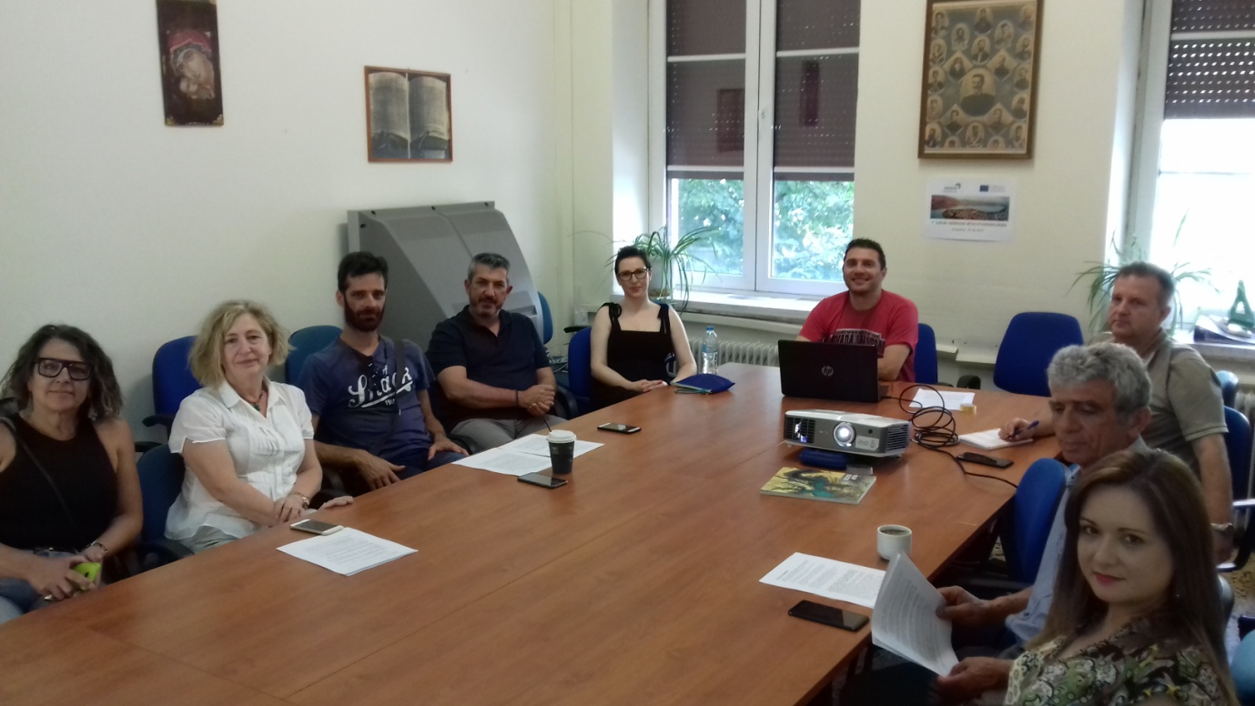

Event assessment

Overall how would you rate the success of this specific event?
X very successful
☐fairly successful
☐not too successful
☐not successful at all

Please briefly describe the event including:
- Main experiences, viewpoints and suggestions of stakeholders on existing regional measures, projects, initiatives on energy efficiency and use of renewable energy, their effectiveness and impact.
- Main specific needs and constraints identified by stakeholders for the promotion of energy efficiency and use of renewables in companies in the region.
- Best practices / examples proposed directly by stakeholders, if any.
- Views / suggestions on the measures / policies / good practices identified in other regions.
- Specific relevant comments made by representatives of the different types of stakeholders involved on the regional analysis.
- Facilitation techniques used, if applicable (ex: brainstorming, role playing, storytelling, etc)

RESOR project was discussed between the program project team of Region of Epirus, the stakeholders who were presented at the 1st local seminar and the stakeholders who were not presented at the previous meeting. The new stakeholders present themselves, their companies and the possibilities of their involvement. We had a fruitful discussion with them about regional measures, projects, initiatives on energy efficiency and the use of renewable energy, their effectiveness and impact in our Region and we came to the conclusion that there is plenty of room for improvements in energy efficiency sector in our area.
Then, there was a presentation of the results of the 1st and 2nd Study Visits in Las Palmas de Cran Canaria and in Madeira with the visits (good practices), within the involved companies there. We also presented them the good practices from the other partners of the program. Stakeholders had lots of questions about how these companies handle the energy efficiency issues, for the financial instruments of these investments and the possibility of implement similar good practices in our area. They also found that some of the good practices are quite remarkable to transfer them in our Region as well.
We discussed with them about the prospect of bringing us in our next meeting some good practices in order some other regions are going to benefit from them.
We informed them about the next steps of the program (next study visits, the chance to present some of their good practices to other partners) and also what we expect from them at this stage of the program. The stakeholders were very positive about the program and expressed their wiliness to transfer their good practices to our partners during our next study visits.
We finally concluded this 2nd local seminar with the promise to have another one meeting with more stakeholders (if possible) involved, so as to discuss the results of the next semester and the progress of finding good energy efficiency practices.
Finally, we informed them about the next study visit in Cyprus next September and we ended up with the stakeholder who is going to accompany staff of the Region of Epirus in order to attend the 3nd Study visit.

Please briefly describe main success and difficulties related to this specific event, if any. Please provide suggestions for similar or future events (including improvement you would like to apply already in the next local group events you will organize in the framework of RESOR), if any.

It was a successful local seminar with the stakeholders. We informed more stakeholders about this meeting, but due to conditions (in between National elections, summer with high temperatures) they could not participate. Of course, their number was satisfactory (12) and we believe that with the directions that Region of Epirus gave to the existent stakeholders, they are going to provide us with some good practices.

