Engaging More Businesses in International Trade

in Coventry & Warwickshire

Engaging more businesses in international trade is an important enabler in increasing the competitiveness of Coventry & Warwickshire’s economy. Although the West Midlands delivers the high volume of exports of any UK region outside London, and Coventry & Warwickshire (CW) has the highest proportion of businesses exporting in the West Midlands region (15.6%), we recognise the need to engage significantly more of our SMEs in international trade if the UK Government’s target of raising the value of exports to 35% of GDP from a base position of 30% is to be achieved. The need to target SMEs is evidenced by the fact that nationally, just one in five small businesses and less than one in ten micro businesses export.

In response to this need, flagship local ERDF programmes have been actively working with specialist partners to raise awareness of opportunities presented by international trade. For example, CW Business Support (funded through ERDF Priority 3) has actively developed closer relationships with Department for International Trade and referred SMEs with international trade potential to this body at an early stage, and potential to service major overseas contracts is also just one of the factors considered when determining the allocation of capital grants to enable SMEs to purchase equipment or upgrade premises. CW Innovation Test Bed (ERDF Priority 1) has been active in supporting the development and testing of new products, services and technologies that demonstrate potential to service international markets, both from the standpoint of 1:1 support and its grant fund, and has also actively referring SMEs to schemes supporting process innovation to help boost international competitiveness. CW Green Business (ERDF Priority 4) is also actively supporting SMEs to develop new low carbon products which longer-term could have exporting potential. Across the three programmes since January 2019, some 50 SMEs have already been supported to access international market opportunities, and this figure is expected to rise before the programmes end in June 2023 given our continued work to support local SMEs to innovate, diversify and expand.

Two examples of Coventry & Warwickshire businesses that have successfully been supported:

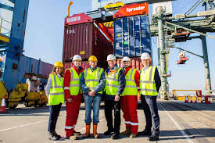
- BLOK Container Systems started in 2016 to improve the handling efficiency of shipping container ports by speeding up the loading and unloading of containers using an innovative lifting system which allows containers to be lifted in blocks of four and will fully integrate with existing port infrastructure. Improving the speed at which ships can be turned around at port will also help shipping lines to consider slow sailing which will massively reduce carbon emissions. To advance the R&D, BLOK were awarded £100k of ERDF funding from CW Innovation Programme, which enabled them to develop prototype products and test successfully at a major UK port, and seek to protect their intellectual property. BLOK is now working with Department for International Trade to market their new system to shipping container ports across multiple continents.

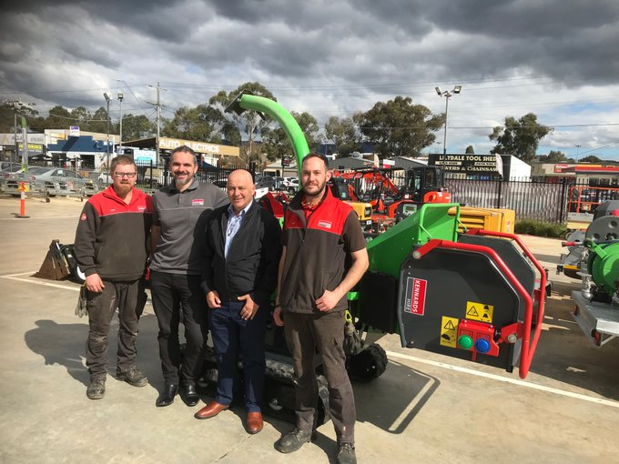
- GreenMech is an established manufacturer of wood chippers and shredders which they supply to the global market. They been supported by CW Innovation Programme to develop an innovative chipper shredder with enhanced capabilities using their disc blade technology, and were awarded £17k to develop and test a prototype product which has the potential to bring several environmental benefit target markets in the Asia-Pacific region. GreenMech has been supported by the Department for International Trade and is now exploring the possibility of using grants funds from CW Business Support Programme to improve their manufacturing efficiency with new machinery.

Prepared by Sarah Barsby, CUE

