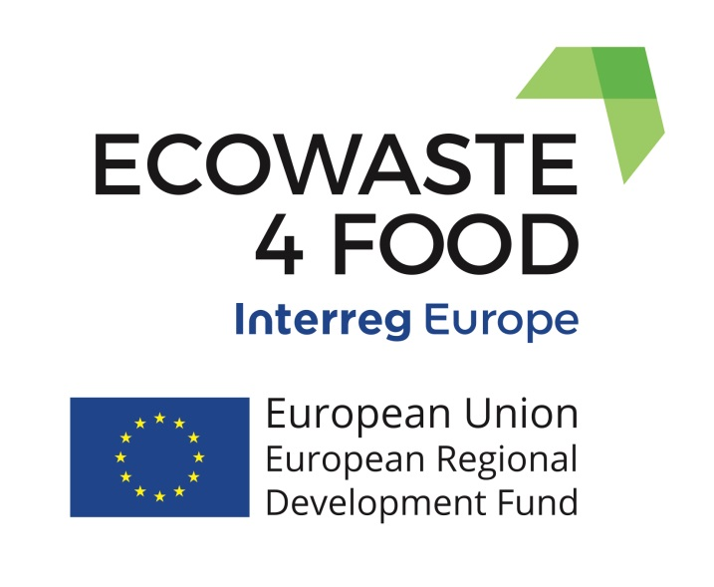

Monitoring the Action Plan Implementation

Example from the Region of Catalonia

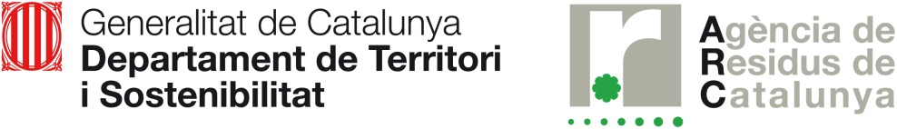

GENERAL CONTEXT
The action plan (AP) was drawn up in Catalonia following the exchange of good practices and experiences between the different regions and cities participating in the project. It was built on the following aspects:
- Identify the main challenges in Catalonia to tackle food waste.
- Identify good practices from other regions to respond to these challenges.
- Formulate an AP with the direct participation of the stakeholder group bringing together representatives of all actors in the food chain with a quadruple helix approach (companies, universities and research, environmental and social entities and public administrations).
As a result of this work, the AP consists of six actions answering six main challenges. These actions are divided into several sub-actions or projects to better perform the execution. Due to the fact that most stakeholders are involved in one or more of these sub-actions, they should be also an active part in the process of monitoring the implementation of the AP.
Find the extend AP here: https://www.interregeurope.eu/fileadmin/user_upload/tx_tevprojects/library/file_1557761067.pdf

THE MONITORING TOOL IMPLEMENTED

Methodology description
The main objectives of the action plan monitoring process are:
- Quantitatively evaluate the degree of execution of the action plan
- Quantitatively evaluate the results obtained with the indicators
- Obtain information of interest to improve action
- Have data for internal and external communication of the action taken.
The monitoring is based on the participation of all the stakeholders involved to a greater or lesser degree in the implementation of the AP and in the application of a common methodology that allows to add the results of the different projects / sub-actions carried out.
Once the AP has been designed and approved, the implementation and monitoring cycle throughout the year takes into account the following elements:
- Annual programming: the priority of implementation, the calendar and the information generated in the monitoring by the action plan allow to make an annual programming of the actions that will have to be coordinated with the budgetary forecasts.
- Execution: during the year, the scheduled projects are carried out.
- Calculation of indicators: provides information on the achievement of the improvement objectives set out in the action plan.
- Project evaluation: provides information on progress in the implementation of the action plan.
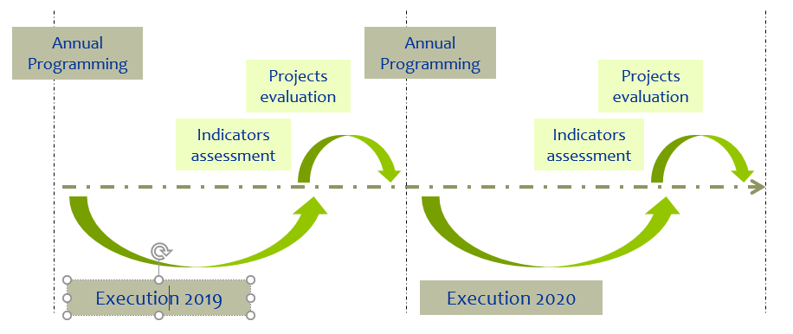
Fig. 1 Annual execution and monitoring cycle

Projects / sub-actions can be very diverse in nature, which is a challenge in quantifying the evaluation of the action plan and giving it objectivity. It is necessary to establish a clearly systematized procedure and reference criteria for the evaluation process.
For each of the projects / sub-actions, the degree of implementation is assessed by assigning a specific category - Pending start (P), Started (S), Ongoing (O), Advanced (A), Completed (C). Each category is associated with a numerical value that allows to obtain quantitative results of the degree of implementation of the whole plan. This numerical value or weighting factor for each of the mentioned categories will be:

(P) Sub-actions/projects pending start: 0
(S) Sub-actions/projects started: 0,25
(O) Ongoing sub-actions/projects: 0,5
(A) Advanced sub-actions/projects: 0,75
(C) Sub-actions/projects completed: 1

From the assignment of these numerical values to each of the actions, the degree of implementation of the Action Plan would be calculated from the following operations:

AP Implementation degree = [[(P * 0) + (S * 0.25) + (O * 0.5) + (A * 0.75) + (C * 1)] / N] x 100

where:
P: number of sub-actions/projects pending start
S: number of sub-actions/projects started
O: number of ongoing sub-actions/projects
A: number of advanced sub-actions/projects
C: number of sub-actions/projects completed
N: total number of actions

Process preparation
From the distribution in percentage of the actions according to categories and their weighting, an indicator of the degree of global implementation of the Plan is obtained (%), which can be segmented according to different variables.
The process is developed following the following phases:

- Creation and sending of the questionnaires to all the agents involved in the evaluation of the PA. The questionnaires are specific to each agent taking into account those sub-actions in which it actively participates.
- Establishment of an extended period to facilitate the answer and identification of an interlocutor for the resolution of doubts.
- Compilation of responses, dumped in a database or joint spreadsheet and review of data for the identification of errors or inconsistencies.
- Data processing for obtaining aggregate indicators and for calculating the degree of implementation of each of the actions of the PA and analysis of the results.
- Communication of results internally with the presentation and discussion with the stakeholder group and externally through a press release or other equivalent resources.
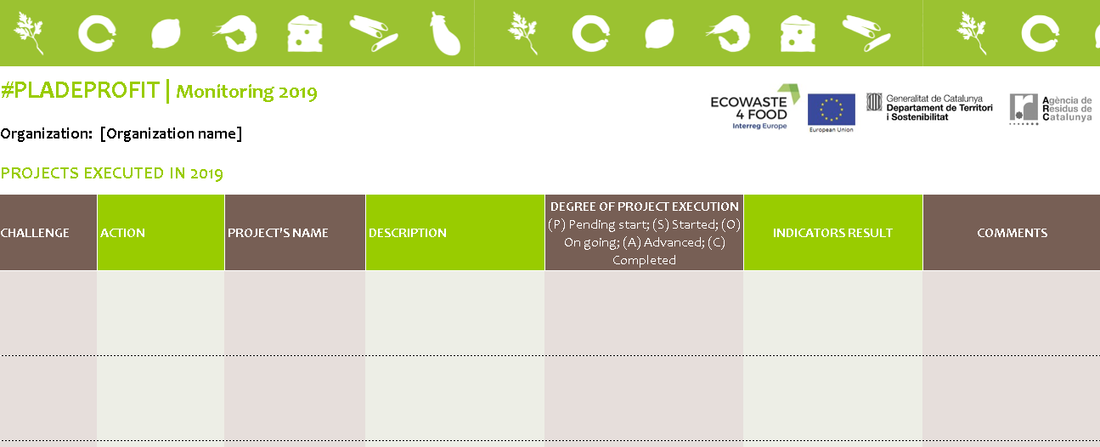
Fig. 2 Example of the specific form

Example of results based on the implementation of the AP in 2019
The results of the monitoring of the AP implementation in Catalonia within the Ecowaste4food project are:

The overall performance level of the Action Plan is very positive and reaches 63% in 2019. It emphasizes the implementation of awareness projects.
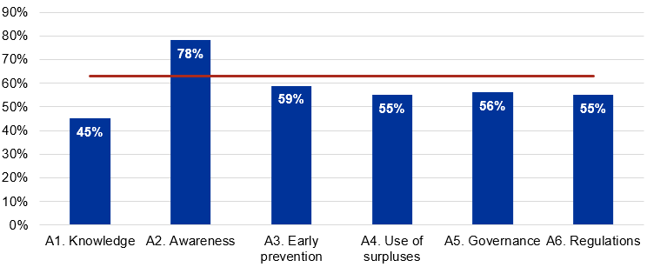

54% of the projects are advanced or finalized in 2019. 87% are in execution.
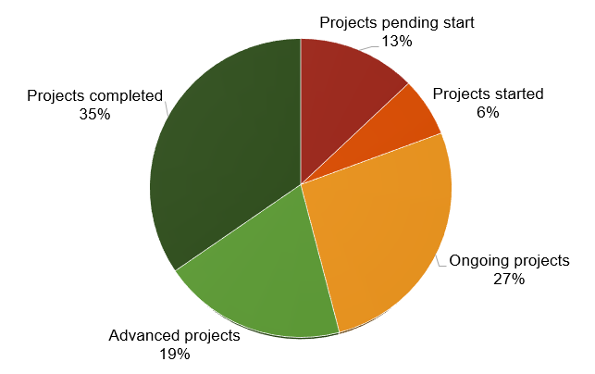

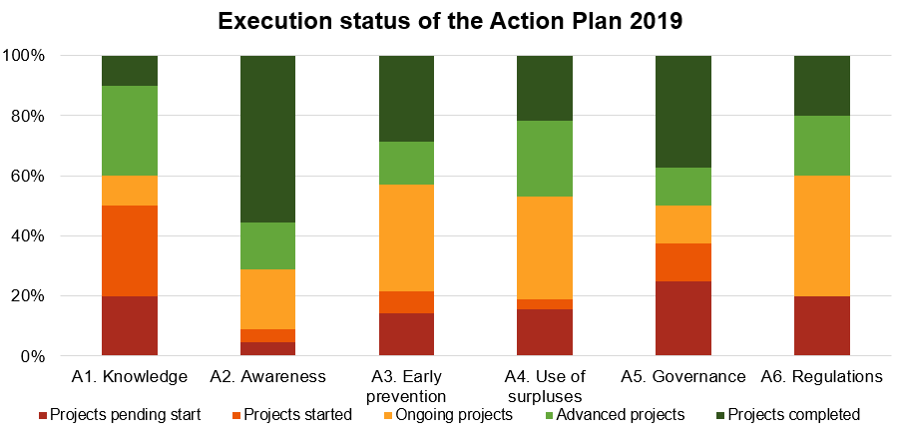

LESSONS LEARNED
The main lessons learned during this process have been:
- In the face of complex issues that cannot be addressed unilaterally, it is very important to have the involvement of members of a broad and representative stakeholder group.
- It is very convenient to take into account the participation of the SH group in all phases of the process: learning and exchange, identification of challenges, design of the action plan and, finally, also in the monitoring of the implementation of the PA.
- It is operational to define a simple monitoring methodology and at the same time that it can be applicable to the different profiles of stakeholders and different types of actions. In this way individual results can be obtained as well as aggregate results that reinforce the idea of common task among a wide variety of stakeholders that are needed from their different points of view.

Project: ECOWASTE4FOOD
Partner organization: Waste Agency of Catalonia (ARC)
Country: Spain
NUTS2 region: Catalonia
Contact person: Míriam González
email address: mgonzalezd@gencat.cat
phone number: +34 93 567 33 00
Date: 23/06/2020

