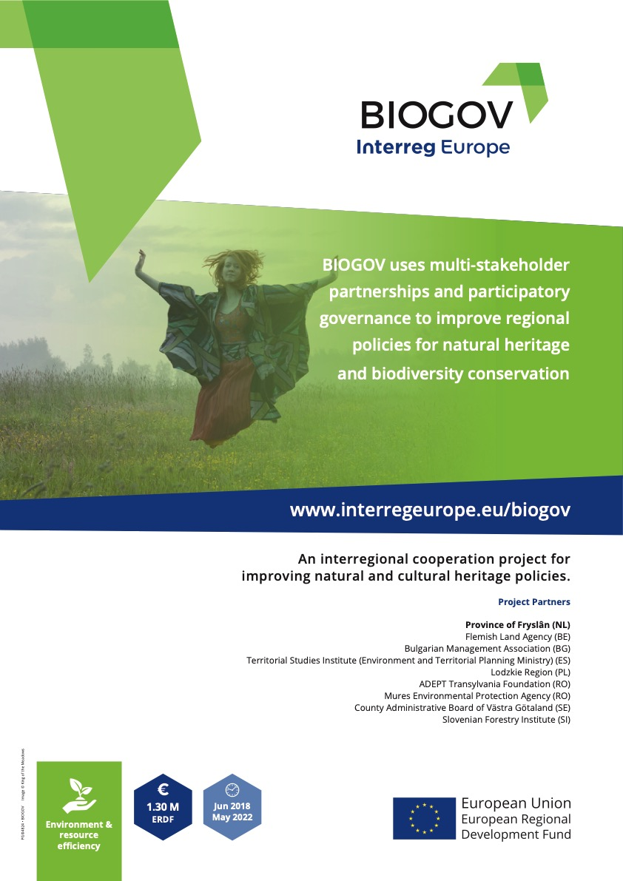

**(draft) Action Plan BIOGOV**

**2020–2022**

Version 4

October 2020

**BIODIVERSITY**

**GOVERNANCE**

**Improving regional policies for natural heritage and biodiversity conservation through Multi-Stakeholder partnerships and participatory governance**

**MURES ENVIRONMENTAL AGENCY ADEPT TRANSILVANIA FOUNDATION**

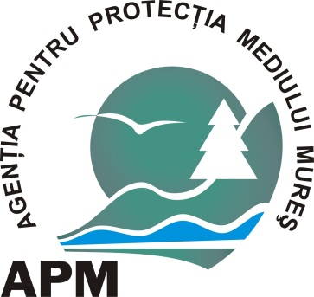



### Project: BIOGOV

Partner organization: EPA Mures & ADEPT Transylvania

Region: Mures

Country: Romania

NUTS2 region:

Contact person:Laura TODORAN (EPA Mures),Razvan Popa (ADEPT)

Email address: laura.todoran@gmail.com, [poparazvand@yahoo.com](mailto:poparazvand@yahoo.com)

Phone number: 0040752300675, 0040752264592

### Part II – Policy context

The Action Plan aims to impact:

Investments for Growth and Jobs of the European Territorial Cooperation programs

XxX

Other regional development policy instruments

Biodiversity governance

### **Improving regional policies for natural heritage and biodiversity conservation through Multi-stakeholder partnerships and participatory governance**

Between June 2018 - May 2022 BioGov project will focus on LIOP (Large Infrastructure Operational Programme), with the aim of influencing the management of 2000 hectares of ecological corridors in county Mures (Romania), outside the protected areas, through a good collaboration of all the stakeholders. The work is carried out using a partnership process with several stakeholders.

A regional stakeholder group (RSG) participating in the project has been formed in a broad stakeholder meeting since October 2018.

We identified which stakeholder groups should be involved and who should represent each perspective, a collaborative working group consisting of 20 participants was created. The group covers both public institutions and authorities as well as farmers and land owners.

The meetings have been characterized by the 7 principles that makes a multi-stakeholder partnership process efficient.

…………………………………………………………………………………………………………

### **This action plan:**

- has been adopted and accepted by the Regional Stakeholder Group

**ACTION PLAN**

**BIOGOV 2020-2022**

**Action 1**

Identification of ecological corridors in Mures County using the information developed in the draft methodology proposed by Connect Green project – also an Interreg project implemented by WWF and partners;

The RSG has identified 2000 ha of ecological corridors, outside the protected areas and will use the information developed in the Connect Green project for monitoring and conservation of measures for ecological corridors together with EPA Mures and ADEPT Transylvania Foundation. The next phase will be to validate the existence and functionality of the ecological corridor in the field (which includes mapping and monitoring).

**Action 2**

Participation in the technical Working Group to develop the national legislation: methodology for inventorying, monitoring and conservation of green corridors in Romania. This will be the basis for developing new legislation at national level for green corridors conservation and will be done together with the policy makers, experts and other projects;

The methodology and legislation for ecological corridors needs to be developed. EPA Mures and ADEPT Transylvania Foundation are part in the technical working group at national level to develop the national legislation together with the policy makers, experts, and other projects experts. Currently, there is no methodology for inventory, monitoring and implementing management conservation measures for ecological corridors in Romania.

**Action 3**

Communication, awareness raising and involvement in activities carried out on two levels: meetings with national stakeholders and local communities. Face-to-face meetings, on the farm level and with landowners. Results will be communicated trough BIOGOV communication instruments: press, social networks.

EPA Mures and ADEPT Transylvania Foundation will organize information action at local, regional and national level about the importance of ecological corridors in the nature conservation and why it is necessary to maintain and conserve the ecological corridors.

**Action 4**

Developing possible compensatory schemes for conservation of ecological corridors

EPA Mures and ADEPT Transylvania Foundation will identify new financing schemes for the conservation of the ecological corridors through the Common Agriculture Policy (CAP) or the Operational Program for Large Infrastructure (LIOP).

**Action 5**

Designation of ecological corridors at local and regional level, according to experience identified at local level, GIS studies or other methodology that can be accepted. The ecological corridor identified in BIOGOV project needs to be part of a national or regional strategy for ecological corridors conservation.

After consultation and participating in working groups, EPA Mures and ADEPT Transylvania Foundation will try to transpose the proposed legislation for ecological corridors into local, regional and possibly national laws, guides or strategies. The action is an ongoing activity and it is still in development and consultation with all actors.

**Action 6**

Initiating collaboration at institutional level with EPA’s from counties neighboring Mures, the National Agency of Protected Areas, and with the Management Authority within the Ministry of Agriculture & Rural Development to identify compensatory schemes for farmers and land owners for the conservation of ecological corridors at larger scales.

EPA Mures and ADEPT Transylvania Foundation has started the collaboration at institutional level with the National Agency of Protected Areas, with EPA’s from counties neighboring Mures and with the Management Authority within the Ministry of Agriculture &Rural Development because compensatory payments should be introduced for farmers and land owners.

|  |  |
| --- | --- |
| **Part III – Details of actions envisaged** | |
| **Action 1** | ***Identification of ecological corridors in Mures County using the information developed in the draft methodology proposed by Connect Green project – also an Interreg project implemented by WWF and partners;*** |
| **1. Background** | ***For the minimum of 2000 hectares of ecological corridors already identified outside the protected areas in Mures county, RSG, EPA and ADEPT will search for conservation measures from the experience from other projects and experiences.*** |
| **2. Activities** | The RSG an ecological corridor of 2000 ha outside of protected areas. Based on expert opinion within the RSG, the corridor has been validated. However, for making sure that the corridor is functional, its validation in the field will be required (the ConnectGreen methodology will be used for this purpose). Conservation measures will need to be developed later on for the corridor within the RSG, under the coordination of EPA Mures and ADEPT Transilvania Foundation. |
| **3. Players involved** | The collaborating parties are EPA Mures , ADEPT Transylvania Foundation with territorial administrative like EPA Harghita - from the area of ​​2000 hectares of ecological corridors as well as farmers and landowners. |
| **4. Timeframe** | The implementation period is 2019-2020 |
| **5. Cost** | The delimitation of 2000 hectares of ecological corridors, outside the protected areas does not require specific funds. We will participate in all relevant working groups that can help with the conservation objectives of ecological corridors. |
| **6. Funding sources** | Other future projects, especially for monitoring and implementation of specific management measures. |
| **7. Lessons learned from BioGov** | In Sweden we have seen models for conservation of ecological corridors. This information and models will be used in our project activities as a model for our stakeholders.  The progress on setting-up ecological corridors requires more steps: spatial data monitoring that should lead at valuable maps, analysis of the natural and human made possible corridors and barriers.  There should be a national strategy adopted at national level that shall impose that above analysis should be carried-out in relation to the natural protected areas. The strategy should lead at the consolidation of the existent management plans for protected areas and, further on, at imposing rules/recommendations on how shall be issued the environmental permits for constructions and the environmental authorizations for running the existent economic activities (conclusion from the peer review report) |

|  |  |
| --- | --- |
| **Part III – Details of actions envisaged** | |
| **Action 2** | *Participation in the technical Working Group for developing the methodology for inventory, monitoring and conservation of green corridors in Romania. This will be the basis for developing the legislation at national level for green corridors conservation and will be made alongside the policy makers and other project experts.* |
| **1. Background** | EPA Mures, Adept Transylvania Foundation *want to try to be part in the technical WG at national level to develop national legislation together with the policy makers, experts, and other project members because in Romania there is no methodology for inventorying, monitoring and implementing management conservation measures for ecological corridors in Romania.* |
| **2. Activities** | The national Working Group for developing the methodology for identifying and designating ecological corridors in Romania, thanks to BioGOV. This national WG has been re-initiated by the Connectgreen project and considering the synergies of this project with BioGOV, joint efforts will be made to advocate for the existence of this Methodology.  On the other hand, Adept Transylvania Foundation is also part of other relevant WGs at national level (e.g. for improving the CAP). Together with EPA Mures and through BioGOV, we will make sure that in Romania the LIOP (POIM) will also consider the needs for identifying, designating and managing ecological corridors. |
| **3. Players involved** | EPA Mures, Adept Transylvania Foundation ,policy makers, experts, and other relevant projects. |
| **4. Timeframe** | The implementation period is 2020-2022 |
| **5. Cost** | ---- |
| **6. Funding sources** | Other future projects, especially for monitoring and implementation of specific management measures |
| **7. Lessons learned from BIOGOV** | It is very important it is to involve, from the beginning all relevant stakeholders taking in consideration the multi-stakeholder analysis. |

|  |  |
| --- | --- |
| **Part III – Details of actions envisaged** | |
| **Action 3** | ***Communication, awareness raising and involvement in activities to be carried out on two levels: meetings with national stakeholders and local communities and face-to-face meetings, on the farm level and with landowners. Results will be communicated through BioGov communication instruments: press, social networks, etc.;*** |
| **1. Background** | ***EPA Mures and Adept Transylvania Foundation*** are going to carry out actions to disseminate and promote knowledge, as well as to inform at local and national levels the importance to maintain and conserve the ecological corridors and their contribution to the conservation of biodiversity and maintaining ecosystem services at landscape level***.*** |
| **2. Activities** | EPA Mures and Adept Transylvania Foundation will inform local and national communities about the importance of ecological corridors in the conservation of biodiversity and why it is necessary to maintain and to conserve the ecological corridors***.*** |
| **3. Players involved** | EPA Mures and Adept Transylvania Foundation in cooperation with local stakeholders |
| **4. Timeframe** | The implementation period is 2020-2022 |
| **5. Cost** | The amount will be detailed later |
| **6. Funding sources** | EPA’s own funds + ADEPT other projects funds |
| **7. Lessons learned from BIOGOV** | The importance of awareness raising at local, regional and national level when new conservation measures are developed. |

|  |  |
| --- | --- |
| **Part III – Details of actions envisaged** | |
| **Action 4** | ***Developing possible compensatory schemes for conservation of ecological corridors.*** |
| **1. Background** | EPA Mures and Adept Transylvania want to find compensatory schemes for the conservation of the ecological corridors through the Large Infrastructure Operational Program (LIOP) or the Common Agriculture Policy (CAP). Basically once the legislation regarding the ecological corridors is improved and the methodology for identifying and designating ecological corridors adopted and enforced, in the technical working groups we will push for e.g. compensatory, payment and other schemes and means to secure the ecological corridors. Farmers should be motivated to contribute to the conservation of corridors at local and regional level, according to the experience gathered at local (Mures) level, including GIS analysis and other relevant means which should be part of the methodology at national level. The ecological corridor identified in BioGov project needs to be part of the national network of ecological corridors and lessons learned included in a potential strategy for conserving ecological corridors***.*** |
| **2. Activities** | Participation in the working groups, EPA Mures and Adept Transylvania Foundation will try to improve the national legislation for ecological corridors, but also the legislation at local and regional levels and to transpose it into guidelines and/or strategies. This action is an ongoing activity and it is still in development and consultation with all actors. The lessons learned from the identification of the ecological corridors in Mures County into the national, but also local and regional legislation related to ecological corridors. The know-how acquired during the BioGOV project will also be included in relevant strategies or other documents concerning the conservation of ecological corridors. |
| **3. Players involved** | All stakeholders |
| **4. Timeframe** | To be implemented by the 2020 - 2022 |
| **5. Cost** | 2500 Euros. |
| **6. Funding sources** | EPA’s own funds + ADEPT other projects funds |
| **7. Lessons learned from BIOGOV** | |  | | --- | | Compensatory payments have been developed in Sweden and all experiences have been collected from the discussions with our Swedish partners.  • EPA Mures and Adept Transylvania Foundation will consider larger areas than analized area and more economic activities (including infrastructure and constructions).  • A strong monitoring system is needed (spatial analysis) for identifying the core biodiversity areas (including fragmented landscape and biodiversity isolated hotspots)  • Roads and other type of infrastructure have an important value for connecting habitats and species, along their route. Identification of valuable species and preparation of recommendations will be part of the Strategy. | |

|  |  |
| --- | --- |
| **Part III – Details of actions envisaged** | |
| **Action 5** | ***Designation of ecological corridors at local and regional level, according to experience identified at local level, GIS studies or other methodology that can be accepted. The ecological corridor identified in BioGov project needs to be part of the national strategy for ecological corridors conservation*** |
| **1. Background** | ***After consultation and participation in the working groups, EPA Mures and Adept Transylvania Foundation will try to transpose the proposed legislation for ecological corridors into local, regional and possibly national laws, guides or strategies. This action is an ongoing activity and it is still in development and consultation with all actors.*** |
| **2. Activities** | Transposition the proposed legislation for ecological corridors into local, regional and possibly national laws or strategies. |
| **3. Players involved** | EPA Mures and Adept Transylvania Foundation in cooperation with Mures County Council and local stakeholders. |
| **4. Timeframe** | To be implemented by 2022 |
| **5. Cost** | 2000 Euros. |
| **6. Funding sources** | EPA’s own funds + ADEPT other projects funds |
| **7. Lessons learned from BIOGOV** | Networking and consultations are very important subjects in developing of nature conservation measures in a multi-stakeholders process. |

|  |  |
| --- | --- |
| **Part III – Details of actions envisaged** | |
| **Action 6** | ***Initiate collaboration at institutional level of EPA Mures with EPAS neighboring counties, the National Agency of Protected areas and with the Management Authority within the Ministry of Agriculture & Rural Development to identify compensatory schemes for farmers and landowners for the conservation of ecological corridors at a larger scale.*** |
| **1. Background** | *The collaboration at institutional level between* EPA Mures with EPAs from the neighboring counties, *the National Agency of Protected Areas and with the Management Authority within the Ministry of Agriculture &Rural Development* to identify joint measures and actions to conserve ecological corridors at different scales, including the development of compensatory schemes for farmers and landowners*.* |
| **2. Activities** | Trying to promote and/or introduce compensatory payments for farmers and land owners. |
| **3. Players involved** | EPA Mures and Adept Transylvania Foundation in cooperation with policy makers. |
| **4. Timeframe** | To be implemented by the 2022 |
| **5. Cost** | 1800 Euros. |
| **6. Funding sources** | EPA’s own funds + ADEPT other projects funds |
| **7. Lessons learned from BIOGOV** | The importance of working together with local, regional, public authorities, farmers associations, landowners and other relevant stakeholders. This process of consultation requires participating in different consultation meetings and working groups. It is an ongoing process and it takes time because it is also a learning experience for all parts. |