WHAT PROJECT EPICAH BROUGHT TO THE CZECH-BAVARIAN BORDER TERRITORY
-
LESSONS LEARNED

Regional Development Agency of the Pilsen Region (Pilsen, Czech Republic)

Report: 2021

We are especially proud that thanks to the EPICAH project we were able to bring expert knowledge and innovative approaches on how to improve cross-border cooperation to our region. Further, we were able to pilot the realization of specific events and activities whose aim was to apply such approaches in our Czech-Bavarian territory.
Thank the gained knowledge we are developing together with our German partner (Centrum Bavaria Bohemia) an idea of establishing a kind of “cross-border think-thank that would pay attention to coordination, capitalization, and communication cross-border activities in more formal and long-term standards. We hope to present a concept of such think thank to relevant stakeholders during 2022 and realize it as soon as possible.
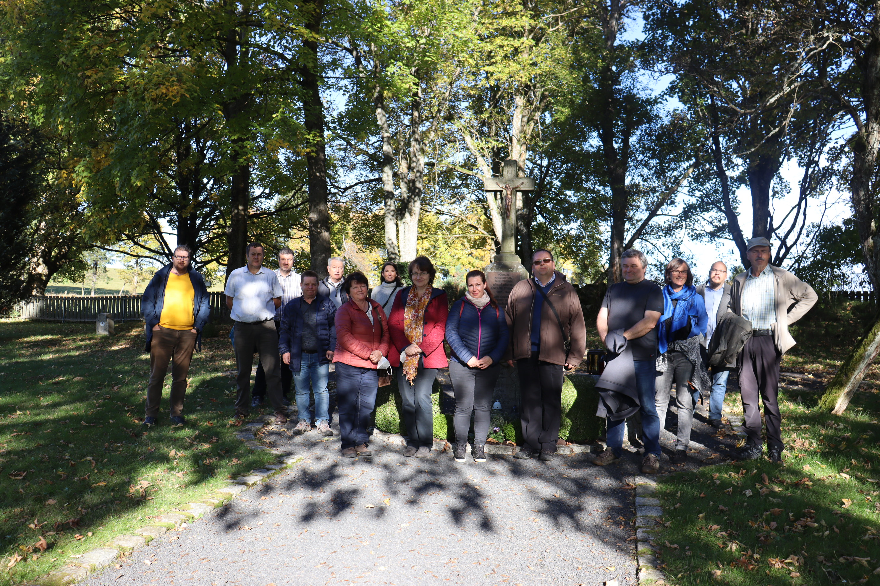
Next, we are happy that we helped to develop a relevant web platform for the long-term presentation of interesting projects’ results and to improve the capitalization process in our territory. It is an online magazine of good practices of the Association of the Municipalities of the Pilsen Region – the new version of the web will be hopefully launched in February 2022.
Based on good practices gained within the EPICAH project and following activities of we prepared together strategy, that is based on the following principles:
- It is necessary to create one platform for the presentation of the interesting good practices financed by all PI relevant for the target group (in this case for municipalities).
- The regional scope of the presented good practices should be cross-regional, and also cross-border. Success does not know borders and people are used to living their lives and learning in wider contexts. Such conception brings to the projects (and therefore to PI) attention of wider target group and the communication instrument (the web magazine) will become more powerful.
- It is useful to present not only basic information about the projects (partners, budget, time plan, main objectives, …) but the emphasis must be placed on the “specific results/outputs” that can be easily taken over by the target group.
- The projects’ results/outputs should be presented not in a formal way, but the principles of modern media should be applied (storytelling, infotainment, pictures, videos, podcasts, ….).
- The good practices must be published regionally and thematically in a balanced, regular, continuous, and long-term manner.
