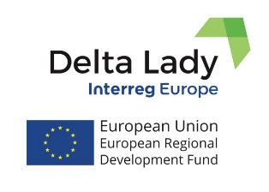
Press Release
May 2022

DELTA LADY PARTNER MEETING IN FRIESLAND
Action Plans and progress with their implementation

Delta Lady Partner Meeting of Phase 2 took place in the Province of Friesland in the Netherlands on May 10-11, 2022. After two years of online meetings, project partners finally met in person in the city of Leeuwarden in the Provincial House of Friesland to exchange the progress in the implementation of their Action Plans. Partners also visited the Afsluitdijk, which is a major dam between Friesland and North Holland, and where one of the Good Practices of the Province of Friesland takes place (Fish Migration). 17 participants including 4 stakeholders from Spain, Romania and the Netherlands, attended the meeting on the first day. Partners and stakeholders presented the progress in the implementation of the Action Plans. Moreover, the progress with the Pilot Action of the Province of Friesland was presented as well which appeared to become a major success. The Pilot is a web-based easy-to-use application that enables regional policy makers and project owners to assess the impact of their projects and policy initiatives on the policy frameworks of ecosystem services, SDG goals and broad well-being, based on the scientific method of policy-enhanced sustainable cost-benefit analysis. The tool can be accessed at: sustainabilityevaluation.org
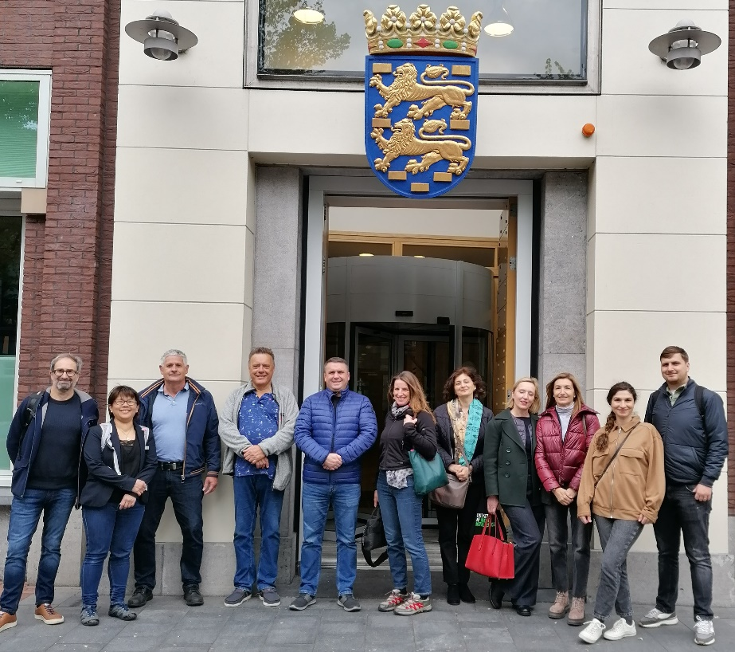
The second day was dedicated to the study visit to the delta. At the Afsluitdijk, the Wadden Center hosted the participants. An inspiring presentation was given on the history and future perspective of the Afsluitdijk. The meeting was finalized by the Steering Group discussion on further progress and management of the project, the next steps in terms of further implementation of the Action Plans, regarding the next meetings in Phase 2 and the final dissemination conference to take place in the last semester of the project.

If you want to know more, please, contact the Lead Partner, University of Twente (CSTM)
f.h.j.m.coenen@utwente.nl or m.lordkipanidze@utwente.nl;

or visit project website or our social media. Delta Lady (Floating Cultures in River Deltas)
Project funded by Interreg Europe programme

