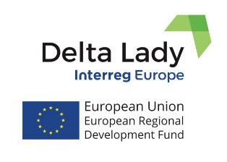
Press Release
September 2020

ONLINE PARTNER MEETING DELTA LADY
The 5th Interregional Learning Event and Partner Meeting of the Delta Lady project was organized online in Microsoft Teams on the 8th and 9th September 2020. The 2-day event was planned in Tulcea, Romania, but travel restrictions prevented partners to travel to Romania, due to Covid-19. Consequently, there was no possibility to visit the Danube Delta. The focus of the meeting was on action plans and sustainable business models. 18 participants attended the online meeting. On the first day, partners presented their progress related to the regional action plans aimed at improving delivery of ecosystem services in participating delta region. The second day was dedicated to the experts’ presentations on sustainable business models in deltas. Partner from Romania presented sustainable tourism activities in the Danube Delta, a combination of different small-scale businesses and community initiatives, cycling, kayaking and sailing combined with accommodation and catering as well as bird watching, photography. Moreover, Dutch expert on sustainable innovations presented the methodology of Innovative Business Model in the Delta environments. Business opportunities in deltas related to the issues mentioned by project partners and stakeholders and observed during the study visits in the participating deltas, were illustrated by the Dutch expert. All presentations are available in the project material database. The meeting was finalized by the Steering Group discussion on further management and communication/dissemination activities of the project, on scientific outputs and project indicators. Partners are mobilized to continue their work on drafting the regional action plans and are motivated to share their experiences with each other. The next partner meeting is planned in the beginning of the next year in the Dutch Province of Friesland.
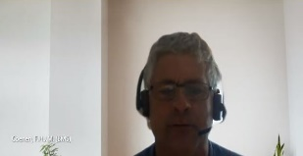
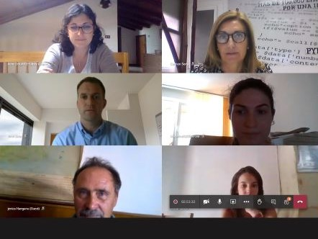
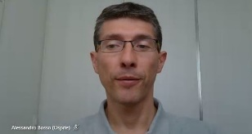
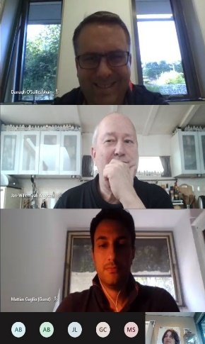
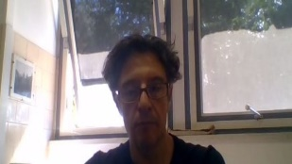

If you want to know more, please, contact the Lead Partner, University of Twente (CSTM)
f.h.j.m.coenen@utwente.nl or m.lordkipanidze@utwente.nl;

or visit project website or our social media:
Delta Lady (Floating Cultures in River Deltas)
Project funded by Interreg Europe programme
Facebook page

