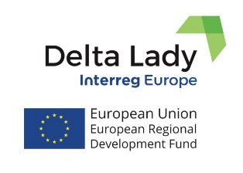
Press Release
September 2021

DELTA LADY PARTNER MEETING
Action Plans and the Lessons Learned from the exchange of experience process

The 6th Interregional Learning Event and Partner Meeting of the Delta Lady project was planned in the Netherlands in Leeuwarden, on the 14th and 15th September 2021, but due to the Covid-19 the 2-day event was organized online in Microsoft Teams. The focus of the meeting was on the progress related to action plans and the lessons learned from the exchange of experiences process in Phase 1 of the project. All partners were present. The 1st day was dedicated to the action plan presentations and discussions. The 2nd day was dedicated to the presentation of the Frisian Pilot Action and presentations of Good Practices identified by the Frisian partner. The action plans of partners will soon be submitted to the project officers for approval. The Pilot Action is related to the Web application for Policy-Enhanced Sustainable Cost-Benefit Analysis. It is dedicated to developing and testing a web-based and user-friendly application that enables regional policymakers and project owners to assess the impact of their projects and policy initiatives on the policy frameworks of ecosystem services, sustainable development goals, and broader well-being, based on the scientific method of policy-enhanced sustainable cost-benefit analysis. The meeting was finalized by the Steering Group discussion on the issues related to the management, communication, and financial matters of the project. This was the last meeting of Phase 1 of the project. Phase 2 starts as soon as the Action Plans of partners are finalized and validated. Phase 2 which is till May 2023, is dedicated to the monitoring of the Action Plans of the partners. At the next meeting, partners will meet to share their progress with the implementation of the Action Plans. The meeting is planned in the first half of 2022.

If you want to know more, please, contact the Lead Partner, University of Twente (CSTM)
f.h.j.m.coenen@utwente.nl or m.lordkipanidze@utwente.nl;

or visit project website or our social media:
Delta Lady (Floating Cultures in River Deltas)
Project funded by Interreg Europe programme

